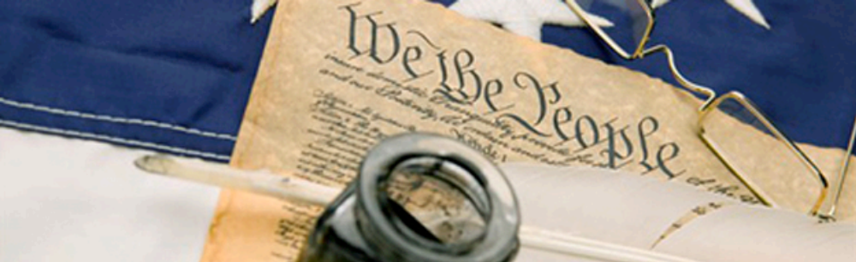

Stark County Teaching American History Grant

Stark County Educational Service Center
2100 38th Street NW
Canton, Ohio 44709

Images and Music of the Vietnam Protest Movement

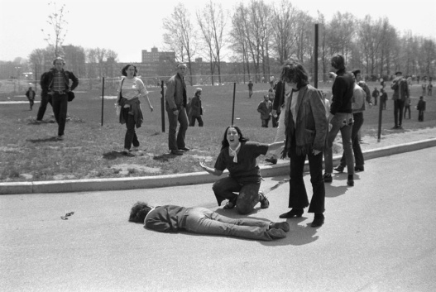
Grade Level:
AP American History (11th Grade)

Louis Doenges
St. Thomas Aquinas High School

Duration:
3 days

Image courtesy of the Library of Congress

Overview

Students will learn about the Vietnam Protest Movement through lecture, historic photographs, and period artwork. They will write an AP style essay and build a collage of artwork and photographs with a corresponding song which details an aspect of the Vietnam Protest Movement. Students will use PowerPoint to build their presentation. Students will write a 1-2 page paper explaining the meaning of the images and song, along with the connection they have together. The student paper will also demonstrate the student’s knowledge of the era by making connections of the images and songs to the mood of the protest movement.

Ohio’s New Learning Standards: K-12 Social Studies

Standard:
26. The Cold War and conflicts in Korea and Vietnam influenced domestic and international politics.

Content Elaboration:
The Vietnam War divided the country and sparked massive protests. Spending for the war came at the expense of the domestic programs launched by President Johnson. This led to urban unrest in the 1960s. The Vietnam War was a dominant issue in the presidential campaigns of 1968 and 1972. The difficulties and eventual withdrawal from Vietnam led to concerted efforts on part of the U.S. to find allies in future conflicts.

College Board AP United States History Themes
2. Reform
Diverse movements focusing on a broad range of issues, including anti-slavery, education, labor, temperance, women’s rights, civil rights, gay rights, war, public health, and government.

3. War and Diplomacy
Armed conflict from the precolonial period to the twenty-first century; impact of war on American foreign policy and on politics, economy, and society.

College Board AP United States History Themes
25. The Turbulent 1960s
The antiwar movement and the counterculture

Historical Background

The Vietnam War sparked a massive and diverse antiwar movement in the United States. The movement peaked in the late 1960s but remained active until the United States formally ended its involvement with the Paris Peace Accords in 1973. The antiwar movement drew upon a number of groups and fed off several other movements of the era. For example, many young Americans of draft age did not see the sense of being forced to fight in a country on the other side of the world. They also argued against the war on moral grounds; for many draft age Americans, the Vietnam conflict did not have the unifying cause behind it like so many earlier wars had. There was also the counterculture movement that was opposed to war, government power, and conformity. The civil rights movement played a critical role in accelerating the antiwar movement. Activists, both white and black, brought their organizing skills to the antiwar movement and began to link racial equality at home with moral arguments against the war; Martin Luther King began speaking out against the war in 1967.

The year 1968 proved especially critical. The Tet Offensive in January 1968 ended Lyndon Johnson's bid for reelection that year. News footage and reports showing attacks by North Vietnamese, especially those in the American Embassy in Saigon, ran counter to message by military and political leaders that the war was under control and the end was in sight. Robert Kennedy's assassination in June was followed by violence outside the Democratic National Convention in August in Chicago as police attacked a group of demonstrators. Republican Richard Nixon capitalized on the tumult by winning the election over Vice President Hubert Humphrey; Nixon promised to restore law and order and pledged peace in Vietnam through a secret plan to end the war.

But the war continued even as troops began to be withdrawn. The people who protested against U.S. involvement in Vietnam at first were split along generational lines. The youth of America were more inclined to be leading from the forefront of the movement, and their parents and grandparents were those who supported the government actions. This would slowly change as more violence was carried out against Vietnam protestors, more American soldiers continued to die in Vietnam, and the war proceeded to drag on with no end in sight. When Nixon announced a U.S. invasion of Cambodia in April 1970, this prompted another wave of antiwar demonstrations, especially on college campuses. At a rally on the campus of Kent State University in Ohio, National Guard troops shot into the crowd, wounding nine and killing four. It was a tragic coda to the era of antiwar and social activism.

In the wake of the shootings came one of the most popular anthems of the antiwar movement, "Four Dead in Ohio" by Crosby, Stills, Nash and Young. The song illustrates the centrality and power of artistic expression to the antiwar movement. Music and artwork was a great medium through which the Vietnam Protest Movement was able to convey its message. This was a result of the growth of the music industry and the collection of newspapers, magazines, and small publishing groups which allowed for the musicians and artists to publish their unconventional message. Protest songs became some of the most popular songs of the time period. Photographs from Vietnam, the first real time coverage of a war on television news, and vivid and eccentric works of protest art stirred feelings within a restless American youth which boiled over into the protests. Some of the more renowned protests artists were Bob Dylan, CSNY, Chicago, Jefferson Airplane, CCR, John Lennon, and John Denver.

Enduring Understandings/ Essential Questions
- Enduring Understanding:
War impacts the relationship between a government and its citizens.
- Essential Questions:
In what ways do citizens demonstrate their reactions to their country’s involvement in war?
Instructional Strategies
Day 1 (Optional Lecture Notes)
- Hand out Appendix A: Vietnam Anti-War Movement Lecture Study Guide to the students.
- Lecture on the Vietnam Ant-War Movement: Use text from the Historical Background and Appendix B: Vietnam Anti-War Movement Lecture.
- Go over the lecture notes with students, answering any questions and filling in any gaps in their study guides.
Day 2
- Hand out Appendix C: Protest Essay and PowerPoint Assignment to the students. Go over with the students the requirements for the assignment and sites where they can find music and images.
- Hand out Appendix D: Essay Rubric to students. Each student will need to read over Rubric to see how they will be graded.
- Hand out Appendix E: Protest PowerPoint Rubric to students. Each student will need to read over Rubric to see how they will be graded.
- Instruct the students to use their copy of the Protest PowerPoint Rubric to assess the provided sample PowerPoint presentation.
- Play the PowerPoint: Kent State Shootings and Song: Neil Young’s, Ohio to the class.
  - Start the song and the PowerPoint as close as possible to each other. The PowerPoint will advance to the next slide on its own.
    - The song “Ohio” is not part of the PowerPoint. It must be acquired by the teacher.
- When the presentation is done have the students try to identify the message which you were trying to portray in the example:
  - Connection of the lyrics to indiscriminate killings of student anti-war protestors;
  - “tin soldiers” = pictures of National Guard units,
  - “four dead in Ohio” = images of wounded or dead/ambulance).
- Ask students to provide their assessment of the presentation based on the Protest PowerPoint Rubric.

Day 3-4 (Depending on class size)
- Students will share their essays with the class in 3-5 minute presentations.
  - Each student should present their PowerPoint presentation accompanied with their selected music on the provided computer, projector, and speakers.
  - Allow for questions to be asked of each presentation and discussion/debate may be held over influence of lyrics/music and imagery.

Classroom Materials
- Projector
- Computer
- Speakers
- Copies of Protest PowerPoint Rubric for each student.
- Copies of Protest PowerPoint Assignment for each student.
- PowerPoint presentation Kent State Shootings
- Copy of Neil Young’s, Ohio (not included due to copyright)

Resources
- Filo, John. Kent State/John Paul Filo. 1970. Photograph. Library of Congress, Washington, D.C.. Web. 5 Mar 2014. <http://www.loc.gov/pictures/collection/cph/item/2009632261/>.

- Kent State University. News Service, Multiple Images. 1970. Photograph. Kent State University: Special Collections and Archives, Kent, OH. Web. 5 Mar 2014. <http://www.library.kent.edu/drc/may4/browse_titles.php>.

- Young, Neil. Ohio. Crosby, Stills, Nash, & Young. Rec. 21 May 1970. Atlantic, 1970. Vinyl recording.

Summative Assessment (or Question)

See Appendix B for “Protest PowerPoint Assignment.”

Assessment or Answer Key

See Appendix C for “Protest PowerPoint Rubric.”

Assessment Rubric

See Appendix C for “Protest PowerPoint Rubric.”

Appendices

Appendix A - Vietnam Anti-War Movement Lecture Study Guide
Appendix B - Vietnam Anti-War Movement Lecture Notes
Appendix C - Protest Essay and PowerPoint Assignment
Appendix D - Essay Rubric
Appendix E - Protest PowerPoint Rubric
Appendix F –Sample PowerPoint

Appendices
Appendix A
Vietnam Anti-War Movement Lecture Study Guide

- When did the first anti-war protests begin?
  - What was Students for a Democratic Society (SDS)?
  - What was the main reason for the protests?
- What was the counter culture of 1960s?
  - What impact did it have on music and art?
- What were the major criticisms of the War?
- Who challenged Johnson for the Democratic nomination in 1968? Why?
  - Who won the Democratic nomination? Why?
  - What gained all the media attention at the Democratic National Convention?
  - Who won the 1968 presidential election? Why?
- What was “Vietnamization”? What protest resulted from it?
- How did the My Lai Massacre change more Americans view of the war?
- How did the invasion of Cambodia fuel the protest movement?
- What occurred at Kent State in 1970 with student protests?
  - What was the reaction of college students to the Kent State shootings?
  - What was the US Senate’s reaction?
- Overall did the Vietnam protest movement influence government policy with Vietnam?

Appendix B
Page 1 of 4
Vietnam Anti-War Movement Lecture Notes

- When did the first anti-war protests begin?
- The first anti-war protest occurred at the University of Michigan in 1965
- These protests soon spread to other college campuses
- College administrative buildings taken over by protestors
  - What was Students for a Democratic Society (SDS)?
- Radical groups, such as the Students for a Democratic Society became involved
- Originally created to gain more student’s rights on college campuses and policy decisions
- Quickly came to the aid of African-American Civil rights movement and Vietnam War protests
- The protests became more violent
  - What was the main reason for the protests?
- Combination of Vietnam draft protests and campus policies of excluding students from university decisions
- Burning one's draft card became the ultimate protest
- 570,000 men would eventually choose to avoid military service
- President Johnson became a prisoner of the White House as a result of these protests

- What was the counter culture of 1960s?
- During the late 1960's, many young people began to protest against American culture
- They attempted to form a counter-culture stressing peace, love , and individuality
- These protesters were known as hippies
  - What impact did it have on music and art?
- Spawned their own music and art
- Folk music and acid-rock produced lyrics against war, conformity, and government power
- Bob Dylan, CSNY, Chicago, Jefferson Airplane, CCR, John Lennon, and John Denver amongst Vietnam protesters
- Slogans such as “Make love, not war” and “Keep calm and carry on” become popular phrases
- Slogans mixed into various forms of artwork throughout the movement

- What were the major criticisms of the War?
- In 1967, Robert McNamara, Secretary of Defense, resigned his position
- He had commissioned a report on U.S. involvement in Vietnam
- It indicated that the U.S. government was lying to the American people about the extent of U.S. involvement in the war
- In 1968, the American commander in Vietnam, General William Westmoreland, said that conditions were beginning to improve
  - What was the Tet Offensive?
- Shortly after Westmoreland’s announcement, the communists launched a major offensive against twenty-six provincial capitals in South Vietnam
- This offensive was timed to coincide with a major Vietnamese holiday known as "Tet," the beginning of the new year under the lunar calendar
- This offensive caught the American forces off guard
Appendix B
Page 2 of 4
Vietnam Anti-War Movement Lecture Notes

  - How did the Tet Offensive appear as a US military defeat?
- Many Americans wrongly believed that the Tet Offensive had been a major defeat for U.S. forces
- Correctly believed that America was not winning the war any time soon in Vietnam
- More Americans turned against the war as a result of this
- Who challenged Johnson for the Democratic nomination in 1968? Why?
- Senator Eugene McCarthy, a Democrat, announced that he would be a "peace" candidate for President
- He promised a negotiated peace settlement of the war in Vietnam
- McCarthy did well against incumbent President Johnson in the early primaries
- Showed desire of Americans to end involvement in Vietnam
- Encouraged by the success of Senator McCarthy, Senator Robert Kennedy also entered into the race the nomination
- In March 1968, President Johnson addressed the nation and announced he would not seek another term
- Also announced a reduction in the bombing of North Vietnam and requested a peace conference with N. Vietnam
- Vice President Hubert Humphrey entered the race after President Johnson's announcement
  - Who won the Democratic nomination? Why?
- By June, it appeared that Kennedy had momentum to win the Democratic nomination
- Kennedy was assassinated by a Sirhan Sirhan after winning the California primary
- Seen by many “doves” – those who wanted peace – as favorite “peace” candidate
- Hubert Humphrey will win Democratic nomination after death of Kennedy
  - What gained all the media attention at the Democratic National Convention?
- The nomination of Hubert Humphrey as the Democratic candidate for President took a back seat to the violence
- When the Democratic Party held its convention in Chicago, it became a target for numerous anti-war protests
- The largest group of protesters were the teenage members of the Youth International Party
- Known as Yippies, they had been called to Chicago by the leader of the party, Abbie Hoffman
- They were to nominate a pig as a protest against the war
- Students for a Democratic Society used this as a opportunity to provoke violence
- Mayor Richard Daley did not want to be embarrassed by these demonstrations occurring in his city
- He ordered his police to end the demonstrations by force
- This order led to more violence and eventually troops had to be called in
- Violence between police and protests were televised nationally
- The delegates to the Democratic Convention were trapped in the convention center
- The violence outside became a major topic of debate in the convention
- Eventually, seven individuals were arrested for inciting the violence outside the Democratic Convention
- The Chicago Seven were put on trial, but acquitted

Appendix B
Page 3 of 4
Vietnam Anti-War Movement Lecture Notes

  - Who won the 1968 presidential election? Why?
- The Republicans nominated Richard Nixon as their candidate for President
- The campaign's major issue was the war in Vietnam
- Nixon claimed to have a "secret plan" to end the war
- He also claimed that he was supported by a "silent majority" who did not go into the streets to protest
- Humphrey was loyal to Lyndon Johnson and did not criticize U.S. participation in Vietnam
- Nixon won a close election victory
- What was “Vietnamization”? What protest resulted from it?
- Nixon ordered major changes in American strategy in Vietnam known as "Vietnamization"
- Turning more and more of the fighting over to the South Vietnamese themselves
- These changes in strategy did not please the anti-war protesters
- 250,000 protesters marched on Washington and attempted to disrupt the government
- How did the My Lai Massacre change more Americans view of the war?
- In 1970, the American public was greatly disturbed by news of an incident at My Lai
- A group of American soldiers massacred an entire village of Vietnamese (old men, women, and children) in 1968
- American officers (Lt. Calley) were court marshaled and sentenced to prison
- The American public had its image of American soldiers tarnished by this episode
- Many began to question what the war was doing to our soldiers
- How did the invasion of Cambodia fuel the protest movement?
- In April of 1970, Nixon approves US attacks into Cambodia to go after Vietcong sanctuaries
- American soldiers were attacking a communist supply line called the Ho Chi Minh Trail
- American planes were also bombing this area
- He did not call it an invasion, but rather an incursion
- Nixon did not publicize the fact that he was escalating the war into Cambodia, while making public less US troops being in Vietnam
- What occurred at Kent State in 1970 with student protests?
- This news angered many Americans
- Anti-war protests erupted all over the nation
- At Kent State University four students were shot by members of the Ohio National Guard during such a protest
- Ohio Governor James Rhodes sent the troops even though they were un-trained for such duty
  - What was the reaction of college students to the Kent State shootings?
- Numerous protests across nation erupt on college campuses in support of Kent State victims
- Even “conservative campuses,” which had not had any protests before, had protests
  - What was the US Senate’s reaction?
- In a "Sense of the Senate" Resolution, the U.S. Senate repealed the Gulf of Tonkin Resolution
- An attempt to regain lost power

Appendix B
Page 4 of 4
Vietnam Anti-War Movement Lecture Notes

- Overall did the Vietnam protest movement influence government policy with Vietnam?
- Classroom discussion

Appendix C
Page 1 of 2
Protest Essay and PowerPoint Assignment

Objective: Complete an AP style essay on a topic or event associated with antiwar protests during the Vietnam War.

Now that you have learned about the Vietnam Protest Movement, you will write an AP style essay on an aspect of the antiwar movement or an event from the movement. The assignment also includes class presentation with a themed collage of photos, artwork, and/or video based on your essay topic. This is your chance to explore different aspects of the protest movement. Look to your notes and the textbook for a jumping off point. Brainstorm a particular aspect or event within the Movement which you might want to utilize. Research images and songs that pertain to this topic/theme. Then build your PowerPoint presentation, while syncing your images to the lyrics and music of your song.

Requirements:
- AP style essay: Select a topic or event from the Vietnam Protest Movement. Provide an overview of the topic and answer the following question:
  - Question: What is the significance of your chosen event in the context of the antiwar movement? For example, is this a reaction to a certain event? Is it promoting a political idea or popular sentiment?
- Each student will give a 3-5 minute oral presentation based on the essay. This presentation will include a 1-2 minute PowerPoint presentation of photos, artwork, and/or video dealing with the Vietnam Protest Movement.
  - The oral presentation should include a review of the essay’s thesis and an overview of the paper.
  - The PowerPoint should deal directly with the students paper topic
- Students need a minimum of 15 pieces of imagery from protests in their PowerPoint.
- Each image slide must include at least one line of explanatory text connecting the imagery to the essay topic.
- Imagery must be appropriate for the school setting.
- Students will choose a song from the Vietnam Protest Movement.
- The song and imagery within the PowerPoint need to correspond to each other.
- PowerPoint Presentation and Song must be compatible with school’s computers.
- Include a Title Slide and Source Cited Slide.

Due Date: Presentations will begin 2 class days from the day you receive assignment. Each student is expected to go on the day they are assigned to present.

Appendix C
Page 2 of 2
Protest Essay and PowerPoint Assignment

Resources:
Possible Topics: Robert McNamara, SDS, 1968 Democratic National Convention, Draft, Tet Offensive, My Lai Massacre, Moratorium
Websites for songs:
http://classicrock.about.com/od/toppickslists/tp/Anti-War-Protest-Songs-Of-The-60s-And-70s.htm
https://www.youtube.com/playlist?list=PL549B0CC0FC2AC8AC

Other sources for songs:
Ask your parents or grandparents. They may have experienced protest songs from this area directly.

Images:
www.loc.gov
www.archives.gov
www.apimages.com

Appendix D

Final Score: _______
Essay Rubric

This is __________________________’s essay. Period: _____

Superior Essay: Score of 25  ___ superior thesis  ___ extremely well-organized essay  ___ addresses all areas of question evenly  ___ strong analysis  ___ substantial use of evidence  ___ extremely well-written essay  ___ generally error free (need not be perfect) | Strong Essay: Score of 20  ___ strong thesis  ___ well-organized essay  ___ addresses all areas of the questions: may lack some balance between major areas  ___ some important information left out  ___ strong analysis in some areas; needs more  ___ strong use of evidence; may lack balance  ___ well-written essay  ___ may contain minor errors
Adequate Essay: Score of 15  ___ clear thesis  ___ thesis a bit vague  ___ fairly well-organized essay  ___ addresses all areas of question but may lack balance  ___ contains analysis:  ___ some major events omitted  ___ contains evidence:  ___ essay deviates sometimes from thesis  ___ fairly well-written essay  ___ may contain some significant historical errors  ___ some facts are irrelevant to time period | Needs Some Work: Score of 10  ___ undeveloped thesis  ___ thesis does not establish purpose of essay  ___ thesis does not fully address the question  ___ thesis vague  ___ weak organization  ___ does not address one or more parts of the question  ___ contains some analysis, but  ___ lacks analysis of key issues  ___ most major events omitted  ___ contains some evidence  ___ lacks evidence to support main ideas  ___ contains major historical errors  ___ much information irrelevant to question  ___ essay is somewhat incomplete
Needs a Lot of Work: Score of 5  ___ no thesis or poor thesis  ___ incorrect or incomplete essay  ___ poor organization  ___ facts not specific, accurate, & relevant  ___ poor analysis of key issues | Did Not Do the Prompt: Score of 0  ___ writes on topic completely different from question  ___ little to not effort shown in preparation for essay

Additional Comments:

Overall Score: ______

Appendix E
Protest PowerPoint Rubric

 | Mastered  (4 pts.) | Standard  (3 pts) | Mediocre  (2 pts.) | Inadequate  (1 pts.)
Use of Imagery | The student’s choice of images shows a clear understanding of the issues going on during the period of protest. All images are directly related to their topic or are connected with the topic through appropriate text. | The student’s choice of images shows a reasonable understanding of the issues going on during the period of protest.  10-14 images are related to their topic or are connected with the topic through appropriate text. | The student’s choice of images shows a fairly reasonable understanding of the issues going on during the period of protest.  5-10 of the images related to their topic or are connected with the topic through appropriate text. | The student’s choice of images shows a weak understanding of the issues going on during the period of protest.  0-4 of the images related to their topic or are connected with the topic through appropriate text.
Use of Song | The student’s choice of song shows a clear understanding of the issues going on during the period of protest. | The student’s choice of song shows a reasonable understanding of the issues going on during the period of protest. | The student’s choice of song shows a fairly reasonable understanding of the issues going on during the period of protest. | The student’s choice of song shows a weak understanding of the issues going on during the period of protest.
Combined Attention to Theme | The student gives a reasonable explanation of how the imagery, song, and essay are related. For most, the relationship is clear without explanation. | The student gives a reasonable explanation of how most of the imagery, song, and essay are related. For many, the relationship is clear without explanation. | The student gives a fairly reasonable explanation of how most of the imagery, song, and essay are related. The relationship is clear for some without explanation. | The student's explanations are weak and illustrate difficulty understanding how to relate the imagery, song, and essay without explanation.
Oral Presentation | Accurately describes several dominant elements of issues associated with the period of protest and can relate them to the message of the images and song. | Accurately describes a couple of dominant elements of issues associated with the period of protest and can relate them to the message of the images and song. | Accurately describes 1-2 dominant elements of issues associated with the period of protest and has difficulty relating them to the message of the images and song. | Has difficulty describing any dominant elements associated with the period of protest and relating them to the message of the images and song.
Formatting | The project includes 15 or more images, each different, a song, and presentation is in sync. | The project includes 10-14 different images, a song, and presentation is mostly in sync. | The project includes  7-9 different items, a song, and presentation is somewhat in sync. | The project contains fewer than 7 different items, no song, or presentation is not in sync.

Comments
Appendix F
Page 1 of 19
Sample PowerPoint

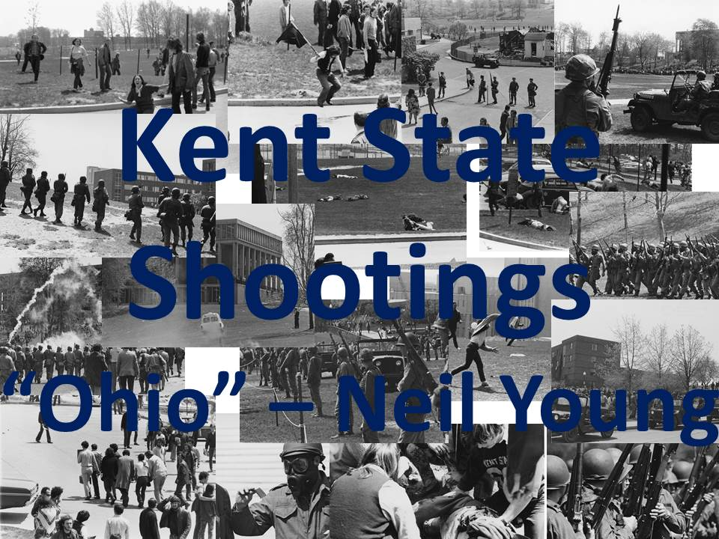

Appendix F
Page 2 of 19
Sample PowerPoint

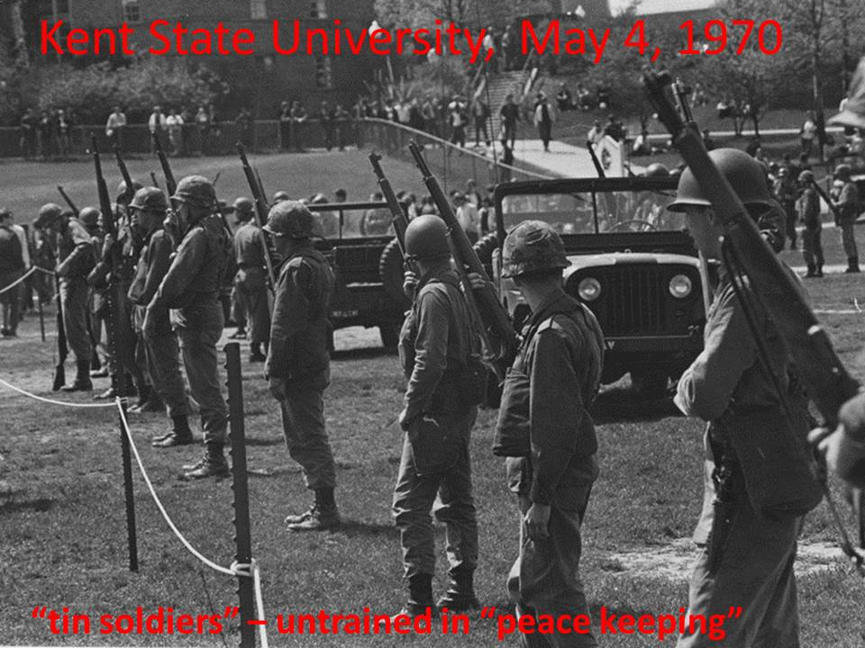

Appendix F
Page 3 of 19
Sample PowerPoint

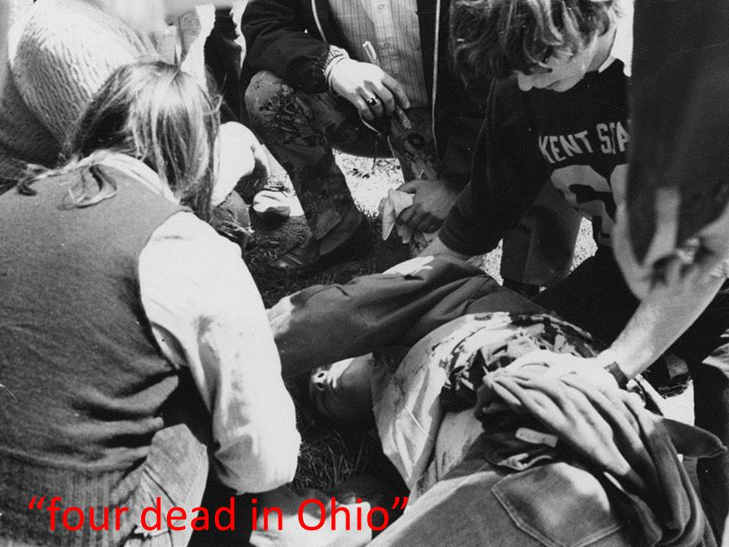

Appendix F
Page 4 of 19
Sample PowerPoint

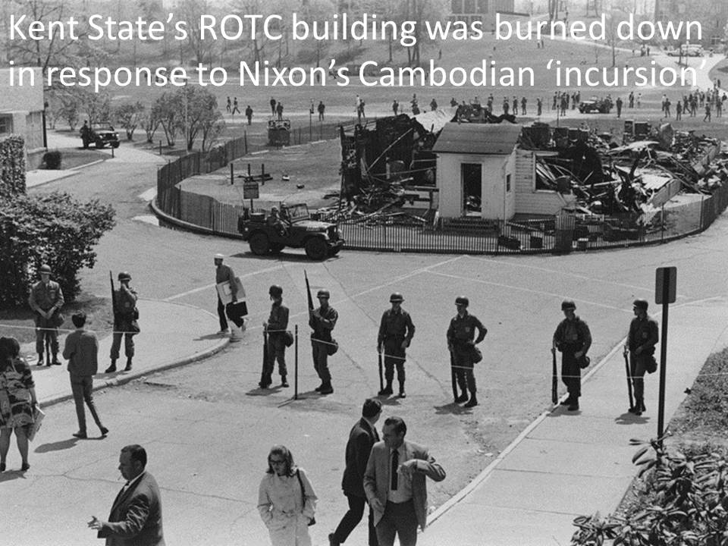

Appendix F
Page 5 of 19
Sample PowerPoint

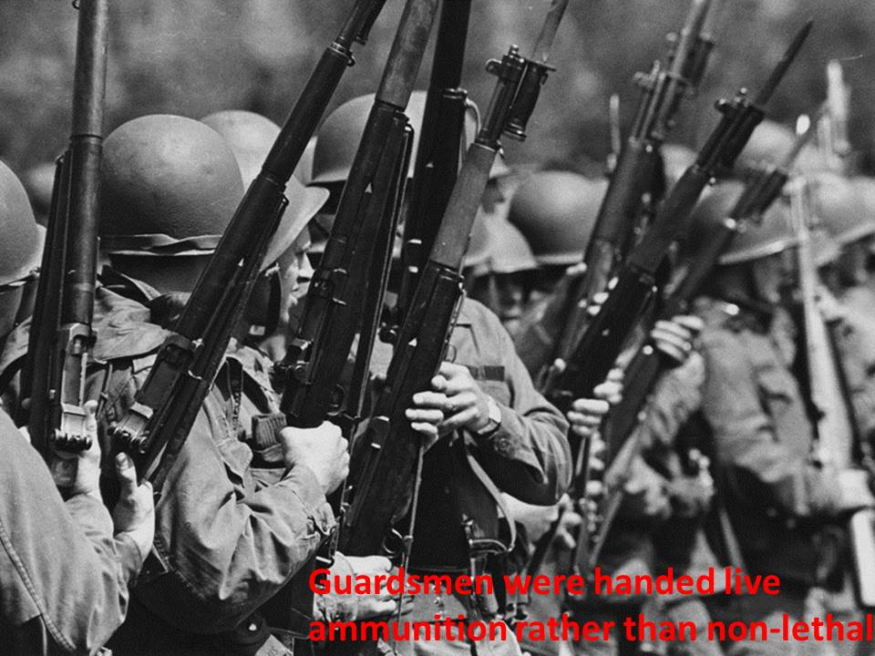

Appendix F
Page 6 of 19
Sample PowerPoint

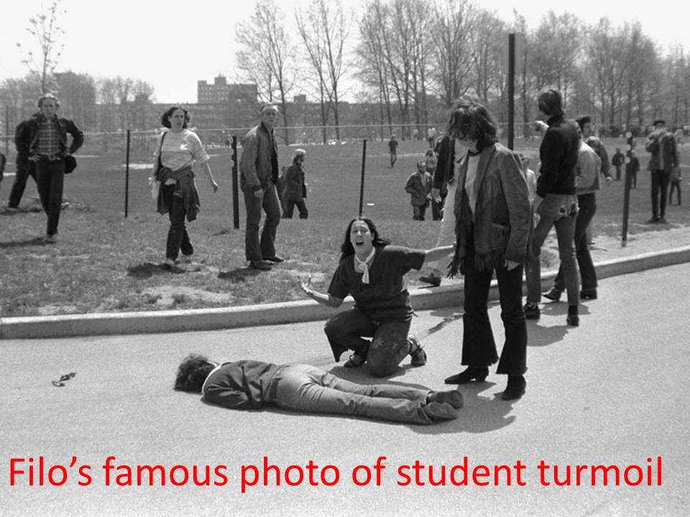

Appendix F
Page 7 of 19
Sample PowerPoint

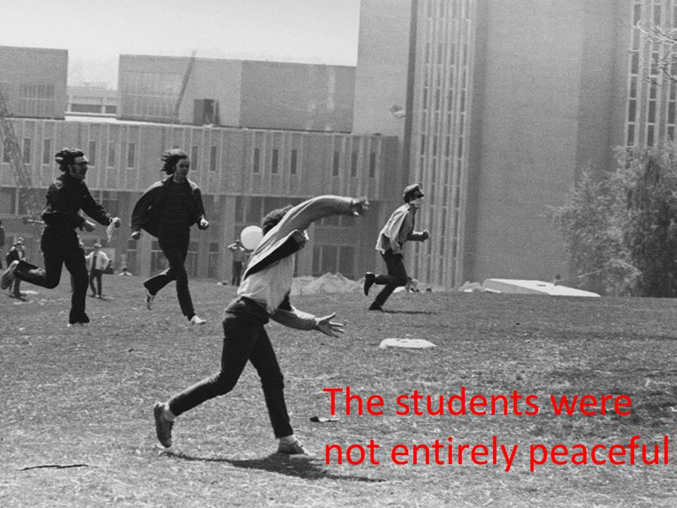

Appendix F
Page 8 of 19
Sample PowerPoint

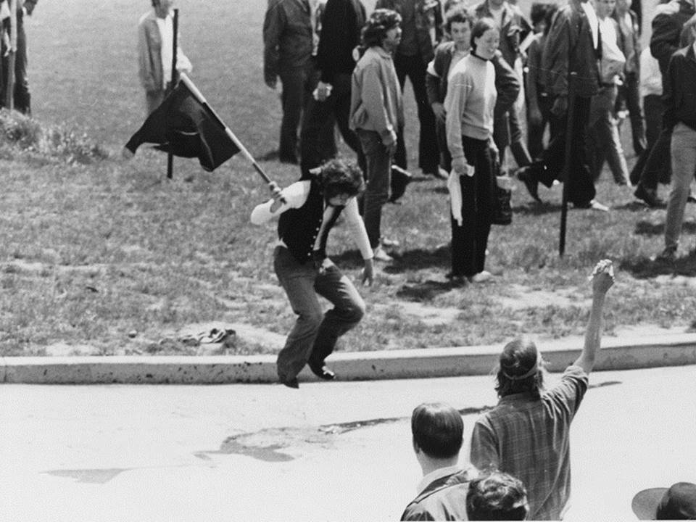

Appendix F
Page 9 of 19
Sample PowerPoint

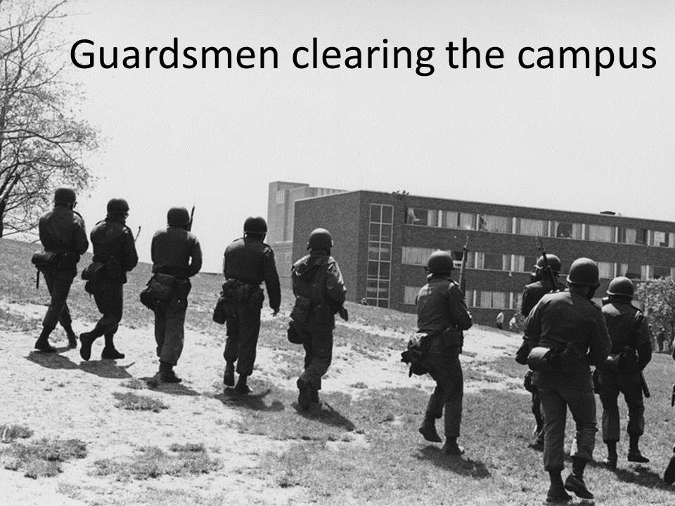

Appendix F
Page 10 of 19
Sample PowerPoint

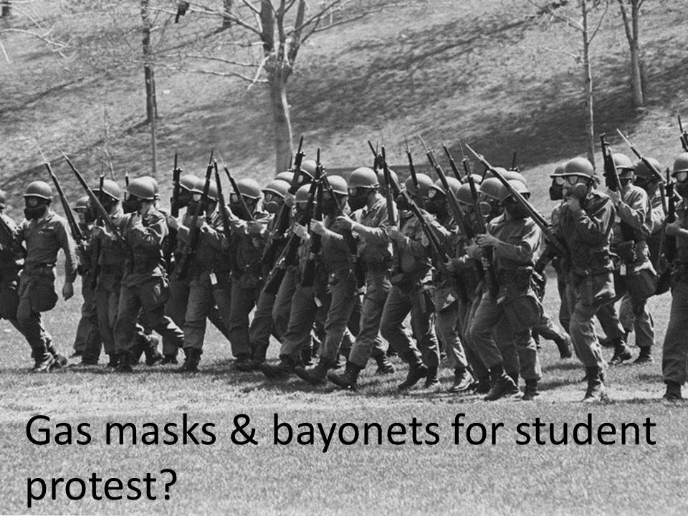

Appendix F
Page 11 of 19
Sample PowerPoint

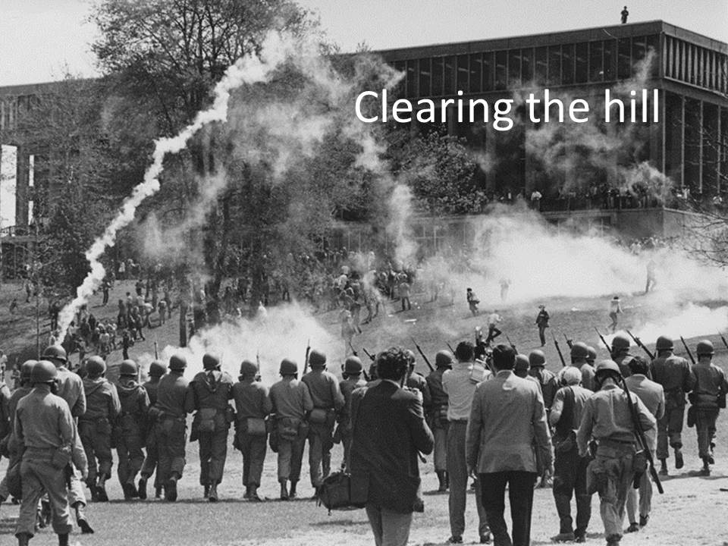

Appendix F
Page 12 of 19
Sample PowerPoint

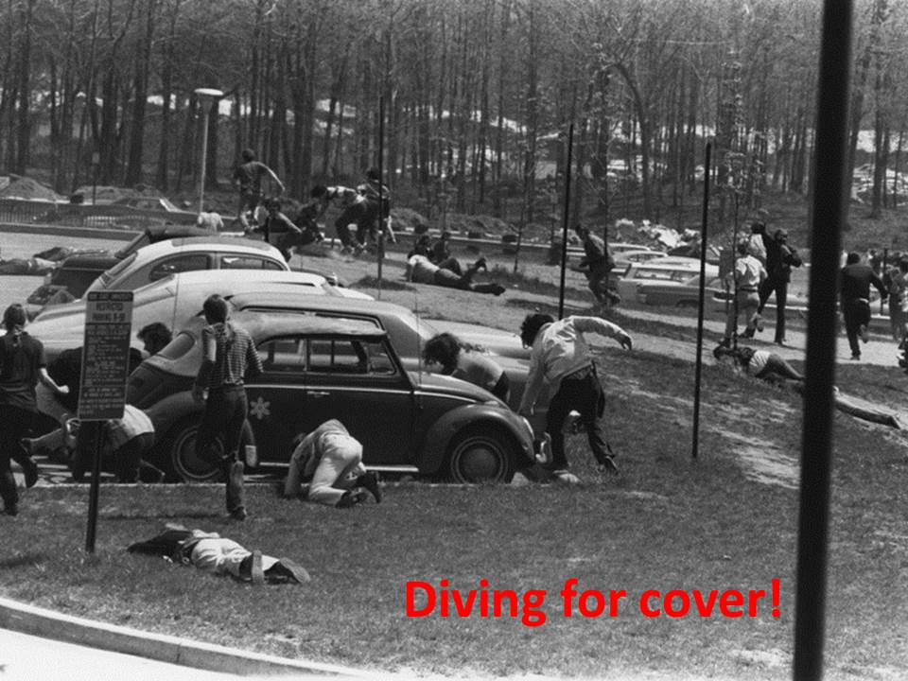

Appendix F
Page 13 of 19
Sample PowerPoint

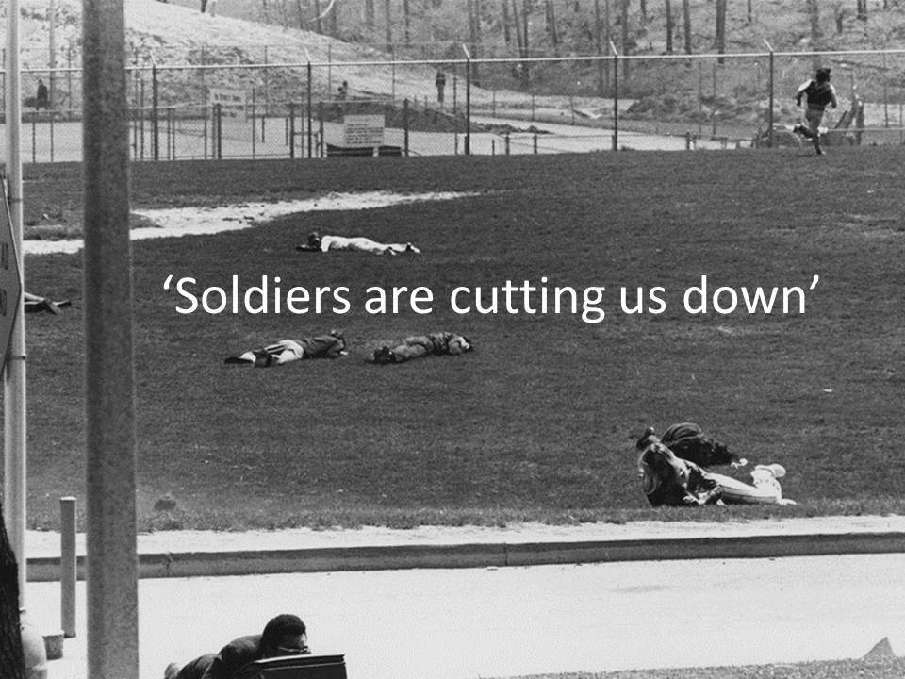

Appendix F
Page 14 of 19
Sample PowerPoint

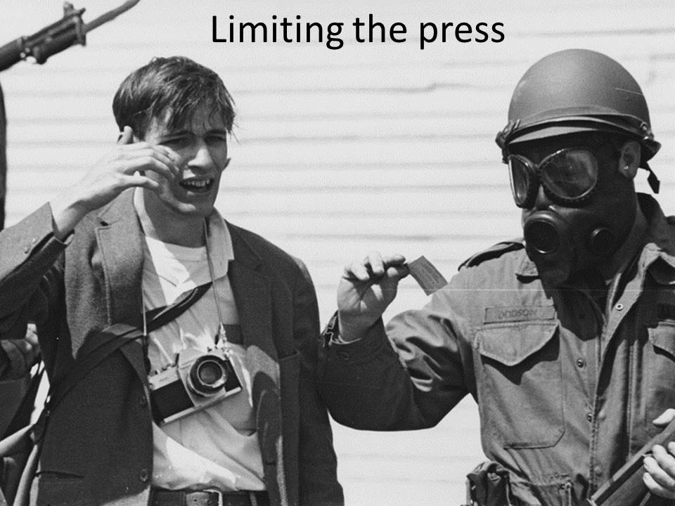

Appendix F
Page 15 of 19
Sample PowerPoint

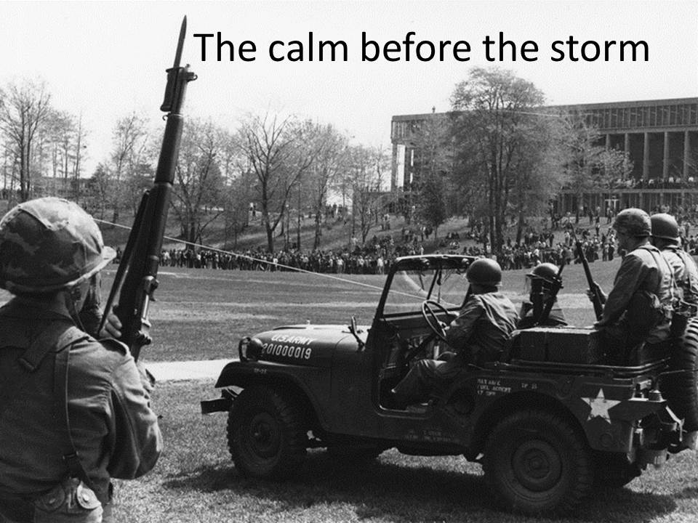

Appendix F
Page 16 of 19
Sample PowerPoint

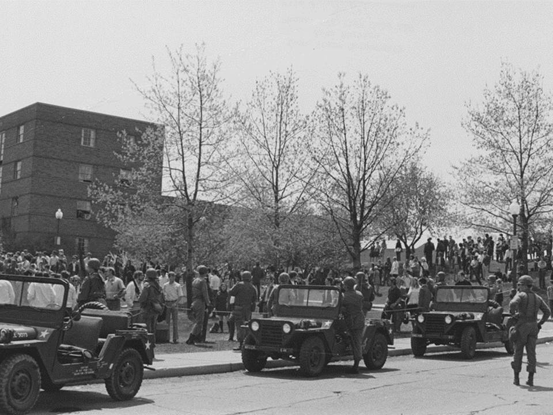

Appendix F
Page 17 of 19
Sample PowerPoint

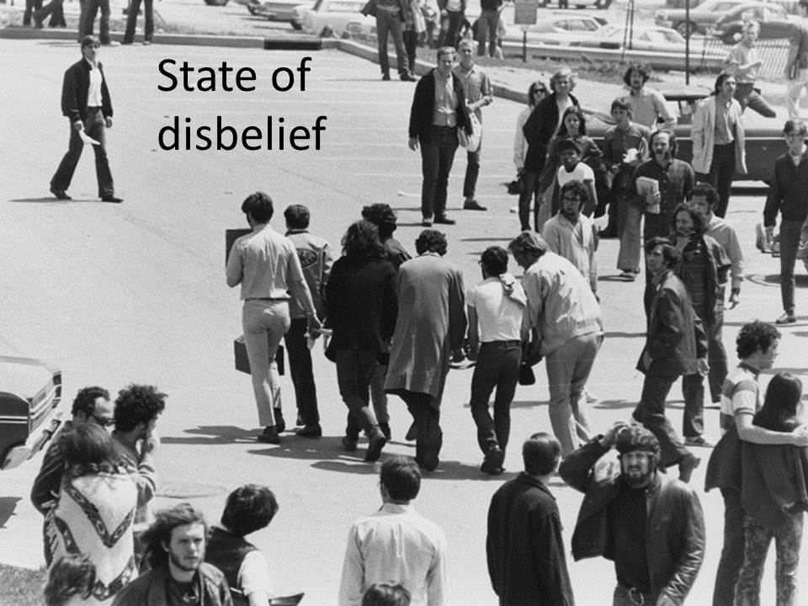

Appendix F
Page 18 of 19
Sample PowerPoint

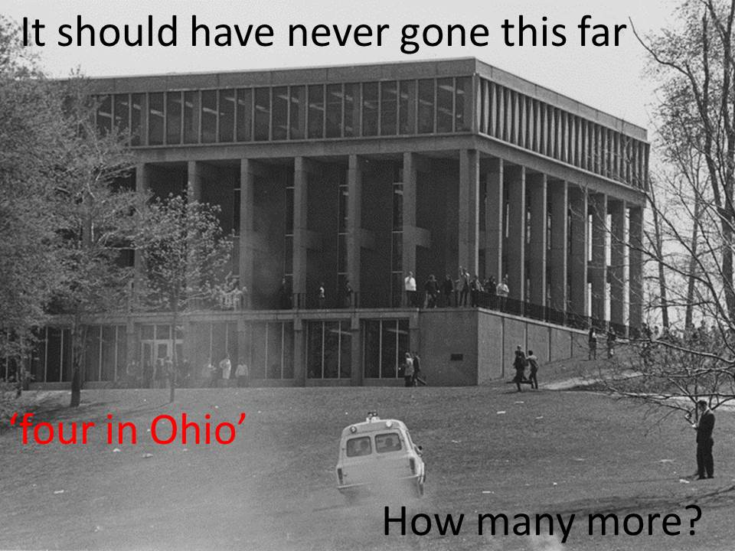

Appendix F
Page 19 of 19
Sample PowerPoint

