Recalculate Grades

This needs to be done, in the middle of every grading period
and when you are finished with end of grading period (before office stores grades).
1 - Open your gradebook click on A+ Charm choose Traditional or Comment Verification - Then click GEAR by grading period
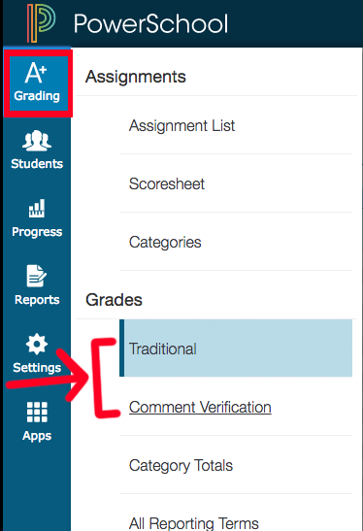
2 - Click on Recalculate Final Grades.
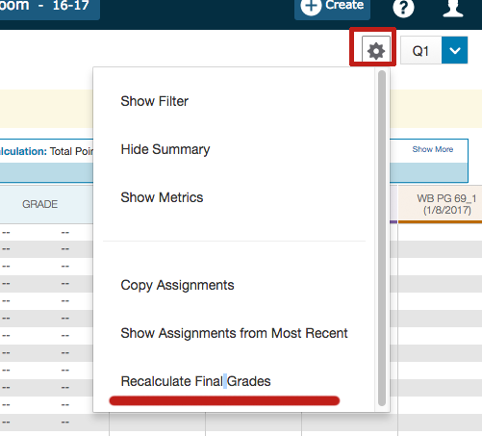
3 - Click check box under the first one (all classes will be selected).
4 - Click RECALCULATE.
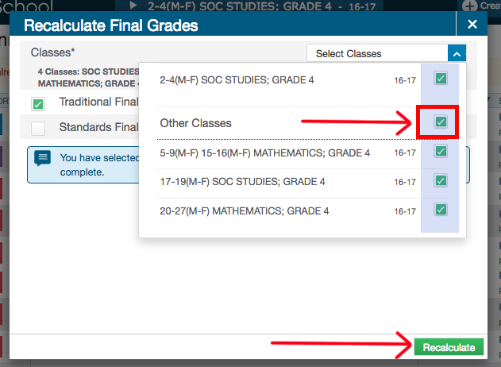
5 - White box with dots will indicate recalculation is being done.
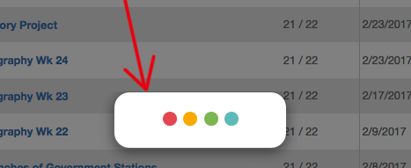
6 - Green box will appear at top once done (box disappears).
