How Do I Set Up Category Weights?
Select settings then Traditional Grade Calculations
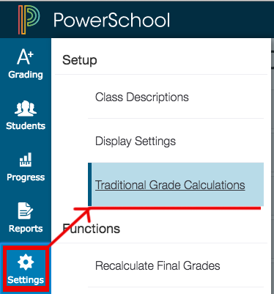
Select class you wish to set weighting for.
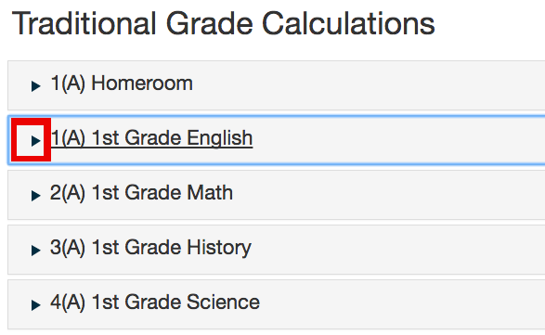
Choose actions by grading period
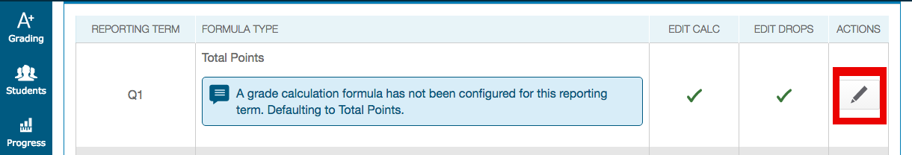
Choose category weighting from drop down and click the "+" sign for as many categories you will be using in your weighint formula.
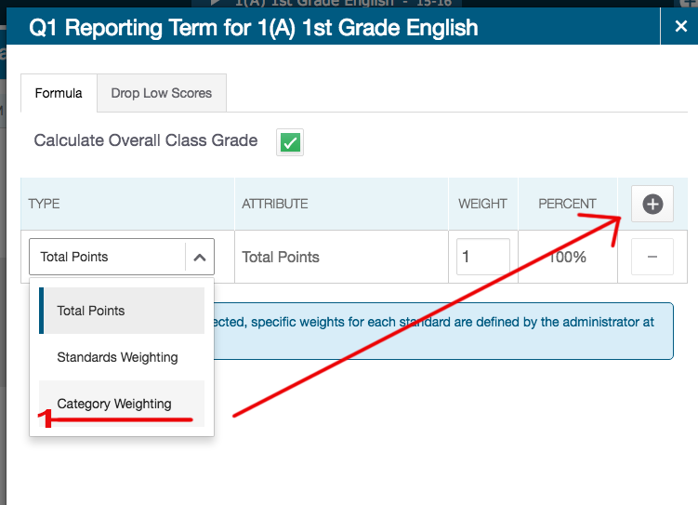
Choose Attribute "Category" and type in the weight, in this example 80% and 20%.
Click SAVE when done.
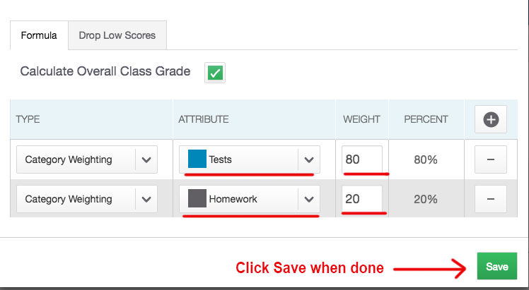
Select other grading periods and repeat following step.
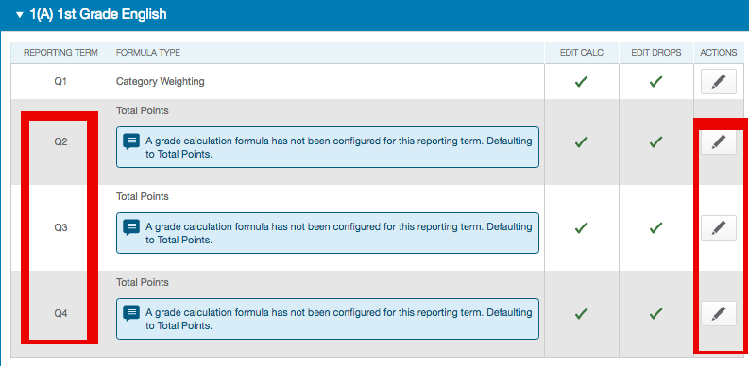
Select other classes and repeat all steps.
