SCHOOL MESSENGER TARGET LIST

. ll contacts that are flagged as Custody and/or Lives With are categorized as "Primary Guardian". All contacts that are flagged as Emergency are categorized as "Emergency".

Click the pull down under Targets that is labeled "Contacts & Guardians"

Pull down the Contacts & Guardians then choose the audience you want to reach:

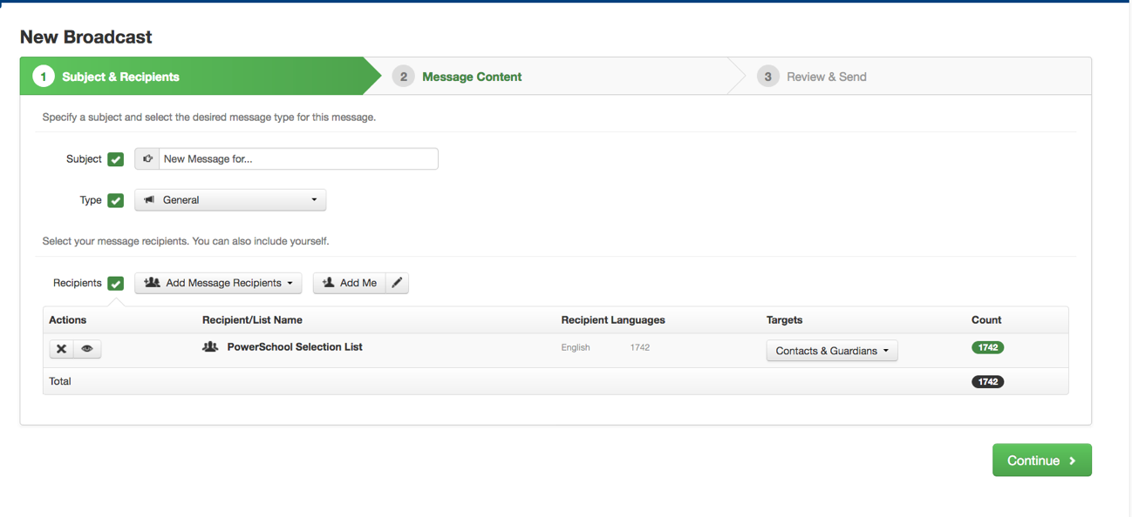
Pull down the Contacts & Guardians then choose the audience you want to reach:

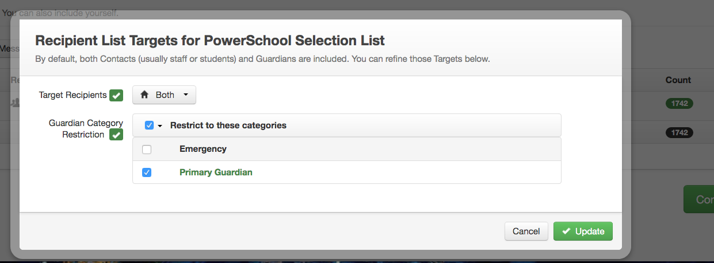
Click the button and then click Update. Your number will still be much larger than it was before. All parent emails that are listed in contacts will be included. Duplicates will not be sent, so don't worry about parents getting the same message twice. More parents will be getting the information now!

Remember to keep your PowerSchool Contacts up to date. The contact information is updated every night at midnight.

