PowerSchool
Setup and Use of the Daily Bulletin
Purpose: School Secretaries – Instructions for the setup and use of the daily bulletin in PowerSchool which can be use to communicate information to parents, students, teachers, and administrators about things like sporting events, fundraising activities, parent nights, and grading terms.

Bulletins can communicate different messages to different audiences. You can post an announcement that teachers and school administrators can view but parents and students cannot.

Creating a New Bulletin Item
On the Start Page:
- Click Special Functions on the main menu
- Click Daily Bulletin Setup
- Click New
- Enter the field information for the message you want to display 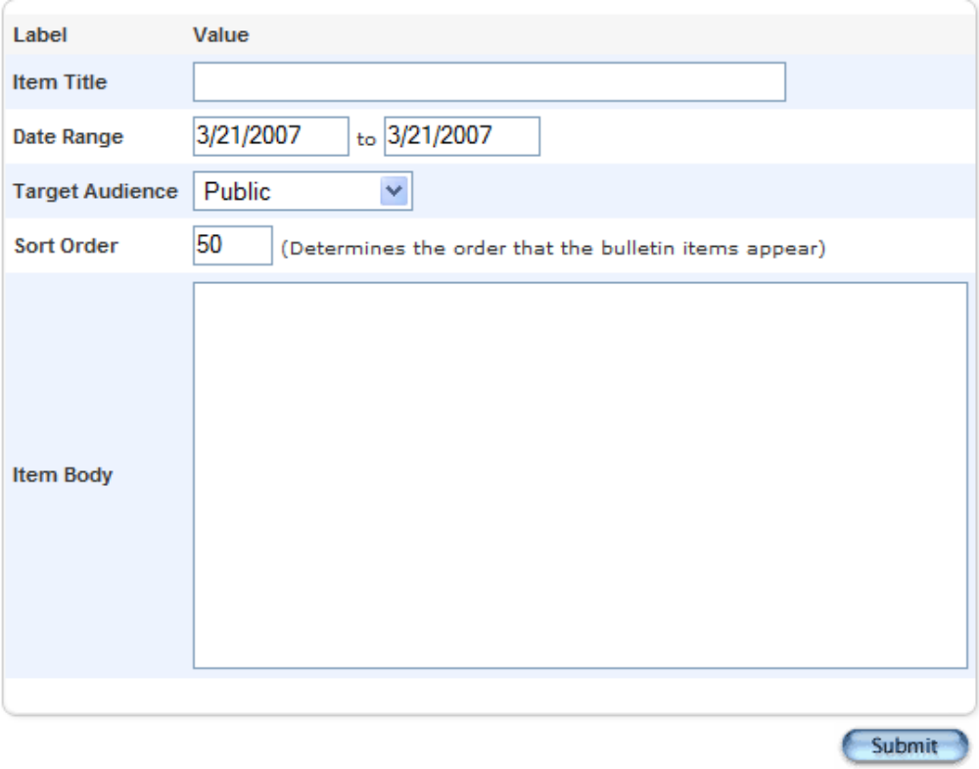
Enter the Text of the bulletin item. You may want to do a copy paste from a word processing program for large bulletins.
Enter the number that you want the item to appear on the bulletin in relation to the other items during the date range you specify. Enter a number to determine the order in which you want the system to display this item relative to other items. The lower the sort order number, the higher the item appears on the daily bulletin.
Note: You can use the sort order 0 or negative numbers, such as -1, to precede other entries. If two items have the same sort order number, the first one created precedes the other. The audience does not affect the sort order.
Choose the audience from the popup menu
Enter the date range during which you want this item to appear on the bulletin
Enter a title of the Item
- Click Submit

Target Audience - The target audience you select determines which types of users can view that bulletin item, whether administrators, teachers, substitutes, or parents and students.
Here is a breakdown of who can view which settings.
- Public: Everyone can view this bulletin item, including those using the URL [your school]/bulletin/[your school number].html. In other words, the public that does not have a log in to PowerSchool can also view your bulletins.
This is done on a school-by-school basis. To allow public access to the Daily Bulletin, please do the following:
- Log in to PowerSchool Admin and select a school.

- Navigate to Start Page > School Setup > Miscellaneous.

- Check the box labeled "Allow public access to school bulletin".

- Teachers: Only those with permission to PowerSchool Teacher and the PowerSchool Admin web pages can view this bulletin item.

- Admin: Only those with permission to the PowerSchool Admin webpage can view this bulletin item.

Options
At the bottom of the Daily Bulletin Setup Page you have three options to help you in our setup process.

- Show all bulletin items, including expired terms
This shows every bulletin entered, including expired items, which have not been deleted

- Bulletin HTML formatting preferences
This allows you to change the font, font size and color of bulletin items

- Preview Bulletin
This provides you with a preview of the bulletin as you have set it.
How to Change Bulletin Formats
Change the font, font size, and color of daily bulletin items. Modifications on this page require basic knowledge of Hypertext Markup Language (HTML).
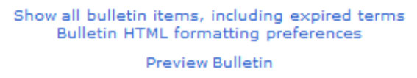
- On the start page, choose Special Functions from the main menu.

- Click Daily Bulletin Setup. The Daily Bulletin Setup page appears.

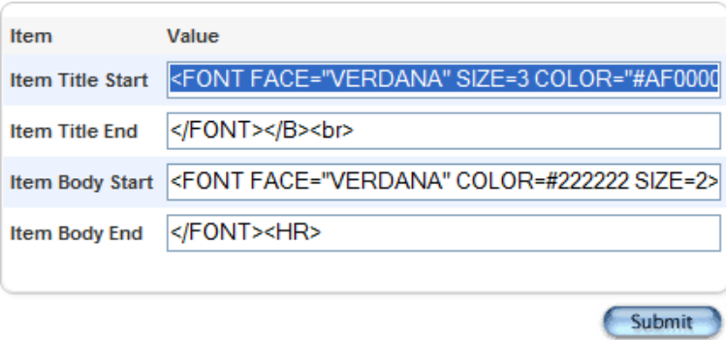
- Click "Bulletin HTML formatting preferences." The Bulletin HTML Formatting Preferences page appears.

- Use the following table to enter information in the fields:
Field | Description
Item Title Start | Enter the start tags for your title to determine how your title will look.
Item Title End | If you do not want the body text to look the same as the title text, enter the end tags for your title text.
Item Body Start | Enter the start tags for your body text to determine how your body text will look.
Item Body End | Enter the end tags for your body text.

Click Submit. The Daily Bulletin Setup page displays the edited bulletin item.

How to Preview the Daily Bulletin

Though it is possible to view the daily bulletin in PowerSchool and from the PowerSchool Teacher start page and the Parent Access pages, view the bulletin items for a particular day from the Special Functions page.

1. On the start page, choose Special Functions from the main menu.

2. Click Daily Bulletin Setup. The Daily Bulletin Setup page appears.
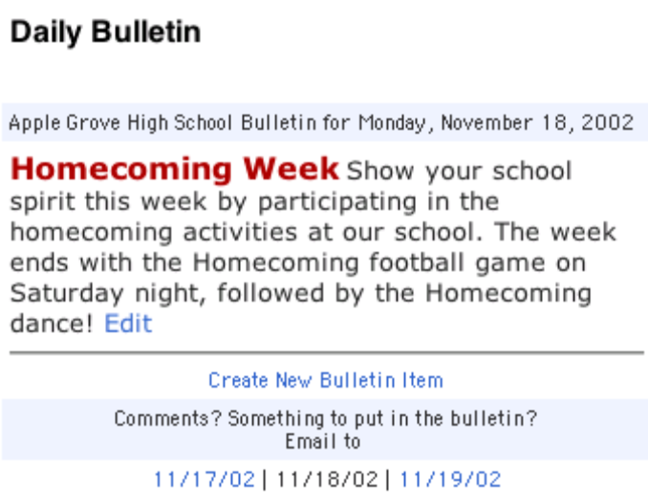
3. Click Preview Bulletin. The Daily Bulletin page appears.
4. Click the dates to navigate to different pages of the bulletin.

How to Edit a Daily Bulletin Item

1. On the start page, choose Special Functions from the main menu.

2. Click Daily Bulletin Setup. The Daily Bulletin Setup page appears. 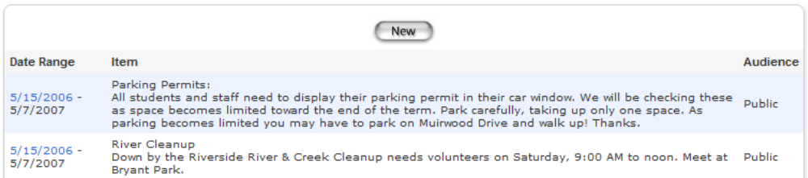

3. Click the date of the bulletin item to be edited. The Edit Daily Bulletin Item page appears.

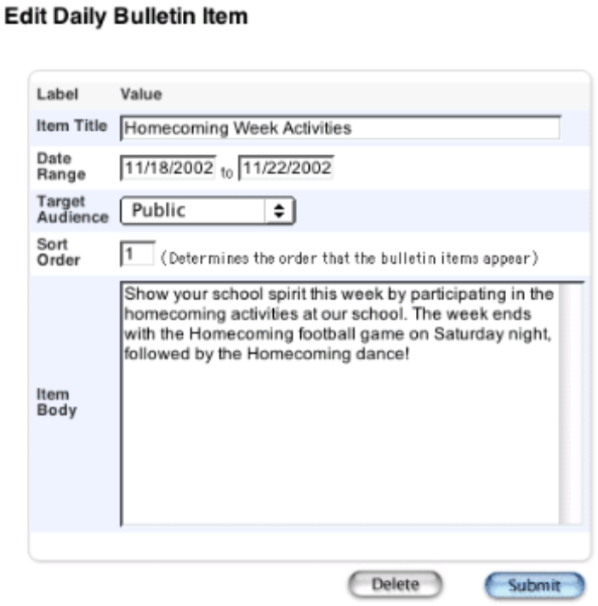
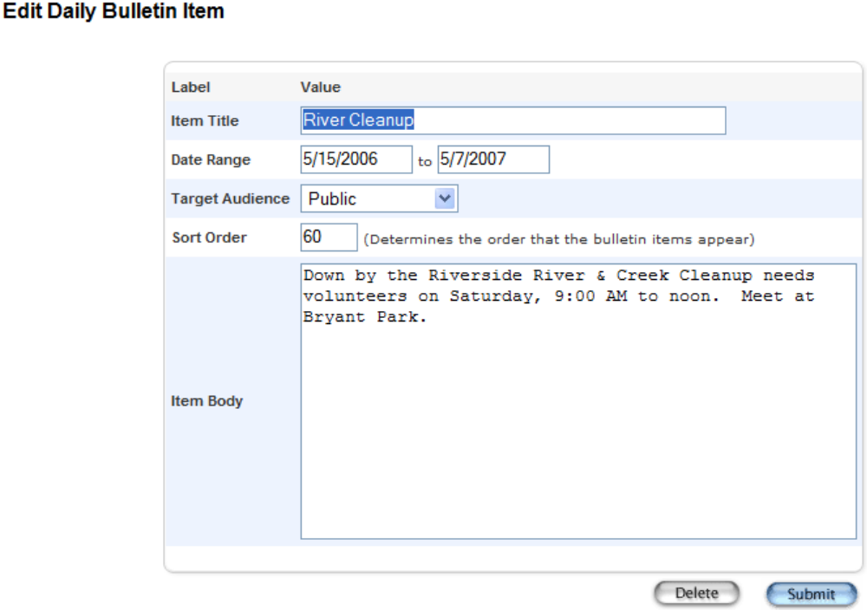

4. Make your changes as needed

5. Click Submit. The Daily Bulletin Setup page displays the edited bulletin item.

How to Delete a Daily Bulletin Item
1. On the start page, choose Special Functions from the main menu.

2. Click Daily Bulletin Setup. The Daily Bulletin Setup page appears.

3. Click the date of the bulletin item to be deleted. The Edit Daily Bulletin Item page appears.

4. Click Delete. The Selection Deleted page appears.

