PowerSchool Online Registration process summary and requirements:
- Future year courses must have been created on the “live side.”
- Courses must be associated with the school on the “live side”.
- In PowerScheduler, the Course Catalog must have been created and associated with the active scheduling scenario.
- Courses must be added to the Course Catalog.
- Course Groups must be created to provide the lists of courses from which students will choose during the online registration process to meet specific registration requirements.
- A Request Screen, made up of registration “requirements,” must be developed for each of the grade levels that will be requesting classes online. Each requirement will have one associated Course Group.
- Prior to registration, request screens must be set to allow the each grade to register for classes.
- Once online registration is completed, request screens are disabled to prevent further request changes by students.
Critical to building usable and accurate online registration screens is having a solid understanding of the way a school’s courses are structured, including:
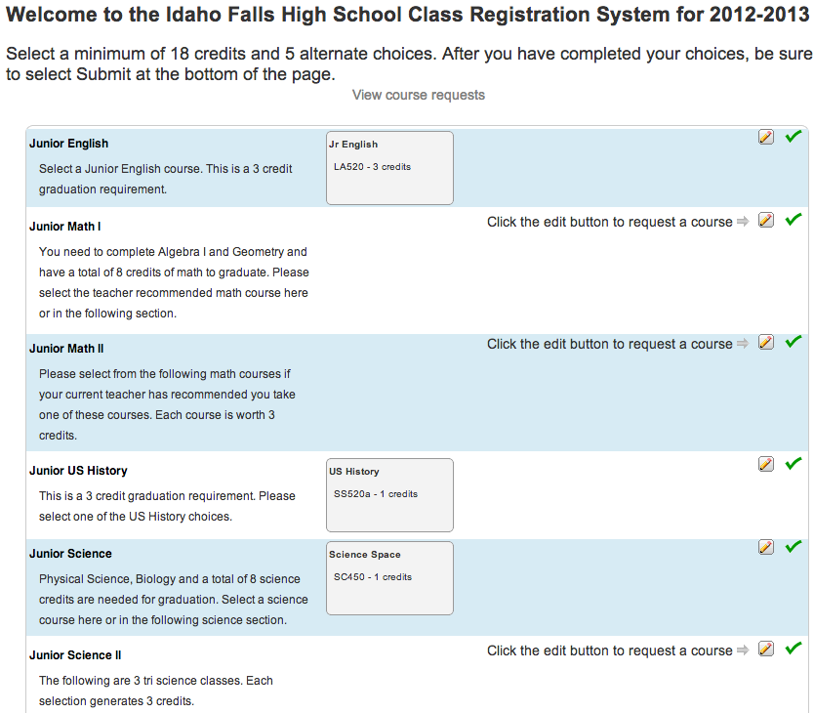
- whether year-long courses are scheduled once to the full year or divided into separate sections across multiple semesters or trimesters;
- which courses are offered to each grade level;
- their term duration and how those relate to credits; and
- which courses can be taken more than once by a student during the same school year or even the same school term.
PowerScheduler allows for many ways to structure student requests, including having requirement course lists from which students may make only one selection (a “single course requirement”), such as variants of the required English course; ones from which students can make more than one choice (“multi-course requirement”), such as lists of electives; and pre-assigned required course requests, presented to students on the registration screen for informational purposes and to be included in the total count of credits requested (“core requirement”), such as Advisory, Speech or P.E. which all students within a grade level must take.
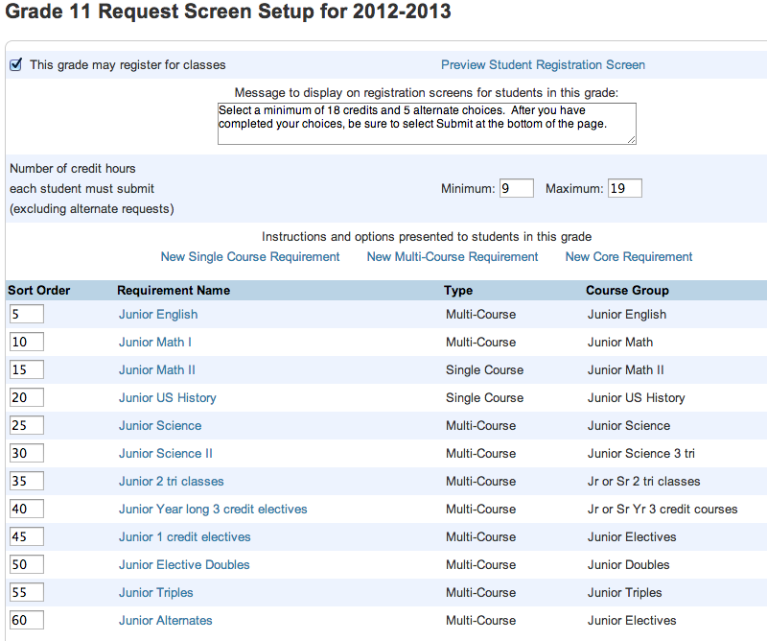
In addition, each requirement can be set up so that a single course checked by a student from the associated course group actually generates two or more requests for that course. This can ensure the student chooses enough terms of a year-long /multi-term course that is scheduled in discrete sections.
You may need to build course groups based both on subject area AND term duration or scheduling structure.
Course Groups
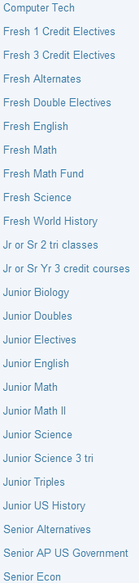
This list of Course Groups reflects both subject-area requirements and a schedule structure that includes year-long courses, trimester-long courses, and courses that meet for a full year but are scheduled as separate sections in each trimester. Course options also differ by grade level.
Some examples:
- “Fresh English” and “Fresh World History” both contain two year-long courses. Freshmen will be required to make a single choice from each of these groups group (they will be used as “single course requirements” on the screen), but some students may choose the general level course while others choose the Honors level course.
- “Jr or Sr Yr 3 credit courses” are courses that meet for the full year but are scheduled as 3 separate trimester-long classes. Rather than expect the students to check off three requests for each of these courses (since they need a request for each term), when this group is used on the registration screen it will be set so that a single check by a course automatically generates 3 requests.
- There are two groups for Jr Science (one “3 tri”) because some of the science courses offered to the Juniors meet for a fixed term (they may be year-long or single semester or trimester) and can be requested with a single check mark, while others meet across 3 terms as described above.
- There are several groups of Alternates, because in this school not all grade levels can take all of the electives that might be offered as alternate choices.
On the request screen, requirements must be specifically set to count as either “primary,” “elective” or “alternate” requests. Schools may choose to use the same group of courses for both an elective and an alternate requirement, or might permit students to select from a larger list for elective requests and a separate more restricted group for alternate requests.

Following are examples of how some of these course groups are used in building the request screens, and how they look to the student completing registration.
Below is the Requirement definition for the Junior Science “multi-course” registration requirement from the Grade 11 Screen Setup.
The school does not require that students take science during their junior year, which is why the minimum “Number of courses student must select to meet this requirement” is zero, although they can choose up to 6 credits worth of courses from the list in the Junior Science Course Group. That is selected as the “List of courses to present to the student in the pop-up menu.”.
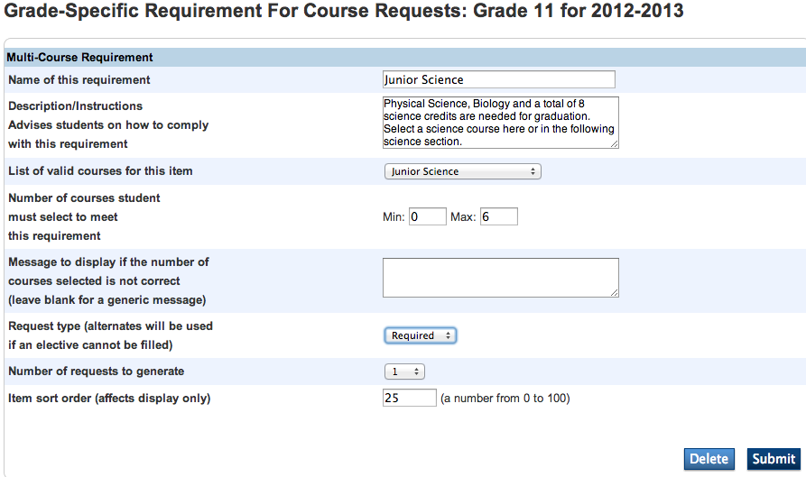
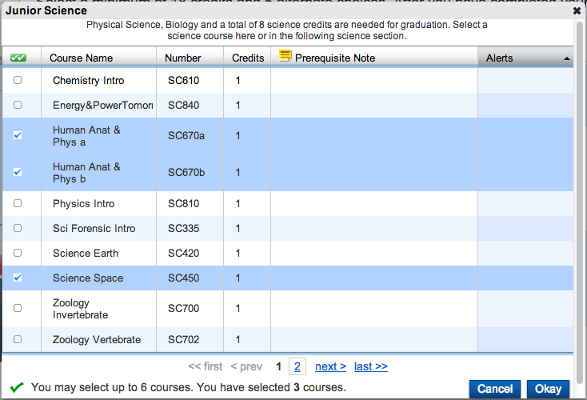
This group has both year-long and trimester-long courses in it, which can be mixed in together in a course group because choosing any of them should generate only a single request. It is a “multi-course” requirement because students may to choose to take more than one of the courses in the same school year, so they can check multiple items from the list as shown here.
Junior History is a graduation requirement; it is recommended but not required that it be taken in the Junior year which is why students “Can leave blank “.
(You may also have to allow blank when courses in the same required subject have different term structures – e.g. some are year-long and generate one request while others are two semesters and generate two requests – and therefore have to be presented in separate requirements.)
There are two courses students may choose from to meet this requirement, in the “Junior US History” Course Group. It is a “single course requirement” because students may choose only one of the courses in the list, not both.
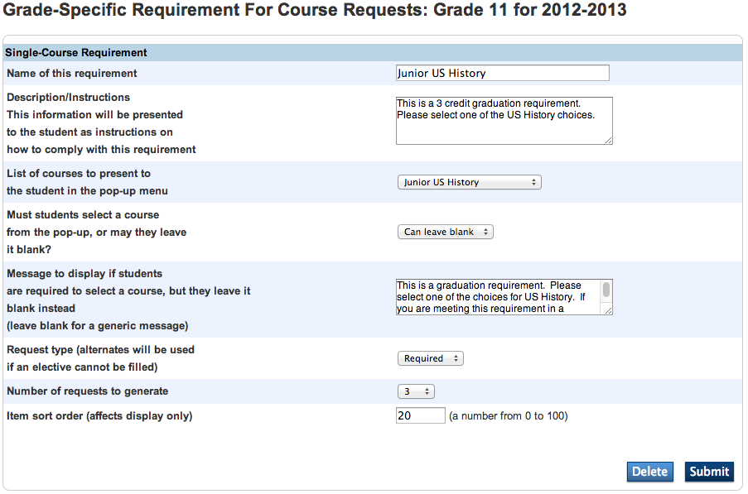
Below is the Requirement definition for the Junior History “single course” registration requirement from the Grade 11 Screen Setup.

These courses, although they are taken for a full year, are actually scheduled as three separate trimester-long sections. Instead of having the student select the same course three times – which would require it to be presented in three requirements on the screen – this has been set up to generate 3 requests when the student checks the course once.
The student sees the choices below when he clicks the Edit pencil icon on the registration screen:
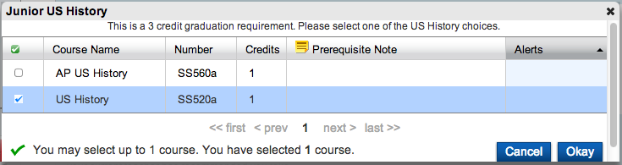
The student’s final credit tally when the request process is complete will actually include 3 credits for the US History course, although the course list shows it as worth only one.
Below is the Requirement definition for the 7 Required “core” registration requirement from the Grade 7 Screen Setup.
The Course Group associated with this registration requirement includes four courses which all 7th graders MUST take, so they are “pre-assigned” to the students; the students cannot opt to remove requests for these courses.
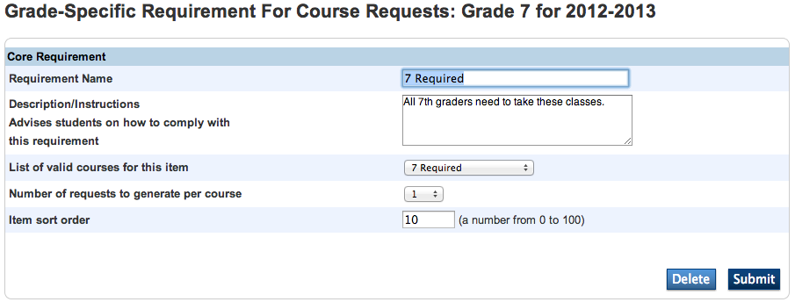
Note that core requirements can still be configured to generate multiple requests per course. (In this case each course will generate only one.)
This is what the students see for this requirement when they register online, without having to check off anything:
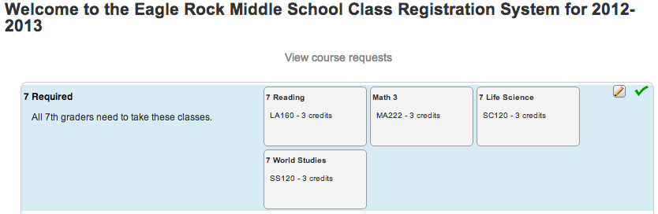
How to Build Online Registration Screens
Add courses to be used in the upcoming year to the active Course Catalog:
- Go to PowerScheduler > Scheduling Setup > Course Catalogs.
- Determine which catalog is the one in use with the active scheduling scenario; this should be the one with the Status of “Active.” (If it is not, go to the current Scenario to correct it.)
- Click the Edit Course Catalog link.
- Checkmark any courses your school expects to offer for next year’s registration and/or will build sections for in PowerScheduler.
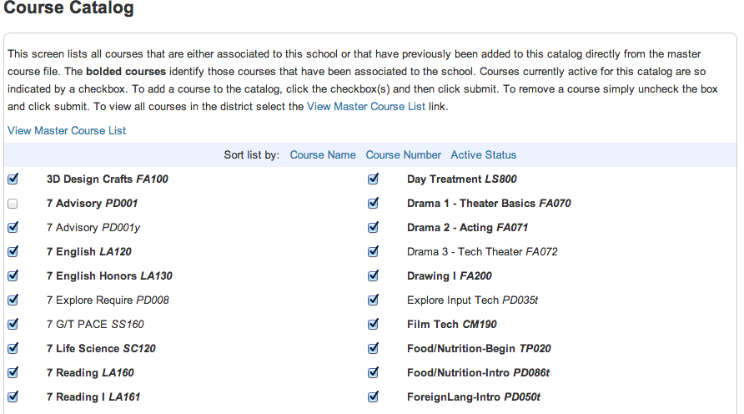
If the course name is NOT in a bold typeface, then the course has not been associated with the school on the “live side.” It will not be consistently accessible during the scheduling process. Return to the main PowerSchool Start page and go to School Setup > Courses > Manage Courses for This School and check the box to add the course to your school’s active course list before proceeding.
- Submit the screen when all desired courses are checked. (Note you can sort the list by either course name or number to make it easier to find them.)
- Best Practices: This process can take a while if your District course list is long, and you don’t want your login to time out before you finish. Consider having a reference list to work from to speed things up, and choose the type of sort order that will let you find courses the fastest (Course Name vs Course Number).
Define Course Groups by choosing PowerScheduler > Requesting > Course Groups and click the New button.
- FIRST click the link to Show Courses from the Current Catalog. If you use the School Master Schedule instead, you may miss courses which have been added for the upcoming year but do not have sections in the current year. If you do this after you’ve started, the screen will redisplay and you’ll be starting again!
- Give the course group a name that will make its purpose clear – subject area, indication of whether these courses will need to generate single requests vs multiple ones etc.
- SUBMIT when done!
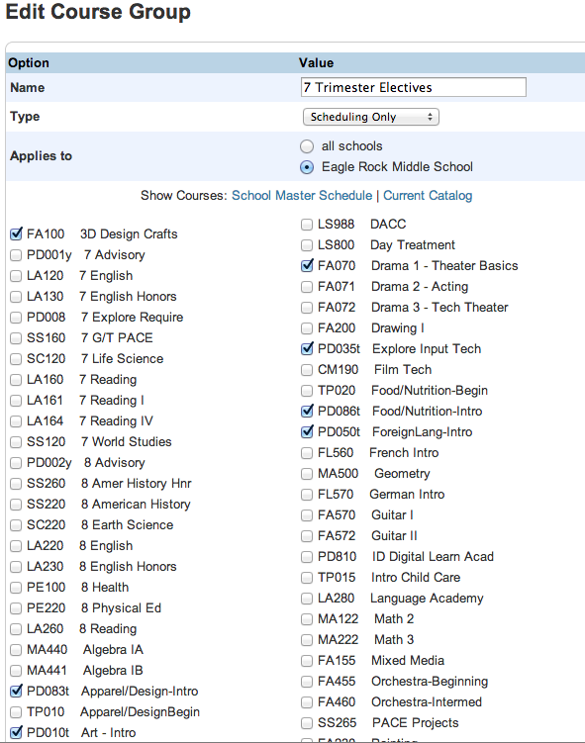
Best Practices:
Set the course group to a type of “Scheduling Only”, not “Both” (which will cause it to show up in Graduation Sets too – don’t assume these two purposes will remain consistent with each other).
Set the group to apply only to your school unless you work centrally with multiple schools and know they offer the same courses for the same purposes and term structures.
Build each grade’s Registration Screen (see requirement samples on pp. 3-5):
- Go to PowerScheduler > Requesting > Screen Setup and click on a grade level.
- Make sure that the checkbox for “This grade may register for classes” is NEVER checked while you are building or changing screens.
- Determine which type of course requirement you need to add, and click the appropriate link for a:
  - New Single Course Requirement (students will only be allowed to check one course from the list); a
  - New Multi-Course Requirement (students will be allowed to check two or more courses from the list); or a
  - New Core Requirement (all courses in the list will have requests pre-assigned to the students).
- Give the requirement a name that indicates its purpose, keeping in mind that you may have course groups that you use in more than one place, so this isn’t necessarily the same. Especially distinguish between requirements for primary requests versus alternates, which may still use the same elective course groups.
- DO use the Description/Instructions box. What you enter here will be seen by the students when they register and can help them make the correct choices, such as how many selections they can or should make.
Best Practices: Proof and SPELL CHECK your instructions!
- Choose the appropriate course group for this requirement. (Note: if you revise the name of this group later on, you will have to return here and re-select the new name.)
- Determine whether students are required to make a choice for this requirement.
  - If it is a single-course requirement, choose either “Can leave blank” or “Must select one.”
  - If it is a multi-course requirement, you instead set a minimum and maximum number of course credits the student can select from the group. If you are requiring that they choose at least one course but they may choose only one, and your course list includes both single-credit semester or trimester and multi-credit year-long courses, be sure to set the minimum at 1 or they will be unable to select any of the single-term courses. Take this issue into account in setting the max as well.
- If a selection is required, you can enter specific instructions that will appear if the student tries to leave the requirement without making a selection. Otherwise the message will simply say that they are required to make a choice.
- Choose the Request Type:
  - Choose Alternate ONLY for requests which the system will not attempt to fulfill and will only be used as substitutes for courses a student cannot get into if a “Load with Alternates” is run.
  - Choose Required if the requests should NEVER be replaced with alternate choices even if the student doesn’t get into them (usually used for core required courses).
  - Choose Elective for courses that could be replaced with alternates if these requests cannot be fulfilled.
- Determine the number of requests to be generated when a course is checked. Use with caution – if a student picks course MA300 once, a number greater than one will cause their request list to have course MA300 in it additional times. Any courses in the group used for such requirements need to be set to “Allow Repeats” on the Course Preferences screens.
- Set a Sort Order to control where in the registration screen this requirement will appear. You can reorder them at any time after building the full set of requirements.
- To see what you’ve created, use the link at the top of the window to Preview Student Registration Screen. You will be able to make selections for each requirement but not save them.
Begin Registering Students: return to PowerScheduler > Requesting > Screen Setup, click each grade level that should be permitted to log in to PowerSchool’s student portal to request courses, and check the box for “This grade may register for classes.”
Close Registration: return to PowerScheduler > Requesting > Screen Setup, click each grade level that is finished, and uncheck the box for “This grade may register for classes.”
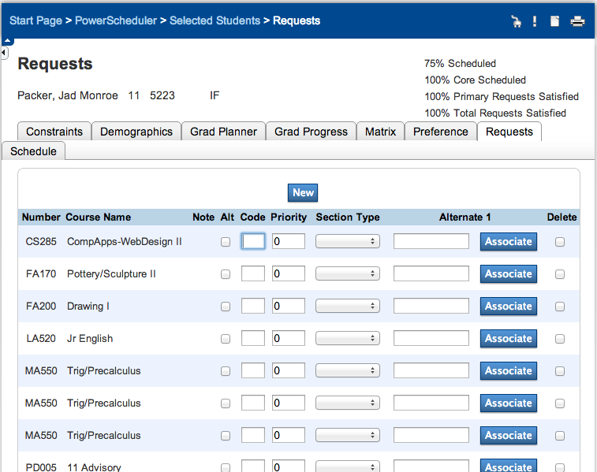
Best Practices: Work with Student Course Requests only through the online registration screens while registration is open, even as an Admin user of PowerSchool. (Admin users can get to the online student version by selecting the student, then going to the live side Student menus for Request Management > Modify Current Requests.)
If requests are added or changed using the Power-Scheduler Requests screen shown here while students and Admin users are also able to use the online Registration screen, requests can accidentally be deleted or duplicated due to the views not matching.

