ACTIVITY ATTENDANCE – HOW TO
Search Activity:
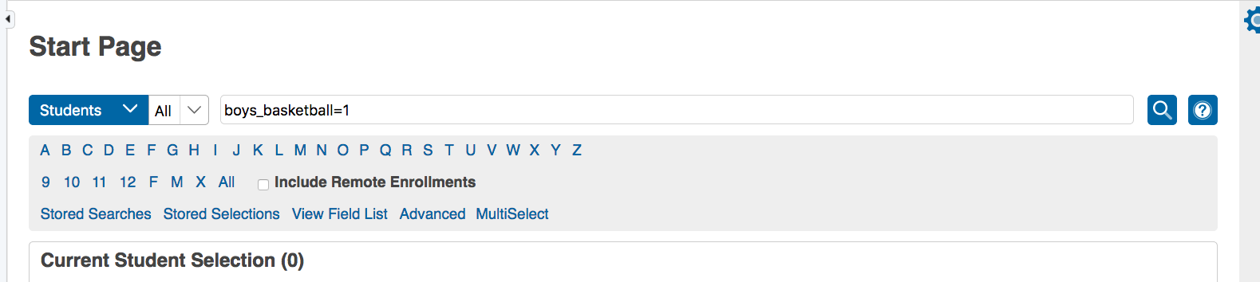
Student Selection, pull down to Attendance Change:
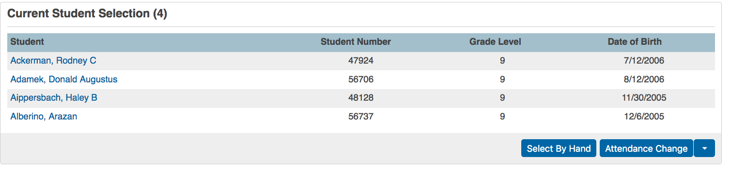
This page appears, choose the date, periods students will be missing, A-Activity for attendance Code (Make sure it’s the pull down) Overwrite is clicked. You can put in a comment if you want, like GHS VS Billings Senior. Click Submit. You are done!
