How to Transfer a Student or Group of Students Out of School

Summary
The article will explain how to transfer one or more students out of school. Prior to running these instructions, it is important the student Schedule enrollments be dropped first, to avoid causing orphan records.

Transferring A Single Student Out of School
To transfer a single student out of school follow the steps outlined below:
- On the Start Page, search for and select the student
- Click Functions under Enrollment
- Click Transfer Out of School
- Fill out the webform using the following reference, then click Submit
Field | Details
Transfer Comment | Enter a comment to record why/where the student is being transferred
Date of transfer | The first date the student will no longer be enrolled in school
Check to delete all future attendance... | When the student has attendance on or after the date or transfer, and the user has permission to enter attendance, a checkbox will appear "Check to delete all future attendance records this student has listed above." checking this box will delete the attendance that would be orphaned by transferring the student out.
Exit Code | Select an appropriate exit code from the dropdown menu.
Also transfer out of selected programs | If the student is also enrolled in special programs at the school, a list of them will appear. Check any the student will be leaving on their date of transfer.
Check here if student intended to enroll...  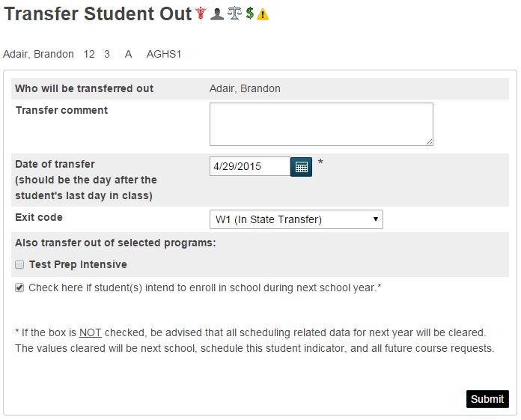 | Selecting this checkbox preserves the students scheduling information, such as Next Year Grade, Course Requests, etc. If unchecked, these are cleared.
After this process, the student will no longer appear as active in the database and will be automatically dropped from the teacher's roster.

Transferring A Selection of Students Student Out of School
To transfer an entire group of students out of school at once (i.e.a family of four are moving to another state), follow the steps outlined below:
- On the Start Page, search for the appropriate group of students that need to be transferred.
- Expand the Functions menu, and select Transfer Out of School.
- Verify that the correct number of students are selected in the message: "Who will be transferred out."
- Fill out the webform using the reference below, then check the verification box and click Submit.
Field | Details
Transfer Comment | Enter a comment to record why/where the student is being transferred
Date of transfer | The first date the student will no longer be enrolled in school
Check to delete all future attendance... | When the student has attendance on or after the date or transfer, and the user has permission to enter attendance, a checkbox will appear "Check to delete all future attendance records this student has listed above." checking this box will delete the attendance that would be orphaned by transferring the student out.
Exit Code | Select an appropriate exit code from the dropdown menu.
Auto-Transfer School Options | You can specify a school to send the students to, skipping the need to run manually transfer them their after running this proces
Also transfer out of selected programs | If the student is also enrolled in special programs at the school, a list of them will appear. Check any the student will be leaving on their date of transfer.
Check here if student intended to enroll... | Selecting this checkbox preserves the students scheduling information, such as Next Year Grade, Course Requests, etc. If unchecked, these are cleared.
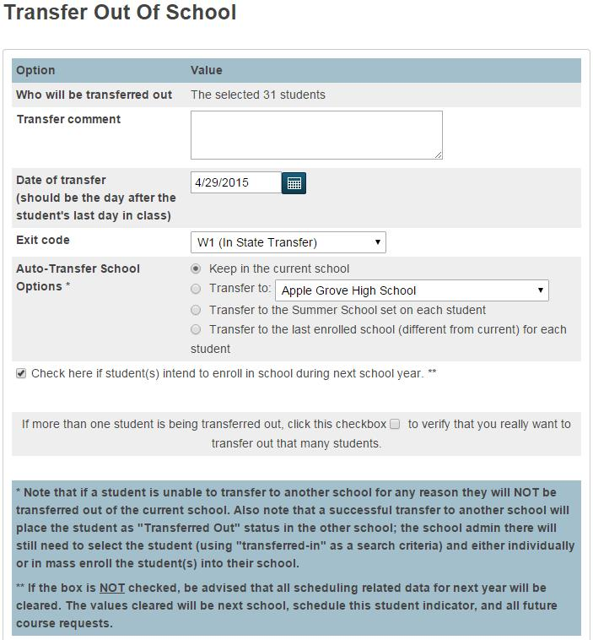

Confirmation Message
Upon hitting submit on the transfer page a user will get one of two messages; either a confirmation in green or a yellow message requesting that future or blank attendance be cleared.
See below for a sample of both messages.
Transfer Completed Message
Transfer not completed due to attendance
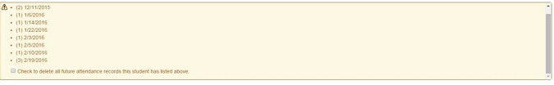
Call Lisa or Suzanne if you get the second message.

