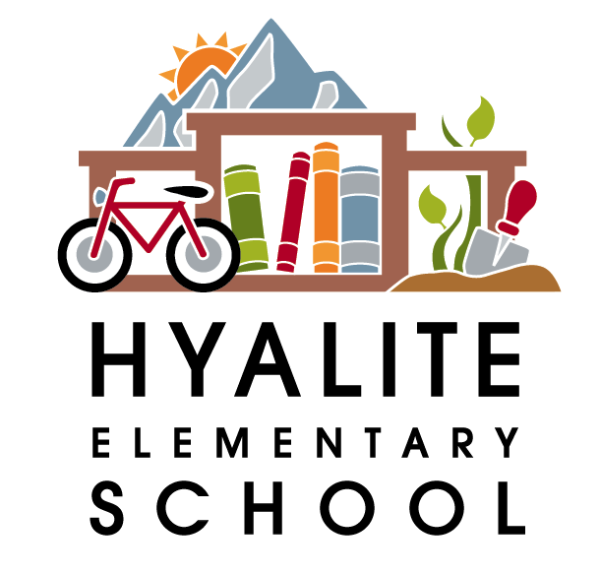 The Hyalite Highlights—October 5th, 2017

Dates to Remember:
Oct. 13th—Family Movie Night from 6-8 pm in the gym—We will be showing Monsters Inc.
Oct. 19&20th—PIR Days--No School for K-12
Nov. 22-27th—Thanksgiving Break—No school
Nov. 14th—Lifetouch Student Retakes from 8:30-11:00am
Dec. 20th—Holiday music program at 9:30am or 2:00pm
Dec. 21st-Jan. 2nd—Holiday Break

Hyalite’s Lost and Found
As many of you know, every year our lost and found is overflowing with jackets, sweatshirts, etc. that are left on the playground. So we began donating the items to a local organization called The Love Inc. Clothes Closet. They come and pick up the unclaimed items once a month. Below are the scheduled dates for the 2017/2018 pick up, which are generally the first Friday of the month. Please make sure you are checking the lost and found before these pick up dates for any items your child might be missing.

October 6th March 2nd
November 3rd April 6th
December 15th May 4th
February 2nd June 8th

 Hyalite’s Movie Night will be Friday, October 13th from 6-8:00pm. You are welcome to bring your entire family. We will be showing Monsters Inc. There will be pizza, bottled water, popcorn and snacks available for cash purchase. Please remember that adult supervision is required. Contact Wendi Rowles at wendirowles@me.com for more information or to volunteer.

Hyalite will be hosting its first STEAM Fair the morning of November 4th. If you are interested in volunteering or helping with planning, please contact our PAC STEAM coordinator, Heather at heather.p.watson@gmail.com


October Harvest of the Month: Kale

This month we are celebrating kale, a champion cold weather vegetable and super nutritious food! It is a tasty addition to salad or soup, and kale can be made into crispy chips as well! Kale is an excellent source of vitamins K, A and C. These nutrients are essential for maintaining good health. Kale is also a source of calcium, which is necessary for building strong bones; something active kids need while growing and playing!

Kale is awesome for Montana gardens and can handle cold weather. After a light freeze it will sweeten, making it a fantastic fall snack for salads, soups, or crispy kale chips.

National Kale Day is held every October! How will you be a Kale Hero? For more information visit nationalkaleday.org.

This month, local kale will be featured for lunch on Thursday, October 26th!

