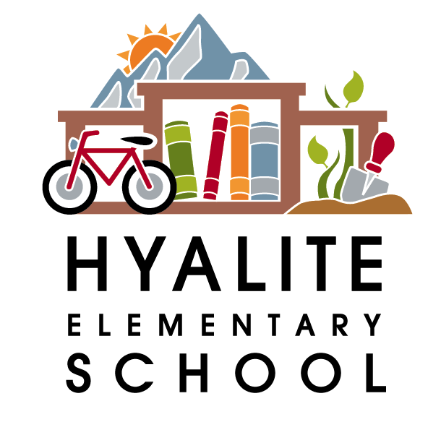 The Hyalite Highlights—February 1st, 2018

Dates to Remember:
February 9th—Lip Sync for Literacy--6:30 pm at the Emerson Cultural Center
Feb. 19th—President’s Day—No School
Feb. 27th—Art Show in the gym from 5:30-6:30pm
March 10-18th—Spring Break—No School
April 12 &13th—PIR Days—No School
May 25th—K-12 PIR day—No School
May 28th—Memorial Day—No School
June 7th—Last day of school—students dismissed at 12:45pm
6th Grade Registration
SMS and CJMS will be hosting registration/parent nights at their schools, to get your 5th graders ready for Middle School. SMS’s will be a parents only night February 15th from 6-7:30 pm. and CJMS’ will be for parents and students starting at 5:30pm with sessions going until 7:30 pm on Feb. 15th. If you have questions, please call Sally Owen (SMS) at 522-6422 or Spree Hincks (CJMS) at 522-6321. Please make sure and attend the Parent night at the school where your child is zoned to go. If you are not sure which school that is, please call Sandi Chamberlain in our enrollment office at 522-6005. Hope to see you there!
NEW STUDENT/KINDERGARTEN REGISTRATION FOR 2017-2018

The 1st round of enrollment for new student and kindergarten registration for grades K-5 will be from Monday, March 5th, through Monday, April 9th. Enrolling during the first Round increases your chance of getting into your attendance area school, but there is no guarantee. Everyone who enrolls during the above time period will all be treated equally.
Registration will be done online – Click here to see Enrollment Instructions. The window for the 2018-2019 School Year will not be available until Monday, March 5, 2018. If you do not have access to a computer, two enrollment stations will be available at the Enrollment Office in the Willson Building, 404 West Main St, room 133. Office hours are 7:30 a.m. to 4:30 p.m.
A copy of a Certified Birth Certificate and most up-to-date Immunization Records are required at time of registration! These documents may be returned to the Enrollment Office at 404 W Main St, room 133. You may also fax to 406-522-6091 or email to sandi.chamberlain@bsd7.org. Any questions, please call Sandi Chamberlain at 522.6005.

Over Please

Note from the School Nurse

Hello Hyalite families,

We have had several cases of head lice in the school. While your child’s classroom may not be directly affected, students in different classrooms may spend time together outside of school hours. For this reason, all families should be aware and occasionally monitor their children at home. If we do have a confirmed case of head lice in a classroom, the entire class is then checked and parents notified of any concerns. If you do find your child has head lice and you treat at home, please let school staff know so we can monitor the entire classroom. Identity remains confidential. Head lice is not a health issue as there is no risk of disease transmission. Head lice does not discriminate and does not indicate poor hygiene or cleanliness of the home. If you have any questions or concerns please don’t hesitate to contact me at 522-6862.

Thank you,

Jill Russo, RN
School Nurse

Hyalite Spirit Week
February 5-9th

Hyalite Hikers! We will be having spirit week the week leading up to our Lip Sync Battle, which is on Friday, February 9th at 6:30 at The Emerson.

The following are the themes for spirit week:

Monday, 2/5 - Hyalite Hiker apparel Day
Tuesday, 2/6 - 80's Day
Wednesday, 2/7 - Wacky Wednesday (crazy hair, socks, etc.)
Thursday, 2/8 - Sports Day (Favorite team or athlete)
Friday, 2/9 - COLOR day Grade levels will wear the following colors:
Pre-K - RED
Kindergarten - ORANGE
1st grade - YELLOW
2nd grade - GREEN
3rd grade - BLUE
4th grade - PURPLE
5th grade – PINK

We will be selling Hyalite apparel at the school store during early dismissal at 2:10 on Friday, Feb. 2nd and Friday, Feb. 9th. Short sleeved t-shirts available for $6-$7.00. Long sleeved t-shirts are $10.00.

Our generous PAC will be offering some scholarships for students who have a financial need for a Hyalite Hiker shirt. Please contact Ms. Anderson at 582-6838 if your child needs a shirt.

