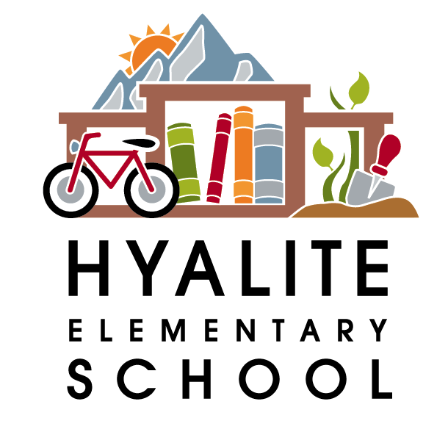 The Hyalite Highlights—December 7th, 2017

Dates to Remember:
Dec. 14th—4th grade goes to Bridger Bowl
Dec. 20th—Holiday music program at 9:30am or 2:00pm
Dec. 21st-Jan. 2nd—Holiday Break
Jan. 19th—Family Movie Night from 6-8pm—Movie yet to be determined
Jan. 22nd—PIR day—No School for K-12
Jan. 23rd—PIR day for grades 9-12 only
Feb. 19th—President’s Day—No School
March 10-18th—Spring Break—No School
April 12 & 13th—PIR Days—No School


Hyalite Holiday Program 2017
Wednesday, December 20th
9:30 a.m. & 2:00 p.m.
“Winter Wonderland”
This year’s Holiday Program will showcase traditional Holiday carols, songs where the children accompany themselves on instruments, and lively songs about the winter season. Piano accompaniment will be provided by one of our Hyalite moms, Susan Jeppson. Please plan to attend one of the performances. Mark your calendar, as this is an event you won’t want to miss.

Calling All Bakers
If you love to bake or make fabulous treats, breads, jams etc. or have a favorite holiday recipe you prepare, we would appreciate it if you would donate some of your tasty creations for the Hyalite School Bake sale which is being held on the day of our all school Holiday program, Wednesday, December 20th, 2017. Please drop your tasty creations off to the front office the day before or right before school on the morning of the program. All proceeds from the Bake sale benefit Hyalite’s 5th grade legacy program. Remember to come prepared to shop the sweet table and stock up on some yummy goodies. Consider purchasing some treats to give to your kids, neighbors, family and friends! If you have any questions, please contact Danny Waldo at 582-6846 or danny.waldo@bsd7.org

Hyalite Apparel is almost here...just in time for the Holidays! Be on the look out for order forms and online ordering. Info will be sent home in early December. Hyalite shirts, hats, hoodies, and more will be available for the whole family and just in time for that Holiday gift giving.

Over please
Thank you to Brenda Huckert, Lisa Innes, Halley Perry and Jodi Tietz, for volunteering your time on picture day. It went very smoothly because of your help.

 Have your kids out grown their clothes? Do you have some smaller sized clothing you would like to pass on? We could use it here at Hyalite. We have a “borrow stash” of pants and shirts for students to use when they have an accident and it has dwindled down to nothing. We are in need of gently worn elasticized waist pants such as sweat pants or leggings. We can use both boys and girls pants in sizes 6x-10. We are also low on both boys and girls underwear. If you have some to donate, please drop them by the office. Thanks for your help.

December Harvest of the Month: Winter Squash

Winter squash is an excellent vegetable for the cold weather months in Montana. It is grown during the summer and harvested in the fall. Due to the hard rind the squash are able to be stored well into winter—thus the name winter squash.

Harsh winters make it difficult for vegetables to grow in Montana year round, so squash are great winter nutrition boosters to include in meals. Winter squash are loaded with vitamins A and C and provide approximately the same amount of potassium as bananas. Vitamin A helps maintain good vision and keeps skin healthy.

Winter squash is delicious on its own, roasted with seasonings. Or add cubed winter squash to chili or to pizza for a delicious and vitamin packed meal.

Look for locally grown winter squash in Bozeman cafeterias in December!

_________________________________________________________________________________________________



