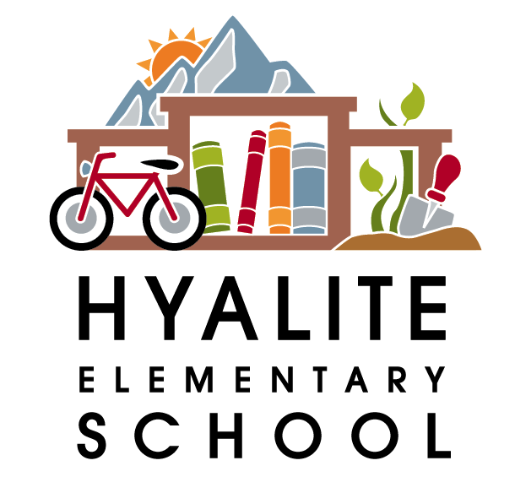 The Hyalite Highlights—Jan. 12th, 2017

Dates to Remember:
Jan. 13th-- Family Movie Night from 6-8pm—Secret Life of Pets-Sign up to volunteer or donate baked goods at hyalitepac.org/volunteer
Jan 23rd—No school for K-12
February 10th—Lip Sync for Literacy—6:30pm at the Ellen Theatre—see below for details
Feb. 20th—President’s Day—No School
March 11th-19th—Spring Break—No School
April 6th & 7th—PIR Days—No school
May 26th—PIR Day—No School
May 29th—Memorial Day—No School
June 8th—Last Day of school—students dismissed at 12:45

Lip Sync for Literacy
February 10th, 6:30pm at the Ellen Theatre
Come watch Hyalite teachers battle the Irving staff in an evening of lipsync fun! Your donations will decide the winner! There will be a silent auction, complimentary dessert table, cash bar and more. Tickets start at $6.50/person and are on sale at www.theellentheatre.com. Proceeds from the FUNdraiser will be divided evenly between the schools for purchasing books! For more information: www.hyalitepac.org/lipsync. If you can make a donation of a silent auction item, please contact Jodi at aboutfamilies@yahoo.com

Friday Spirit Days
Every Friday
Fridays have traditionally been School Spirit Days! Encourage your student to wear blue and orange to show their school spirit on Fridays! Hyalite Logo Gear is also available at www.hyalitepac.org/apparel if you’d like to place an order!
 World Language
Spring Semester begins January 30th
The second semester of World Language will kick off starting January 30th. Be on the look out for a flyer regarding class scheduling and registration information.


10 HEALTHY NEW YEAR’S RESOLUTIONS FOR KIDS

- I will clean up my toys, and keep my room in good order.
- I will brush my teeth twice a day, and wash my hands before eating and after bathroom use.
- I will keep my hands out of my mouth.
- I will drink more milk and water and limit soda and fruity drinks.
- I will apply sunscreen before going outdoors.
- I will find a sport or activity that I enjoy, and do it at least three times a week.
- I will always wear a helmet when skiing, bicycling or boarding.
- I will be nice to others, and friendly to kids who need friends, like someone shy or new to school.
- I will eat an apple a day, to keep the doctor away.
- I will listen to and respect my parents and teachers. I will be a helper at home and in the classroom.

Healthy Parent: Make healthy food choices, be active, make an appointment for a check-up, vaccination or screening. Know your numbers, such as weight, blood pressure, and cholesterol. Make time for yourself everyday to relax and reflect. Wash your hands often. Be smoke free. Get enough sleep. Learn and practice a new health tip each week.

Healthy Family: Plan to eat more meals together as a family. Encourage and support physical activity as a family. Add a health related website to your favorites list and check weekly updates and share information with each other. Spend more time together. Be courteous to one another.

Healthy Home: Go Green. Reduce, Reuse, and Recycle. Keep cleaning products and medications away from children. Have a winter weather emergency plan, and stock your home and car with necessary supplies. Thoroughly deep clean the house weekly. Have cleaning wipes available in bathroom to clean areas after use. Change towels out daily.

Healthy Workplace & School: Stay home if you are sick. Wash hands often, participate in healthy workplace and school programs. Take steps to prevent or reduce job stress. Reduce work injuries and practice good body mechanics.

Make Health Your Resolution, and enjoy a New Year of Healthy Possibilities!
By Kelli Robinson BSD Nurse



