Exhibit 1: Signed local Board of Education resolution approving the creation of the charter system.
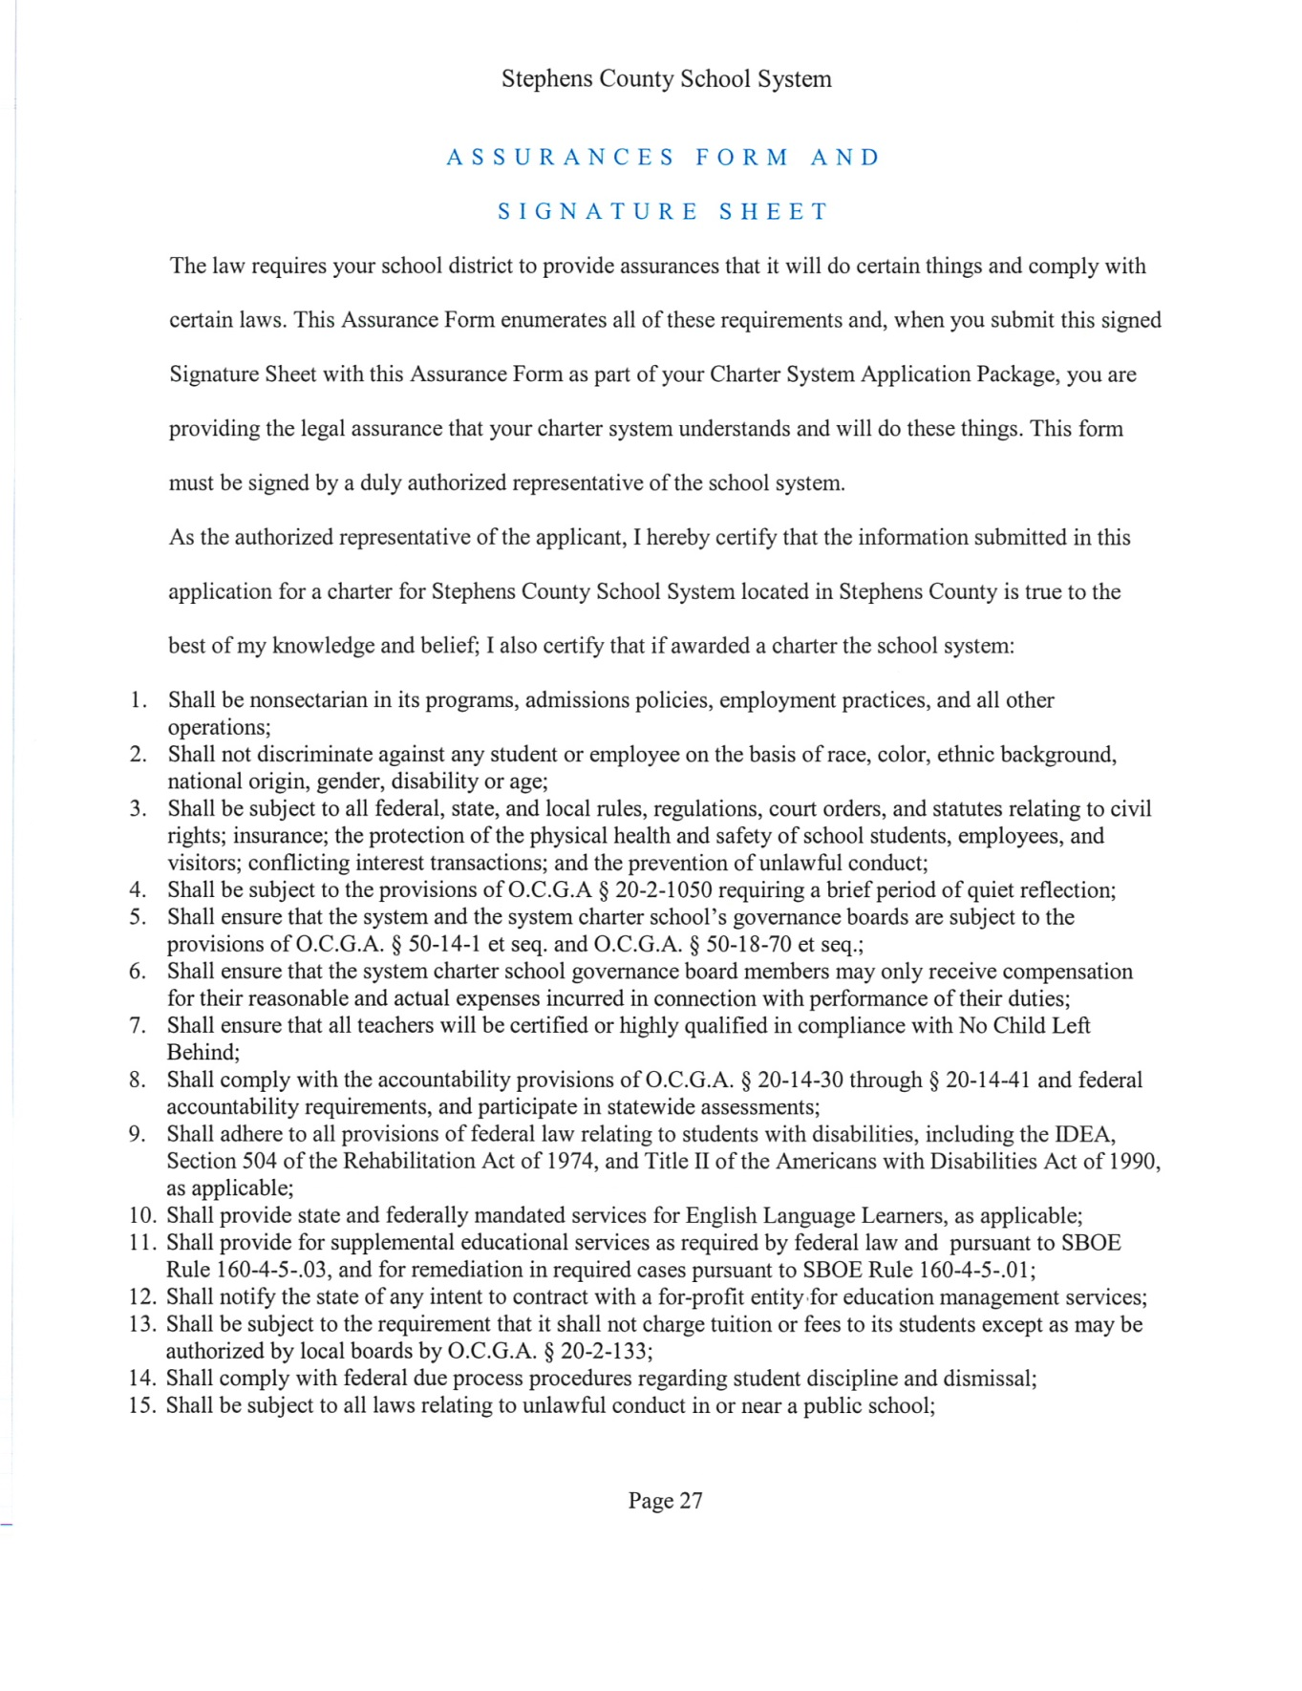

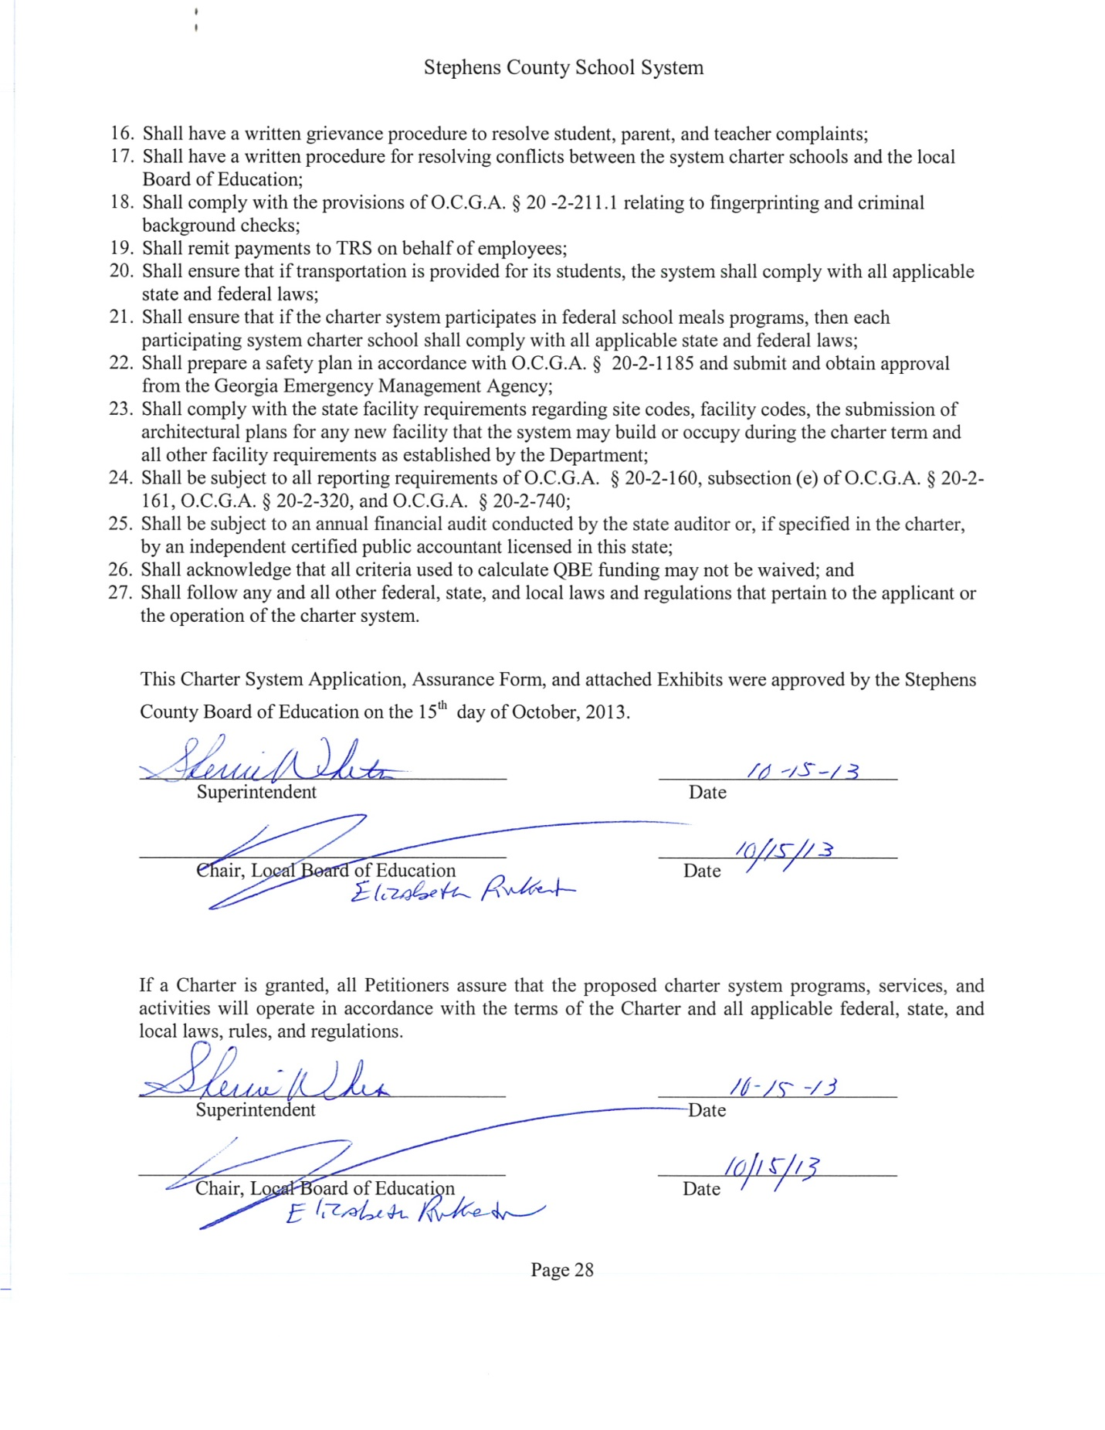

Exhibit 2: Notice that was sent to each principal within the proposed charter system regarding required hearings on the charter system application.

Notice

To: The Toccoa Record
Radio Station WNEG
Principals, Stephens County School System

From: Sherrie Whiten, Superintendent

Date: September 9, 2013

Re: Public Hearing

There will be two public hearings to review the draft of the Charter System Petition for Stephens County School System.

The meetings will be held Monday, September 30, 2013 at 9:00am, and at 5:00pm. The meetings will be held at the Administrative Offices of Stephens County School System, 2332 Mize Road, Toccoa, GA.

Exhibit 3: Description of how stakeholders, including parents and community members, were involved in the development of the Charter System Application.
As the 2012-2013 school year began, Stephens County School System started the process of consolidating many of the systems’ plans as we began to prepare for district SACS accreditation. These plans included: school level accreditation plans, technology plans, consolidated grant application for the state of Georgia, professional development plans , Title I plans, Title II-A Equity plan, CTAE plan, IDEA plan, safety plans, facilities plans, charter system application requirements, and annual school improvement plans. The goal was to see how the different plans were connected and were used to guide teaching, learning, and assessment in Stephens County.
In January 2013, the Stephens County Board of Education submitted a letter of intent to the
Georgia State Department of Education to become a charter system. The Stephens County Charter
System development process started immediately and involved approximately 400 community members, staff, and parents. The information was presented to all employees of the school system, including bus drivers, cafeteria staff, clerical staff, paraprofessionals, maintenance staff, teachers, administrators, and the school board members. Several Town Hall and community meetings were held to present Charter System information to parents and community members, and many community members served on the Governance, Innovations, and Waiver Committees who contributed to the charter application. The 10-month process involved many hours of meetings, presentations, surveys, discussions, visits, and conversations with other Charter Systems. During the Charter System planning meetings, the parents, community, and staff expressed concerns that students graduating from Stephens County School System are not always prepared for the level of problem-solving, team building, and critical thinking that are essential in today’s fast-paced and complex work environments. A survey of business leaders in the community supported this observation. The Charter System development process is chronicled on the district web site: www.stephens.k12.ga.us
From March until May, the community and staff provided input and discussed the decision to become a Charter System and were in full agreement that it was the right choice. The details for implementing the plan are not in place, since the School Governance Teams will be critical in developing the specifics to a well-rounded and rigorous experience for all students in Stephens County.
Once a draft concept was formed the draft was shared with principals, Board of Education members, teachers, and community members. In September, two public hearings were held seeking input into the petition draft. Suggestions were incorporated into the draft. Throughout the process, a copy of the draft was posted on the school system’s website and available for review. At the October Board of Education meeting, the petition was approved and ready for submission to the Georgia Department of Education.

Exhibit 4: A list of all schools to be included in the charter system, including new schools or college and career academies that will be formed throughout the life of the charter, with an indication of which existing schools are currently in Needs Improvement status.

- Big A Elementary School
- Eastanollee Elementary School
- Liberty Elementary School
- Toccoa Elementary School
- Stephens County Middle School
- Stephens County High School

Exhibit 5: A brief description of the charter system that includes the name, the mission, grades served, the focus of the curriculum, instructional methods to be used, including any distinctive or unique instructional techniques or educational programs to be employed, and other pertinent information.
- Your description will be used by the Department to provide information to the public about applicants and new charter systems.
The Stephens County Schools System’s mission continues to be “Schools Committed to Student Success” which is supported through clear expectations of the students, parents, teachers, and community members. Foundational in this mission is a set of beliefs that guide the system’s commitment to student success. They are:
- We believe ALL students can learn and achieve success.
- We have high expectations for ALL students and staff.
- We encourage and appreciate parent involvement.
- Our focus on constant improvement is imperative to our continued success.
- The integration of new and engaging technology into the curriculum is a focus within all departments and at all grade levels.
- We believe in offering multiple, high-quality extra-curricular activities for our students.
- We believe that all children, kindergarten through high school, should be exposed to multiple opportunities to participate in the Arts.
- Our Career Technical and Agricultural Education departments are second to none and provide yet another means by which our children can become engaged students and productive citizens.
- The teachers of Stephens County Schools believe in continuing education, with over 78% having advanced degrees.
- Our administrators, board of education, and superintendent support us in our efforts to reach and teach all of our students.
Stephens County is a rural community of approximately 26,000 located in the mountains of Northeast Georgia. The community places an emphasis on agriculture. Manufacturing has long been a cornerstone of the Stephens County economy, but as the global economy changed, many of the plants closed down. However, companies such as Crown, Caterpillar, Patterson Pump, and GEM Southeast are helping drive down an unemployment rate that was once around 11%. In July 2013, the unemployment rate was 8.8%, compared to the national average of 7.6%. Employers in Stephens County are interested in supporting the system’s efforts to build a solid local workforce around technology, science, math, as well as “soft” skills such as work ethics, social skills, and responsibility. The school system is committed to working together with the community to improve this rate by graduating students who will be viable and capable employees. Community demographics should be considered in order to improve the unemployment rate. The median income is $37,502, significantly below the state’s which is $49,736. Educational attainment in Stephens County indicates that 20.7% of county residents have a college degree and above compared to 27.5% in Georgia. Forty percent (40.9%) have a high school diploma compared with 84% across the State of Georgia. Stephens County School System is a high poverty district as evidenced by a free and reduced lunch rate of over 62%. Demographically, our student population is made up of 77% White, 19% African-American, and 4% Hispanic.
Stephens County School System has approximately 4,000 students (Pre-K to 12th Grade), and the school system has six schools: four elementary schools, one middle school, and one high school. Programs include: Standards-Based Instruction (Pre-K to 12); academic after-school tutoring (K-12); technology integration (Pre-K to 12); Georgia Lottery Pre-kindergarten; Schoolwide Title I (K-12); Technology courses (K-12); Career Tech and Agricultural Education (CTAE, 9-12); Advanced Placement (9-12); Post-Secondary Articulation (9-12); Jr. ROTC (9-12); High Schools That Work (9-12), and a 9th Grade Academy.

Exhibit 6: Local school governance training timeline including training topics.
August 2014- Purpose, Parliamentary Procedure, Protocol, Sunshine Laws, Etiquette
September 2014- By-laws
October 2014- School Improvement Plan/SACS process
November 2014- Report of Progress, CCRPI/Standards
January 2015- Budget
February 2015- Effective Decision Making
March 2015- Personnel
April 2015- Conflict Resolution/Team Building/Reaching Consensus
May 2015- Technology Integration
Year Two Topics:
Assessment, Hiring Practices, Parent and Community Engagement, Special Education Law, Federal Programs, Strategic Planning, School Operations, SACS Recommendations
Year Three Topics:
Topics will be based on the Needs-Assessment of the School Governance Teams and the schools.

Exhibit 7: Conflict of interest policy for local school governing councils.
 | Descriptor Code: BHA
  Board Policy
Board Member Conflict of Interest

The Stephens County Board of Education shall adhere to these Conflict of Interest provisions, as set forth in state law.

Financial Governance

1. No Board member shall use or attempt to use his or her official position to secure unwarranted privileges, advantages, or employment for himself or herself, his or her immediate family member, or others.

2. No Board member shall act in his or her official capacity in any matter where he or she, his or her immediate family member, or a business organization in which he or she has a material financial interest that would reasonably be expected to impair his or her objectivity or independence of judgment. Compliance with Code Section 20-2-505 shall not constitute a violation of this paragraph.

3. No Board member shall solicit or accept or knowingly allow his or her immediate family member or business organization in which he or she has an interest to solicit or accept any gift, favor, loan, political contribution, service, promise of future employment, or other thing of value based upon an understanding that the gift, favor, loan, contribution, service, promise, or other thing of value was given or offered for the purpose of influencing that board member in the discharge of his or her official duties. This paragraph shall not apply to the solicitation or acceptance of contributions to the campaign of an announced candidate for elective public office if the local board of education member has no knowledge or reason to believe that the campaign contribution, if accepted, was given with the intent to influence the local board of education member in the discharge of his or her official duties. For purposes of this paragraph, a gift, favor, loan, contribution, service, promise, or other thing of value shall not include the items contained in subparagraphs (a)(2)(A) through (a)(2)(J) of Code Section 16-10-2.

4. No Board member shall use, or knowingly allow to be used, his or her official position or any information not generally available to the members of the public which he or she receives or acquires in the course of and by reason of his or her official position for the purpose of securing financial gain for himself or herself, his or her immediate family member, or any business organization with which he or she is associated.

5. No Board member or business organization in which he or she has an interest shall represent any person or party other than the local board of education or local school system in connection with any cause, proceeding, application, or other matter pending before the local school system in which he or she serves or in any proceeding involving the local school system in which he or she serves.

6. No Board member shall be prohibited from making an inquiry for information on behalf of a constituent if no fee, reward, or other thing of value is promised to, given to, or accepted by the local board of education member or his or her immediate family member in return therefor.

7. No Board member shall be deemed in conflict with these provisions if, by reason of his or her participation in any matter required to be voted upon by the local board of education, no material or monetary gain accrues to him or her as a member of any profession, occupation, or group to any greater extent than any gain could reasonably be expected to accrue to any other member of that profession, occupation, or group.

8. No Board member may also be an officer in any organization that sells goods or services to that local school system, except as provided in Code Section 20-2-505 and excluding nonprofit membership organizations.

9. No Board member shall be deemed in conflict with these provisions if, by reason of his or her participation in any matter required to be voted upon by the local board of education, no material or monetary gain accrues to him or her as a member of any profession, occupation, or group to any greater extent than any gain could reasonably be expected to accrue to any other member of that profession, occupation, or group.

10. No Board member shall sell to any county board any supplies or equipment used, consumed, or necessary in the operation of any public school in this state unless there are fewer than three sources for such supplies or equipment within the county; provided, however, that any purchase pursuant to this subsection for supplies or equipment that is equal to or greater than $10,000.00 shall be approved by a majority of the members of the board in an open public meeting. Any member violating this shall be guilty of a misdemeanor.

11. No local board may do business with a bank or financial institution where a Board member is an employee, stockholder, director or officer when such board member owns 30% or more stock in that institution.

12. No Board member may have a financial interest in school buses, bus equipment or supplies, provide services for buses owned by the Board, or sell gasoline to the Board from a corporation in which the Board member is a shareholder.
13. No Board member shall accept a monetary fee or honorarium in excess of $101.00 for a speaking engagement, participation in a seminar, discussion panel, or other activity that directly relates to the official duties of that public officer or the office of that public officer. Actual and reasonable expenses for food, beverages, travel, lodging, and registration for a meeting which are provided to permit participation in a panel or speaking engagement at the meeting shall not be monetary fees or honoraria.

Conduct As Board Member

1. No Board member shall disclose to or discuss any information which is subject to attorney-client privilege belonging to the local board of education to any person other than other Board members, the Board attorney, the local school superintendent, or persons designated by the local school superintendent for such purposes unless such privilege has been waived by a majority vote of the whole Board.

2. No Board member shall vote on the employment or promotion of any of his or her immediate family members. No immediate family member of a Board member may be employed or promoted unless a public, recorded vote is taken separately from all other personnel matters.

3. No Board member may be employed in any position in the school district in which they serve.

4. No Board member shall hold another county office.

5. No Board member shall be employed by the State Department of Education or serve concurrently as a member of the State Board of Education.

6. No Board member shall serve on the governing body of a private elementary or secondary educational institution.

Each member of this Board understands and acknowledges that no person shall be eligible for election as a member of a local board of education unless he or she:

(1) Has read and understands the code of ethics and the conflict of interest provisions applicable to members of local boards of education and has agreed to abide by them; and

(2) Has agreed to annually disclose compliance with the State Board of Education's policy on training for members of local boards of education, the code of ethics of the local board of education, and the conflict of interest provisions applicable to members of local boards of education.

Each person offering his or her candidacy for election as a member of a local board of education shall file an affidavit with the officer before whom such person has qualified for such election prior to or at the time of qualifying, which affidavit shall affirm that he or she meets all of the qualifications required pursuant to this subsection. This subsection shall apply only to local board of education members elected or appointed on or after July 1, 2010.

Stephens County Schools
  Date Adopted: | 1/18/2011

NOTE: The State of Georgia has moved the Georgia Code. This new environment no longer allows us to link directly to the Georgia Code. For example enter 20-02-0211 in the search window and the Georgia Code will appear.
Georgia Code | Description
O.C.G.A. 20-02-0049 | Standards for local board of education members
O.C.G.A. 20-02-0063 | Prohibit certain conflicts of interest of board members
O.C.G.A. 21-05-0050 | Filing by public officers; filing by candidates for public office; filing by elected officials and members of the General Assembly; electronic filing
O.C.G.A. 20-02-1072 | Financial interest in transportation services by board members/superintendent prohibited
O.C.G.A. 20-02-0505 | School board members prohibited from selling school supplies or equipment to county board
O.C.G.A. 20-02-0505.1 | Board transacting business with bank or similar institution in which member has interest
O.C.G.A. 20-02-0051 | Election of county board members; persons ineligible to serve
O.C.G.A. 20-02-0058.1 | "Immediate family" defined; employment of family members
O.C.G.A. 21-05-0001 | Ethics in Government Act - short title
O.C.G.A. 21-05-0011 | Acceptance by public officers of monetary fees or honoraria
O.C.G.A. 21-05-0033 | Disposition of contributions
O.C.G.A. 21-05-0034 | Campaign Disclosure Reports
O.C.G.A. 21-05-0041 | Maximum allowable contribution by persons or partnerships
O.C.G.A. 21-05-0070 | Public Officials Conduct and Lobbyist Disclosure - Definitions
O.C.G.A. 45-02-0002 | Person to hold only one county office; commissioned officer not to be deputy for another
Rule 160-5-1-.36 | Local School Board Governance

These references are not intended to be part of the policy itself, nor do they indicate the basis or authority for the board to enact this policy. Instead, they are provided as additional resources for those interested in the subject matter of the policy.

Exhibit 8: A list of business arrangements of partnerships with existing schools, educational programs, businesses and non-profits and the nature of services provided, including disclosure of any potential conflicts of interest.
There are no potential conflicts of interest with any of the partners listed.
Big A Elementary School:
Bulldog Carwash
Big A Road
Toccoa, GA
Chuck Wright-Owner
Dominos Pizza
103 West Currahee Street
Toccoa, GA 30577
Contact: Beth Griner
Home Depot
302 Memorial Drive
Toccoa, GA 30577
Contact: Andrew Watson
Sonic Drive In
15 Wal-Mart Court
Eastanollee, GA 30538
Contact: James Addison
Inflate-A-Fun
55 Oak Street
Toccoa, GA 30577
706-244-4124
Contact: Wesley Copelan
Northeast Georgia Bank
624 S. Big A Road
Toccoa, GA 30577
706-886-4351
Contact: Brenda Sorrells
Stephens Teachers Federal Credit Union
Highway 106
Toccoa, Ga
706-886-7145
Contact: Laura Dennison
Edward Jones
29 Wall St. Way
Toccoa, GA
706-886-0411
David Plaisted, Aaron Plaisted
Lanier Clothes Distribution Center
6124 Old Liberty Hill Road
Toccoa, GA 30577
706-886-0362
Contact: Burt Holmes
Hayes Automotive Group
933 W. Currahee
Toccoa, GA
706-886-3146
Contact: Stan Tabor
Wendy's - Calhoun Management Corporation
600 College Avenue
Clemson, SC 29631
Contact: Sherry Wynn
Cabe Crest Catering
251 Pulliam Road
Eastanollee, GA 30538
Contact: Alisha Adams

Eastanollee Elementary School
ACREE OIL COMPANY
AGRI AUCTION OF GA
ARROWOOD GENERAL CONTRACTING
BAR-B-QUE SHACK
CENTRAL CNC, LLC
CROWN RESOURCES
DODD CONSTRUCTION
EASTANOLLEE ELEMENTARY PTO
EASTANOLLEE LIVESTOCK BARN
HART E.M.C.
HERRON GRADING
JAMES WHITEN LIVESTOCK
JERRY WHITE’S PHARMACY
MARTIN LIONS CLUB
MARTIN WOMEN’S CLUB
MOUNTAIN AIR
NEXT TO ME MEDICAL SUPPLIES
NORTH GEORGIA CREDIT UNION
PAYNE’S CONSTRUCTION & RENOVATION
RENAE FOWLER HAIR DESIGN
SAGE AUTOMOTIVE
SCOTT JEWELERS
TWO DAY DESIGN

Liberty Elementary School

Commercial Printing
1st Franklin Financial
Talan Properties, LLC
DOCO Federal Credit Union
Java Station
North Georgia Credit Union
First United Methodist Church
New Hope Baptist Church
High Point Community Church
Toccoa Kiwanis Club
Toccoa Woman's Club

Toccoa Elementary School
Pruitt Corporation
David Benfield, CPA
Threads
First Citizens Bank
Elks Lodge
Toccoa National Guard
McDonalds
Hardees
Woodmen of the World
(Lodge 47-Toccoa)
Stephens-Franklin Teachers Federal Credit Union
The Toccoa Record
Tates Creek Baptist Church
North Georgia Technical College
Arby's
Toccoa Christian Church
First Presbyterian Church
Stephens County Middle School
Community Bank and Trust
Stephens Federal Bank
Wal-Mart
Wendy’s
Toccoa Clinic Medical Associates
Toccoa Falls College/Human Resources
Boys & Girls Club of Toccoa
Morgan Concrete Company
North Georgia Credit Union
Stephens-Franklin Teachers Credit Union
McDonald’s
Regions Bank
Martin Lions Club
CROSSROADS SUCCESS ACADEMY
1stFranklin Financial Corp
Stephens Federal Bank
Stephens County High School
1st Franklin Financial Corp
Accent on Beauty
Acree Oil
Advance Auto Parts
Applebee’s
Arby’s
Arrowood Contractors
Bar-B-Q Shack
Bojangles
Bowen and Watson
Brenda’s Boutique
Brother John’s Sub & Sandwich Shop
Bulldogs Xpress Lube
Café Kava. LLC
Carter’s Royal Dispos-All, Inc.
Christ Fellowship Church
City of Toccoa
Community Bank and Trust
Constitutional Officers and Elected Officials
Cups and Cones
Currahee Club
Cutting Edge Day Spa
Dalco, Inc.
Department of Economic Development
DOCO Credit Union
Eaton
Fieldale Farms
First Citizens Bank
Franklin Insurance
Foothills Community Church
G&M Manufacturing
Hair Design (Renee Fowler)
Harris Communications
Heavenly Desserts
Heritage Healthcare
Hill’s Exxon
Lanier Clothes
Larry’s Service Center
LeCroy Office Supplies
Little Caesars
McDonald’s of Toccoa
Meadows Surgical Arts
Med Access of Toccoa
Morgan Concrete Company
Next to Me Medical Supplies
North Georgia Credit Union
North Georgia Technical College
Northland Cable
O'Reilly's
Patterson Pump
Perk Up Cafe
Physical Therapy Specialist
Piedmont College
Rabun County Hospital
Raceway of Toccoa
Rose Lane Bowling
Sanders Drugs
Sonic Drive-In
Standard Register
Stephens County Hospital
Stephens County Literacy Foundation
Stephens Federal Bank
Sugar Creek Trucking
Terry and Kay Reed
Thread’s Sports, Inc
Toccoa Clinic
Toccoa Falls College
Toccoa-Stephens County Chamber of Commerce
Troup’s Studio and Hallmark
TruVista
Vanminos Insurance Agency-State Farm
WNEG
Stephens County School System
Bowen and Watson, Inc.
Global Partitions
TruVista
Stephens County Sheriff’s Office
Energy Star Partner
Toccoa- Stephens County Chamber of
Commerce
Foodbank of Northeast Georgia
Toccoa Police Department
LeCroy Office Products

Exhibit 9: A brief description of the system’s fiscal history and whether the system is or has ever operated under a fiscal deficit.
One of the most effective ways of building public support for the school district is through demonstrating responsible use of the public funds that we are entrusted with. Over the past several years the national economic downturn has resulted in decreased budgets throughout the school district, however, with the fund balance, and strategic budgeting of resources we have been able to maintain our academic program with minimal charges to class sizes and the number of instructional days available to students. Over the past three fiscal years, we have had a district budget of $42.6M (FY12), $397.7M (FY13), and $40.4M (FY14). Our fund balance over these years has been $5.4M (FY12), $4.2M (FY13), and $1.7M (FY14). In the 2010-2011 school year we did implement a Reduction in Force (RIF) as a means to prevent fiscal deficit. Stephens County Schools has a bond rating of AA+ as evaluated by Standard & Poor (S&P).
To ensure the Stephens County School System budget targets our academic priorities, our budget process emphasizes a zero based budgeting philosophy and a detailed examination of all the budget line items to ensure there are no unnecessary budget line items that could be used to bolster the academic program. Additionally, the Stephens County School District has worked to implement a comprehensive energy management program that offsets operational costs in our district facilities to protect instructional dollars that are critical to the school level academic programs. Since 1999 we have realized over $5M in energy savings through our energy management efforts.
The Stephens County School District has adequate insurance in place to protect the capital, fixed, and operational assets of the school system. There is comprehensive coverage through Wright Specialty Insurance that includes: property, casualty, business auto, education legal liability, law enforcement liability, and crime in a comprehensive commercial package. Further, our employees are covered under our workers’ compensation policy through the Georgia Educators Workers’ Compensation Trust (GEWCT). These policies are evaluated annually both in terms of appropriate coverage and rates to best meet the needs of the school district. Procedures are in place to ensure compliance with state and federal programs and all required records are maintained with fidelity by the school district.

Exhibit 10: Online link to the school system’s most recent annual audit.
http://goo.gl/j1f58g

Exhibit 11: Online link to the school system’s most recent accreditation report.
Big A Elementary School Accreditation Report - http://goo.gl/tZ6XWw
Eastanollee Elementary School Accreditation Report - http://goo.gl/G7EnVh
Liberty Elementary School Accreditation Report - http://goo.gl/1Xn8Ic
Toccoa Elementary School Accreditation Report - http://goo.gl/WSKsDe
Stephens County Middle School Accreditation Report - http://goo.gl/nNqH8e
Stephens County High School Accreditation Report - http://goo.gl/kkVGxC

Exhibit 12: Online link to the school system’s most recent strategic plan.
https://eboard.eboardsolutions.com/StrategicPlan/MeasureScorecard.aspx?S=4145&PID=1803

Additional Exhibit 13: Stephens County School System’s student performance data for past five years.
