St. Louis Park Middle School Site Council Meeting Notes
November 10, 2021

- Icebreaker – we shared something we ae grateful for
- Principal’s Report – Jason Boll
  - Student led conferences next week. Wednesday 11/17 will be an asynchronous day. Schoology will be used to take attendance and then transfer into power school. Students expected to be present virtually for all classes, do whatever activity, etc. Conferences are 17th during the day and 18th evening. Sign-up Genius to be sent 11/11. PM
  - Vaccination clinic on Monday 11/15 and Dec 4 at 2-4pm for 6th graders. 65 have signed up! Open to SLP families from 4:20 – 7:00pm. Kids will leave class (in staggered groups of 10) to get vaccinated. School will communicate with kids when to come.
Looking for parent volunteers from 4:00ish-7:00 for the vaccination clinic on Monday. We have a total of over 500 students signed up for the age 5-11 vaccine. See 11/10 SLP Schools Communicator for more info.
  - First use of Performing Arts Center Monday 11/15 at 7pm – Spelling Bee Finalists, very supportive atmosphere. Most concerts will be held there – Orchestra, Choir, and Band concerts will be held in December in the space.
  - End of first quarter - Parent and Student Portal are off as final grades are stored and saved. Will be back on on Friday.
  - MAP testing took place – tested the whole school at the same time. Planning for spring testing already and applying learnings from the fall. Condensed amount of time vs running over 5 weeks for MCA and MAP testing – expecting to limit to one week in the spring, which really minimizes impact to learning time.
  - Referendum dollars approved ran out and we are not able to fully fund projects at High School – will require additional voter funding. $3.5M will be directed to the Middle school. Some funds will be applied to remodeling classrooms at the middle school that haven’t been remodeled yet.
  - New counselor starting. New social worker position as well.
  - Kudos for students and teachers – great to see kids loving being at school. Staff working really hard. Hard to be in education right now - hard 20 months. Really proud of the staff for all they’ve done full 20 months and this year especially! Big shout out to teachers and staff!
- School Board Report – provided by Julie Yakes on behalf of Laura McClendon
Elections took place. Karen Waters choosing to step down. Mary Tomback, Anne Casey re-elected, Abdihakim Arabow Ibrahim is newly elected member. Very exciting for next term to begin!
- Site Council Key Updates – Julie Yakes
  - Providing conference meals for staff – Site Council is funding main part of the meal through reserves. This is because we need to have packaged meals vs homemade (b/c Covid). There will be a sign-up genius for individually wrapped items like fruit, desserts, paper products.
  - Open leadership team roles – Co-Chair… help make big decisions! Let Julie know if interested.
  - Thanksgiving teacher treat bags – Friday or Monday near Thanksgiving. Let Julie know if you would like to help package up goodies and deliver treats to teachers – it’s fun!
  - Art Commission: Sarah Paul has helped identify student artists from current sophomores (deadline Jan 7, 2022) $100 stiped + $50 in supplies – for Performance Space. This is using funds meant for 8th graders when Covid hit (now sophomores)
  - Ask for Reflection Room – water bottles and snacks. Let Julie know if interested in helping.

- Student Leadership Teams – Samantha Wyffels (8th grade INS teacher and Liaison for Student Leadership Team)
  - New program to build leadership, hear more student voice.. Center groups on student voice- what do they want and hope for the school?

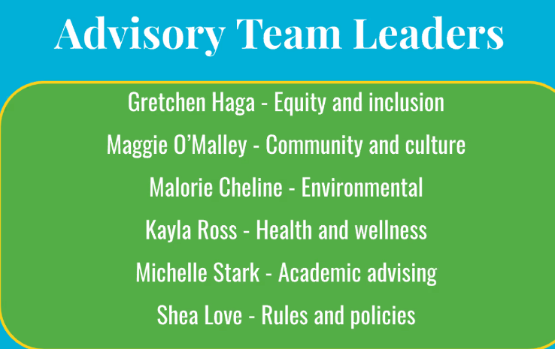

  - Examples - new courses/classes. Recycling Day. Anti-Bullying Programs. Volunteer at Westwood Nature center. Will flex topics over time based on student interest. Teacher assignments will rotate so others can bring new perspectives.
  - Sam shared a video of SLP MS Rules and Beliefs
  - Students learn about the program through Advisory. Interviewed for the role. All who were interested are part of the groups.

- Committee Reports –
  - Communications – Frances Bressman-Egan and Jason Boll. The group is looking at other district handbooks, past committee recommendations; vision is an online resource for parent communications.
  - Racial Equity – Heidi Meyer. The group discussed the district’s draft Racial Equity Policy, dialogue on the Thought exchange for giving feedback. Planning to watch a documentary for middle schoolers called “Neutral Ground”; meeting December 8th to discuss. Group plans to connect with Gretchen Haga to explore partnering with the Equity and Inclusion Student Leadership Team.
  - Mental Health – Julie Yakes. The group advanced their brainstorming – landed on wanting to go bigger/bolder: Find a speaker and hold grade level assemblies. Student appreciation. Week around mental health. Connect to SLP Beliefs

Next meeting January 12, 2022

