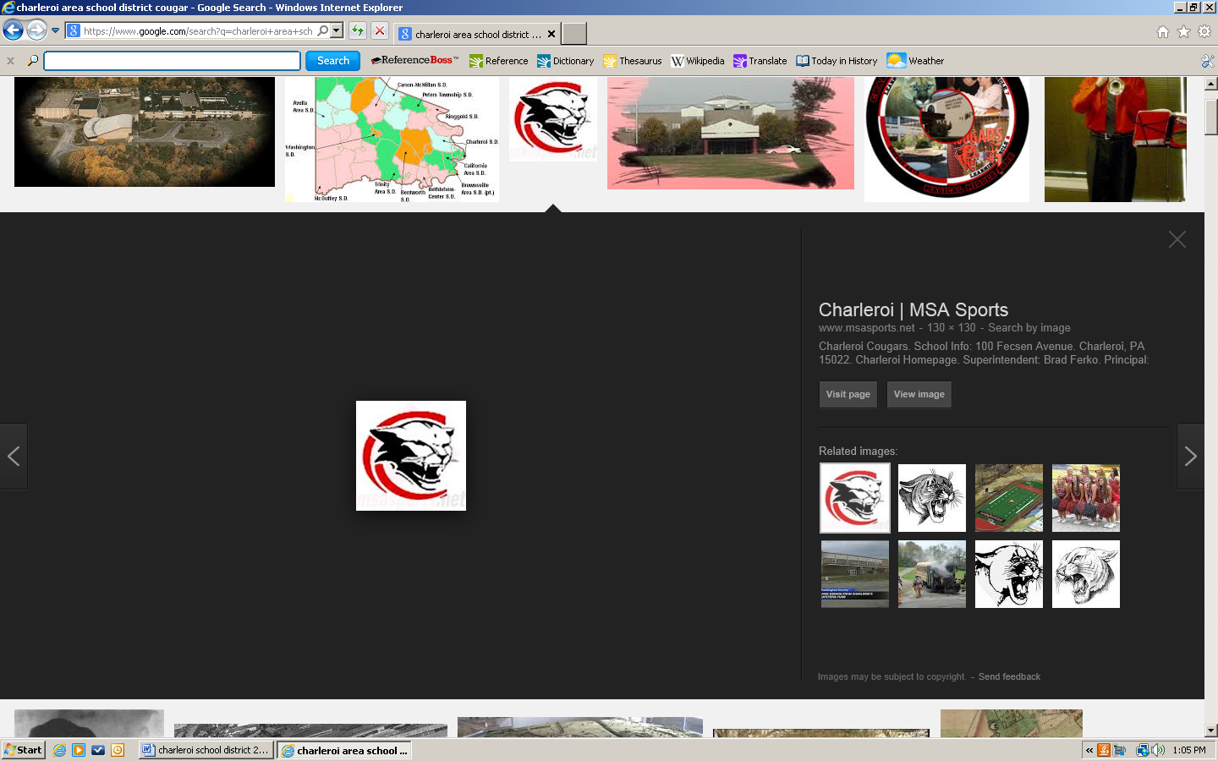
CHAIN OF COMMAND
When You Have a Question or Concern
The Charleroi Area School District Chain of Command
August 2021

The Charleroi Area School District takes pride in its communication efforts with all stakeholders of the District. To ensure that your concerns or issues are heard by the appropriate individual who can provide you with a speedy response, the Board of School Directors asks that you follow the District’s Chain of Command outlined below. Our goal is to address concerns and issues quickly and efficiently through the individual(s) directly involved. This Chain of Command will ensure a structured communications opportunity for all stakeholders and will allow the District to respond to all inquiries in a timely manner.

Administration Office  724-483-3509 | Superintendent  Business Manager  Special Education/Program Director  Food Service Manager  School Board  Transportation Director  Technology Director  Maintenance Director  Safety Director
Charleroi Area High School  724-483-3573 | Principal  Assistant Principal  Athletic Director  School Counselors  Teachers
Charleroi Area Middle School  724-483-3600 | Principal, School Counselors/Dean of Students, Teachers
Charleroi Area Elementary Center  724-483-5554 | Principal, School Counselors/Dean of Students, Teachers

Area of Concern | First Level | Second Level | Third Level | Fourth Level | Fifth Level | Sixth Level
Academic/Curriculum | Teacher | Guidance Counselor | Principal | Superintendent | Board
Athletics | Coach | Athletic Director | Principal | Superintendent | Board
Athletic Facilities | Athletic Director | Principal | Superintendent | Board
Athletic Injuries | Coach | Athletic Trainer | Athletic Director | Principal | Superintendent | Board
Attendance | Attendance Clerk | Asst Principal / Dean of Students | Principal | Superintendent | Board
Building Cleanliness | Principal | Maintenance Director | Superintendent | Board
Business Office | Business Manager | Superintendent | Board
Cafeteria | Food Service Manager | Principal | Business Manager | Superintendent | Board
Computer Hardware/Software Problem | Teacher | Work Order to Technology Director | Principal | Superintendent | Board
Discipline | Teacher | Assistant Principal/Dean of Students | Principal | Superintendent | Board
Facilities | Principal | Maintenance Director | Business Manager | Superintendent | Board
Guidance | School Counselor | Principal | Program Director | Superintendent | Board
Instruction | Teacher | Principal | Superintendent | Board
Special Education | Teacher | Principal | Director of Special Education | Superintendent | Board
Student Concern | Teacher | Dean of Students/Asst Principal | Principal | Superintendent | Board
Taxes | Business Manager | Superintendent | Board
Transportation | Transportation Director | Principal | Business Manager | Superintendent | Board

