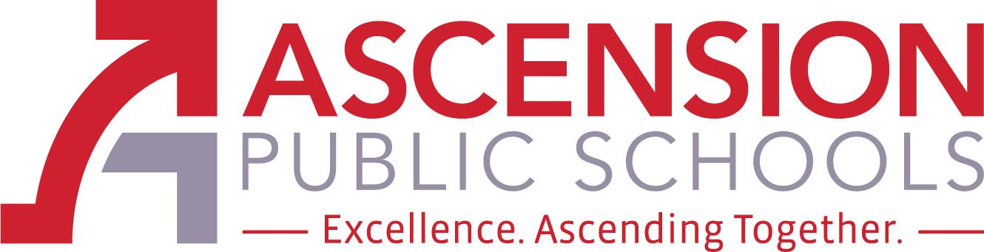

Ascension Special Education Advisory Council

January 28, 2021 at NOON
Join Zoom Meeting
https://apsb.zoom.us/j/83982567405?pwd=U0E4djJ4UmJzRFRXVjdtWG9KMmptQT09
Meeting ID: 839 8256 7405
Passcode: 157874
One tap mobile
+13126266799,,83982567405#,,,,*157874

LeBlanc Special Services, Third Floor
611 N. Burnside Avenue
Gonzales, LA 70737
(225) 391- 7270

The Ascension Special Education Advisory Council (Ascension SEAC) is an opportunity for parents, district staff, and community stakeholders to provide advice and feedback regarding special education policies, procedures, and resources. The members of Ascension SEAC shall engage in outreach activities in the community to increase the level of knowledge, support, and collaboration in regard to special education. The council will consist of 4 members, 2 shall be parents of a child who receives special education services, one shall be an Ascension Parish Principal, Teacher or Paraprofessional, and one shall be a special education stakeholder. Each member will be appointed for a one-year term (to continue through next school year 2020-2021) and will act as an advisory council to the superintendent and/or the school board. The Ascension SEAC will meet three times per school year.

SEAC Members: Danielle Louque (Pupil Appraisal Coordinator), Leslie Watts (Special Education Teacher), Crystal White (parent), Biyaka Williams (parent), and Lynn Hathaway (chairperson).

- Call to Order
- Roll Call
- Public comment procedures
- Review & Approval of Minutes from April 30, 2020
- Review & Approval of Minutes from October 30-2020 (No Quorum)

- OLD Business - Approved at last SEAC meeting:
  - Ad Hoc Committee on Behavior: Crystal White & Danielle Louque committee members
  - Transition Focus

- NEW Business -
  - APS SEAC By-laws
  - Parent Agenda Item
  - Stakeholder Agenda Item
  - District Agenda Item - APS Public Information Officer Jackie Tisdell - STATE SEAP & parent information: Increasing Communication & Resources; introduction parent facilitators: Wanda August & Sara Recile

- Next steps - Ad Hoc Behavior Committee

- Closing of Meeting - Next APS SEAC Meetings: April 29, 2021

