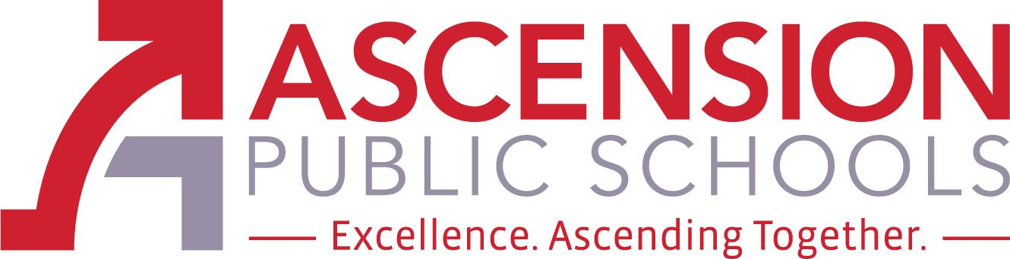

Ascension Special Education Advisory Council

April 29, 2021 at NOON

Join Zoom Meeting
https://apsb.zoom.us/j/87517968342?pwd=MWR2S0RIWUZKalBFT0lGZktLODZNUT09

Meeting ID: 875 1796 8342
Passcode: 471739
One tap mobile
+13017158592,,87517968342#,,,,*471739# US (Washington DC)
+13126266799,,87517968342#,,,,*471739# US (Chicago)

LeBlanc Special Services, Third Floor
611 N. Burnside Avenue
Gonzales, LA 70737
(225) 391- 7270

The Ascension Special Education Advisory Council (Ascension SEAC) is an opportunity for parents, district staff, and community stakeholders to provide advice and feedback regarding special education policies, procedures, and resources. The members of Ascension SEAC shall engage in outreach activities in the community to increase the level of knowledge, support, and collaboration in regard to special education. The council will consist of 4 members, 2 shall be parents of a child who receives special education services, one shall be an Ascension Parish Principal, Teacher or Paraprofessional, and one shall be a special education stakeholder. Each member will be appointed for a one-year term (to continue through next school year 2020-2021) and will act as an advisory council to the superintendent and/or the school board. The Ascension SEAC will meet three times per school year.

SEAC Members: Danielle Louque (Pupil Appraisal Coordinator), Leslie Watts (Special Education Teacher), Crystal White (parent), Biyaka Williams (parent), and Lynn Hathaway (chairperson).

- Call to Order
- Roll Call
- Public comment procedures
- Review & Approval of Minutes from April 30, 2020
- Review & Approval of Minutes from October 30-2020 (No Quorum)
- Review & Approval of Minutes from January 28, 2021 (No Quorum)

- OLD Business - Approved at last SEAC meeting with Quorum:
  - Ad Hoc Committee on Behavior: Crystal White & Danielle Louque committee members
  - Transition Focus - APS teaming with LRS and ARC to increase collaboration for our students; creation of parent resource video

- NEW Business -
  - SEAC applications for 2021-22 school year; deadline May 14, 2021
  - Parent Agenda Item
  - Stakeholder Agenda Item
  - District Agenda Item - Introduction of Sara Recile & Wanda August - Parent Facilitators; Middle School Adaptive playgrounds

Closing of Meeting - Next APS SEAC Meetings: August 27, 2021

