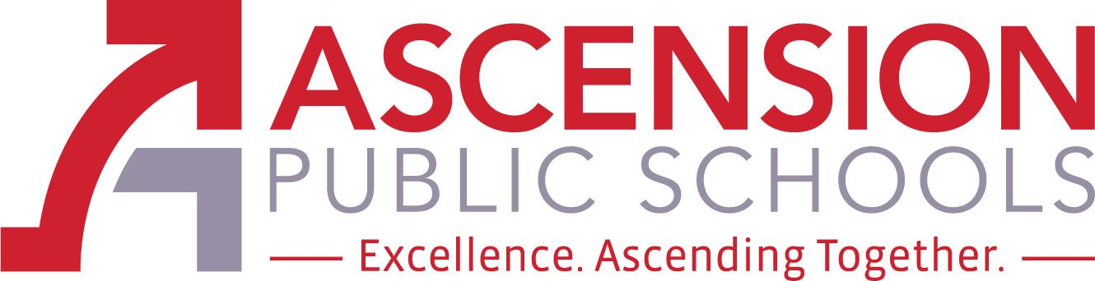

Ascension Special Education Advisory Council

December 3, 2021 at NOON



Join Zoom Meeting

ID: 81755705603

Passcode: bCU0KIzg

‪(US) +1 301-715-8592‬

Passcode: 78204355

The Ascension Special Education Advisory Council (Ascension SEAC) is an opportunity for parents, district staff, and community stakeholders to provide advice and feedback regarding special education policies, procedures, and resources. The members of Ascension SEAC shall engage in outreach activities in the community to increase the level of knowledge, support, and

collaboration in regard to special education. The council will consist of 4 members, 2 shall be

parents of a child who receives special education services, one shall be an Ascension Parish Principal, Teacher or Paraprofessional, and one shall be a special education stakeholder. Each member will be appointed for a one school year term and will act as an advisory council to the superintendent and/or the school board. The Ascension SEAC will meet three times per school year.

SEAC Members: Honesty Howard (parent member), Jodi Rollins (parent member), Katie Millet (teacher member), and Sara Recile (other special education stakeholder). Chair: Lynn Hathaway, Director of Special Education
- Call to Order
- Roll Call
- Public comment procedures

- SEAC Purpose & Process

- Approval of minutes from August 27, 2021 SEAC meeting

- 1. OLD Business - SEAC Focus-2021: for 2020 - to provide parents with information and resources that will help them participate in the IEP process in a meaningful way through the creation of:
  - a one page informational sheet that explains the IEP process and encourages & welcomes parents as critical team members
  - a Welcome Packet that provides parents with IEP information and resources in a user-friendly format
  - a survey for teachers to anonymously give feedback around needed supports
  - a more user-friendly, easy access web presence for parents
Progress/updates on focus area items

- NEW Business - Parent Agenda Items-
2.a. Parental attendance and meeting time
2.b. Meeting frequency
  - District Agenda Item - Speaker: Cynthia Chesterfield, Families Helping Families
3.a. Suggestions for future topics from Families Helping Families

Closing of Meeting - Next APS SEAC Meetings: March 25, 2022

Meeting Dates for Ascension SEAC Meetings:

August 27, 2021 at NOON

December 3, 2021 at NOON

March 25, 2022 at NOON

