

YES PREP PUBLIC SCHOOLS
REQUEST FOR SEALED PROPOSALS

RFP#YESP2022-03 Infrastructure Equipment E-rate
(FCC Form 470 # 220015578)
Submittal Deadline:
2:00 PM CST Wednesday, February 23rd 2022

YES Prep Public Schools Home Office 5455 South Loop E. Fwy
Houston, Texas 77033

Name of Company Submitting Proposal:

Table of Contents
Items below are components of this bid/proposal package. Respondents are asked to review the proposal document and attachments package to be sure that all applicable parts are included.
This attachment package must be completed, signed, and dated by the authorized bidder and must be returned with the proposal in a sealed envelope.
Attachments

- Proposer’s Certification and Signature Page
- IRS Form W-9
- Anti-Collusion
- Felony Conviction Notice
- Certification of Residency
- Debarment and Suspension Certification
- Affidavit of Non-Discriminatory Employment
- Child Support Certification
- SB 9 Contractor Certification: Contractor Employees
- Federal Funds / EDGAR Certifications
- Conflict of Interest Questionnaire
- Antitrust Certification
- ERATE SUPPLEMENTAL TERMS AND CONDITIONS

Attachment 1. Proposer’s Certifications and Signature Page

The undersigned authorized representative of proposer, on behalf of proposer, represents and acknowledges that:

- the undersigned is authorized to negotiate and to enter into contractual relationships on behalf of proposer;
- the undersigned has carefully examined the RFP package, including all terms and conditions, the Agreement, evaluation criteria, responsibilities of proposers, scope and specifications, etc.;
- proposer is incorporated and/or licensed to do business in the State of Texas;
- proposer represents that proposer does not have a record of substandard work or performance;
- proposer offers to furnish and deliver any goods and/or services submitted pursuant to this RFP at the prices quoted in the submitted proposal and to strictly comply with all terms and conditions of this RFP, the Agreement, and proposer’s proposal, unless any exceptions are noted in writing in the submitted proposal;
- if any part of proposer’s proposal is accepted, proposer will furnish all goods and/or services awarded under this RFP at the prices quoted in the submitted proposal and proposer will strictly comply with all terms and conditions associated of this RFP, the Agreement, and proposer’s proposal, unless any exceptions are noted in writing in the submitted proposal and are accepted by YES Prep;
- the individual, firm and/or any principal of the firm on whose behalf this proposal is submitted is not listed on the Federal Government’s “List of Parties Excluded from Federal Procurement and Non-procurement Programs” published by the U. S. General Services Administration (GSA) effective and compliance with the FCC “Red Light Rule” as of the date of opening of the proposal, and agrees to notify YES Prep of any debarment inquiries or proceedings by any federal, state or local governmental entity that exist or may arise between the date of this submission and such time as an award has been made under this RFP;
- proposer is in compliance with all federal, state, and local environmental codes, laws, and statutes; and
- by submitting a proposal, proposer agrees to waive any claim it has or may have against YES Prep and YES Prep’s responsive directors, employees, or agents arising out of or relating to (1) the administration, evaluation, or recommendation of any proposal; (2) any requirements under the RFP or related documents; (3) the rejection of any proposal or any part of any proposal; and/or (4) the award of a contract, if any.

Actual work to be performed and the schedule for performance under this solicitation will be upon the terms, conditions, and timelines agreed upon by the YES Prep and the selected contractor. Time is of the essence for this project. All items listed in the scope of work shall be completed no later than 08/01/2022

Legal Company Name
Address
City/State/Zip
Telephone No.
Fax No.
Tax ID number
Authorized Signature
Printed Name
Position With Company
E-mail Address

Attachment 2. W-9
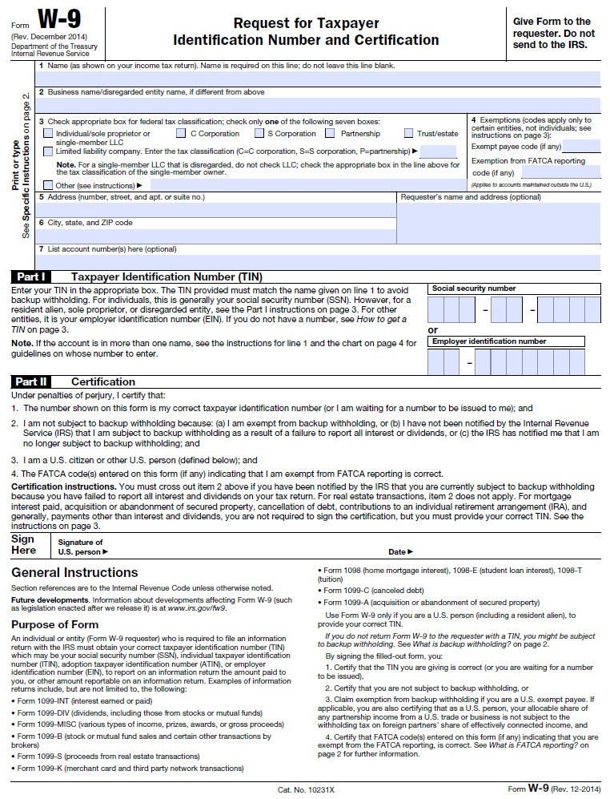

5
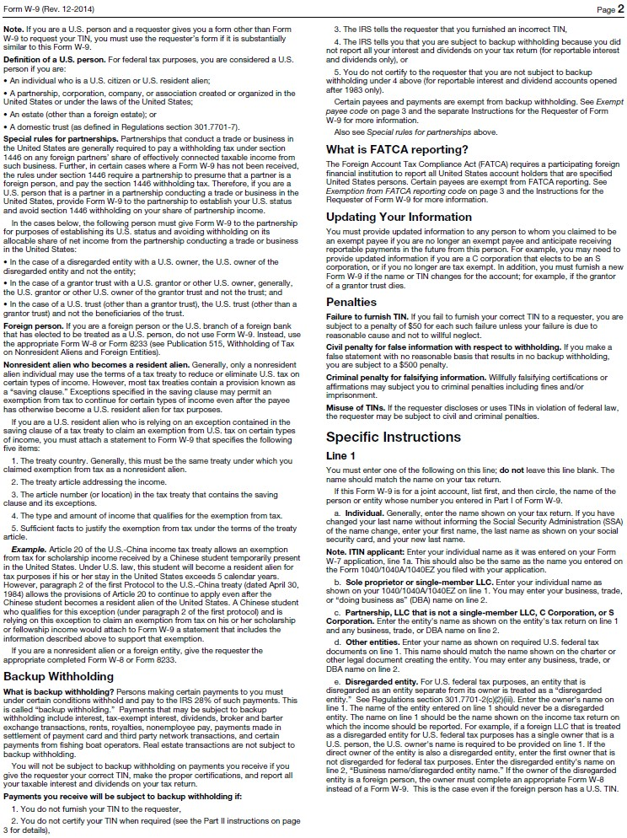

6
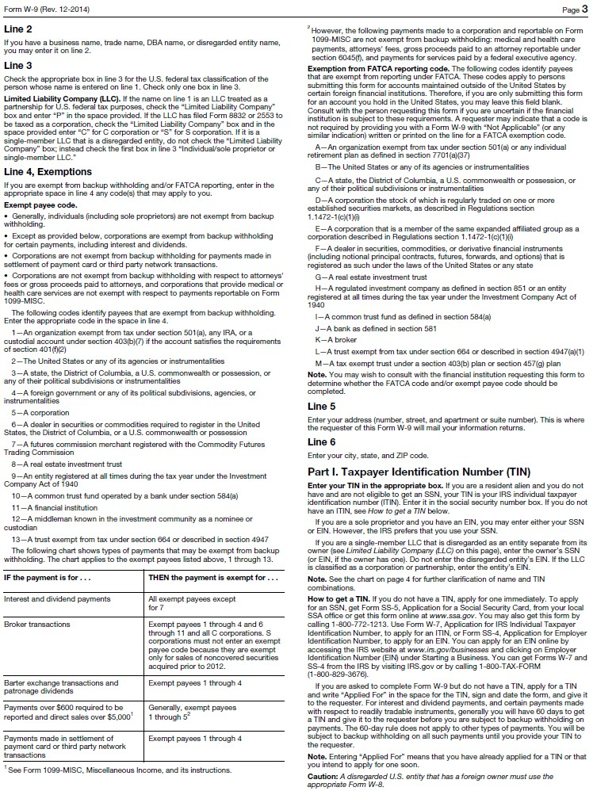

7
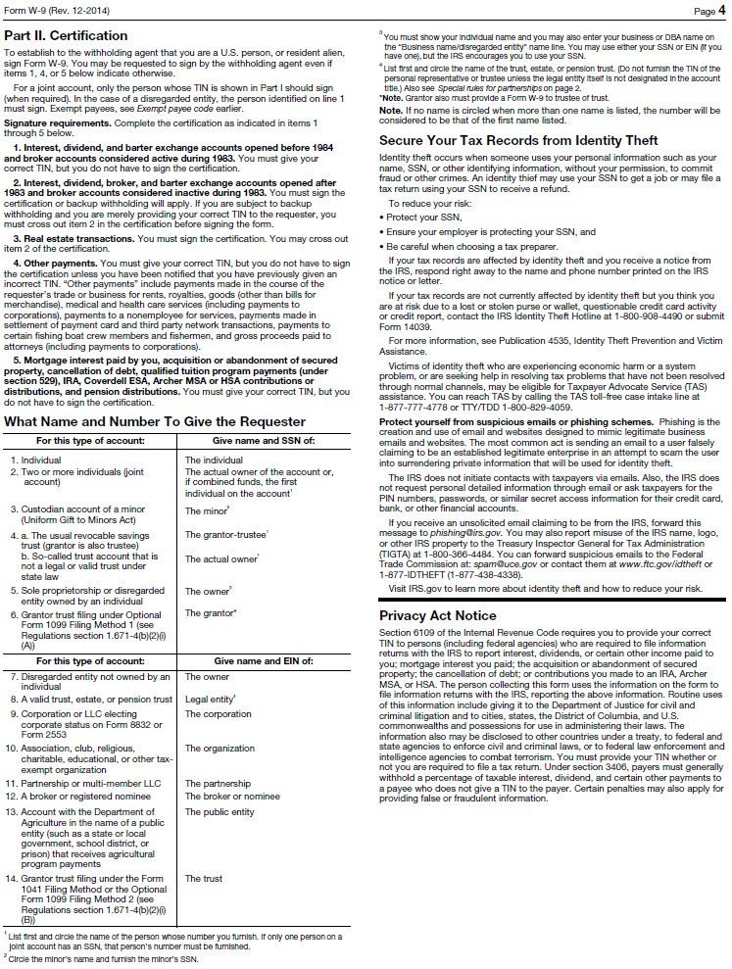

Attachment 3. ANTI-COLLUSION AFFIDAVIT

STATE OF )

COUNTY OF )

, of lawful age, being first sworn on oath say, that he/she is the agent authorized by the proposer to submit the attached proposal. Affiant further states that the proposer has not been a party to any collusion among proposers in restraint of freedom of competition by agreement to propose at a fixed price or to refrain from proposing; or with any state official of employees to quantity, quality, or price in the prospective contract, or any other terms of said prospective official concerning exchange of money or other thing of value for special consideration in the letting of contract; that the proposer had not paid, given or donated, or agreed to pay, give or donate to any officer or employee either directly or indirectly in the procuring of the award of a contact pursuant to this procurement solicitation.

Signed

Subscribed and sworn before me this day of , ,

Notary Public (or Clerk or Judge)

My commission expires

Attachment 4. FELONY CONVICTION NOTIFICATION

State of Texas Legislative Senate Bill No. 1, Section 44.034, Notification of Criminal History, Subsection (a), states "a person or business entity that enters into a contract with a school district must give advance notice to the district if the person or an owner or operator of the business entity has been convicted of a felony. The notice must include a general description of the conduct resulting in the conviction of a felony".

Subsection (b) states a “public school” may terminate a contract with a person or business entity if the “public school” determines that the person or business entity failed to give notice as required by Subsection (a) or misrepresented the conduct resulting in the conviction. The “public school” must compensate the person or business entity for services performed before the termination of the contract".

I, the undersigned agent for the firm named below, certify that the information concerning notification of felony convictions has been reviewed by me and the following information furnished is true to the best of my knowledge.

VENDOR'S NAME:

SIGNATURE OF AUTHORIZED COMPANY OFFICIAL:

AUTHORIZED COMPANY OFFICIAL'S NAME (PLEASE PRINT):


My firm is a publicly held corporation; therefore, this reporting requirement is not applicable.

My firm is not owned or operated by anyone who has been convicted of a felony.

My firm is owned or operated by the following individual(s) who has/have been convicted of a felony:

Attachment 5. CERTIFICATION OF RESIDENCY

To comply with the non-resident vendor laws detailed in Chapter 2252 of the Texas Government Code, YES PREP must determine the residency of its vendors. YES PREP may not award a contract to a nonresident bidder unless the nonresident underbids the lowest bid submitted by a responsible resident bidder by an amount that is not less than the amount by which a resident bidder would be required to underbid the nonresident bidder to obtain a comparable contract in the state in which the nonresident's principal place of business is located. See TEX. GOV’T CODE § 2252.003. This requirement does not apply to a contract involving federal funds unless the procurement and/or contract involves unprocessed locally grown or locally raised agricultural products for use by YES Prep in a Child Nutrition Program. See Texas Government Code §§ 2252.001 - .004; 2 C.F.R. § 200.319.

“Resident bidder” is a person whose principal place of business is in Texas, including a contractor whose ultimate parent company or majority owner has its principal place of business in Texas. “Nonresident bidder” is a person who is not a resident. See TEX. GOV’T CODE § 2252.001.

Vendor is a resident bidder. Yes No

City and state of Vendor’s principal place of business:

- Does your “resident state” require proposers whose principal place of business is in Texas to give preference to proposers whose resident state is the same as yours by a prescribed amount or percentage to receive a comparable contract? (“Resident State” means the state in which the principal place of business is located.)

Yes No

- If yes, what is the prescribed amount or percentage? $ or %

Certification: I certify that the information provided above is true and correct.

Signature of Authorized Representative

Name (Please Print) Title

Attachment 6. DEBARMENT AND SUSPENSION CERTIFICATION

This certification is required by the Federal Regulations implementing Executive Order 12549, Debarment and Suspension, 45 CFR Part 93, Government-wide Debarment and Suspension, for the Department of Agriculture (7 CFR Part 3017), Department of Labor (29 CFR Part 98), Department of Education (34 CFR Parts 85, 668, 682), Department of Health and Human Services (45 CFR Part 76).

The undersigned certifies, to the best of his or her knowledge and belief, that both it and its principals:

  - Are not presently debarred, suspended, proposed for debarment, declared ineligible, or voluntarily excluded from participation in this transaction by any federal department or agency;

  - Have not within a three-year period preceding this contract been convicted of or had a civil judgment rendered against them for commission of fraud or a criminal offense in connection with obtaining, attempting to obtain, or performing a public (Federal, State, or Local) transaction or contract under a public transaction, violation of federal or State antitrust statues or commission of embezzlement, theft, forgery, bribery, falsification, or destruction of records, making false statements, or receiving stolen property;

  - Are not presently indicated for or otherwise criminally or civilly charged by a government entity with commission of any of the offense enumerated in Paragraph (2) of this certification; and,

  - Have not within a three-year period preceding this contract had one or more public transactions terminated for cause or default.

Where the prospective recipient of federal assistance funds is unable to certify to any of the statements in this certification, such prospective recipient shall attach an explanation to this certification form.

Name of Organization/Firm:

Signature of Authorized Representative:

Attachment 7. Affidavit of Non-Discriminatory Employment

This company, contractor, or subcontractor agrees to refrain from discrimination in terms and conditions of employment on the basis of race, color, religion, sex, or national origin, and agrees to take affirmative action as required by Federal Statutes and rules and regulations issued pursuant thereto in order to maintain and insure non-discriminatory employment practices.

Signature of Authorized Representative:

Printed Name & Title:

Attachment 8.

State of Texas
Health & Human Services Commission Child Support Certification
- Section 231.006, Texas Family Code, as amended by Section 82 of House Bill No. 433, 74th Regular Legislative Session (Acts 1995, 74th Leg., R.S., ch. 751), prohibits the payment of state funds under a grant, contract, or loan to

- a person who is more than 30 days delinquent in the payment of child support, and
- a business entity in which such a person is the sole proprietor, partner, shareholder or owner with an ownership interest of at least 25%.

Section 231.006 further provides that a person or business entity that is ineligible to receive payments for the reasons stated above shall continue to be ineligible to receive payments from the state under a contract, grant, or loan until
- all arrearages have been paid, or
- the person is in compliance with a written repayment agreement or court order as to any existing delinquency.
Section 231.006 further requires each bid, or application for a contract, grant, or loan to include
- the name and social security number of the individual or sole proprietor and each partner, shareholder, or owner with an ownership interest of at least 25% of the business entity submitting the bid or application, and
- the statement in Part III below.

Section 231.006 authorizes a state agency to terminate a contract if it determines that statement required below is inaccurate or false, in the event the statement is determined to be false, the vendor is liable to the state for attorney's fees, costs necessary to complete the contract [including the cost of advertising and awarding a second contract], and any other damages provided by law or contract.

- In accordance with Section 231.006, the names and social security numbers of the individual identified in the contract, bid, or application or of each person with a minimum 25% ownership interest in the business entity identified therein are provided below.

Name Social Security #

- As required by Section 231.006, the undersigned certifies the following: "Under Section 231.006, Family Code, the vendor or applicant certifies that the individual or business entity named in this contract, bid, or application is not ineligible to receive the specified grant, loan, or payment, and acknowledges that this contract may be terminated and payment withheld if this certification is inaccurate."

Signature Title

Printed Name Date

Attachment 9. SB 9 CONTRACTOR CERTIFICATION: CONTRACTOR EMPLOYEES
Background
TEX. EDUC. CODE, Chapter 22 requires entities that contract with school districts to obtain criminal history records on covered employees. Covered employees with disqualifying criminal histories are prohibited from serving at a school district. Vendors must certify to YES Prep that they have complied and must obtain similar certifications from their subcontractors. The law requires each contractor to obtain the criminal histories of its covered employees. For more information or to set up an account, contact the Texas Department of Public Safety’s Crime Records Service at 512.424.2474.
Definitions
Covered employees: Employees of a contractor who have or will have continuing duties related to the service to be performed at a school district and have or will have direct contact with students. YES PREP will be the final arbiter of what constitutes continuing duties and direct contact with students.
Disqualifying criminal history:
  - A conviction or other criminal history information designated by YES PREP;
  - A felony or misdemeanor offense that would prevent a person from being employed under Tex. Educ. Code
§ 22.085(a), that is: if at the time of the offense, the victim was under 18 or was enrolled in a public school:
    - a felony offense under Title 5, Texas Penal Code;
    - an offense on conviction for which a defendant is required to register as a sex offender under Chapter 62, Texas Code of Criminal Procedure; or
    - an offense under federal law or the laws of another state that is equivalent to (a) or (b).

On behalf of _ (“Vendor”), I, the undersigned authorized signatory for Vendor,
certify to YES Prep Public Schools (“YES Prep”) that [check one]:
[ ] None of Vendor’s employees are covered employees, as defined above. If this box is checked, I further certify that Vendor has taken precautions or imposed conditions to ensure that its employees will not become covered employees. Vendor will maintain these precautions or conditions throughout the time the contracted services are provided.
Or
[ ] Some or all of Vendor’s employees are covered employees. If this box is checked, I further certify that:
- Vendor has obtained all required criminal history record information regarding its covered employees. None of the covered employees has a disqualifying criminal history.
- If Vendor receives information that a covered employee subsequently has a reported criminal history, Vendor will immediately remove the covered employee from contract duties and notify YES PREP in writing within 3 business days.
- Upon request, Vendor will provide YES PREP with the name and any other requested information of covered employees so that YES PREP may obtain criminal history record information on the covered employees.

If YES PREP objects to the assignment of a covered employee on the basis of the covered employee’s criminal history record information, Vendor agrees to discontinue using that covered employee to provide services at YES Prep. I also certify to YES Prep on behalf of Vendor that Vendor has obtained certifications from its subcontractors of compliance with Texas Education Code, Chapter 22. Noncompliance or misrepresentation regarding this certification may be grounds for contract termination.

_ _
Signature Title Date

Attachment 10.

REQUIRED CONTRACT PROVISIONS FOR NON-FEDERAL ENTITY CONTRACTS UNDER FEDERAL AWARDS – APPENDIX II TO 2 CFR PART 200

The following provisions are required and apply when federal funds are expended by YES Prep for any contract resulting from this procurement process.
- Contracts for more than the simplified acquisition threshold currently set at $150,000, which is the inflation adjusted amount determined by the Civilian Agency Acquisition Council and the Defense Acquisition Regulations Council (Councils) as authorized by 41 U.S.C. 1908, must address administrative, contractual, or legal remedies in instances where contractors violate or breach contract terms, and provide for such sanctions and penalties as appropriate.

Pursuant to Federal Rule (A) above, when federal funds are expended by YES Prep, YES Prep reserves all rights and privileges under the applicable laws and regulations with respect to this procurement in the event of breach of contract by either party.

Does vendor agree? YES Initials of Authorized Representative of vendor

- Termination for cause and for convenience by the grantee or subgrantee including the manner by which it will be effected and the basis for settlement. (All contracts in excess of $10,000)

Pursuant to Federal Rule (B) above, when federal funds are expended by YES Prep, YES Prep reserves the right to immediately terminate any agreement in excess of $10,000 resulting from this procurement process in the event of a breach or default of the agreement by Vendor, in the event vendor fails to: (1) meet schedules, deadlines, and/or delivery dates within the time specified in the procurement solicitation, contract, and/or a purchase order; (2) make any payments owed; or (3) otherwise perform in accordance with the contract and/or the procurement solicitation. YES PREP also reserves the right to terminate the contract immediately, with written notice to vendor, for convenience, if YES Prep believes, in its sole discretion that it is in the best interest of YES Prep to do so. The vendor will be compensated for work performed and accepted and goods accepted by YES Prep as of the termination date if the contract is terminated for convenience of YES Prep. Any award under this procurement process is not exclusive and YES Prep reserves the right to purchase goods and services from other vendors when it is in the best interest of YES Prep.

Does vendor agree to abide by the above?
YES Initials of Authorized Representative of vendor

- Equal Employment Opportunity. Except as otherwise provided under 41 CFR Part 60, all contracts that meet the definition of “federally assisted construction contract” in 41 CFR Part 60-1.3 must include the equal opportunity clause provided under 41 CFR 60-1.4(b), in accordance with Executive Order 11246, “Equal Employment Opportunity” (30 FR 12319, 12935, 3 CFR Part, 1964-1965 Comp., p. 339), as amended by Executive Order 11375, “Amending Executive Order 11246 Relating to Equal Employment Opportunity,” and implementing regulations at 41 CFR part 60, “Office of Federal Contract Compliance Programs, Equal Employment

Opportunity, Department of Labor.”

Pursuant to Federal Rule (C) above, when federal funds are expended by YES Prep on any federally assisted construction contract, the equal opportunity clause is incorporated by reference herein.

Does vendor agree to abide by the above?
YES Initials of Authorized Representative of vendor

- Davis-Bacon Act, as amended (40 U.S.C. 3141-3148). When required by Federal program legislation, all prime construction contracts in excess of $2,000 awarded by non-Federal entities must include a provision for compliance with the Davis-Bacon Act (40 U.S.C. 3141-3144, and 3146-3148) as supplemented by Department of Labor regulations (29 CFR Part 5, “Labor Standards Provisions Applicable to Contracts Covering Federally Financed and Assisted Construction”). In accordance with the statute, contractors must be required to pay wages to laborers and mechanics at a rate not less than the prevailing wages specified in a wage determination made by the Secretary of Labor. In addition, contractors must be required to pay wages not less than once a week. The non-Federal entity must place a copy of the current prevailing wage determination issued by the Department of Labor in each solicitation. The decision to award a contract or subcontract must be conditioned upon the acceptance of the wage determination. The non-Federal entity must report all suspected or reported violations to the Federal awarding agency. The contracts must also include a provision for compliance with the Copeland “Anti-Kickback” Act (40 U.S.C. 3145), as supplemented by Department of Labor regulations (29 CFR Part 3, “Contractors and Subcontractors on Public Building or Public Work Financed in Whole or in Part by Loans or Grants from the United States”). The Act provides that each contractor or subrecipient must be prohibited from inducing, by any means, any person employed in the construction, completion, or repair of public work, to give up any part of the compensation to which he or she is otherwise entitled. The non-Federal entity must report all suspected or reported violations to the Federal awarding agency.

Pursuant to Federal Rule (D) above, when federal funds are expended by YES PREP, during the term of an award for all contracts and subgrants for construction or repair, the vendor will be in compliance with all applicable Davis-Bacon Act provisions.

Does vendor agree? YES Initials of Authorized Representative of vendor

- Contract Work Hours and Safety Standards Act (40 U.S.C. 3701-3708). Where applicable, all contracts awarded by the non-Federal entity in excess of $100,000 that involve the employment of mechanics or laborers must include a provision for compliance with 40 U.S.C. 3702 and 3704, as supplemented by Department of Labor regulations (29 CFR Part 5). Under 40 U.S.C. 3702 of the Act, each contractor must be required to compute the wages of every mechanic and laborer on the basis of a standard work week of 40 hours. Work in excess of the standard work week is permissible provided that the worker is compensated at a rate of not less than one and a half times the basic rate of pay for all hours worked in excess of 40 hours in the work week. The requirements of 40 U.S.C. 3704 are applicable to construction work and provide that no laborer or mechanic must be required to work in surroundings or under working conditions which are unsanitary, hazardous or dangerous. These requirements do not apply to the purchases of supplies or materials or articles ordinarily available on the open market, or contracts for transportation or transmission of intelligence.

Pursuant to Federal Rule (E) above, when federal funds are expended by YES PREP, the vendor certifies that during the term of an award for all contracts by YES PREP resulting from this procurement process, the vendor will be in compliance with all applicable provisions of the Contract Work Hours and Safety Standards Act.

Does vendor agree? YES Initials of Authorized Representative of vendor

- Rights to Inventions Made Under a Contract or Agreement. If the Federal award meets the definition of “funding agreement” under 37 CFR §401.2 (a) and the recipient or subrecipient wishes to enter into a contract with a small business firm or nonprofit organization regarding the substitution of parties, assignment or performance of experimental, developmental, or research work under that “funding agreement,” the recipient or subrecipient must comply with the requirements of 37 CFR Part 401, “Rights to Inventions Made by Nonprofit Organizations and Small Business Firms Under Government Grants, Contracts and Cooperative Agreements,” and any implementing regulations issued by the awarding agency.

Pursuant to Federal Rule (F) above, when federal funds are expended by YES PREP, the vendor certifies that during the term of an award for all contracts by YES PREP resulting from this procurement process, the vendor agrees to comply with all applicable requirements as referenced in Federal Rule (F) above.

Does vendor agree? YES Initials of Authorized Representative of vendor

- Clean Air Act (42 U.S.C. 7401-7671q.) and the Federal Water Pollution Control Act (33 U.S.C. 1251-1387), as amended—Contracts and subgrants of amounts in excess of $150,000 must contain a provision that requires the non-Federal award to agree to comply with all applicable standards, orders or regulations issued pursuant to the Clean Air Act (42 U.S.C. 7401-7671q) and the Federal Water Pollution Control Act as amended (33 U.S.C. 1251- 1387). Violations must be reported to the Federal awarding agency and the Regional Office of the Environmental Protection Agency (EPA).

Pursuant to Federal Rule (G) above, when federal funds are expended by YES PREP, the vendor certifies that during the term of an award for all contracts by YES PREP resulting from this procurement process, the vendor agrees to comply with all applicable requirements as referenced in Federal Rule (G) above.

Does vendor agree? YES Initials of Authorized Representative of vendor

- Debarment and Suspension (Executive Orders 12549 and 12689)—A contract award (see 2 CFR 180.220) must not be made to parties listed on the governmentwide exclusions in the System for Award Management (SAM), in accordance with the OMB guidelines at 2 CFR 180 that implement Executive Orders 12549 (3 CFR part 1986 Comp., p. 189) and 12689 (3 CFR part 1989 Comp., p. 235), “Debarment and Suspension.” SAM Exclusions contains the names of parties debarred, suspended, or otherwise excluded by agencies, as well as parties declared ineligible under statutory or regulatory authority other than Executive Order 12549.

Pursuant to Federal Rule (H) above, when federal funds are expended by YES PREP, the vendor certifies that during the term of an award for all contracts by YES PREP resulting from this procurement process, the vendor certifies that neither it nor its principals is presently debarred, suspended, proposed for debarment, declared ineligible, or voluntarily excluded from participation by any federal department or agency.

Does vendor agree? YES Initials of Authorized Representative of vendor

- Byrd Anti-Lobbying Amendment (31 U.S.C. 1352)—Contractors that apply or bid for an award exceeding
$100,000 must file the required certification. Each tier certifies to the tier above that it will not and has not used Federal appropriated funds to pay any person or organization for influencing or attempting to influence an officer or employee of any agency, a member of Congress, officer or employee of Congress, or an employee of a member of Congress in connection with obtaining any Federal contract, grant or any other award covered by 31 U.S.C. 1352. Each tier must also disclose any lobbying with non-Federal funds that takes place in connection with obtaining any Federal award. Such disclosures are forwarded from tier to tier up to the non-Federal award.

Pursuant to Federal Rule (I) above, when federal funds are expended by YES Prep, the vendor certifies that during the term and after the awarded term of an award for all contracts by YES Prep resulting from this procurement process, the vendor certifies that it is in compliance with all applicable provisions of the Byrd Anti-Lobbying Amendment (31 U.S.C. 1352). The undersigned further certifies that:
  - No Federal appropriated funds have been paid or will be paid for on behalf of the undersigned, to any person for influencing or attempting to influence an officer or employee of any agency, a Member of Congress, an officer or employee of congress, or an employee of a Member of Congress in connection with the awarding of a Federal contract, the making of a Federal grant, the making of a Federal loan, the entering into a cooperative agreement, and the extension, continuation, renewal, amendment, or modification of a Federal contract, grant, loan, or cooperative agreement.
  - If any funds other than Federal appropriated funds have been paid or will be paid to any person for influencing or attempting to influence an officer or employee of any agency, a Member of Congress, an officer or employee of congress, or an employee of a Member of Congress in connection with this Federal grant or cooperative agreement, the undersigned shall complete and submit Standard Form-LLL, “Disclosure Form to Report Lobbying”, in accordance with its instructions.
  - The undersigned shall require that the language of this certification be included in the award documents for all covered sub-awards exceeding $100,000 in Federal funds at all appropriate tiers and that all subrecipients shall certify and disclose accordingly.

Does vendor agree? YES Initials of Authorized Representative of vendor

Procurement of Recovered Materials – When federal funds are expended by YES Prep, YES Prep and its contractors must comply with section 6002 of the Solid Waste Disposal Act, as amended by the Resource Conservation and Recovery Act. The requirements of Section 6002 include: (1) procuring only items designated in guidelines of the Environmental Protection Agency (EPA) at 40 CFR part 247 that contain the highest percentage of recovered materials practicable, consistent with maintaining a satisfactory level of competition, where the purchase price of the item exceeds $10,000 or the value of the quantity acquired during the preceding fiscal year exceeded $10,000; (2) procuring solid waste management services in a manner that maximizes energy and resource recovery; and (3) establishing an affirmative procurement program for

procurement of recovered materials identified in the EPA guidelines.

Pursuant to Federal Rule (J) above, when federal funds are expended YES PREP, as required by the Resource Conservation and Recovery Act of 1976 (42 U.S.C. § 6962(c)(3)(A)(i)), the vendor certifies, by signing this document, that the percentage of recovered materials content for EPA-designated items to be delivered or used in the performance of the contract will be at least the amount required by the applicable contract specifications or other contractual requirements.

Does vendor agree? YES Initials of Authorized Representative of vendor
RECORD RETENTION REQUIREMENTS FOR CONTRACTS PAID FOR WITH FEDERAL FUNDS – 2 CFR § 200.333

When federal funds are expended by YES PREP for any contract resulting from this procurement process, the vendor certifies that it will comply with the record retention requirements detailed in 2 CFR § 200.333. The vendor further certifies that vendor will retain all records as required by 2 CFR § 200.333 for a period of three years after grantees or subgrantees submit final expenditure reports or quarterly or annual financial reports, as applicable, and all other pending matters are closed.

Does vendor agree? YES Initials of Authorized Representative of vendor

CERTIFICATION OF COMPLIANCE WITH THE ENERGY POLICY AND CONSERVATION ACT

When federal funds are expended by YES PREP for any contract resulting from this procurement process, the vendor certifies that the vendor will be in compliance with mandatory standards and policies relating to energy efficiency which are contained in the state energy conservation plan issued in compliance with the Energy Policy and Conservation Act (42 U.S.C. 6321, et seq.; 49 C.F.R. Part 18).

Does vendor agree? YES Initials of Authorized Representative of vendor

CERTIFICATION OF COMPLIANCE WITH BUY AMERICA PROVISIONS

Vendor certifies that vendor is in compliance with all applicable provisions of the Buy America Act. Purchases made in accordance with the Buy America Act must still follow the applicable procurement rules calling for free and open competition.

Does vendor agree? YES Initials of Authorized Representative of vendor

CERTIFICATION OF NON-COLLUSION STATEMENT

Vendor certifies under penalty of perjury that its response to this procurement solicitation is in all respects bona fide, fair, and made without collusion or fraud with any person, joint venture, partnership, corporation or other business or legal entity.

Does vendor agree? YES Initials of Authorized Representative of vendor

CERTIFICATION OF COMPLIANCE WITH EPA REGULATIONS
APPLICABLE TO GRANTS, SUBGRANTS, COOPERATIVE AGREEMENTS, AND CONTRACTS IN EXCESS OF $100,000 OF FEDERAL FUNDS

When federal funds are expended by YES PREP for any contract resulting from this procurement process in excess of
$100,000, the vendor certifies that the vendor is in compliance with all applicable standards, orders, regulations, and/or requirements issued pursuant to the Clean Air Act of 1970, as amended (42 U.S.C. 1857(h)), Section 508 of the Clean Water Act, as amended (33 U.S.C. 1368), Executive Order 117389 and Environmental Protection Agency Regulation, 40 CFR Part 15.

Does vendor agree? YES Initials of Authorized Representative of vendor

CERTIFICATION REGARDING TERRORIST ORGANIZATIONS &
BOYCOTTING OF ISRAEL
Vendor hereby certifies that it is not a company identified on the Texas Comptroller’s list of companies known to have contracts with, or provide supplies or services to, a foreign organization designated as a Foreign Terrorist Organization by the U.S. Secretary of State. Vendor further certifies and verifies that neither Vendor, nor any affiliate, subsidiary, or parent company of Vendor, if any (the “Vendor Companies”), boycotts Israel, and Vendor agrees that Vendor and Vendor Companies will not boycott Israel during the term of this Agreement. For purposes of this Agreement, the term “boycott” shall mean and include terminating business activities or otherwise taking any action that is intended to penalize, inflict economic harm on, or limit commercial relations with Israel, or with a person or entity doing business in Israel or in an Israeli-controlled territory.

Initials of Authorized Representative of Vendor

Vendor agrees to comply with all federal, state, and local laws, rules, regulations and ordinances, as applicable. It is further acknowledged that vendor certifies compliance with all provisions, laws, acts, regulations, etc. as specifically noted above.

Vendor’s Name/Company Name: Address, City, State, and Zip Code:
Phone Number: Fax Number:
Printed Name and Title of Authorized Representative: Email Address: Signature of Authorized Representative: Date:

Attachment 11. YES Prep Conflict of Interest
YES Prep Public Schools (YES Prep) is required to comply with Texas Local Government Code Chapter 176, Disclosure of Certain Relationships with Local Government Officers. House Bill 23 significantly changed Chapter 176 as well as the required disclosures and the corresponding forms. As of September 1, 2015, any vendor who does business with YES PREP or who seeks to do business with YES PREP must fill out the new Conflict of Interest Questionnaire (CIQ) whether or not a conflict of interest exists. A conflict of interest exists in the following situations:
- If the vendor has an employment or other business relationship with a local government officer of YES PREP or a family member of the officer, as described by section 176.003(a)(2)(A) of the Texas Local Government Code; or
- If the vendor has given a local government officer of YES PREP, or a family member of the officer, one or more gifts with the aggregate value of $100, excluding any gift accepted by the officer or a family member of the officer if the gift is: (a) a political contribution as defined by Title 15 of the Election Code; or (b) a gift of food accepted as a guest; or
- If the vendor has a family relationship with a local government officer of YES PREP.

“Vendor” means a person who enters or seeks to enter into a contract with a local governmental entity. The term includes an agent of a vendor. The term includes an officer or employee of a state agency when that individual is acting in a private capacity to enter into a contract. The term does not include a state agency except for Texas Correctional Industries. Texas Local Government Code 176.001(7).

“Business relationship” means a connection between two or more parties based on commercial activity of one of the parties. The term does not include a connection based on: (A) a transaction that is subject to rate or fee regulation by a federal, state, or local governmental entity or an agency of a federal, state, or local governmental entity; (B) a transaction conducted at a price and subject to terms available to the public; or (C) a purchase or lease of goods or services from a person that is chartered by a state or federal agency and that is subject to regular examination by, and reporting to, that agency. Texas Local Government Code 176.001(3).

“Family relationship” means a relationship between a person and another person within the third degree by consanguinity or the second degree by affinity, as those terms are defined by Subchapter B, Chapter 573, Government Code. Texas Local Government Code 176.001(2-a).

“Local government officer” means: (A) a member of the governing body of a local governmental entity; (B) a director, superintendent, administrator, president, or other person designated as the executive officer of a local governmental entity; or (C) an agent of a local governmental entity who exercises discretion in the planning, recommending, selecting, or contracting of a vendor. Texas Local Government Code 176.001(4).

If no conflict of interest exists, you must fill out Box 1 and type N/A on Box 3 of the CIQ form, sign and date it. In the event of changed circumstances, an updated CIQ must be filed within seven (7) business days after the vendor becomes aware that a conflict of interest exists.

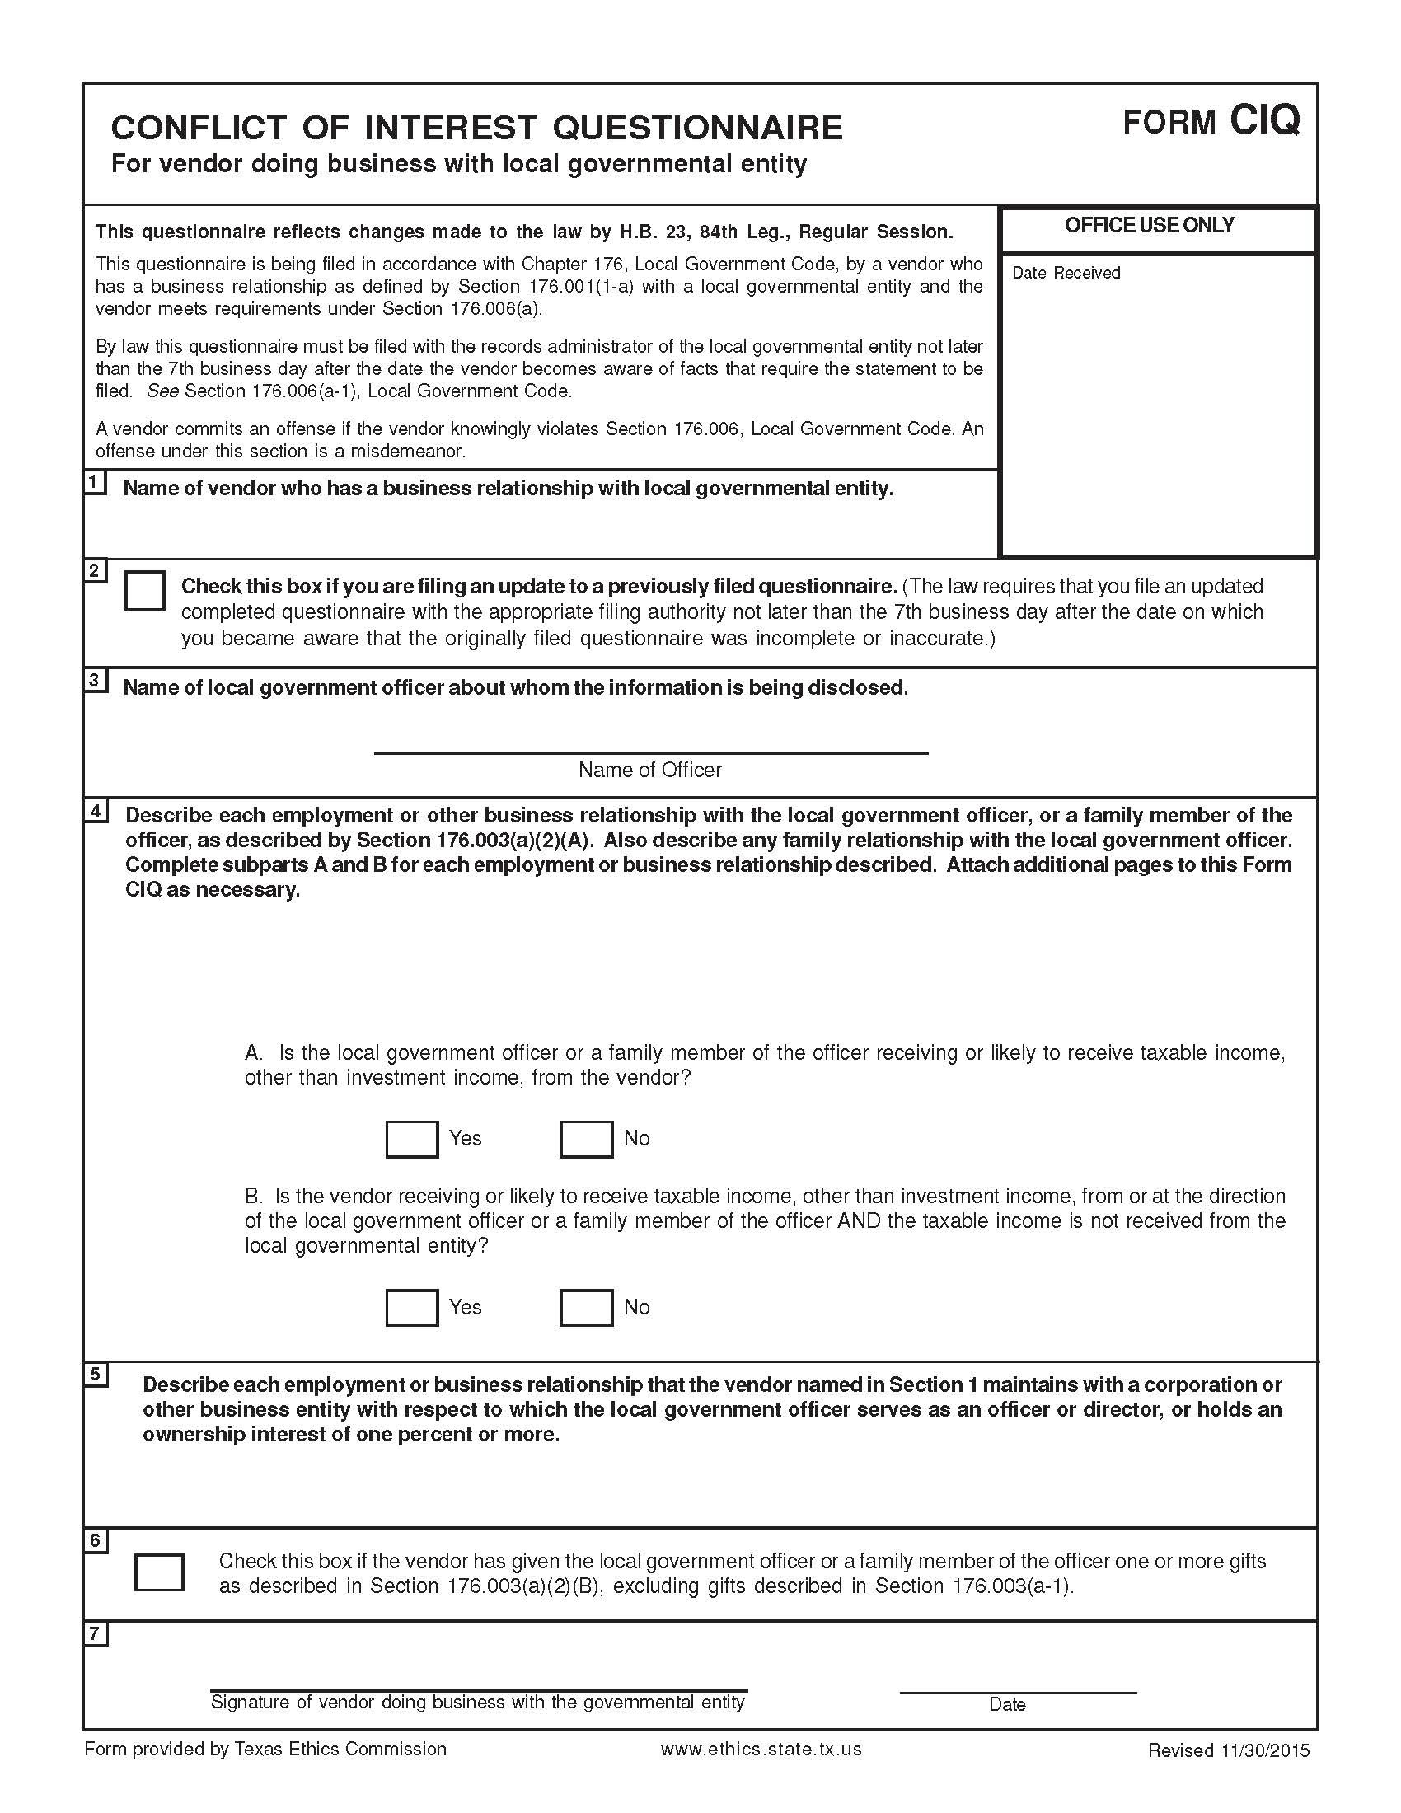

Attachment 12:

ANTITRUST CERTIFICATION STATEMENT

(Tex. Government Code § 2155.005)

I affirm under penalty of perjury of the laws of the State of Texas that:

- I am duly authorized to execute this contract on my own behalf or on behalf of the company, corporation, firm, partnership or individual (Company) listed below;
- In connection with this bid, neither I nor any representatives of the Company have violated any provision of the Texas Antitrust laws codified in Tex. Bus. & Comm. Code Chapter 15;
- In connection with this bid, neither I nor any representative of the Company have violated any federal antitrust law; and
- Neither I nor any representatives of the Company have directly or indirectly communicated any of the contents of this bid to a competitor of the Company or any other company, corporation, firm, partnership or individual engaged in the same line of business as the Company.

Contractor’s Name/Company Name:

Address, City, State, and Zip Code:

Bidder Signature:

Printed Name:

Title: Date Signed:

Attachment 13: E-RATE SUPPLEMENTAL TERMS AND CONDITIONS
Signed copy to be returned with bid response.
The Telecommunications Act of 1996 established a fund by which Schools and Libraries across the Country could access discounts on eligible telecommunications products and services. The program is commonly known as the E-rate Program. The eligibility for discounts on internet access, telecommunications products and services, internal connection products, services and maintenance is determined by the Federal Communications Commission (FCC). Funding is made available upon application approval by the Schools and Libraries Division (SLD) of the Universal Service Administrative Company (USAC), which was established by the Act. The amount of discount is based on the numbers of students receiving free and reduced price meals.

- E-RATE CONTINGENCY
The project herein is contingent upon the approval of funding from the Universal Service Fund’s Schools and Libraries Program, otherwise known as E‐rate. Even after award of contract(s) and/or E-rate funding approval is obtained, the District may or may not proceed with the project, in whole or in part. Execution of the project, in whole or in part, is solely at the discretion of the District.

- SERVICE PROVIDER REQUIREMENTS
The District expects Service Providers to make themselves thoroughly familiar with any rules or regulations regarding the E-rate program.

- Service Providers are required to be in full compliance with all current requirements and future requirements issued by the SLD throughout the contractual period of any contract entered into as a result of this RFP.

- Service Providers are responsible for providing a valid SPIN (Service Provider Identification Number). More information about obtaining a SPIN may be found at this website: https://www.usac.org/e-rate/service-providers/step-1-obtain-a-spin/

- Service Providers are responsible for providing a valid Federal Communications Commission (FCC) Registration Number (FRN) at the time the bid is submitted. More information about obtaining an FRN may be found at this website: https://fjallfoss.fcc.gov/coresWeb/publicHome.do

- Service Providers are responsible for providing evidence of FCC Green Light Status at the time the bid is submitted. Any potential bidder found to be in Red Light Status must provide an explanation of the steps it is undertaking to be removed to Red Light Status and the expected timeframe for resolution. A Service Provider's sustained Red Light Status may be grounds for contract termination as it could prohibit the Service Provider from providing E-rate discounts in a timely manner which would cause harm to the Applicant. More information about FCC Red and Green Light Status may be found at this website: http://www.fcc.gov/debt_collection/welcome.html

- Products and services must be delivered before billing can commence. At no time may the Service Provider invoice before July 1, 2022.

- Prices must be held firm for the duration of the associated E-rate Funding Year(s) or until all work associated with the project is complete (including any contract and USAC approved extensions).

- Goods and services provided shall be clearly designated as “E-rate Eligible”. Non-eligible goods and services shall be clearly called out as 100% non-eligible or shall be “cost allocated” to show the percentage of eligible costs per SLD guidelines.

- Within one (1) week of award, the awarded Service Provider must provide the District a bill of materials using a completed USAC “Item 21 Template”. Subsequent schedules of values and invoices for each site must match Item 21 Attachment or subsequent service substitutions. A summary sheet must also be provided to provide the cumulative amount for all sites.

- In the event of questions during an E-rate pre-commitment review, post-commitment review and/or audit inquiry, the awarded Service Provider is expected to reply within 3 days to questions associated with its proposal.

- The awarded Service Provider is required to send copies of all forms and invoices to the District prior to invoicing USAC for pre-approval. Failure to comply with this requirement may result in the District placing the vendor on an “Invoice Check” with the USAC https://www.usac.org/e-rate/applicant-process/invoicing/invoice-check/

- Services providers must comply with the FCC rules for Lowest Corresponding Price ("LCP"). Further details on LCP may be obtained at USAC's website: https://www.usac.org/e-rate/service-providers/step-2-responding-to-bids/lowest-corresponding-price/

- SERVICE PROVIDER ACKNOWLEDGEMENTS
  - The Service Provider acknowledges that no change in the products and/or services specified in this document will be allowed without prior written approval from the district and a USAC service substitution approval with the exception of a Global Service Substitutions.

  - The Service Provider acknowledges that all pricing and technology infrastructure information in its bid shall be considered as public and non-confidential pursuant to §54.504 (2)(i)(ii).

  - The Service Provider acknowledges that its offer is considered to be the lowest corresponding price pursuant to § 54.511(b). Further details on LCP may be obtained at USAC's website: https://www.usac.org/e-rate/service-providers/step-2-responding-to-bids/lowest-corresponding-price/. Should it not be the lowest corresponding price, the service provider must disclose the conditions leading to the applicant being charged in excess of lowest corresponding price.

  - BIDDERS are required to comply with the FCC’s Lowest Corresponding Price (“LCP”) Requirement for all equipment and Services. BIDDER acknowledges that BIDDER is solely responsible to comply with LCP requirements. To the extent that USAC finds an LCP violation and reduces the E-rate Funding, BIDDER agrees that it will not hold the DISTRICT liable for any shortfall in E-rate funding and will be responsible for any ensuing appeals, COMADS and/or RIDFS.

  - The Service Provider attests that its offer does not violate the FCC’s REPORT AND ORDER, FURTHER NOTICE OF PROPOSED RULEMAKING, AND ORDER in the matter of “Protecting Against National Security Threats to the Communications Supply Chain Through FCC Programs” (FCC 19-121, adopted November 22, 2019, released November 26, 2019) and provisions contained in the Order and any subsequent Orders related to the FNPRM referenced in FCC 19-121. FCC 19-121 can be viewed at https://docs.fcc.gov/public/attachments/FCC-19-121A1.pdf

  - This offer is in full compliance with USAC’s Free Services Advisory https://www.usac.org/e-rate/applicant-process/competitive-bidding/free-services-advisory/. There are no free services offered that would predicate an artificial discount and preclude the applicant from paying its proportionate non-discounted share of costs. The service provider agrees to provide substantiating documentation to support this assertion should the applicant, USAC, or the FCC request it.

- STARTING SERVICES/ADVANCE INSTALLATION – Category 1 Services

The annual E-rate Funding Year begins on July 1 and expires on June 30 of each calendar year. Regardless of the contract “effective date”, E-rate eligible goods and/or services requested in this RFP shall be delivered no earlier than the start of the 2022 funding year (July 1, 2022). If Category 1 services (Telecommunication Services and Internet access) will begin on or shortly after July 1 of a funding year, the service provider, in some cases, may need to undertake some construction and installation work prior to the beginning of that funding year. Within the limitations indicated below, the infrastructure costs of a service provider can be deemed to be delivered at the same time that the associated Category 1 services begin. That is, if services begin on July 1, then the delivery of service provider infrastructure necessary for those services can be considered as also delivered on July 1. However, NO INVOICING can take place prior to July 1 of the associated Funding Year.

EARLY FUNDING CONDITIONS

Category 1
There are four conditions that must be met in order for USAC to provide support in a funding year for Category 1 infrastructure costs incurred prior to that funding year.

- Initiation of installation cannot take place before selection of the service provider pursuant to a posted Form 470 and in any event no earlier than six months prior to July 1 of the funding year.
- The Category 1 service must depend on the installation of the infrastructure.
- The underlying Category 1 service cannot have a service start date prior to July 1 of the funding year.
- No invoices can be submitted to USAC for reimbursement prior to July 1 of the funding year.

For more information, please refer to the FCC Order involving the Nassau County Board of Cooperative Educational Services (DA 02-3365 , released December 6, 2002). This FCC decision only applies to Priority 1 services (telecommunications services and Internet access).

The complete text can be found at the following URL:
https://www.usac.org/e-rate/applicant-process/starting-services/advance-installation/

Category 2
There is one condition that allows USAC to provide support in a funding year for Category 2 installation costs incurred prior to that funding year.

- We also amend our rules for category two non-recurring services to permit applicants to seek support for category two eligible services purchased on or after April 1, three months prior to the start of funding year on July 1. This will provide schools with the flexibility to purchase equipment in preparation for the summer recess and provide the maximum amount of time during the summer to install these critical networks.

For more information, please refer to the FCC Report and Order and Further Notice of Proposed Rulemaking (FCC 14-99 , released July 23, 2014). This FCC decision only applies to Category 2 services (Internal Connections).

However, NO INVOICING can take place prior to July 1 of the funding year.

- INVOICING

- The Service Provider agrees to bill and receive a portion of the payment for the provisions of goods and services described herein directly from USAC via the Form 474 Service Provider Invoice (SPI). The District will only be responsible for paying its non‐discounted share of costs and does not intend to use the BEAR process (Form 472). The maximum percentage the District will be liable for is the pre-discount amount minus the funded amount as shown on the FCC Form 471 Block 5 and any identified ineligible costs. Upon the successful receipt or posting of a Funding Commitment Decision Letter from the SLD and submission, certification and USAC approval of Form 486, the District shall pay only the discounted amount beginning with the billing cycle immediately following said approval. Alternatively, should the District decide that it is in the best interest of the District to file a Form 472, the District will inform the Service Provider of its intent.

- All Service Provider invoicing to USAC must be completed within 120 days from the last day of service. Should the Service Provider fail to invoice USAC in a timely manner, the District will only be responsible for paying its non-discounted share.

- FCC/SLD AUDITABILITY
The E-rate program requires that all records be retained for at least ten (10) years from the last date of service provided on a particular funding request. Respondent hereby agrees to retain all books, records, and other documents relative to any Agreement resulting from this RFP for ten (10) years after final payment. The District, its authorized agents, and/or auditors reserves the right to perform or have performed an audit of the records of the Respondent and therefore shall have full access to and the right to examine any of said materials within a reasonable period of time during said period.

- procurement of additional goods and/or services/coterminous expiration
During the term of any Agreement resulting from this RFP, the District may elect to procure additional or like goods and/or services offered by the Respondent. Such services shall be negotiated and obtained via an official amendment to this Agreement and approval by the District’s Governing Board. All terms, conditions, warranties, obligations, maintenance and support of said goods or services shall have a coterminous expiration date with the original date of this Agreement. The District shall not enter into a separate Agreement for said goods or services. Respondents must state in their proposal that they acknowledge, accept and are in agreement with coterminous expiration conditions.

I, the undersigned, as an authorized agent of ______________________________ (Service Provider Name), hereby certify that I have read the E-rate Supplemental Terms and Conditions, am fully compliant and intend to cooperate with the E-rate process as outlined above.

Signature: _______________________________ Title: _______________________________

Phone Number: __________________________ Email: _____________________________

Service Provider Name: _________________________________________________________

