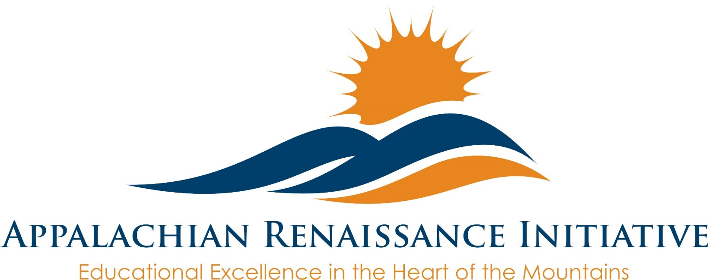
Appalachian Renaissance Initiative

Fire Cast Video

KVEC’s FIRECAST is a new half-hour show highlighting creative and determined educators building their classrooms into a one of a kind experience. The goal of the show is to showcase these classroom innovations and inspire others to help change the narrative of Eastern Kentucky.

Learning Innovation Grants $1,000.00
PLAN MUST BE COMPLETED BY 8-22-18
Apply for the competitive Learning Innovation Grants. Educators may apply for up to $1,000.00 to enhance classroom learning by implementing innovative strategies and approaches to learning. One-hundred Learning Innovation Grants will be awarded.
- MUST attend Fire Summit October 23, 2018 –reimbursed for substitute
- MUST attend Fire Summit April 10, 2019 –reimbursed for substitute

*Grants available for Special Education and Preschool/Headstart

Free Professional Development
Ron Clark July 31, 2018 Mountain Arts Center
(Breakout Sessions- Community College)
Hal Bowman TBA Deeper Academic Engagement
Adolph Brown TBA Motivational
TBA TBA

On-going Development

Micro-Credentials
Micro-Credentials are a digital form of certification indicating that a person has demonstrated competency in a specific skill, such as data literacy, teacher leadership, or growth mindset.
https://bloomboard.com/
http://digitalpromise.org/

https://www.theholler.org/request-forms/firecast-application/
https://www.theholler.org/request-forms/firecast-minisode/

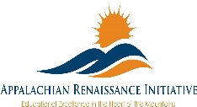

LOCATION
Big Sandy Community and Technical College
1 Bert Combs Drive
Prestonsburg, KY 41653

DATE AND TIME
Tue, July 31, 2018
1:00 PM – 3:30 PM EDT

K-5 Math Strategies
https://www.eventbrite.com/e/kvec-renaissance-academy-afternoon-session-k-5-math-strategies-tickets-47925417213

Grades 6-12 Reading Writing Connection https://www.eventbrite.com/e/kvec-renaissance-academy-afternoon-session-the-readingwriting-connection-grades-6-12-college-and-tickets-47924747209

Classroom Maker Space
https://www.eventbrite.com/e/kvec-renaissance-academy-afternoon-session-making-learning-real-how-a-classroom-maker-space-can-tickets-47925253724



In each of these interactive, grade level specific sessions teachers will examine strategies that focus on improving students’ reading and writing skills for academic success:
• Deeper understanding of the KY Academic Standards for English/LA & Literacy in History/Social Studies, Science and Technical Subjects
• Components of effective literacy instruction (reading, writing, speaking and listening) at each range of the continuum
• Essential writing skills needed for passage-based writing on timed and untimed tasks
• Effective disciplinary literacy skills

All workshops will be held at the KVEC Training Center in Hazard.
Registration information will be sent at a later date
carole.mullins@hazard.kyschools.us


Appalachian Renaissance Initiative

