General Para Certificate Clock Hours and Compensation

The instructions that follow provide the necessary information to:
- Get paid for 14 hours of course work.
- Register for clock hours
- Take a course in Vector Solutions (previously known as Safe Schools) listed below by topic, college courses completed after July 1, 2019, complete courses through accredited clock hour providers, complete a PGP, etc to accumulate your required hours.

Who can help me if I have trouble with these steps?
Try a few of these supports before emailing:
- Ask another para or two in your building, it is likely someone has figured this out or has already asked the question.
- Ask one of your union leads. They have been working very closely with us to help develop these steps.
- Within some of the steps below a contact is provided if you can not resolve the issue.
- Please try to utilize email as it provides a good system to track communication.

How do I get paid for my 14 hours?
For 2021-22 Paras are eligible to receive up to 14 hours of pay for FCS and/or GPC courses attended outside your regularly scheduled workday.

      - If you attend courses outside of your regular scheduled hours, please log these as extra hours on your timecard in Employee Online in the month in which you attended the course. Use GLKey 6710583199 and GLObj 3310 and list the course number in the notes. See example below.

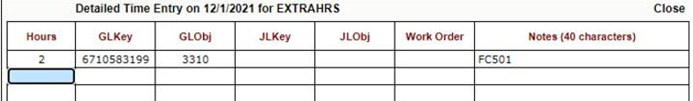

      - If you have already completed hours for pay, in previous months, please complete a paper timecard and provide that to your secretary so it can be processed through payroll. You will use the budget code 67105831993310 for our timecard. A timecard can be found on the district professional development website for paras.
Step 1: Determining what I want to take:

What course can I take?
The courses available can be found on the Para Training Flyer linked here.

Each course on the flyer is made up of several smaller courses from Vector Solutions. Page 2 of the flyer provides the details of each course and the number of clock hours.

How many clock hours can I get for each course?
You are able to earn up to the number of clock hours listed on page 2 of the Para Training Flyer. For example, for Autism you can earn up to 10.5 clock hours.

Step 2: Registering for clock hours:

How do I register for the clock hours?
You must register for the clock hours before you start the course. Go to page 1 of the Para Training Flyer and look for 1. Register Here for clock hours. That is the link to the ProDev system where you will need to register. Click here for steps on how to register in ProDev.

What do I do if I am having problems logging in?
- Your login is your district email. The password is the password you set up when you created your prodev account.
- If your password does not work, from the login screen, you can click on send password.
- Under the login is the email address if you are having problems. Please send an email with a very short message about the issue. For example, my login doesn’t work. Someone will respond to you within 24 hours. See the picture below.
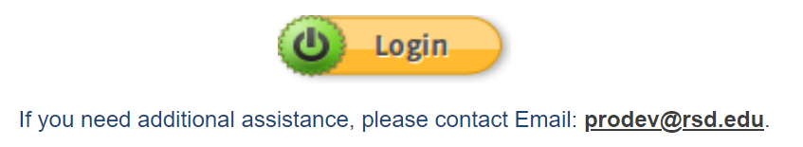

- Any other problems that arise in prodev should be addressed to the email prodev@rsd.edu. Please utilize the email instead of a phone call.

Step 3: Starting the Vector Solutions Course:

- You are now ready to begin learning. Go to page 1 of the Para Training Flyer, and look for 2. Log in Here to begin learning. This will take you to the Vector Solutions login page.
- If you have trouble logging in please email Joan.Gribskov@rsd.edu with a short email that your login is not working.
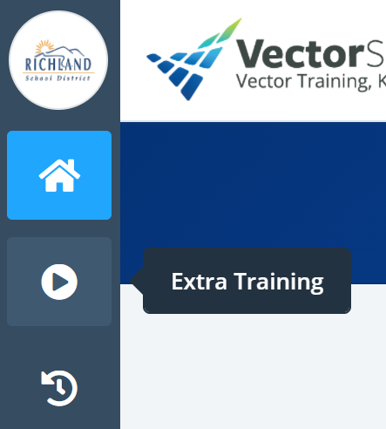
- Navigate to the top left-hand corner of the screen where you will see the icons below. Click on the arrow under the house to access the “Extra Training” courses.

- Select your topic and begin learning. Be sure you check page 2 of the flyer carefully to ensure you are taking the topics and content which are approved. Not all topics and content are approved in each course.

Step 4: Once Course Is Completed:

How do I let you know I am done with a course?
- Once you have completed a course, it is now time to let us know you are done. . For example, I have completed 2.5 hours of ADHD and I do not plan on completing any more of the course work. It is now time to submit that work for clock hours.
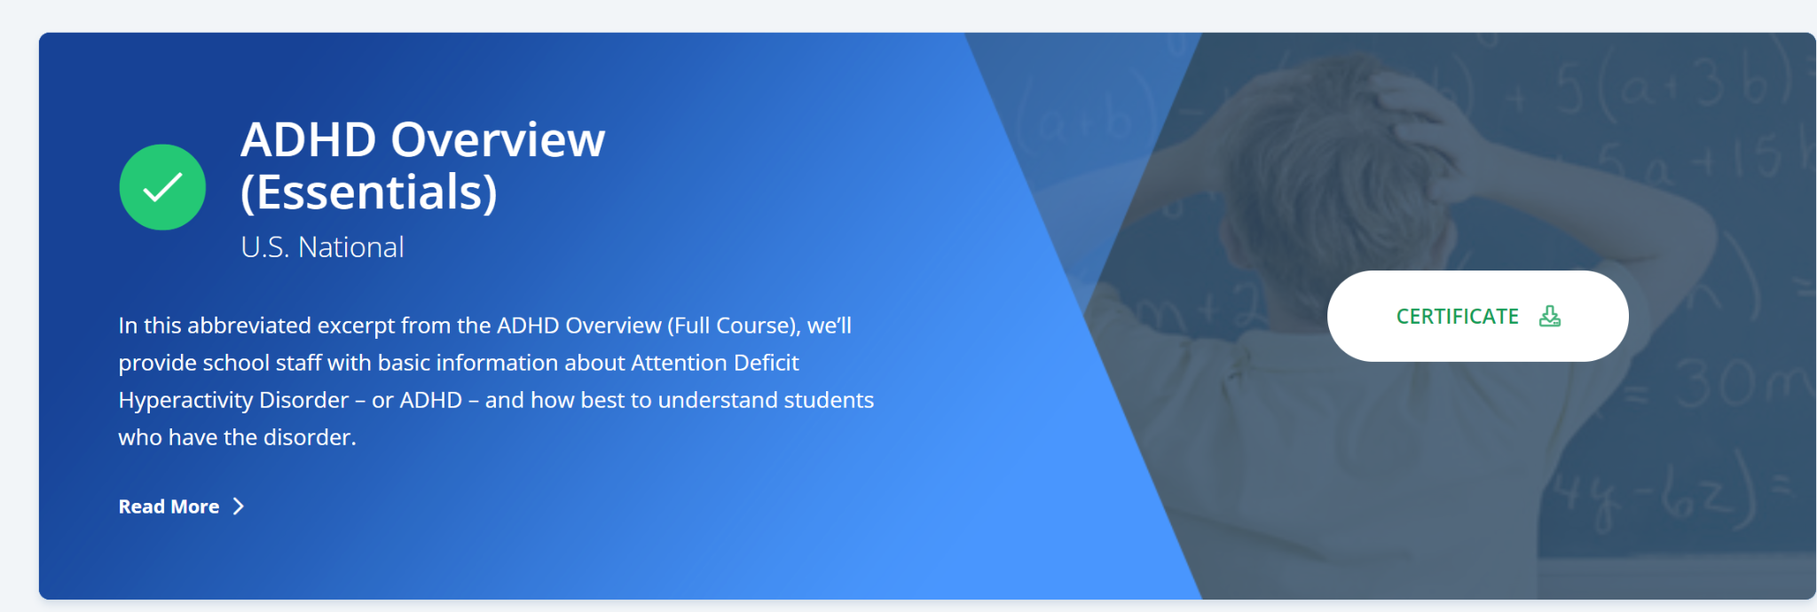
- From the home screen in your Vector Solutions (click the house on the left-hand side of the screen), print out all your certificates for the course. In this example, it would be all the ADHD certificates. The certificates are at the top of the page when you complete the course. The certificate will always be there so if you forget to print it, just go back to the course like you are going to start watching and you will see the screen below.

- From your building copy machine, scan the certificates in one packet to your district email. Your building staff can help you do this. Once you have them in email, forward them to prodev@rsd.edu.
- Next, fill out the google survey to let us know which course you have completed. Go to page 1 of the Para Training Flyer and look for Click Here to complete course.
- You will get an email from prodev@rsd.edu once steps 3 and 4 are complete. Please keep your own coursework records and save the email as evidence of completion of these steps.
- Each time you complete an entire course, you will repeat steps 1-5.

Step 5: Uploading and Reporting Completed Clock Hours to the State
- The state requires you to document your clock hours in your OSPI account. After completing courses please go to page 1 of the Para Training Flyer and look for 4. Input to State Here general paraeducator certificate. Login here:
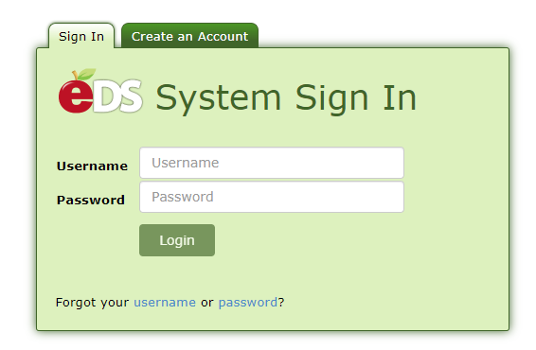
- Under the My Application List click on E-Certification.
- Click on My Credentials at the top of the page.
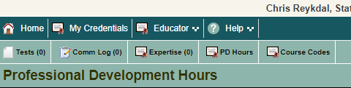
- Next click on PD Hours.

- In the middle of this page click on Click Here to Add Professional Development Hours.
- Fill in the information and save all the documents for your records in case the state audits you and asks for your documentation.

