Port Arthur Independent School District
Student Health Advisory Council (SHAC)

Monday, November 12, 2018
4:00 PM
PAISD Administration Building – Media Room

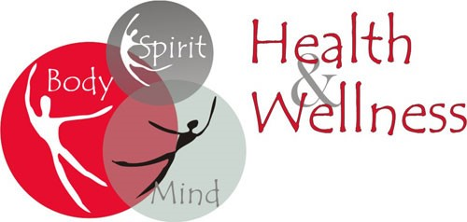
Agenda

- Sign In
- Welcome
- Introductions
- Health & Wellness Initiative - SKYLYNN Mind Body Health
- October – Breast Cancer Awareness; Bullying Prevention
- November – Veterans Day Observance; Diabetes Month
- Community Activities
- Announcements
- Adjournment
Next Meeting: February 18, 2019


