School Protection and Evacuation Plan (SPEP)
WILDFIRES

Facility Name
Street Address
City, State, Zip Code

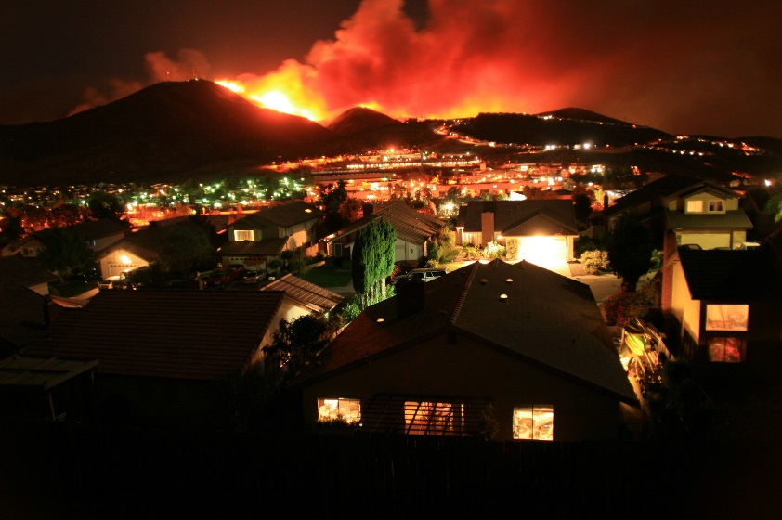

Collaborating Agencies

San Diego County Office of Education | San Diego County Office of Emergency Services San Diego County Sheriff’s Department |CA Dept. of Forest & Fire Protection XXX Local Fire Department |XXX Local Law Enforcement



Last Updated: Aug. 9, 2019
TABLE OF CONTENTS

I. Collaborating Agencies
II. Overview
III. Wildfire Evacuation Decision Support Tree
IV. Emergency Evacuation
V. Voluntary Evacuation/Unplanned Early Dismissal/
Precautionary Closure
VI. Shelter-in-Place
VII. Remaining in Session – Maintaining Situational Awareness

Appendix A. Campus Overview and Maps
Appendix B. School Overview
Appendix C. Transportation Overview
Appendix D. Emergency Preparedness Plan
Appendix E. Emergency Evacuation Plan
Appendix F. Voluntary Evacuation/Unplanned Dismissal/
Precautionary Closure Plan
Appendix G. Shelter-in-Place Procedures
Appendix H. Maintaining Situational Awareness
Appendix I. Emergency Communications Plan
Appendix J. Contact List

OVERVIEW

The purpose of this School Protection and Evacuation Plan (SPEP) is to help school officials and collaborating agencies coordinate preparedness efforts to protect life, property, and critical infrastructure at this site in advance of a wildfire, and to clearly outline procedures and protocols for when evacuation or voluntary dismissal becomes necessary.

This template addresses only the School Protection and Evacuation Plan during a wildfire, and is meant to enhance your existing safety plan.

In preparing this document, school administrators should meet with local fire and law enforcement representatives prior to an emergency to discuss preparedness considerations for your facility. Fire and law enforcement officials can assist in the identification and coordination of evacuation routes and traffic patterns, as well as shelter-in-place procedures and protocols. Fire representatives can also assist in evaluating a facility’s defensible space and fire mitigation efforts.

Administrators should also meet with district officials to coordinate availability of resources, including alternative safe zones, parent/student reunification areas, communication resources, and transportation options if it becomes necessary to evacuate all students and staff.

This document is designed to serve as a template to guide school administrators in creating a locally-focused wildfire preparedness and response plan. Information that should be included in this plan may already exist in your site’s Comprehensive School Safety Plan. Working in coordination with fire and law enforcement representatives and district officials, school administrators can add facility-specific characteristics and details to general emergency-related information, thereby providing each school site with its own unique preparedness and response plan.

Prior to a disaster, school administrators should have emergency preparedness plans in place. Once an emergency occurs, particularly during fast-moving fires or “no-notice” disasters, school administrators may need to decide whether to evacuate or shelter-in-place before receiving official notification from first responders. School administrators should also understand the terminology used by fire and law enforcement personnel in San Diego County and plan for evacuation warnings, evacuation orders, voluntary evacuations/early dismissals and sheltering-in-place.

The following page includes an Evacuation Decision Support Tree to help schools decide whether to evacuate, shelter-in-place or remain in session during a wildfire. The succeeding pages contain additional general information on each option.

This document contains various appendices designed to serve as templates for site-specific emergency preparedness and response protocols, procedures and plans. Each appendix contains guidance on how to personalize the section with information specific and relevant to each facility. It is recommended that school administrators work with local fire and law enforcement representatives and district officials when filling out these sections.

*In the case of an emergency, please refer to the Incident Command System (ICS) section of your Comprehensive School Safety Plan.

WILDFIRE EVACUATION DECISION SUPPORT TREE

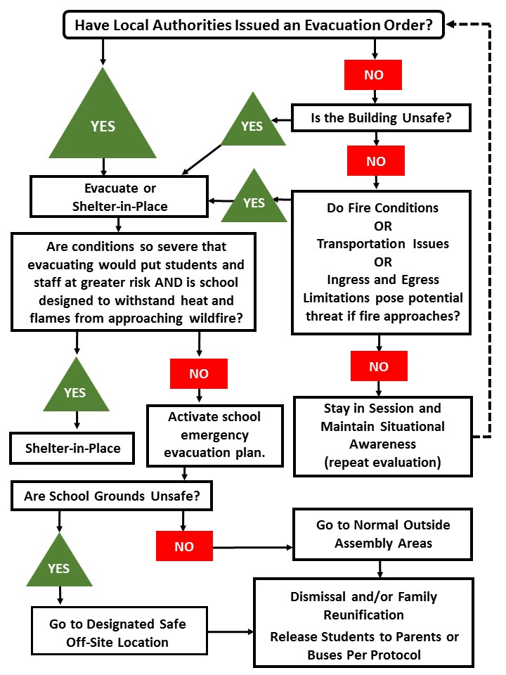

EMERGENCY EVACUATION

In an emergency, local officials may issue either an evacuation warning or an evacuation order.

An evacuation warning is the alerting of people in an affected area of potential threat to life and property. An evacuation warning considers the probability that an area will be affected within a given timeframe and prepares people for a potential evacuation order. Evacuation warnings are particularly necessary when dealing with a variety of issues such as large school populations or people with disabilities and access and functional needs. In a fast-moving fire there may not be time for first responders to issue an evacuation warning (prepare to evacuate).

Evacuation order: Requires immediate movement of people out of an affected area due to an imminent threat to life.

Once an evacuation warning or order has been issued, school administrators should listen to, and comply with, directions provided by law enforcement to maintain a safe and streamlined evacuation process.

If it becomes necessary to conduct an emergency evacuation of the school, please refer to Appendix E: Emergency Evacuation Plan.

Communicating emergency evacuation plans with parents and staff in advance of an emergency is crucial. Please refer to Appendix I: Emergency Communications Plan.

VOLUNTARY EVACUATION/ UNPLANNED DISMISSAL/ PRECAUTIONARY CLOSURES

In evolving situations, local authorities may not issue an evacuation warning or order early in the event, only to do so later when the event poses a greater threat. To best ensure the safety of your staff and students, school administrators should work in conjunction with local fire and law enforcement to evaluate these events relative to your school’s unique characteristics, such as facility age and construction, transportation dependencies, ingress and egress options and capacity, level of defensible space around your structures, and surrounding topography. It may be best for some schools to issue an early dismissal and voluntarily evacuate due to unique characteristics and circumstances.

Occasionally, an unforeseeable event or emergency may require the closing of a school for a period of time. The decision to close schools, or alter opening and closing times is made by the superintendent in consultation with the school principal, National Weather Service, and first responder agencies. Notification of emergency closings should be given as soon as possible so parents and guardians can make arrangements for students to be cared for during these times. The decision to close schools is based on many considerations, the most important of which is the safety of students, staff, parents, and others in the community.

If the decision is made to initiate an early dismissal and voluntarily evacuate the school due to a potential fire threat, please refer to Appendix F: Voluntary Evacuation/Unplanned Early Dismissal/Precautionary Closure (Page XX).

Communicating voluntary evacuation/early dismissal plans with parents and staff is crucial. Please refer to Appendix I: Emergency Communications Plan (Page XX).

SHELTER-IN-PLACE

In some instances, when an evacuation may put students and staff at greater risk, it may be necessary to shelter-in-place. This may be the most appropriate protective action during a fast moving, approaching wildfire, when leaving school grounds poses more of a danger than remaining in place.

Under the best circumstances, sheltering‐in-place should be considered when one or more buildings on campus is designed to withstand heat and flames from an approaching wildfire. In other words, these buildings must be built with ignition‐resistant construction, including well maintained defensible space, such as fire-resistant landscaping, with a minimum 100‐foot defensible space surrounding the structure(s). Local fire authorities can assist in evaluating a facility’s defensible space, ignition-resistant construction, and fire mitigation efforts.

If the decision is made to shelter-in-place, please refer to Appendix G: Shelter-in-Place Procedures (Page XX).

Communicating shelter-in-place plans with parents and staff is crucial. Please refer to Appendix I: Emergency Communications Plan (Page XX).

REMAINING IN SESSION – MAINTAINING SITUATIONAL AWARENESS

If there is a wildfire burning in the general area of your school, but law enforcement has not yet issued an evacuation order, it may be safest to remain in session, maintain situational awareness and make preparations for evacuation if and when local authorities require it. The decision to remain in session will depend on the specific event relative to your school’s unique characteristics, such as facility age and construction, transportation dependencies, ingress and egress options and capacity, level of defensible space around your structures, and surrounding topography.

If the decision is made to remain in session, maintaining situational awareness is crucial. Please refer to Appendix H: Maintaining Situational Awareness (Page XX).

When a wildfire is burning in the area, refer to the Evacuation Decision Tree (Page XX) throughout the day and update decision-making as necessary.

APPENDIX A: CAMPUS OVERVIEW AND MAPS

This section should provide a detailed overview of your specific facility. Work with your local fire, law, and other first responding agencies to create maps specific to your school. Consider the following topics:

Campus layout (Facilities)

- Description of campus
- Location of buildings
- Location of administrative offices
- Location of classrooms
- Parking lots
- Sports fields

Ingress and Egress Routes (Consult: facilities and local law enforcement)

- Primary vehicle routes into and out of campus
- Alternate vehicle routes into and out of campus
- Pedestrian routes onto and off of campus
- Estimated capacity of vehicle routes
- Time required for student pick-up
- Bus and parent zones adjacent to each other
- School building located near the front of the site – frequent traffic congestion
- School site located on high-speed roadway without turn lanes
- Site with driveway located near horizontal curve – inadequate sight distance
- Parents using the bus-only loading zone
- Methods to stage buses at school site
- Placement of traffic cones to create a single-lane queue
- Placement of traffic cones to create a dual-lane queue

Assembly Areas (Consult: facilities and local law enforcement)

- On-Campus Primary Assembly Areas
- On-Campus Secondary Assembly Areas
- Alternate Off-campus assembly points

APPENDIX B: SCHOOL OVERVIEW

This section should provide a detailed overview of the fire resistance and defensibility of your specific facility. Work with your local fire, law, and other first responding agencies to create an overview of your school.

Fire Defensibility (Consult: district officials, facilities, local fire department)

- Year of construction
- Building materials
- Sprinkler systems
- Defensible space
- Temporary classrooms, such as portables
- Topography

APPENDIX C: TRANSPORTATION OVERVIEW

This section should provide a detailed overview of the transportation needs for your specific facility. Work with your local fire, law, and other first responding agencies to create an overview specific to your school.

Transportation Overview (Consult: district office)

Some topics to consider:

- If evacuation becomes necessary, what transportation resources are necessary to evacuate students and staff members?

- How many buses are available during normal operations?

- How many buses can be accessed to supplement the current number in case of an emergency?

- Who provides these buses, what is the process for making the request, how long before buses will be available, and what plans or agreements need to be in place? Will increased traffic due to a disaster in your area prevent or delay the arrival of additional transportation resources?

- Will other schools with transportation agreements request the same resources?

- Will traffic issues and congestion cause problems?

APPENDIX D: EMERGENCY PREPAREDNESS PLAN

This section should help assist you in putting together an Emergency Preparedness Plan for your facility. This plan will outline steps you can take before an emergency occurs to enhance the safety of your students and staff. Preparedness planning should include working with local law and fire representatives to discuss evacuation procedures, traffic patterns and concerns, and defensible space efforts.

Schools also should communicate regularly with parents about what they should know before an emergency and what they should do in the event a disaster impacts the school.

Work with your local fire, law, and other first responding agencies to finalize a preparedness plan for your school – including plans to regularly communicate with parents regarding recommended actions and what they can expect from school administrators during disasters.

Emergency Preparedness Plan (Consult: district officials, local fire department, local law enforcement)

Preparedness is achieved and maintained through a continuous cycle of planning, organizing, training, equipping, exercising, evaluating, and taking corrective action. Ongoing preparedness efforts require coordination among all those involved in emergency management and incident response activities. Your school should foster preparedness at all levels including students, parents, teachers, staff, district officials and local law and fire representatives. Examples of preparedness actions include maintaining a plan, conducting training and planning, and implementing drills and exercises.

Preparedness efforts also include mitigation activities, such as those intended to reduce the loss of life and property from natural and/or human-caused disasters by avoiding or lessening the impact of a disaster and providing value to the public by creating safer schools.

Emergency Preparedness Plan for Parents (Consult: district officials, staff and parents)

Recommended actions for parents in advance of a disaster may include:

- Review the family emergency plan with your child, including reunification and communication options.

- Provide the school with information about any unique needs your children may have. This can be accomplished by filling out an emergency information form and working with school health staff to be sure there is an emergency plan on file for your child that includes information on health issues and what is needed during school emergencies.

- Arrange for the school to have back up/extra medication or other items to address the unique needs of your child so they have what they need if there is an emergency where they need to remain in the school building for a longer period of time.

- Provide the school and your child's teacher with up-to-date emergency contact information for family or friends who can help out if you are unavailable. Be sure to update this information as needed throughout the school year.

- Learn about the school's plan for emergency response, including parental access during emergencies, school emergency contact information, meet-up locations, and other reunification plans.

In a school emergency, the first instinct for a parent is to call or rush to the school to pick-up his/her child/children. These actions can complicate matters from a safety and security standpoint.

Parents too close to an incident often hinder the response and rescue attempts of police and fire officials on the scene. The best action parents can take in an emergency is to stay close to phone and e-mail and to monitor local radio and TV reports for regular updates and instructions.

What parents SHOULD do:

- Tune into local TV/Radio stations for official school news alerts. Instruct parents where they can find up-to-date information from the school and/or district.
- Rely only on official communication from the school or public safety officials.
- Listen for official information regarding reunification.

What parents SHOULD NOT do:

- Call or rush to the school. Excessive traffic may interfere with emergency responders’ ability to curtail the disaster or render life-saving aid to those in need.

APPENDIX E: EMERGENCY EVACUATION PLAN

This section should provide a detailed overview of procedures to follow when an emergency evacuation becomes necessary. Work with your local fire, law, and other first responding agencies to create a plan specific to your school.

Emergency Evacuation (District Officials and Local Law Enforcement)

- Outline emergency evacuation/early dismissal procedures for when time or events do not allow for normal dismissal operations.

Alternate Assembly Areas (Facilities, District Officials and Local Law Enforcement)

- If the campus is unsafe, where are the alternate off-site assembly locations and how do you transport students and staff?

Parent Pick Up Zones/Reunification Zones (District Officials and Local Law Enforcement)

- Identify in advance your reunification site(s).
- What is the process for notifying parents of an unexpected early dismissal?
- If the normal pick up locations are not available, how is the location of the alternate site communicated to parents?
- What is the process of reunification and release of students to parents and/or guardians in an emergency, and how is this process communicated to parents and/or guardians?

APPENDIX F: VOLUNTARY EVACUATION/UNPLANNED DISMISSAL/
PRECAUTIONARY CLOSURE PLAN

During fast moving fires or “no-notice” events, it may be necessary for school administrators to initiate an evacuation without a direct order from first responders. School administrators should consider, in advance, the circumstances that may necessitate a voluntary evacuation or unplanned early dismissal. This section is intended to provide a detailed overview of procedures to follow when it becomes necessary to initiate a voluntary evacuation/early dismissal. Work with your local fire, law, and other first responding agencies to create a plan specific to your school.

Outline voluntary evacuation/unplanned early dismissal/precautionary closure procedures here.

APPENDIX G: SHELTER-IN-PLACE PROCEDURES

This section should provide a detailed overview of procedures to follow when it becomes necessary to shelter-in-place. If you are unable to safely evacuate from the area, or if evacuating puts your students and staff at greater risk, a fire-resistant building is the safest place to seek shelter to wait out the fire. The following are some things you can do to shelter‐in‐place. Work with your local fire department to finalize a plan for your school.

Shelter-in-Place Procedures (Local Fire Department)

- Stay indoors and wait for the wildfire‐front to pass.
- Call 9-1-1 to let them know you are sheltering‐in‐place.
- Advise parents not to attempt to pick up children from school.
- Notify school district office.
- If landlines go down, try using a cellular phone as an alternative.
- Since the electricity may go out, have a battery or solar‐powered radio, with extra batteries.
- Listen for fire updates.
- Have trained staff members protect students and institute proper emergency procedures on site.
- If time and conditions permit, move anything that can catch fire away from the exterior of classrooms, including combustible furniture, cloth awnings, and trash cans. Re‐locate these items to the furthest point outside, away from buildings.
- Turn off all fans and air conditioning/heating units.
- Close all interior and exterior doors and windows to prevent embers from entering your building. Draw draperies and window coverings wide open, well past the perimeter of the window. This will prevent radiant heat from catching the window coverings on fire.
- Do not cover the inside of windows with foil or any other materials.
- Move interior furniture away from windows to prevent radiant heat from catching the furniture on fire.

APPENDIX H: MAINTAINING SITUATIONAL AWARENESS

This section has information to help you stay informed during a wildfire event (and other emergencies). The following are some local information resources. Work with your local fire, law and other first responding agencies to create a full list of resources specific to your school.

Maintaining Situational Awareness (Consult: district officials, local fire department, local law enforcement)

SDCountyEmergency.com
- During a disaster, this website will be promoted by the County of San Diego to the media/public as the official disaster information website.
- The site will include:
  - Emergency maps, evacuation areas, disaster perimeter, shelter locations, Local Assistance Center locations, road closures, Press Releases, and other pertinent disaster-related information.

ReadySanDiego.org
- Before a disaster strikes, this website provides preparedness information, resources and tools.

SDCountyRecovery.com
- Following a disaster, this website provides recovery information, resources and tools.

SD Emergency Mobile Application
- Provides push notifications (disaster updates) to your mobile device.
- Offers quick access to preparedness, emergency and recovery information found on the County’s Emergency Portal (ReadySanDiego.org, SDCountyEmergency.com and SDCountyRecovery.com) in the palm of your hand.
- Available at no cost in English and Spanish on the App Store (iOS) and Google Play Store (Android).

2-1-1 San Diego
- Provides a 24/7 toll-free hotline connected to a highly trained team providing up-to-date information during an emergency.
- Vital information about conditions and services such as road closures, evacuation routes, shelters and more.
- If Life/Safety, call 9-1-1.

Social Media
- Twitter
  - www.twitter.com/readysandiego (@readysandiego) (English)
  - www.twitter.com/listosandiego (@listosandiego) (Spanish)

- Facebook
  - www.Facebook.com/ReadySanDiego

AlertSanDiego
- The regional mass notification system used by law enforcement, fire and emergency response personnel to send evacuation orders/warnings, protective actions, and disaster-related information to residents and businesses within San Diego County that are impacted by, or in danger of being impacted by, an emergency or disaster.
- Listed and unlisted landlines are already included in the database and do not need to be registered. Cell phone numbers and email addresses are not and must be registered.
- Register your cell phone number and email at www.readysandiego.org/alertsandiego/

Accessible AlertSanDiego
- Part of the AlertSanDiego system that provides messaging for residents of San Diego County who are deaf, blind, hard of hearing, and deaf/blind before, during, and after a disaster.
- Residents can register for Accesible AlertSanDiego notifications by selecting the Accessible Option during registration at www.readysandiego.org/alertsandiego/

Wireless Emergency Alerts (WEA)
- Emergency notifications from local, state or federal officials that are broadcast to cell phones in a targeted area using cell phone towers. Most updated cell phones are WEA-capable and will receive the message. No registration is needed.
- Alerts residents about the emergency with important, but limited information:
  - Emergency location
  - What actions residents should take
  - How they can find out more information.

Emergency Alert System (EAS)
- A national public warning system.
- Broadcasters, satellite digital audio service and direct broadcast satellite providers, cable television systems, and wireless cable systems are required to provide a communications capability to address San Diegans within 10 minutes during an emergency.
- The primary Emergency Alert System station for San Diego County is radio station KOGO AM 600. The secondary station is KLSD AM 1360.

APPENDIX I: EMERGENCY COMMUNICATIONS PLAN

This section should provide a detailed overview of procedures to follow when it becomes necessary to communicate with staff, parents, district officials, and others during an emergency. The following are some suggested steps you can include in an emergency communications plan. Work with your local fire, law, and other first responding agencies to create a plan specific to your school.

Some topics to consider:
- How do you communicate emergency/early dismissal/shelter-in-place information to staff, school administrators, local authorities and parents/guardians?

- If the normal pick up locations are not available, how is the location of the alternate site communicated to parents?

- What is the process for reunification and release of students to parents/guardians in an emergency, and how is this process communicated to parents/guardians?

Emergency Communications Plan for Evacuations, Voluntary Evacuations and Sheltering-in-Place (Consult: district officials, local law enforcement, SDCOE communications, staff and parents)

SAMPLE/SUGGESTED STEPS
- Designate a spokesperson. In most cases the spokesperson should be the person possessing the most direct knowledge of the crisis (for example: the school principal in the event of a school incident or a school district Public Information Officer).
- Notify key constituencies. Among the groups that should be considered for communication in a crisis situation are:
- District office and County Office of Education
  - Law enforcement agencies
  - Administration, faculty and staff
  - Students
  - Parents/guardians of students
  - Local community
  - Local and national media
- Assemble a Crisis Communications Team to communicate the facts during the event.
- Establish a Crisis Command Center.
- Request assistance from your district’s Public Information Officer/Communications Department or contact the SDCOE Public Information Officer/Communications Department to work with media.
- Utilize established avenues to communicate with internal stakeholders.
- Discuss alternative communications. Discuss alternative or additional means of conveying information to parents/guardians of students if your primary method is not operational.
- Establish means for handling incoming calls. The main office in an affected school should expect a significant increase in calls. Determine if additional staffing is required to handle incoming calls. Create a message to parents in advance that notifies them what to do if the school cannot respond to phone calls. This message can either be recorded on the school’s voice message system or sent to parents directly using the school’s mass notification system.
- Assess the situation to determine if outside help is needed.

APPENDIX J: CONTACT LIST

This section should provide a detailed list of critical contacts that may be needed in the event of an emergency. Work with your local fire, law, and other first responding agencies to create a complete list for your school.

List of important contacts if electronic records are unavailable. (Consult: staff, parents, district officials, local fire department, and local law enforcement).

- School Staff
- Parents/Guardians and Emergency Contacts
- Local Fire Department
- Local Law Enforcement
- District Offices
- Facilities
- Transportation Resources
- PIO

