Changing the year within the YTD Budget Report
Run a report using either “Seg Find” or the “Query Wizard” then select “Report Options”:
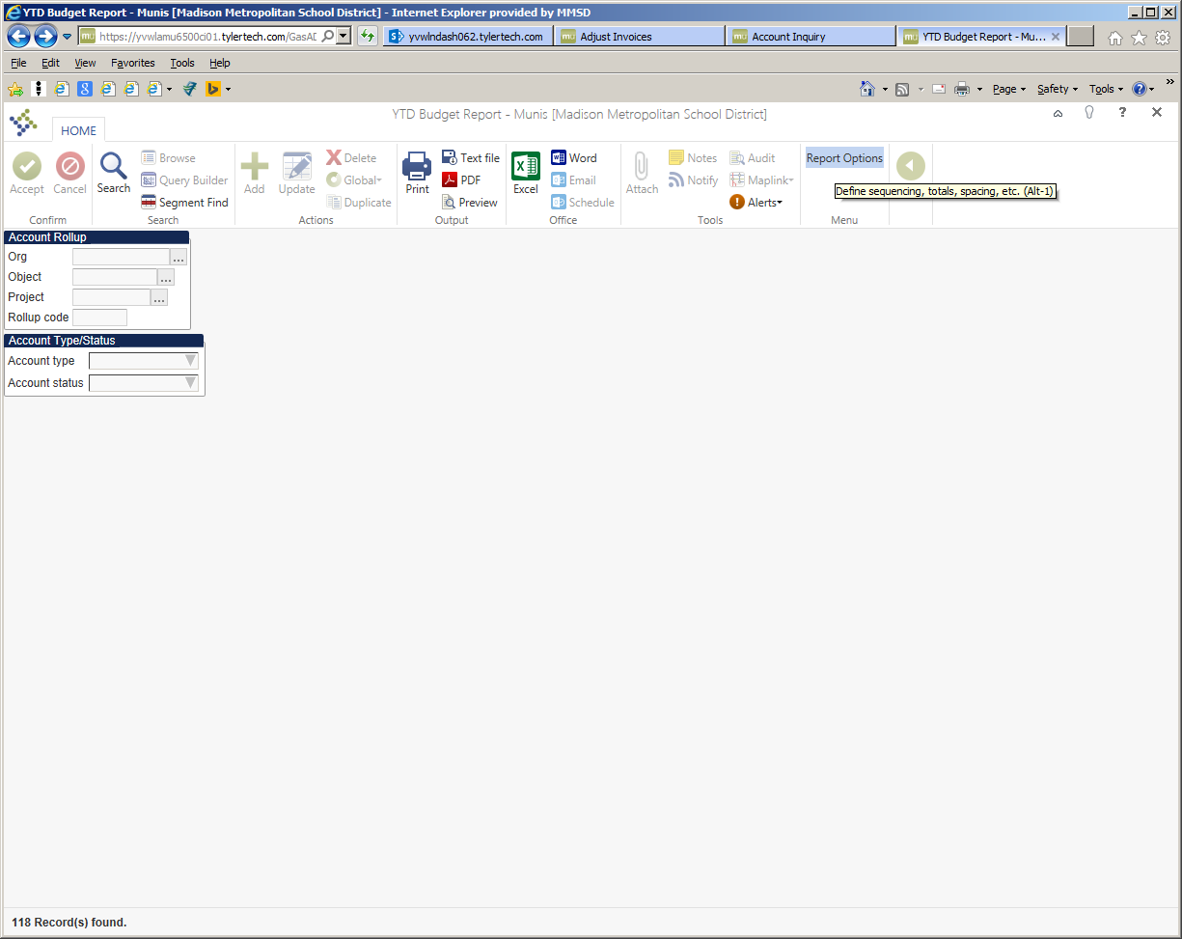
“Report Options”
Change the year to 2016:
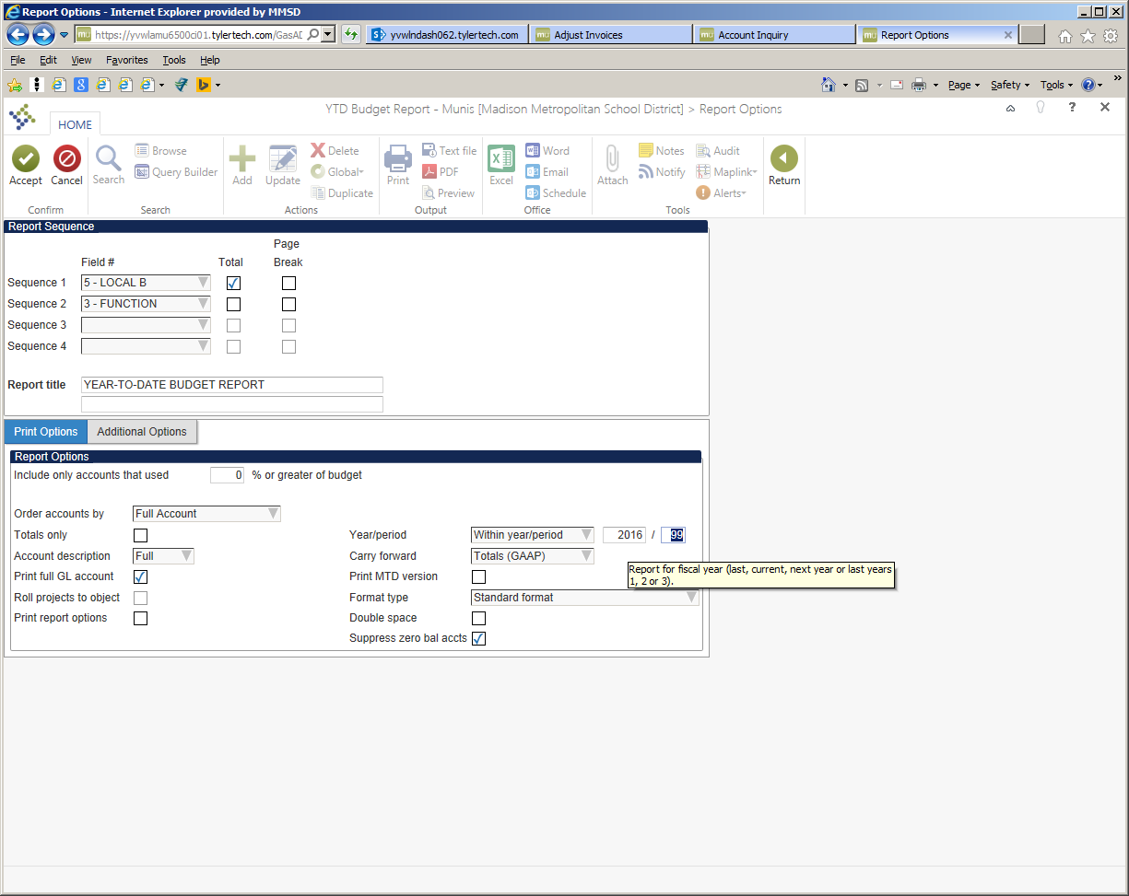
Enter the year below:
Click “Accept” then “Return”

