SENDING KIDS HOME WHEN THEY HAVE LICE ISN’T HELPFUL  - If live lice are easy to see, the child probably has been infested for weeks, and a few more hours at school is unlikely to expose anyone new.  - However, the child’s guardian should be notified, and the child should be treated before returning to school.  WHY NO-NIT POLICIES ARE NOT HELPFUL  - Nits don’t spread; only live lice do.  - Many children who have nits will not develop live lice.  - It is extremely difficult to remove all nits, and in schools with no-nit policies, some children end up missing weeks of school for no good reason.  YOUR CHILD’S CLASSROOM IS NOT CRAWLING WITH LICE  - As noted, lice do not live for more than 24-48 hours off the scalp.  - In a classroom where 20% of kids (1/5) were infested with lice, NO lice were found on desks or carpeting.  WHY REGULAR “LICE CHECKS” AT SCHOOL ARE NOT PRACTICAL  - This is extremely time-consuming for the nurse, who has many other obligations.  - It can be invasive and uncomfortable for the child.  - It might be helpful in a classroom where there are several affected students.  WHY YOU SHOULD TELL YOUR FRIENDS IF YOUR CHILD HAS LICE  - Lice are more likely to spread at home, and especially at sleepover parties, than at school. Let other parents know about possible exposure so they can check their child. |  | Albemarle County Public Schools  401 McIntire Road, Charlottesville, VA 22902  434-296-5820  www.k12albemarle.org
  This information and guidelines followed by Albemarle County Public Schools are consistent with guidelines from the Centers for Disease Control and Prevention (CDC), the American Academy of Pediatrics (AAP), and the American Association of School Nurses. For further information, see:
  CDC: Head Lice Information for Schools
  http://1.usa.gov/1Nc54Hm
  IdentifyUS: Head Lice
  http://bit.ly/1bqLyuR
  HealthyChildren.org: Head Lice Symptoms
  http://bit.ly/1GeCsgA
  AAP: Head Lice Clinical Report
  http://bit.ly/18Vf1vD
  ACPS School Health Services: Lice FAQs
  http://bit.ly/1BL02e9
  Dale Pearlman, MD: Nontoxic Head Lice Treatment
  www.nuvoforheadlice.com
  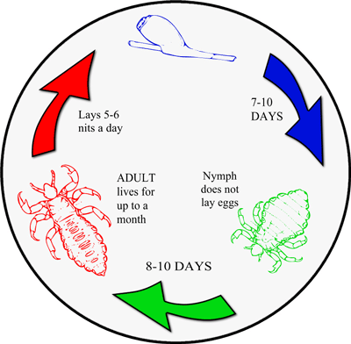
  Lifecycle of Lice
  
  Head Lice
  Fact Sheet

EVERYONE HATES HEAD LICE!  - However, they do not cause or spread any disease.  - They are not a sign of poor hygiene.  - They survive by feeding on blood from the scalp. (Ew!)  HOW LICE SPREAD  - They cannot fly or jump; they only crawl.  - They normally spread by direct head-to-head contact.  - An adult louse needs to feed daily; it will not survive on clothing, furniture or objects for more than 24-48hrs.  - A nymph (young louse) must feed every hour or two.  - Nits (eggs) are very firmly attached to hair and do not spread. They will die if they are not at body temperature (i.e., on the scalp).  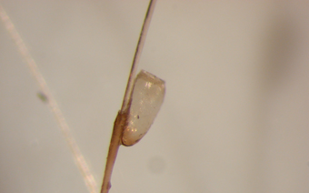  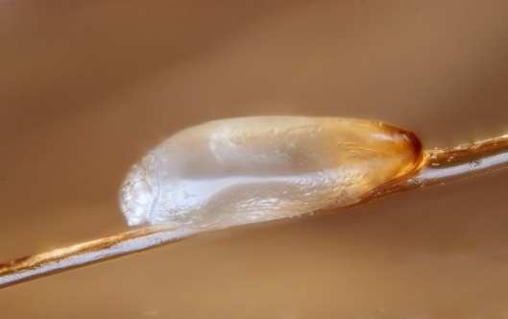  - It is unusual for lice to spread on objects, but it is smart to avoid sharing combs/barrettes/ towels, etc.  Empty Egg Shell or Nit  Lice Egg Attached to Hair Shaft |  | HOW TO KNOW IF YOUR CHILD IS INFESTED  - Your child is infested if you see live lice. However, lice are tiny and fast, so they are hard to find. A good way to detect lice is to saturate the child’s hair with conditioner (which will slow down the lice) and comb through the hair multiple times with a fine tooth comb. Wipe the comb onto a white tissue or towel to find lice.  - If you only see nits (eggs), the child may not be infested. Nits that are more than ¼ to ½ inch from the scalp are likely dead or already hatched. You need to find live lice to confirm a true infestation.  - Many things can be mistaken for nits or lice, including other insects, bits of dirt or grass, and dandruff. Nits are firmly attached to the hair and cannot be “flicked” off the way dandruff or dirt can. (Refer to images at left.)  - If you are unsure, ask your child’s school nurse or doctor for advice.  HOW TO GET RID OF LICE  - Only treat a child if you are sure he/she is infested.  - There is a nontoxic method that uses Cetaphil Gentle Skin Cleanser to smother and dry out the lice. The treatment method needs to be followed exactly and is done three times at weekly intervals. It is described in detail at www.nuvoforheadlice.com.  - There are over-the-counter treatments, like Nix and Rid that are toxic to the louse and nit nervous system. There also are prescription medications. All of these need to be used carefully and as directed, and most need to be repeated in a week to kill any newly hatched lice.  - Some people have had success smothering lice and nits with olive oil or full-fat mayonnaise, but it is difficult to do this effectively. |  | - You should check everyone in your house and treat anyone who has live lice. It is probably a good idea to check everyone at least once or twice a week to catch infestations early, if you know they’ve been exposed.  - Change your child’s clothing and bedding. You can put these in the dryer on high heat for 10 minutes to kill lice, OR put things you can’t launder in a bag for a week. Lice can’t survive off the head for more than two days.  - You might want to vacuum sofas and chairs, but DO NOT use insecticide sprays in the house. These are unnecessary and can be toxic.  HOW TO GET RID OF NITS  - YOU DO NOT HAVE TO DO THIS. As noted above, nits that are not close to the scalp are probably dead or already hatched. However, getting rid of viable (live) nits will prevent them from hatching, and some people like to do this instead of or in addition to repeated treatments. You will need a special nit comb, a bright light, something to distract your child, and lots of patience to do this.  Various Life Stages of Lice  