Anaphylaxis Standing Order Quick Reference
Determine Anaphylaxis May be Occurring
Act quickly!! Anaphylaxis is life-threatening!!!!!

Locate EPI-PEN prescribed for student
Recognizing Signs a Possible Allergic Reaction:
- Lungs – Difficulty breathing, wheezing, repetitive cough
- Skin - Many hives, redness, flushing
- Mouth – tingling or swelling of throat, lips, tongue, tightness or change of voice, trouble swallowing
- Other: feelings of apprehension, agitation, repetitive vomiting
*** Symptoms may involve more than one body system and may be progressive ***

ADMINISTER Generic Epinephrine Auto-injector
Step 1: Prepare auto-injector for injecton Step 2: Administer injection
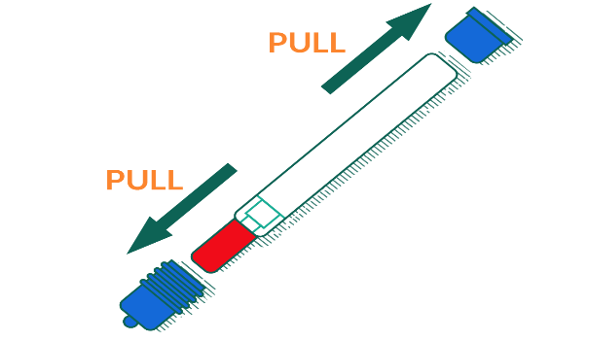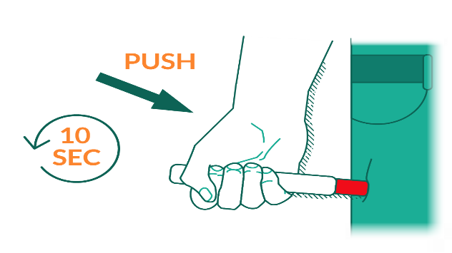
Step 3: GET EMERGENCY HELP!
Call 9-1-1 and state that it is an anaphylaxis emergency!

Step 4: Cover exposed needle (see instructions below)

Lay the labeled half of the carrying case cover down on a flat surface. Use one hand to carefully slide the end of the auto-injector, needle first, into the labeled carrying case. After the needle is inside the labeled cover, push the unlabeled half of the carrying case cover firmly over the non-needle end of the auto-injector.
- Provide care: have student lie down and elevate legs
- Monitor closely
- May give second dose in 5 to 15 minutes if no improvement or if symptoms return
- Give used covered injector(s) to EMS personnel
- Ensure parents have been notified

