How to change your direct deposit through Skyward Employee Access

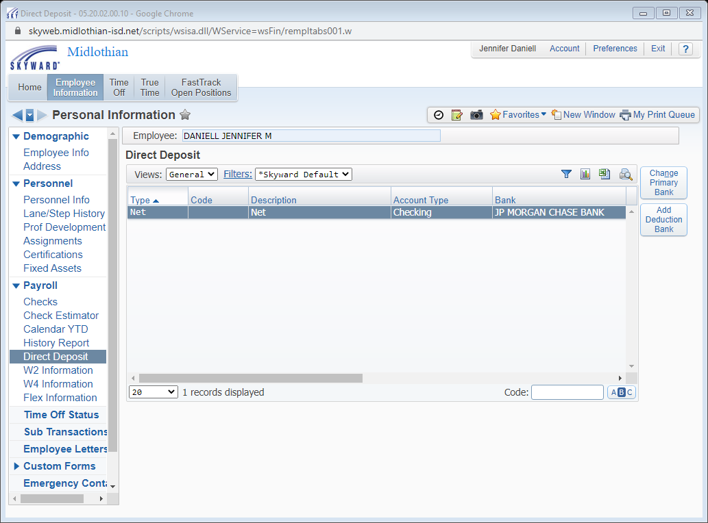

Employee Information
Payroll
Direct Deposit
See boxes on the left side of the screen to make the changes you need

