
Alameda Community Learning Center - Governing Board Meeting Agenda

May 18th, 2021 from 6:30PM - 8:30PM

This meeting will be held via public Zoom:
https://tinyurl.com/ACLCBoard
Meeting ID: 848 4086 4940
Passcode: gohawks

- Public Session (ACLC) 6:30 PM

- Call to Order & Attendance
Meeting is called to order at ____6:36pm__________

Board Members Present Absent

Michael McCaffrey, ACLC Lead Facilitator ___X___ ______
Robert Clark, ACLC Facilitator ___X___ ______
Daniel Cabrales, ACLC Facilitator ___X___ ______
Kimberly Skuta, ACLC Parent Member ___X___ ______
Ann-Marie Gamble, ACLC Parent Member ___X___ ______
Kaia Foster, ACLC Learner ___X___ ______
Annie Liu, ACLC Learner ___X___ ______
Jim Kaufman, Community Member ___X___ ______
Lisa Gleason, Community Member ______ ___X___

- Review and Approval of Agenda 6:35 PM
Approval: Kaia
Second: Daniel

Michael McCaffrey, ACLC Lead Facilitator ___aye___
Robert Clark, ACLC Facilitator ___aye___
Daniel Cabrales, ACLC Facilitator ___aye___
Ann-Marie Gamble, ACLC Parent Member ___aye___
Kaia Foster, ACLC Learner ___aye___
Annie Liu, ACLC Learner ___aye___
Jim Kaufman, Community Member ___aye___

- Presentations from the floor 6:40 PM
PRESENTATIONS FROM THE FLOOR - At this time any person wishing to speak to any item not on the agenda will be granted three minutes to make a presentation to the Board of Directors.

- Annie Liu announced a group that she belongs to called IWAY which stands for Improving the Wellness of Asian Youth. This group focuses on promoting mental health for Asian youth.

https://drive.google.com/file/d/1O-Khk7arT7huvBldd-53m8NOiZdiFfnr/view?usp=sharing

https://drive.google.com/file/d/1RzZRChWLvudvrUf5qGOKNpDyPPDkOhLT/view?usp=sharing

- Annie Liu: New learner invitational event with breakout rooms that have parents supporting the breakout sessions to answer questions and provide information

PRESENTATION ON AGENDA ITEMS – Any person wishing to speak to any item on the agenda will be granted three minutes to make a presentation just prior to the discussion of the agenda item.

None

- Consent Agenda: 6:45 PM
  - Approve check register for April 2021
Approval: Robert
Second: Ann-Marie

Michael McCaffrey, ACLC Lead Facilitator ___aye___
Robert Clark, ACLC Facilitator ___aye___
Daniel Cabrales, ACLC Facilitator ___aye___
Kimberly Skuta, ACLC Parent Member ___abstain__
Ann-Marie Gamble, ACLC Parent Member ___aye___
Kaia Foster, ACLC Learner ___aye___
Annie Liu, ACLC Learner ___aye___
Jim Kaufman, Community Member ___aye___

  - Approve meeting minutes for April 2021

Approval: Kimberly
Second: Kaia

Michael McCaffrey, ACLC Lead Facilitator ___aye___
Robert Clark, ACLC Facilitator ___aye___
Daniel Cabrales, ACLC Facilitator ___aye___
Kimberly Skuta, ACLC Parent Member ___aye___
Ann-Marie Gamble, ACLC Parent Member ___aye___
Kaia Foster, ACLC Learner ___aye___
Annie Liu, ACLC Learner ___aye___
Jim Kaufman, Community Member ___aye___

- Committee Reports 6:55 PM
  - Curriculum (Daniel Freedman)
See website

- Discussion Items 7:05 PM
  - Resolution in Support of Full-Day, In-person Instruction Beginning Fall 2021-22 (lead by Annalisa Moore)
Presentation on resolution to open the 2021-2022 school year with five days a week in-person instruction with full school days.

  - ACLC LCAP & LCP Narrative Final Drafts (lead by Michael McCaffrey)
See website

  - CLCS Equity Statement (lead by Annalisa Moore)
CLCS Board JEDI Committee that includes Annalisa Moore, Jim Kaufman, Daniel Cabrales, Karen Rojas, Nadia Bueno, Charlotte Pickett, Heather Dutton

Committee designed an equity statement for CLCS to be discussed during the CLCS Board meeting and then brought to additional stakeholders. I am here to gather any feedback members on this board may have.

  - CLCS Equity Policy (lead by Annalisa Moore)
CLCS Board JEDI Committee that includes Annalisa Moore, Jim Kaufman, Daniel Cabrales, Karen Rojas, Nadia Bueno, Charlotte Pickett, Heather Dutton

Committee designed an equity statement for CLCS to be discussed during the CLCS Board meeting and then brought to additional stakeholders. I am hear to gather any feedback members on this board may have.

  - Enrollment Update (lead by Michael McCaffrey)
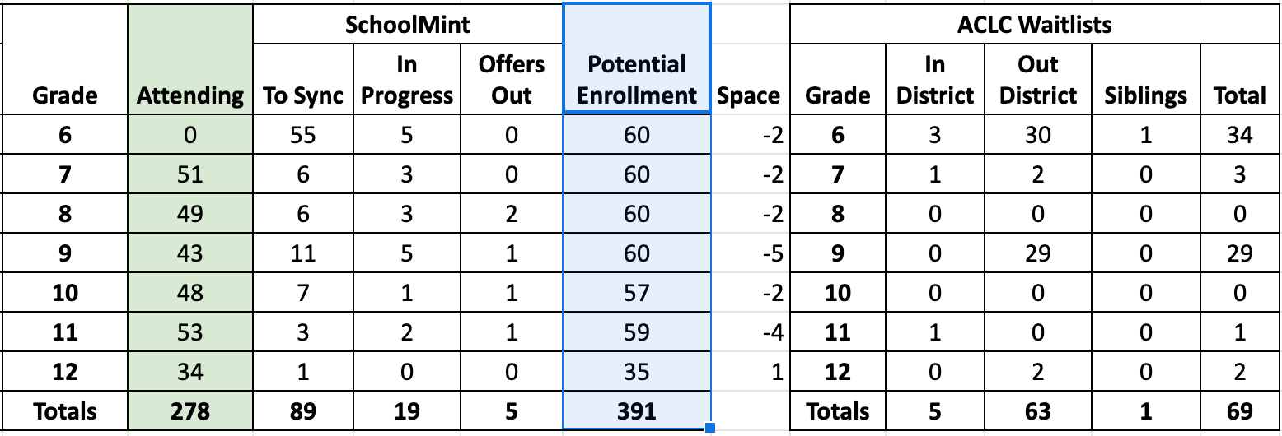
  - Graduation Update (lead by Michael McCaffrey

- Learners who are in danger of not graduating have a plan for completion through Amanda and on track to get a diploma by the end of summer.

  - Learner Survey Data (lead by Michael McCaffrey)
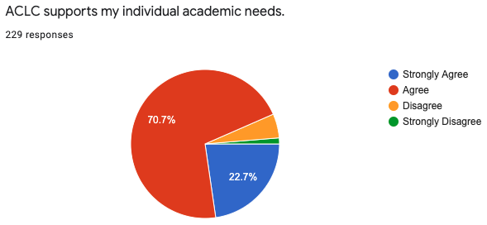
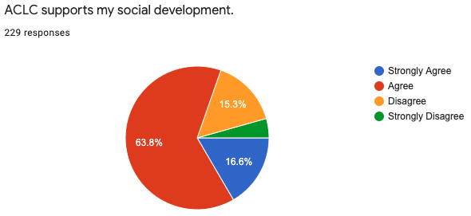
- Adjourn to Closed Session 7:45 PM
  - With respect to every item of business in closed session pursuant to Section 54956.8: 9 cases
    - Case #8174256028, Case #4174256340
    - Case #9177876371, Case #4174258860, Case #5174254192
    - Case #3176905487, Case #8178757108, Case #7171210866, Case #3174255887

- Reconvene Public Session 8:10 PM
Announcement of action(s) taken in closed session and the vote of every member regarding these actions.

i. Case #8174256028, Case #4174256340
Robert motion to approve
Jim second
board voted unanimously to approved 6:0

ii. Case #9177876371, Case #4174258860, Case #5174254192 board voted unanimously to approved
Kimberly motion to approve
Ann-Marie second
board voted unanimously to approved 6:0

iii. Case #3176905487, Case #8178757108, Case #7171210866, Case #3174255887 board voted unanimously to approved
Kimberly motion
Rob second
board voted unanimously to approved 6:0

- Future Items of Discussion 8:15 PM
- Data comparison on learners passing/not passing classes (D/F)
- Discussion on what was learned that can be carried forward
- Transition plan welcoming learners back in the Fall

- Adjournment 8:20 PM
Adjourn at 8:08PM

THE ORDER OF BUSINESS MAY BE CHANGED WITHOUT NOTICE
Notice is hereby given that the order of consideration of matters on this agenda may be changed without prior notice.

REASONABLE LIMITATIONS MAY BE PLACED ON PUBLIC TESTIMONY
The Board of Directors’ presiding officer reserves the right to impose reasonable time limits on public testimony to ensure that the agenda is completed.

SPECIAL PRESENTATIONS MAY BE MADE
Notice is hereby given that consistent with the requirements of the Bagley Open Meeting Act, special presentations not mentioned in the agenda may be made at this meeting. However, any such presentation will be for information only.

REASONABLE ACCOMMODATION WILL BE PROVIDED FOR ANY INDIVIDUAL WITH A DISABILITY
Pursuant to the Rehabilitation Act of 1973 and the Americans with Disabilities Act of 1990, any individual with a disability who requires reasonable accommodation to attend or participate in this meeting of the Board of Directors may request assistance by contacting Community Learning Center School, Inc., 1900 Third Street, Alameda, CA 94501, phone 510-995-4300, fax 510-995-4307.

FOR MORE INFORMATION
For more information concerning this agenda or for materials pertaining to the board meeting, please contact Community Learning Center Schools, Inc.,1900 Third Street, Alameda, CA 94501, phone (510) 263-9957, during school hours

