WILDE’S WEEKLY WISDOM – BUMPER EDITION

We currently have 6 puzzle types with videos. These are:

Sudoku | https://clickv.ie/w/aeNm
Kakuro | https://clickv.ie/w/1-Sm
Nonogram | https://clickv.ie/w/Qxan
KenKen | https://clickv.ie/w/Uz4n
Futoshiki | https://clickv.ie/w/iE_o
Shikaku | https://clickv.ie/w/Dnep

Sudoku 204
 |  | 1 |  | 7 | 2
 |  | 3 |  |  |  | 5 | 4
 |  |  |  |  |  |  | 6
 | 6 |  |  | 4
 |  | 9 |  |  |  |  |  | 8
 |  |  |  |  |  |  |  | 7
 |  |  |  |  | 1 |  | 2
 | 4
 |  |  |  |  | 9 |  |  | 3

Kakuro
https://www.kakuros.com/?s=20x20 (more puzzles and answers)
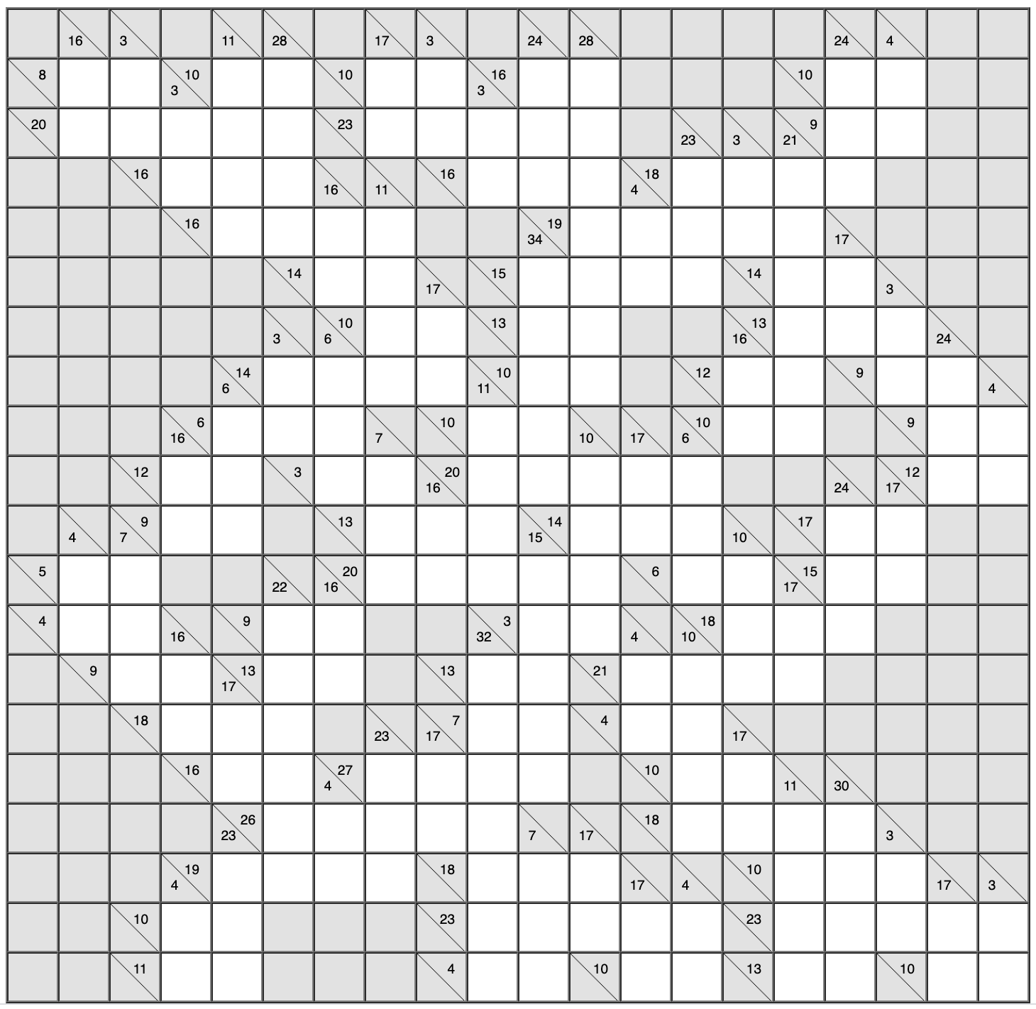

Nonogram
https://www.puzzle-nonograms.com/?size=3 (more puzzles and answers)
https://www.nonograms.org/nonograms/i/40509 (more puzzles and answers)
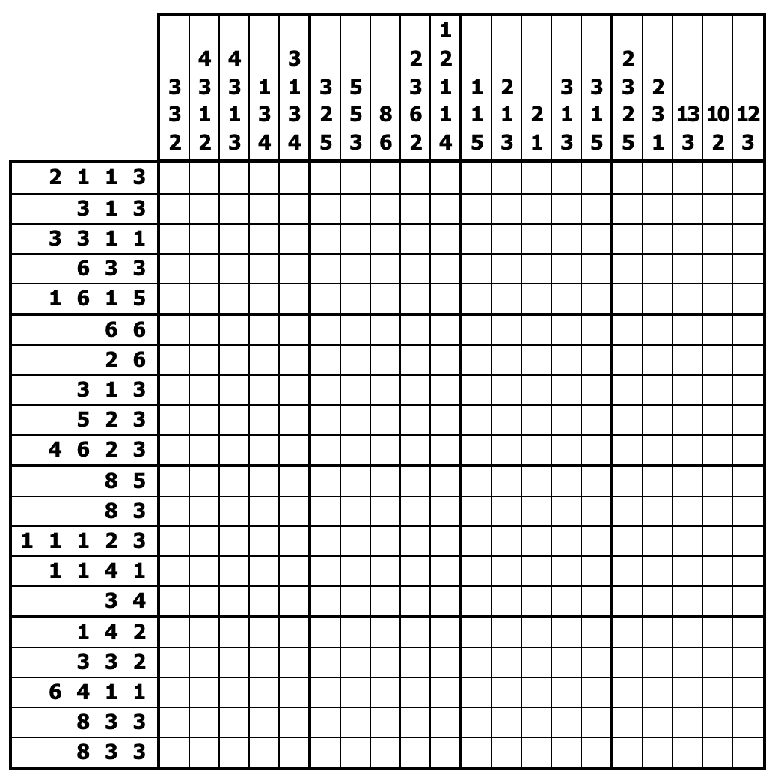

KenKen
http://www.kenkenpuzzle.com/game (more puzzles and answers)
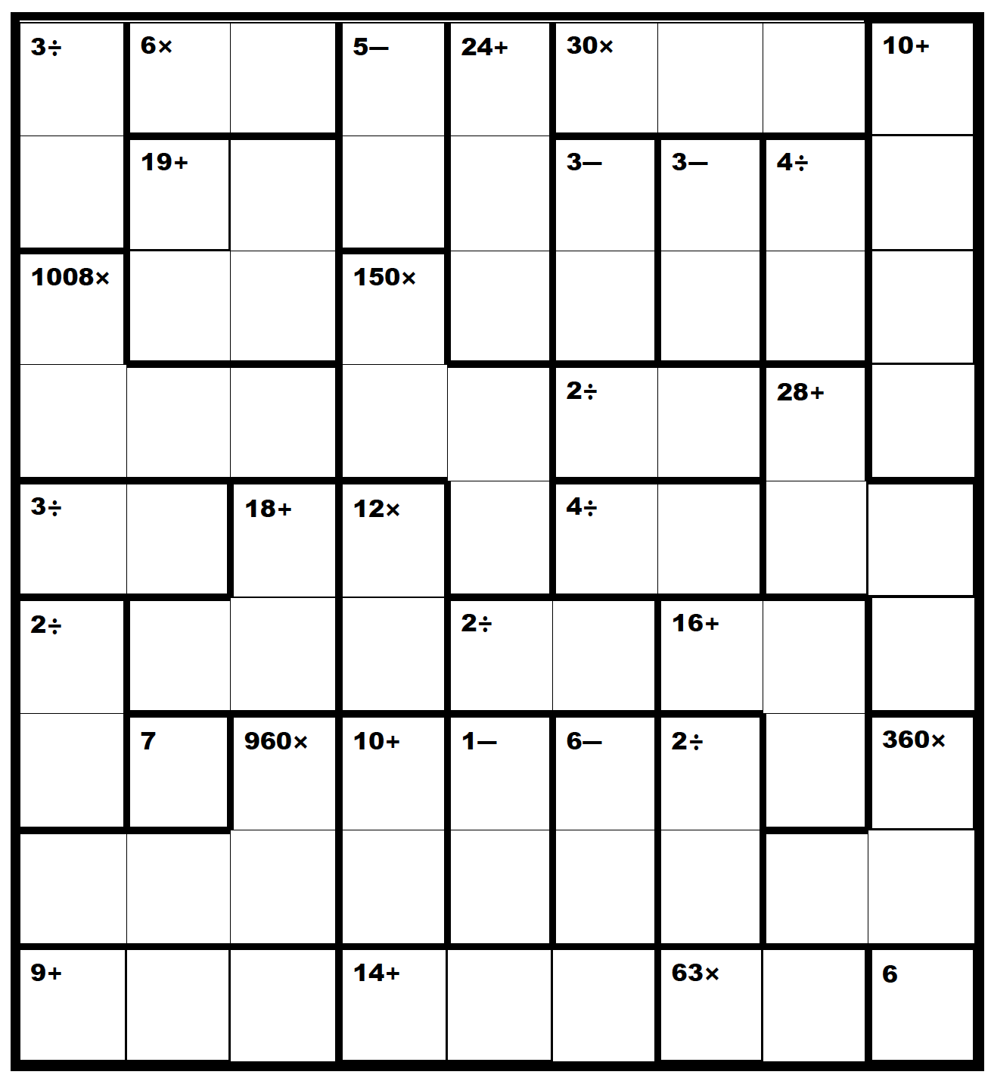

Futoshiki
https://www.futoshiki.org/ (more puzzles and answers)
https://www.puzzle-futoshiki.com/futoshiki-4x4-easy/ (more puzzles and answers)
https://www.brainbashers.com/futoshikihelp.asp (more puzzles and answers)
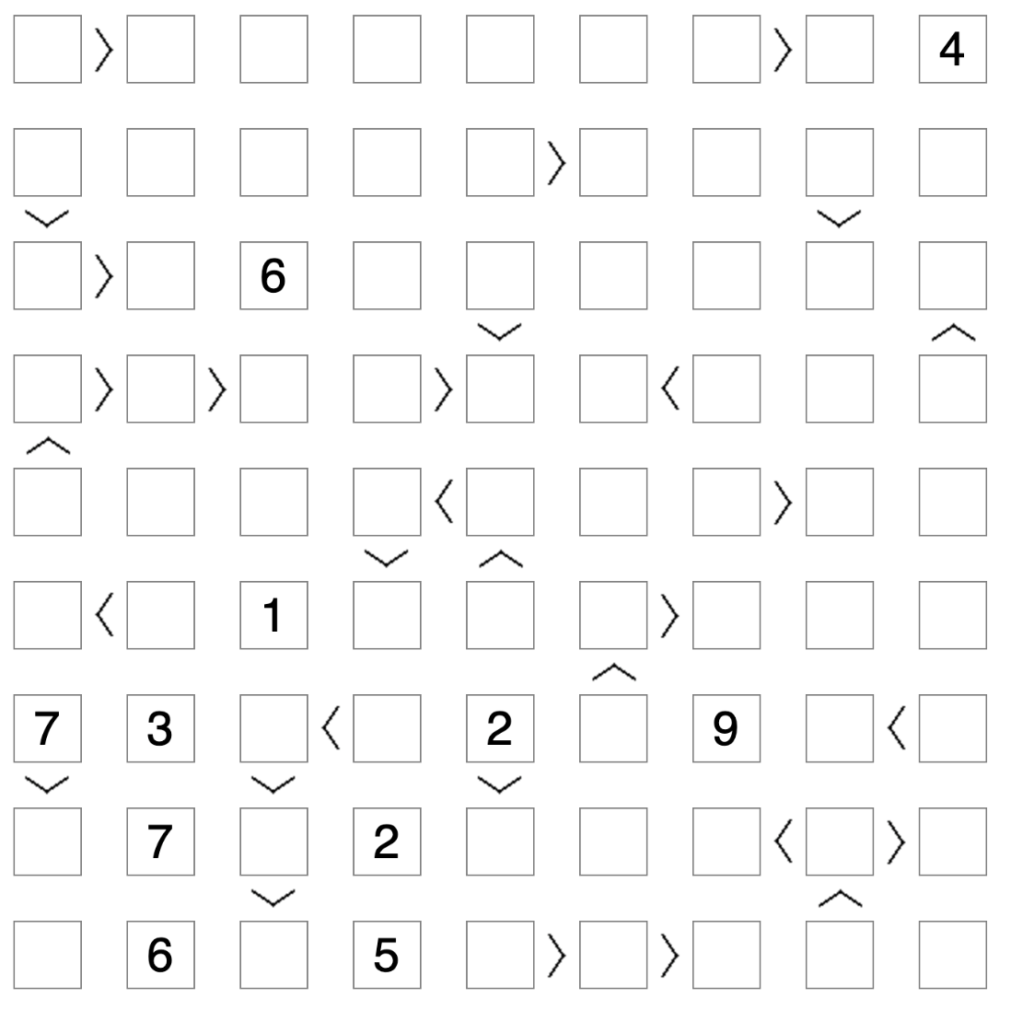

Shikaku
https://www.puzzle-shikaku.com/?size=4 (more puzzles and answers)
http://www.nikoli.co.jp/en/puzzles/shikaku.html (more puzzles and answers)
https://www.puzzle-magazine.com/shikaku-strategy.php (more puzzles and answers)
