Alum Rock School District Meeting: Combined for DELAC & DAC Committee)
December 7, 2020 @ 5:00pm via Zoom

Attendance:
Alisia Delfin - Lyndale Elementary
Bertha Gomez - Lyndale elementary
Alejandra `Arias- Adelante 1
Azucena Aguilar- Sylvia Cassel Elementary school
Wilma Tamayo - Renaissance at Mathson
maria razo: russo
Arlet cruz representó cureton elementary
Edith DelVillar – Fischer
Sharon Chen-
Sudha McCollam:
Rosa Sepulveda
Lorenal Alatore
Joanna

Azucena: 5:03 meeting to order
Araceli: 5:04 meeting to order
Sandra: Reviewing the agenda
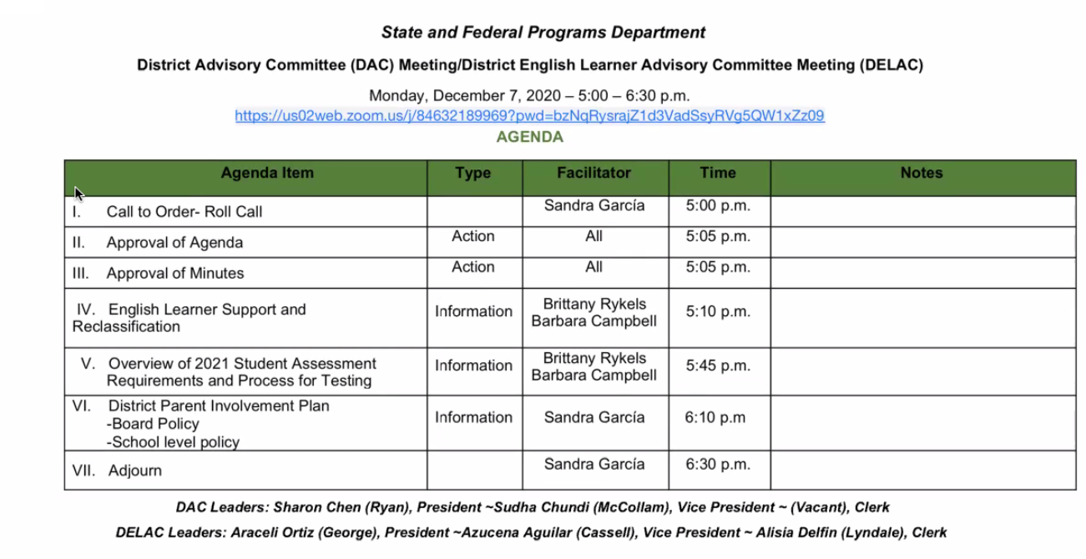
All agenda approved @ 5:10

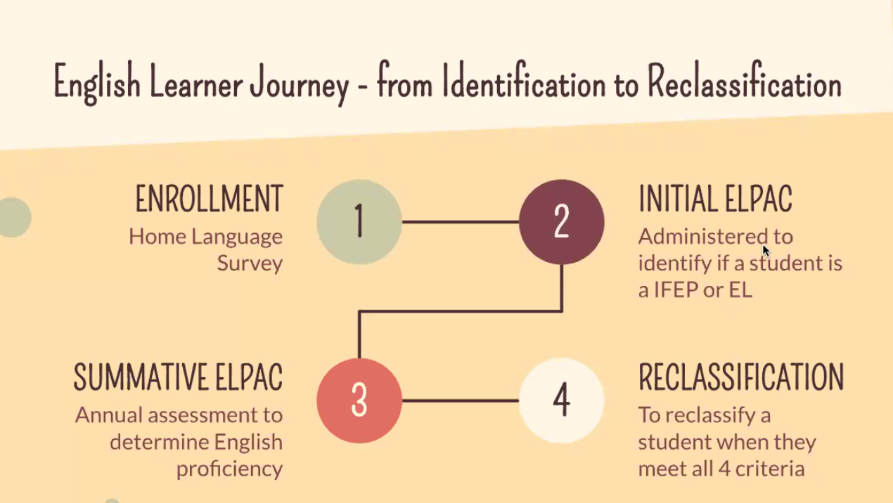
New reclassification criteria
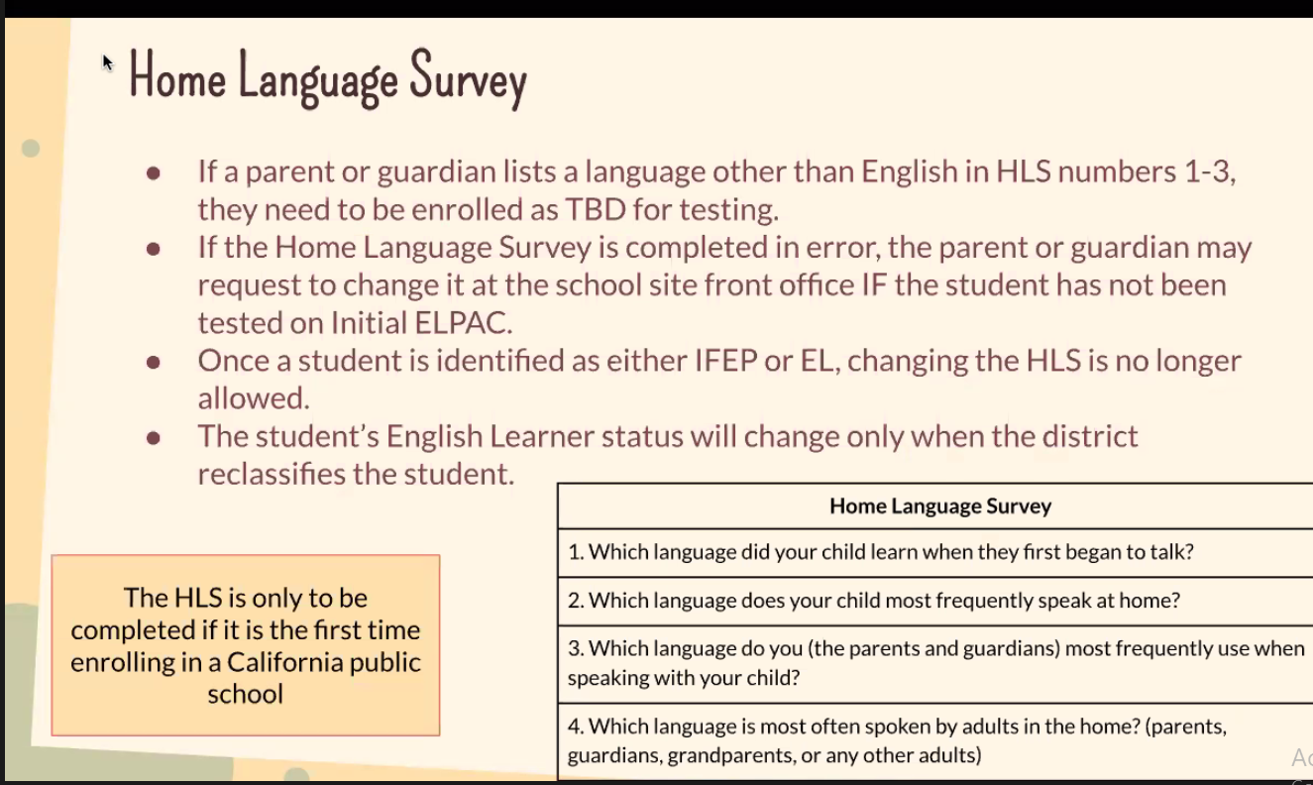
- If any of the first 3 questions are answered yes = goes into system TBD status
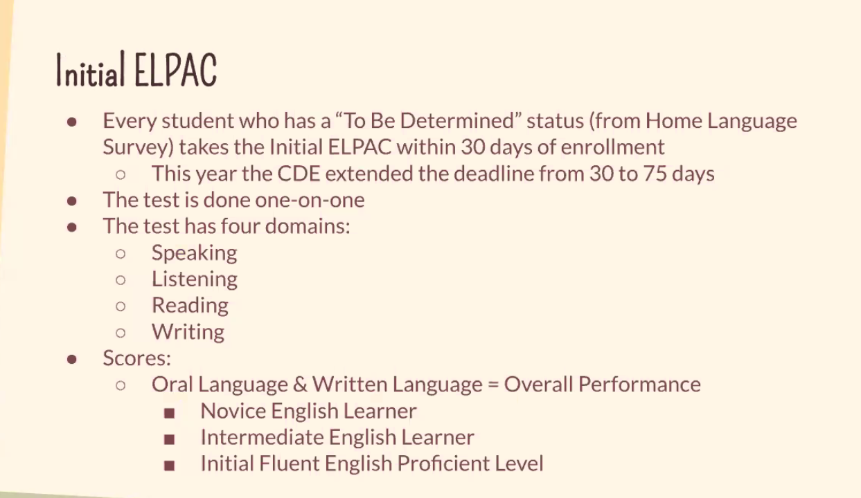
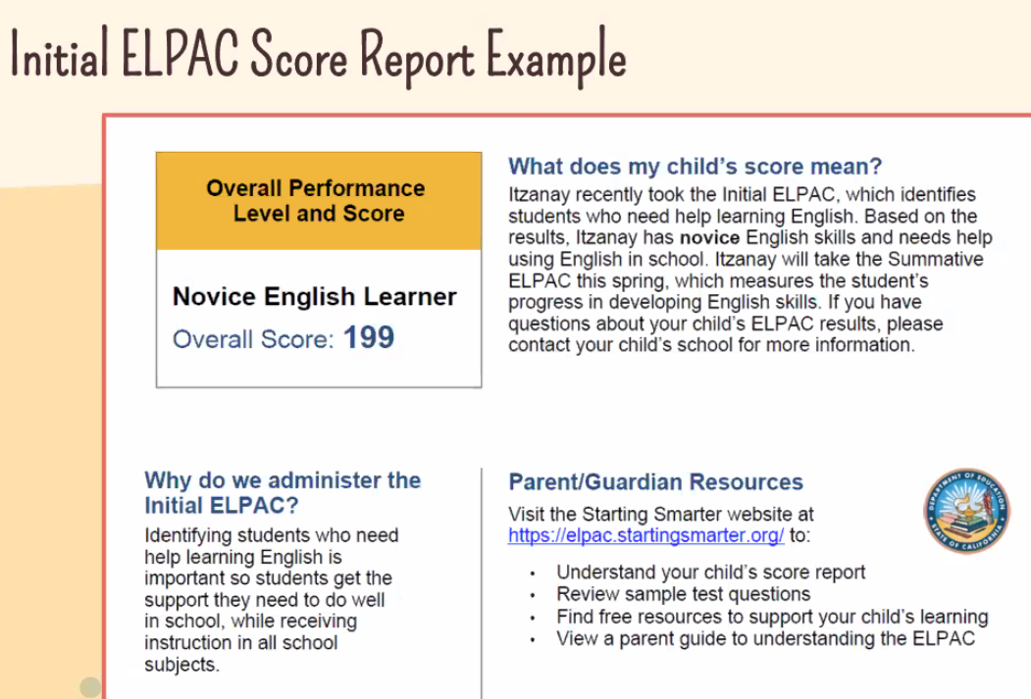

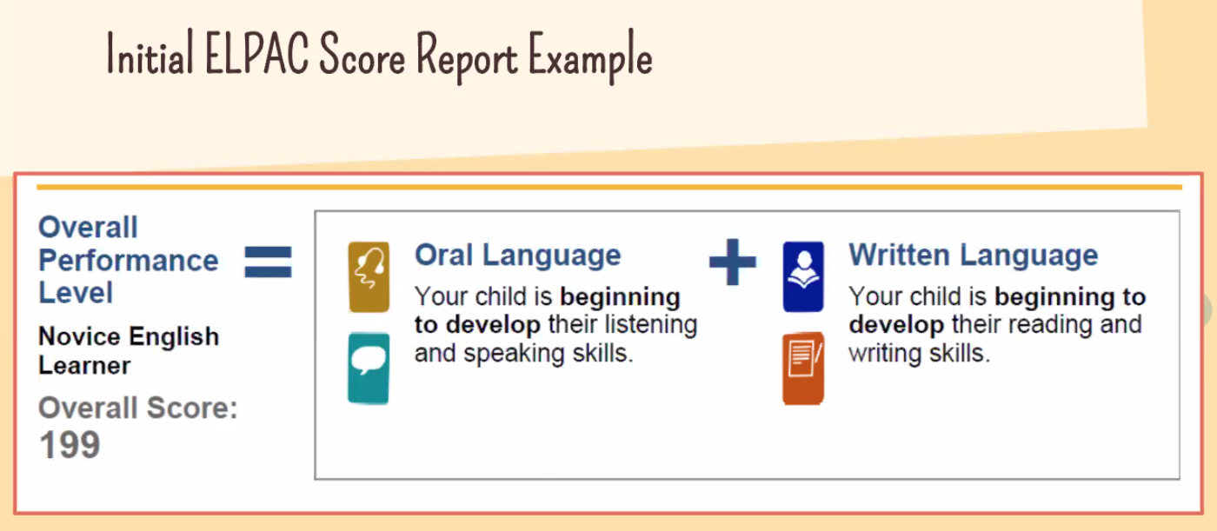

- Overview/review of student testing score
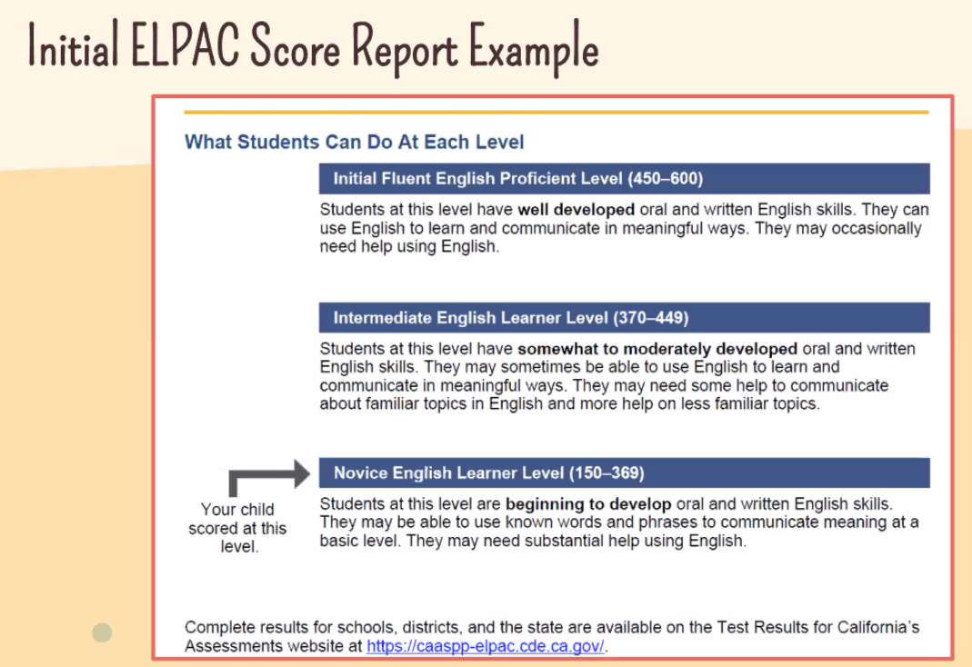
Report sent home 30 days after test submitted
Every year until they are reclassified
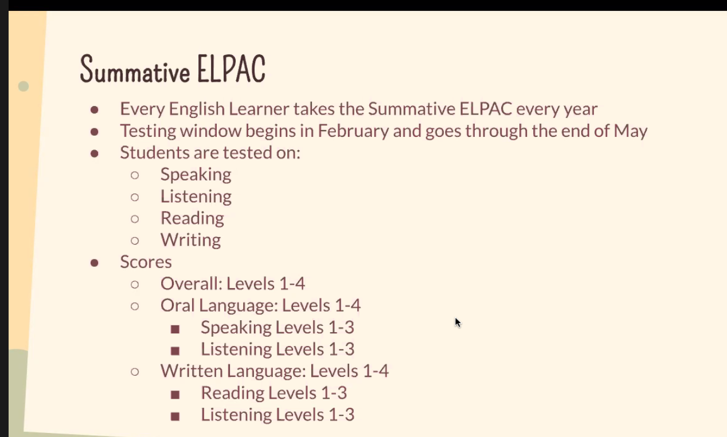
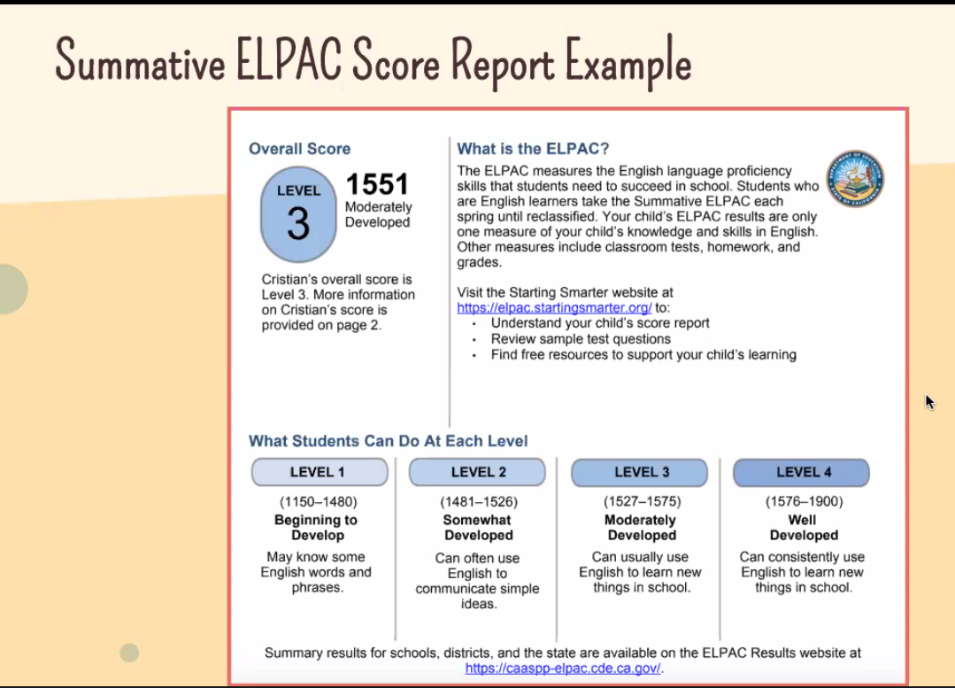
Sample report
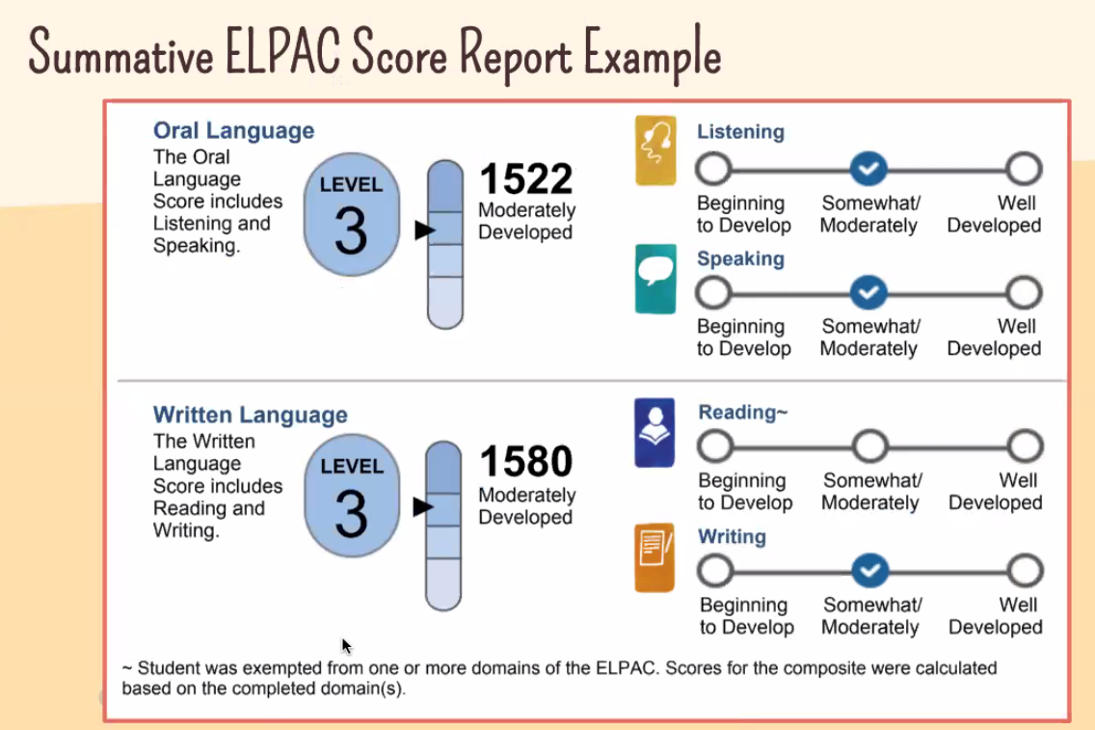
Sample.
Sandra: If IEP and has a not passing level (accommodations may be done, only for IEP’s have the exceptions)
Azucena: All other students don’t have accommodations.
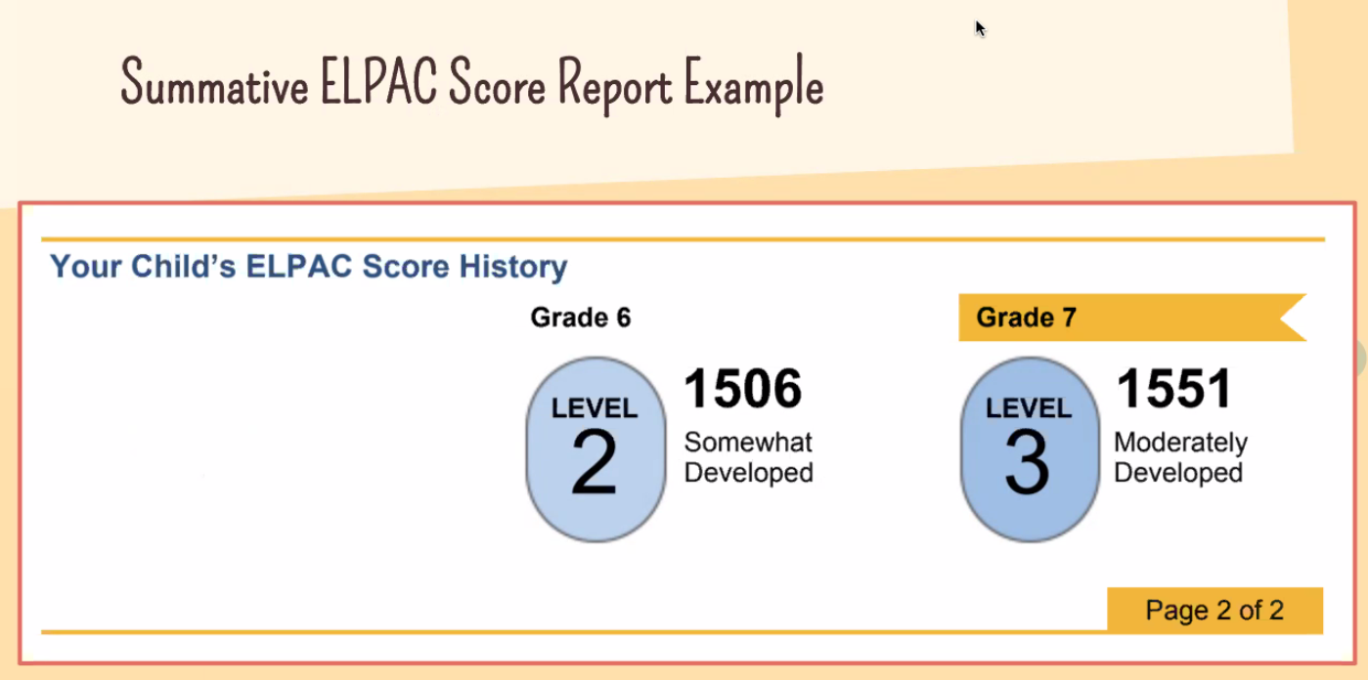
Progress report
Any questions on how the testing is conducting.
Rose: with my child, when she enrolled her in school. I made a mistaken wrote both languages and she has an IEP, but is not an English learner.??? I accidentally classified my daughter as English learner, once classified how do we remove her from EL classification?
Brittany: according to the ED code, you have to answer the questions 1-3, should be TBD and question 4 should not mark the classification.
EL’s can’t change statues once they are deemed as one.
Barb: alternative way on how to reclassified students with special needs.

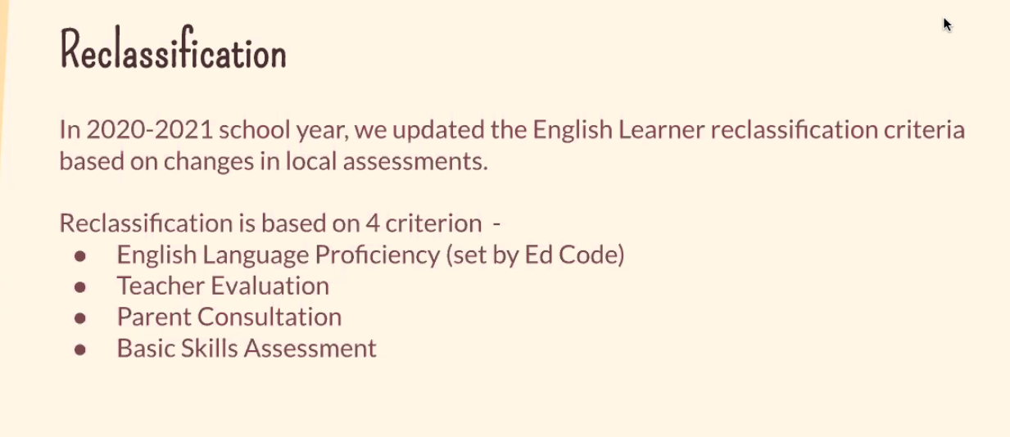
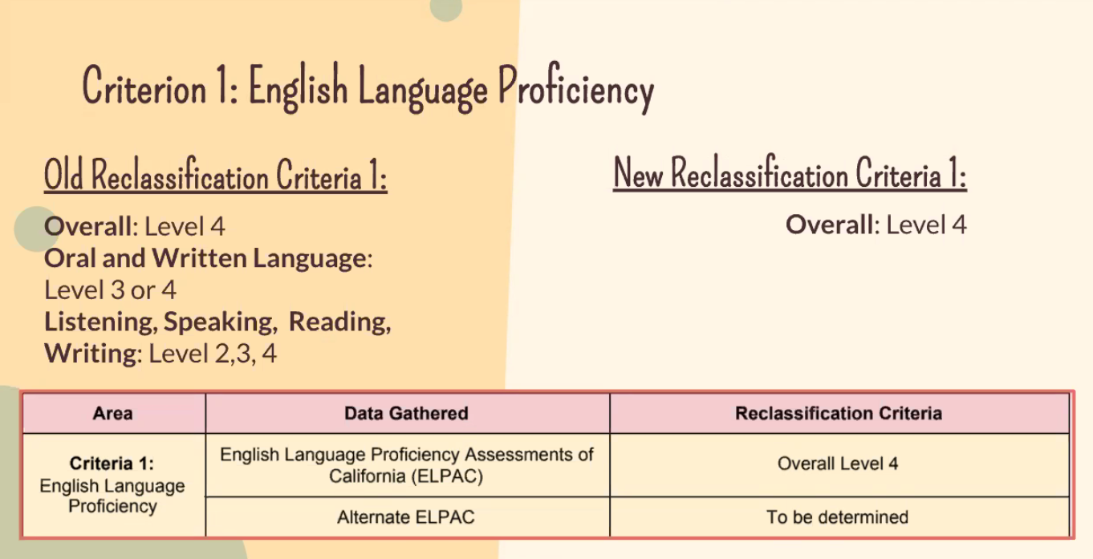
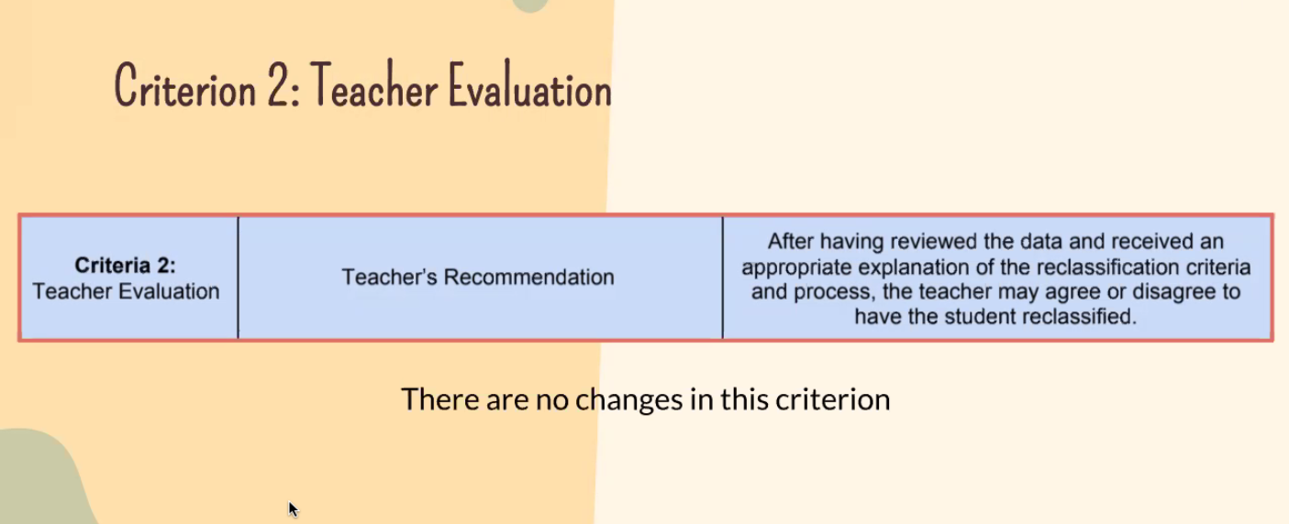
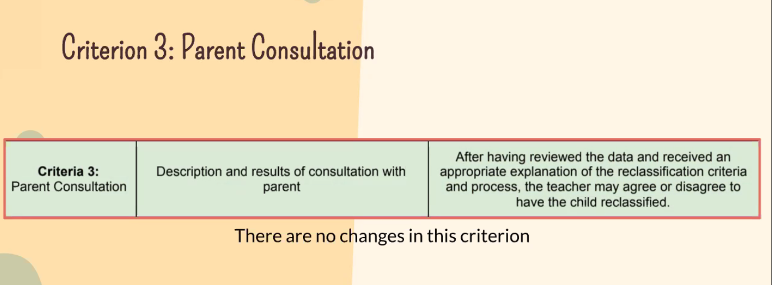
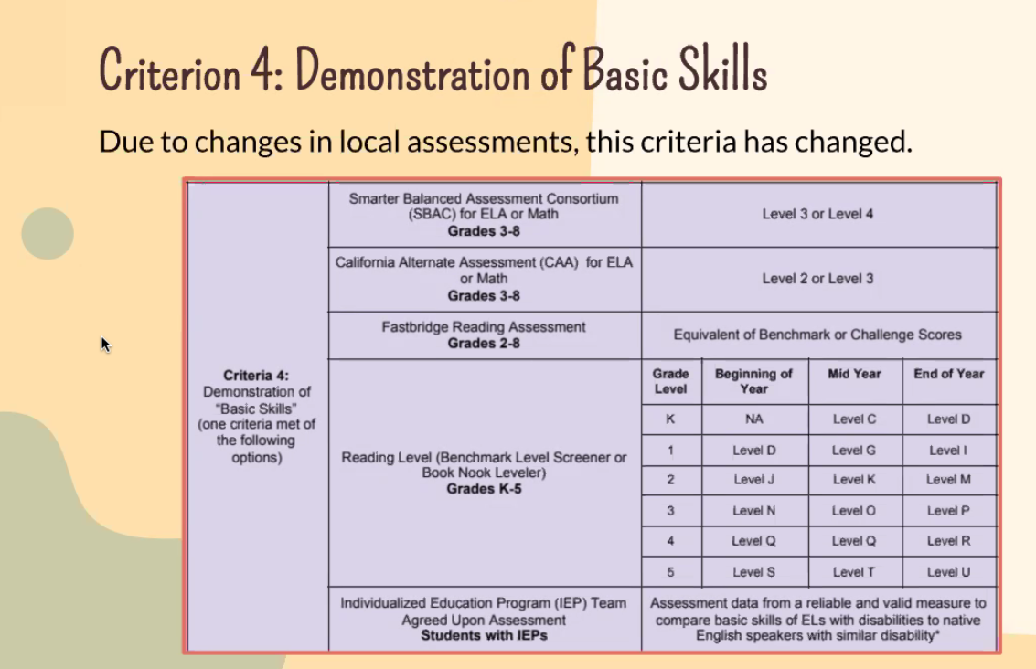
Change is: student has to meet at least 1 classification
Sudah: Son is an EL and is not now in the classification. Daughter is 4 and is an EL?.
Sandra: How do u classify our children correctly?
Brittney: The home survey is important; it is when the survey is completed, the classification is marked.
Alejandra: How can we know if our child is classified as an EL?
Barb: Call the school, a letter should have been send home. ELPAC scores send home annually.
Alejandra: My child received a low grade, but the teacher did not know she was a EL.
Barb: Teachers should know based on the system, principals should be spending time with teachers on how teachers should support second language learners.
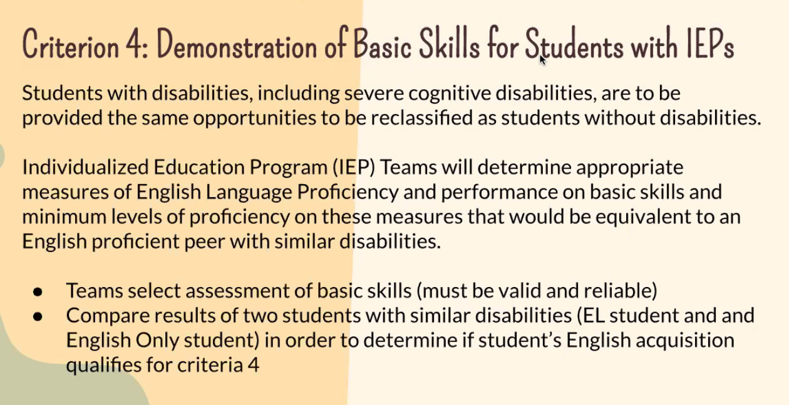
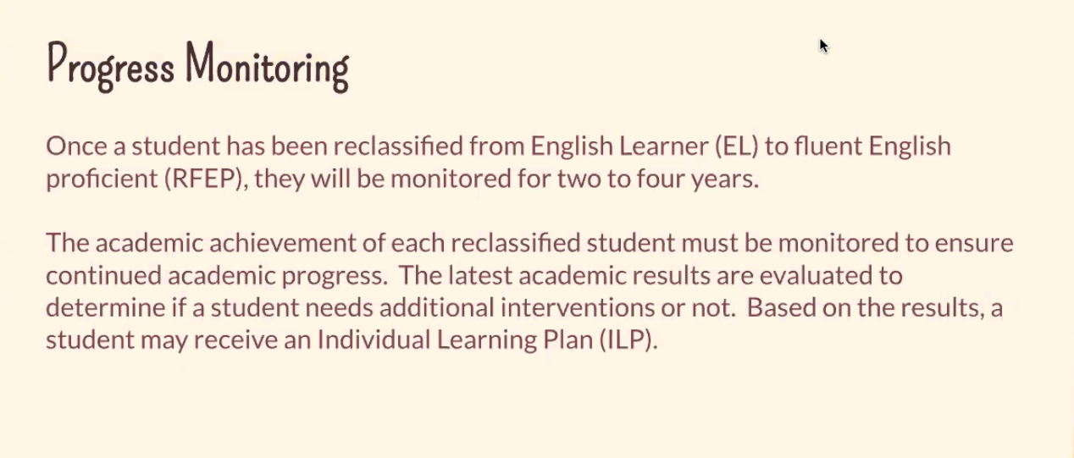

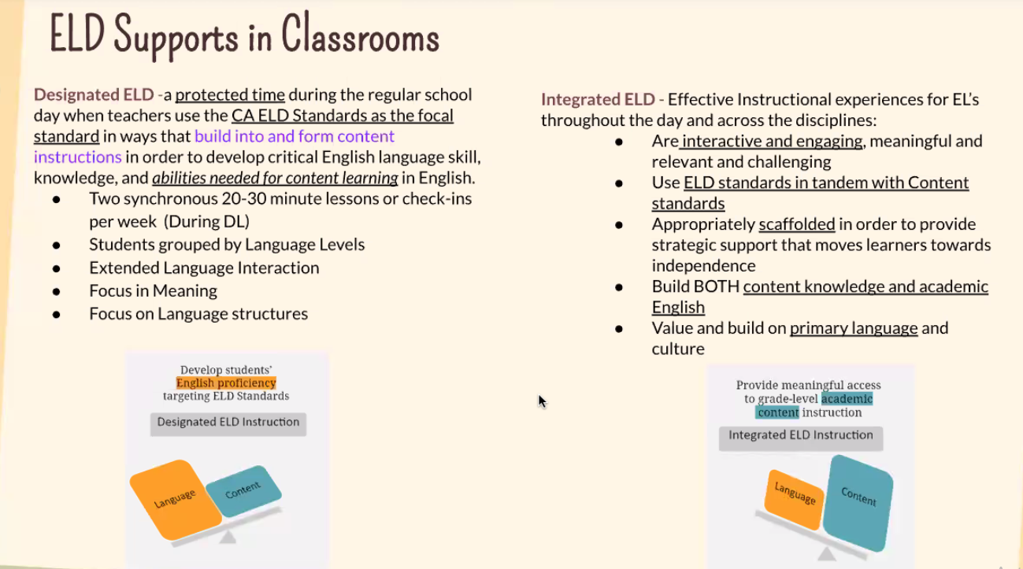
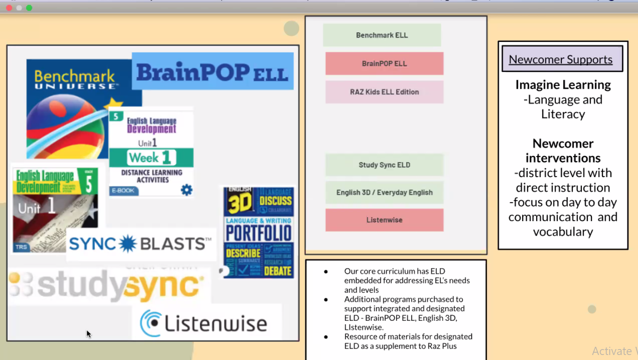
- Some pieces have recently been purchased to support current situation from title 1 budget.
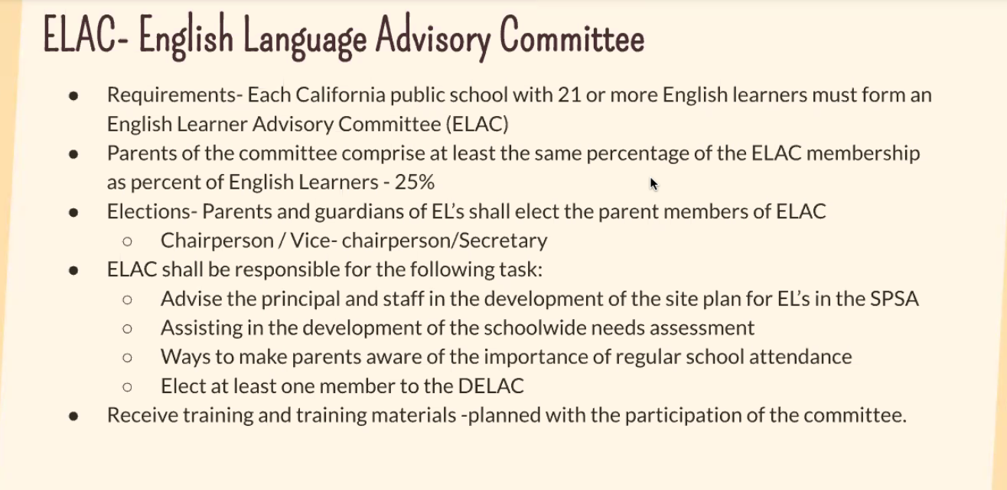
Azucena: questions because of current situation are these programs just available or has it always been??
Barb: These new programs will be evaluated based on the success of each programs. Benchmark has always been in place. There has always be additional support for all the EL’s.

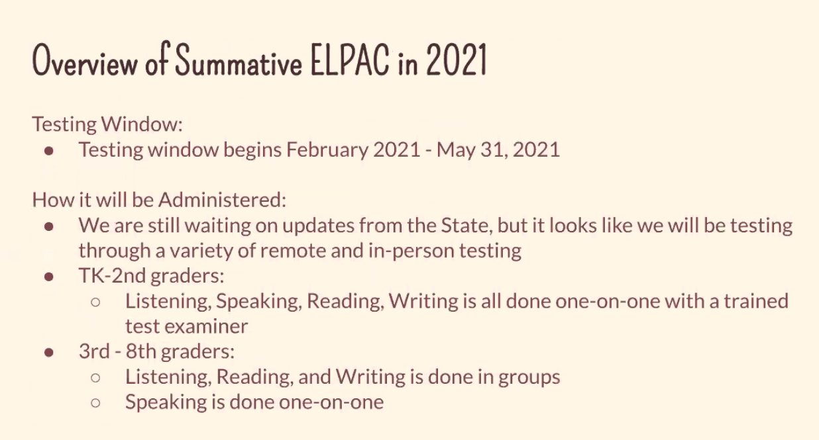
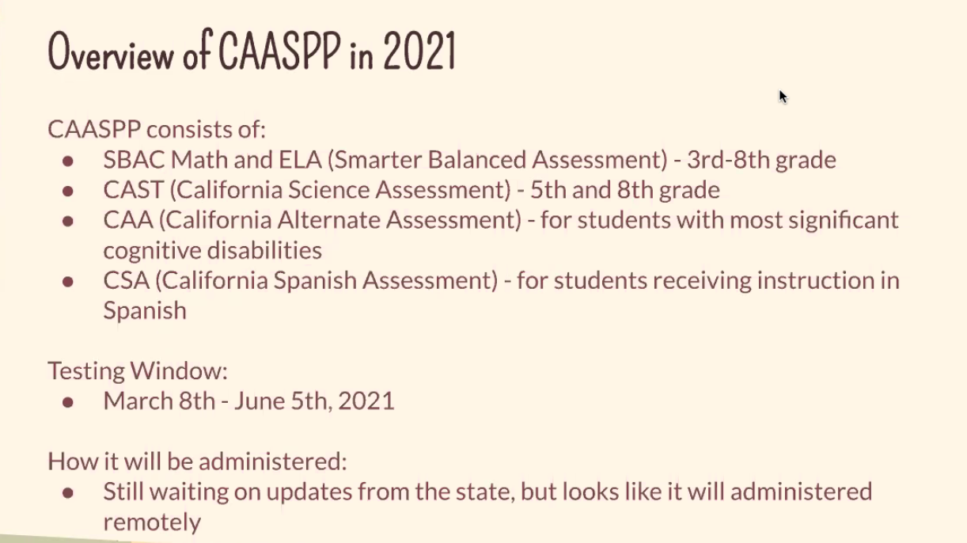
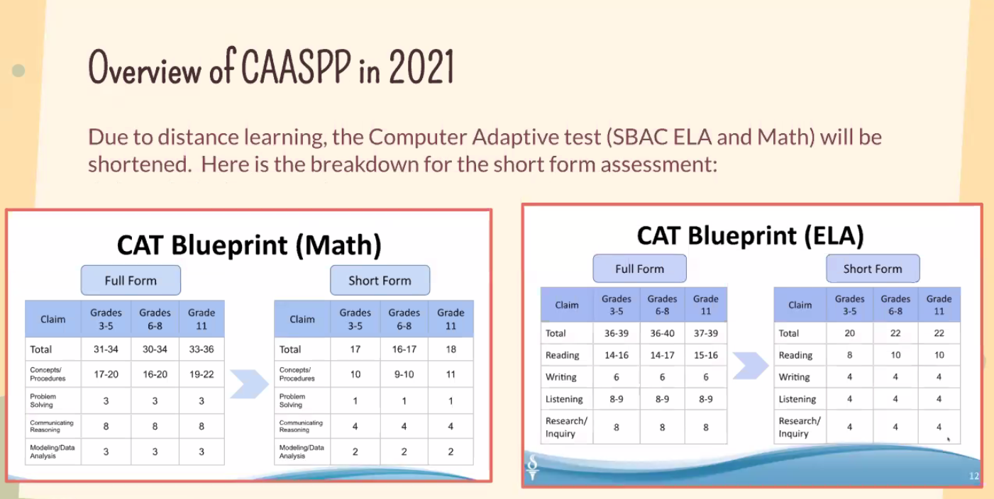
Sandra: have they talked about combing the test?? Both test be equivalent?
Brittany: not sure if they will be the same or accountability.
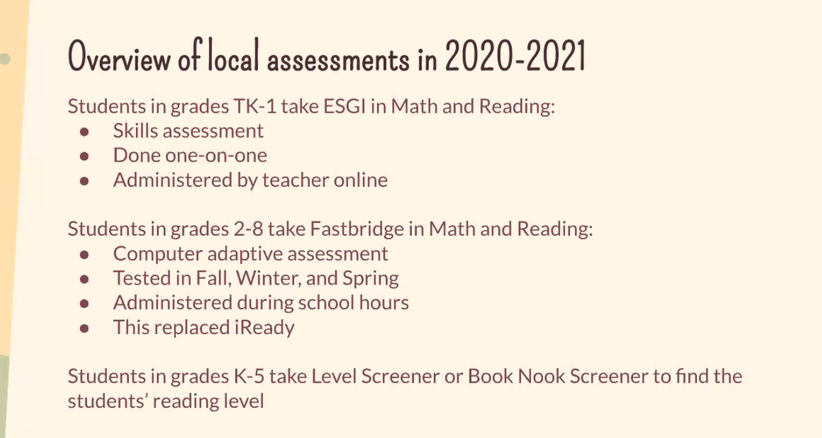


Joanna: test results of EL’s that are on the benchmark app??
Barb: CAASPP are scored from the dashboard.
Joanna: $$ allocated will the EL will it be reallocated based on the scores? Is this funding also funded for the programs used for EL and new comers??
Barb: Yes, funding is used for programs, teachers support.
Azucena: will there be testing?
Brittany: yes, there will be testing, sometime in May CASSPA.
Azucena: Last year, testing was not done… how will this affect the EL’s??
Brittany: Monitoring progress, have some data with programs being used.
Barb: local assessment, provide intervention.
Sudah: Fastbridge and Iready… are they the same… Fastbrigde seems easier than Iready.
Testing short form and full form what are the differences.
Barb:
Brittany: test will be condensing, should have the same results.
Joanna: Please send the slides via email.
Sandra: will post the link to access the slides in the chat box.
End of meeting @ 6:10 pm
Sandra: any additional questions before we end the meeting…
Sudah: distance learning will be continued?
Sandra: not sure on how distance learning will be. Fastbridge will be used distance or in person, formative assessment will continue to be in place. We have to try this new assessment a few years, might be too soon to say its working or not.
Sandra: making sure everyone has received the meetings slides.
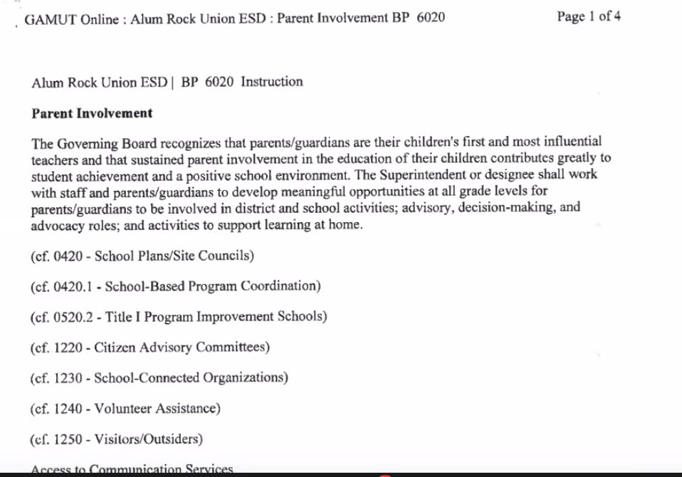
Review the policy
Joanna: Part 30 hours, with distance learning how is this going to implementing??
Sandra: hard to say, but all parents are spending more than 30 hours with their students. Challenge, but district is offering virtual things for parents.
Delia: of the 30 hours of volunteer is that for all schools or just Title 1 schools?
Sandra: all alum rock schools are title 1 schools. Every school has a plan, on how to have parent involvement. This needs to be done, and done annually. School site council, approved.
Delia: who is the school site council??
Sandra:

Sudah: how is this parent involvement policy monitored, I don’t have any clue about the policy prior to this meeting? How to get a copy of this policy?
Sandra: ask your school principal for a copy, and if it has not been done. This needs to be done for the school. All parents should get a copy to be reviewed.

Delia: board policy is reviewed every 4 -5 years to be reviewed.
Sandra: not sure, but every meeting 2 policies are reviewed, should be update and adopted.
Delia: does every school have a community liaison?
Sandra: yes, only 2 schools don’t’ have one. But we are on the process of hires them.
Araceli: comment to the parents on how to make the 30 hours for parent involvement.
- All the classes, parent café etc. they all count as parent involvement (currently in JG Middle school)
  - Talk to your principals and see if this count for your schools.
Sandra: any questions….
Joanna: if a specific school wants to use $$$ for a specific thing how can this funding be used to buy the items.
Sandra: school site council needs to be reviewed on how the funds can be used. Need to be on the meeting minutes and reviewed and approved.
Sudah: school site council has a say on how to use the funds…
Sandra: school plan has $$ allocation on how the principals has allocated the budget. Re approved by site council.
Sudah:
Sandra: Principal can advise but not

Sandra: 6:35 pm end the meeting, be respectful of everyone’s time. We had a full agenda.
DELAC: DAC:
Sharon: Close the meeting @ 6:37pm
Joanna: Motion to close the meeting
Sudah: 2nd motion to close the meeting
Sharon: Meeting closes at 6:38 pm
Araceli: closes the meeting for DELAC 6:38 pm
Maria Razo: motion to close the meeting
Azucena: 2nd the motion to close the meeting
Araceli: close the meeting at 6:40 pm

