High School & Beyond Plan - 10th Grade Instructions
Renton High School
SOPHOMORE YEAR ASSIGNMENTS

Complete any tasks from the previous year’s High School & Beyond Plan’s assignments, if necessary.
- Review My Career Matchmaker Assessment results from freshman year. Improve/update results (Save at least 3 Careers of Interest)

- Update Career and Life Goals – reflect on last year’s goals and edit/update, as appropriate

- Update My Activities and Experiences
- Schools – Finding the Right Match – explore post-secondary education options (Save at least 2 schools)

GETTING STARTED:

Log into Career Cruising:

Username: RSD-Username (“RSD-” followed by the first part of your district email (e.g., RSD-aaa.bbb001))
Password: Student ID (your lunch number; listed as “Internal ID” on Skyward)
Update Profile: click on My Account, then Profile at the top. Update as needed.

ASSIGNMENT #1: REVIEW MY CAREER MATCHMAKER ASSESSMENT RESULTS (SAVE AT LEAST 3 CAREERS OF INTEREST)

- Review your Career Matchmaker Results from the 9th Grade HSBP activity:
  - Click on My Plan at the top, then My Assessments. Click on the title of your saved results from last year under the Matchmaker & My Skills section.

- Improve your Career Matchmaker Results:

  - Under Improve My Results on the left, click on Review my Answers. As you consider your previous responses, if you feel differently about anything, modify your response using the dropdown menu on the right.

  - Click on Save & Update Career Suggestions at the bottom.

  - Under My Skills on the left, click on Review My Answers. Review and modify your responses as needed using the dropdown menu on the right.

  - Click on Save & Update Career Suggestions at the bottom.

- Explore the list of Careers from your Matchmaker session, as results may have changed. Click on careers that interest you to learn more. Click on Save to My Plan in the upper right when you find a good match.

- Review your Saved Careers:

  - Click on My Plan at the top, then My Careers, then My Saved Careers. Review your saved careers. As you think about each career, click on + Add Comment and answer the following questions:

    - What interests you about this career?

    - What classes or activities could you do in the next few years that would help you increase the skills related to this career?

    - What else could you do now that would help prepare you
for this career?

  - If there are careers of interest you that are not yet on the list, click the Find Careers button to search for them. Review the description, then click Save to My Plan in the upper right.

  - When you have saved at least 3 Careers of interest to your plan, you have completed this task for this year.
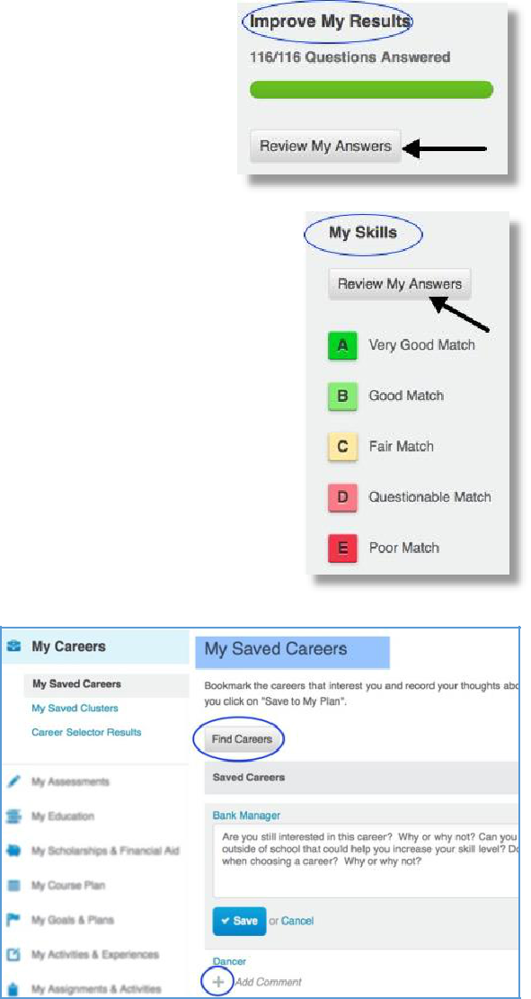

10th Grade HSBP Instructions

High School & Beyond Plan – 10th Grade

ASSIGNMENT #2: UPDATE CAREER AND LIFE GOALS

Click on My Plan (under your name), then on My Goals & Plans on the left column. Click on Career & Life Goals.

- Click on the + sign under Short Term Goals. Read the short term goals you wrote last year. If you have accomplished it, type what you did to make that happen. If you have not yet met the goal, explain what you will do in the future to meet it. If the goal is no longer applicable, explain why.
- If you have met your goals from last year, type in one or two new Short Term Goals for this year. You can click on the yellow icon to see a few examples.

- Click on the + sign under Long Term Goals. Read the long term goals you wrote last year – are they still applicable to your life? Explain. Write additional Long Term Goals, as appropriate. You can click on the yellow icon to see a few examples.

After completing each section, check the box in the Reflect & Confirm box.

ASSIGNMENT #3: UPDATE MY ACTIVITIES AND EXPERIENCES

Click on My Plan (under your name), then on Build My Resume. You will see a series of possible sections to add to a resume – this is an excellent place to keep track of your experiences throughout high school. You can return to this section of your Career Cruising account at any time to add or update any activities or experiences. Keeping track of this information can help you later when you write a resume and prepare for your post high school goals and plans.

To the right of each section, you will see a pencil icon that you can select to edit that section.

EXTRACURRICULAR ACTIVITIES: (SAVE at least 1 Activity)

- Click on pencil icon on the right of Extracurricular Activities.

- Click + Add an activity. Select a category from the dropdown menu.
  - Choose an activity you have participated in the next menu.
  - Record the start and end dates. If you are still participating, enter “to present” as the end date.

  - Enter a description of how you are involved and what skills you have learned from the activity. For example, if you are on the basketball team, you may have gained collaboration skills.

- If you participate in an activity that is not on the list, use the Enter Your Own link by the Activity menu.
- Click on the SAVE button.

HOBBIES & INTERESTS: (SAVE at least 1 Hobby)

- Click on pencil icon on the right of Hobbies & Interests.

- Click + Add a new interest. Select a hobby or interest category from the dropdown menu.
  - Choose an activity you have participated in from the next menu.

  - Record your thoughts about the activity – such as what skills you learned. For example, if you are a collector, you may have gained organizational skills.

- If you are involved in a hobby not on the list, use the Enter your own link.
- Click on the SAVE button.

SKILLS & ABILITIES: (SAVE at least 1 Skill)

- Click on pencil icon on the right of Skills & Abilities.

- Click + Add a new skill. Select a category from the dropdown menu.

  - Choose a skill you have and record your comments. Include examples of how you used this skill or how you acquired the skill.

- If you want to include a skill not on the list, use the Enter your own link.
- Click the SAVE button at the bottom of the page.

AWARDS & CERTIFICATES: (Optional)

- Click on pencil icon on the right of Awards & Certificates.

- Click + Add an award. Select a category from the dropdown menu.

  - Type in the award, date earned, and description

- Click the SAVE button at the bottom of the page.

VOLUNTEER EXPERIENCE: (Optional)

- Click on pencil icon on the right of Volunteer Experience.

- Click + Add a volunteer experience.
  - Enter your position title, organization, city, state, and dates of involvement and the number of hours you have served in this position.
  - In the Description field, enter the duties and special projects you did while volunteering.

- Click the SAVE button.

After completing each section, check the box in the Reflect & Confirm box.

ASSIGNMENT #4: SCHOOLS – FINDING THE RIGHT MATCH (SAVE AT LEAST 2 SCHOOLS)

Begin exploring post-high school education options with School Selector

1. Use the School Selector tool to search for schools, based on criteria important to you. You can specify criteria such as on-campus services, admission difficulty, tuition, and athletics.

    - a. Click on the Education tab at the top, then click School Selector in the next line. Select the level of education of interest to you.

    - b. Use the blue links on the left to select criteria important to you. Once you have made your selections, click on the View Results button on the left to see schools that match your criteria. If you receive no matches, click on View Results and then the Close Matches tab to find schools that match most of your criteria.

Optional: If you are dissatisfied with your results from School Selector, you can search for educational options based on Your Saved Careers results.

a. Click on My Plan at the top, then click on My Education in the list below, on the left column.
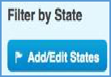
b. Click on My Saved Majors, then on Find majors related to My Saved Careers. Click on a major that interests you. You will see a list of WA state schools that offer that major.

c. Add different states or regions by clicking on the Add/Edit States button.

2. Research and Save Schools (save a minimum of 2 schools)

  - Click on the name of a school, and then browse through information about that school, using links on the left.

  - You can search for a specific school that interests you too. Click on the Education tab at the top, and use the Keyword search to find the school by name.

  - When you find school of interest, click on Save to My Plan in the upper right. You can find these schools later saved in the My Education section under My Plan.
  - You can also compare 3 schools side-by-side using the Compare Schools option under the Education tab.
  - When you have saved at least 2 schools, you have completed this task for sophomore year.

10th Grade HSBP Instructions

