

Reflect on past semester

7 Things to Do During School Holiday Break

Write down your answers to these questions:  - What did I do well this past semester?  - What did I not do well this past semester?  - What will I do differently next semester?  Set goals for next semester  Set 5-10 progress goals:  Describe step by step what you intend to do next semester to make progress. Be specific.  Example: I will do three extra math problems after dinner every day or I will practice my violin every day.  Improve your Physical Health  Start a routine to sleep well, eat healthy and exercise.  Eat more veggies, take walks with family or friends or keep my school bedtime and wake schedule.  Use YouTube videos for great home workouts. IT’S FREE WORKOUTS!  100 MED HIGH DR. MERCEDES, TX 78570 P: 956.565.2454 STISD.NET
  
  

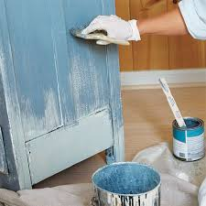 |  | Build or fix something  Help a parent fix something broken at home. Help a parent paint a table or make, then paint a table. Reorganize and declutter your bedroom.
Learn money management  Knowing how to manage your money is a valuable life skill. Get started by checking out the resources at Practicalmoneyskills.com |  | 
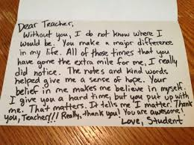 |  | Write thank-you notes  Few people are actually writing these days. During school holiday, write some thank you notes for friends, relatives, teachers or others who have helped you get through this difficult time. You can either mail the note or give it to them in person.
Start a new hobby  - Drawing  - Gardening  - Dancing  - Photography  - Stargazing |  | 
100 MED HIGH DR. MERCEDES, TX 78570 P: 956.565.2454 STISD.NET

