IBERIAN MUN Historical Security Council
Officer Report 2020
The situation in South Vietnam (9 January 1962)

Background Information:
In 1949, China became a communist country and was spreading this ideology throughout Asia. China had already made North Vietnam a communist country and the United States, being the defenders of democracies, became fearful that South Vietnam was vulnerable to encounter the same fate. Though the U.S began aiding South Vietnam financially, by sending supplies and military consultants. The U.S really dedicated themselves to where they joined the war in 1965 on the side of South Vietnam.

Introduction:
In 1962-1971, the U.S. used herbicides (toxic to plants) to defoliate jungles in Vietnam. This was to rid food sources and places to hide in the South Vietcong. The Americans called this project, “Operation Ranch Hand” which had the target to remove the leaves in the South Vietnamese countryside in order to leave the Vietnamese with little place to hide and to simultaneously rid their supply of food. However, this tactic had been already thought of during World War II, where the tactical herbicides were developed by both the U.S and the British. Although it was never used during that war, the British used it in the 1950s.
Several different types of said herbicides, collectively called the Rainbow Herbicides, were used in Operation Ranch Hand. These included Agent Green, Agent Pink, Agent Purple, Agent Blue, Agent White, and Agent Orange, all of which varied in strength depending on their ingredients. Among them, Agent Orange was notably the most powerful. Today it is known that Agent Orange contained dioxins named 2,3,7,8-tetrachlorodibenzo-p-dioxin, or TCDD, which were extremely harmful. Exposure to these dioxins could lead to severe side effects, including cancer, skin diseases, birth defects, and miscarriages.

Consequences:
During Operation Ranch Hand, the U.S. applied a total of 20 million gallons of Rainbow Herbicides across 4.5 acres of land in Vietnam as well as in the territories of Cambodia and Laos. Military aircrafts began by spraying the herbicides from the air above roads, waterways, and farmlands in South Vietnam; land vehicles such as trucks also sprayed them onto areas around U.S. military bases. Agent Orange constituted approximately 13 million gallons of all 20 million used. The danger of the TCDD contained by Agent Orange was evident, as demonstrated by the numerous negative effects it had.
The U.S.’s usage of Agent Orange in the Vietnam War, albeit intended to prevent the enemy troops from being concealed by plants and to decrease the quantity of food sources for the enemy, clearly had unintended consequences. Firstly, while the main ingredients of Agent Orange cleared foliage as expected, the TCDD dioxins polluted sites in residential and agricultural areas. They entered the soil and water in parts of South Vietnam, thus contaminating the food items – including crops, meat, and dairy products – that were consumed by the civilians living nearby. Later studies have shown that even a small amount of food that contains the TCDD can toxify the human body upon consumption. Therefore, the impacts of Agent Orange were directly causing significant harm to the innocent residents of South Vietnam. In total, around four hundred thousand people in Vietnam died or suffered severe health damages due to their exposure to Agent Orange. Furthermore
In addition, the American soldiers that participated in the Vietnam War during that period were also exposed to the dioxins, resulting in a deterioration in their health as well. After the return of the U.S. veterans to their home country, many developed symptoms that were associated with exposure to Agent Orange. Furthermore, the chemicals still pollute the soil to this day. It is clear that the usage of Agent Orange had damaged both parties in the war along with innocent civilians of South Vietnam, and impacted generations afterwards.
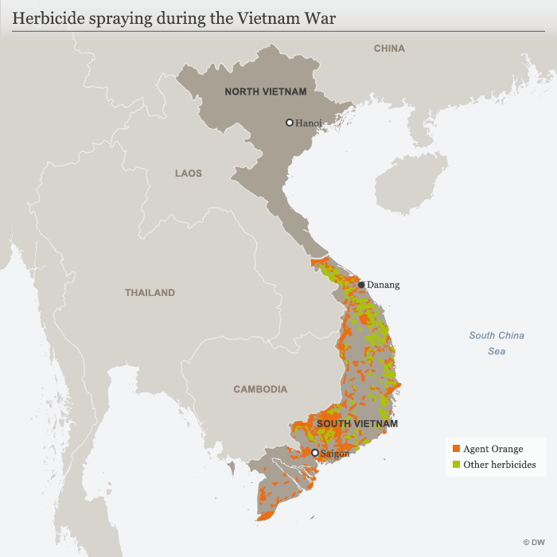
A map of the areas that were targeted during Operation Ranch Hand

Aftermath:
A few years after the end of the Vietnam War, several lawsuits were filed by veterans who were impacted by Agent Orange, and it was agreed upon that firms in charge of the production of the herbicides were responsible of compensating the surviving veterans. Moreover, U.S. legislation passed the “Agent Orange Act of 1991” which stipulated that National Academy of Sciences’ Institute of Medicine would be requested to conduct research to find out the health effects to those exposed to Agent Orange. This was the bare minimum; more efforts came about a couple of years later. Beginning in 1979, Agencies and Federal departments developed these projects and performed numerous health studies of Vietnam Veterans. Ronald Raegan also organized for “The Agent Orange Working Group” which had a purpose “… to guide and monitor all Federal research into the possible adverse health effects of Agent Orange and similar chemicals on humans, with a particular focus on the health of VN veterans.” This initiative, by the U.S government and military to find out whether Agent Orange was harmful or not, was not taken seriously early enough.
In 2004, lawsuits from Vietnam were also filed against U.S. manufacturers due to the long-lasting effects of Agent Orange that remained from the war, demanding compensation of up to billions of dollars. These demands, however, were rejected in 2005 and later in 2008, inflaming the public.

Expectations for Research:
Delegates should refrain from using sources that originated from after 1962, which was the first year in which the U.S. sprayed herbicides in Vietnam. The situation addressed in this conference will solely focus on the initial implementation of Operation Ranch Hand and the resultant usage of the herbicides in 1962. The debate should be centered around these decisions made by the United States, possibly in order to determine whether or not they are most appropriate. As Vietnam was not part of the United Nations Security Council in 1962, it is especially important for delegates to research the positions of their countries in this conflict and in the Vietnam War. For example, a country that had been allies with Vietnam would be on Vietnam’s side in the debate; therefore, research should be conducted primarily based on Vietnam’s perspective as it may be difficult to encounter sources that clearly represent the views of the other countries.

Bibliography:
"Agent Orange." HISTORY, A&E Television Networks, 2 Aug. 2011, www.history.com/topics/vietnam-war/agent-orange-1. Accessed 20 Sept. 2020.
"Agent Orange." Public Health, U.S. Department of Veterans Affairs, www.publichealth.va.gov/exposures/agentorange/. Accessed 20 Sept. 2020.
The Editors of Encyclopaedia Britannica. "Agent Orange." Encyclopædia Britannica, Encyclopædia Britannica, inc., www.britannica.com/science/Agent-Orange. Accessed 29 Nov. 2019.

