Cleaning and Disinfection: How shared surfaces will be regularly cleaned and disinfected and how use of shared items will be minimized.

All trained TUSD employees will clean and disinfect commonly touched surfaces within school and on school busses, as frequently and practicable throughout the day. The use of shared playground equipment will be suspended until further notice. When using air-conditioning, use the setting that brings in fresh air and check air filters to ensure optimal air quality.
  - Ensure staff clean and disinfect frequently touched surfaces within school daily and as practicable throughout the day by trained staff
  - Shared playground equipment will be suspended until further notice
  - Choose cleaning products that are approved for use against COVID-19 by CDC (Centers for Disease Control) and follow product instructions
  - Establish a cleaning and disinfectant schedule in order to avoid both under and overuse of cleaning products
  - Ensure safe and correct application of disinfectant and keep products away from students
  - Ensure proper ventilation during cleaning and disinfecting
  - All TUSD air conditioning units are equipped with economizers allowing 10%-20% outside fresh air depending on outside temperatures. Fresh air from outside of the buildings replenishes the oxygen level and reduces the carbon dioxide level in the room, helping to maintain good quality air.
  - TUSD uses high quality anti-microbial air filters with a MERV 9 rating to filter any particulates exiting the room to avoid returning to the room. Air filters will be regularly checked for replacement as needed.

Cohorting: How students will be kept in small, stable, groups with fixed membership that stay together for all activities (e.g., instruction, snack, recess) and minimize/avoid contact with other groups or individuals who are not part of the cohort.

TUSD School Readiness Programs will implement a Hybrid Model to ensure small cohorts of students:
- Group A (student last name beginning with A-L) cohort shall attend in person learning on Mondays and Thursday of each week. A calendar will be created for weeks that do not have five student days so that half of the week’s days will be assigned for cohort A to attend in person learning.
- Group B (student last name beginning with M-Z) cohort shall attend in person learning on Tuesday and Friday of each week. A calendar will be created for weeks that do not have five student days so that half of the week’s days will be assigned for Group B to attend in person learning.
- One day per week (Wednesdays) will be assigned for both Group A and Group B cohorts to receive distance learning so that Unit members may perform all professional duties for both the in-person and distance learning. Teachers will have the option to work from home on this day, including attendance at professional development and staff meeting activities.
- All shared playground structures and equipment will be suspended until further notice
- All shared classroom supplies will be limited and disinfected between cohorts.
- School Readiness Program families will have the opportunity to continue in shelter in place (distance learning model) if they choose to do so, even when it is deemed safe for preschools to reopen.
  - Distance learning services will be offered through various methods to maintain the developmental progress of currently enrolled children that are not receiving in-person services. Distance learning services and outreach efforts will include, but are not limited to, home activity packages, lending libraries, phone calls, text messages, emails, online learning platforms and/or video. Activity packets distribution will comply with all social distancing requirements.

Entrance, Egress, and Movement Within the School: How movement of students, staff, and parents will be managed to avoid close contact and/or mixing of cohorts.

All schools will follow their TUSD site operational plans to keep cohorts together. The site operational plans include: keeping cohorts together and not mixing cohorts as much as possible, one directional foot traffic patterning in buildings and hallways, identified designated areas for each cohort outside of the classroom to enter the campus, line up, and exit the campus.

Face Coverings and Other Essential Protective Gear: How CDPH’s face covering requirements will be satisfied and enforced.

COVID-19 Face Covering Quick Guide for TUSD Students

Face coverings may help reduce the spread of potentially infectious droplets within the community when combined with physical distancing and hand washing.

Per California Department of Public Health (CDPH) guidance dated August 25th, 2020: Physical distancing, in combination with the use of face coverings, decrease the risk of COVID 19 from respiratory droplets. Physical distancing between adults must be maintained as much as possible, and adults and students must use face coverings at all times, pursuant to the CDPH Schools Guidance. See the CDPH Guidance on Schools and School Based Programs (PDF) and Child Care (PDF) for additional considerations regarding, face mask, meals, cleaning, drop off/pick up, and health screenings.
Face Coverings must be used in accordance with CDPH guidelines unless a person is exempt as explained below. Face Coverings are particularly important in places such as indoor environments, on school buses, and areas where physical distancing alone is not sufficient to help prevent disease transmission.
How to Use:
The San Joaquin County Department of Public Health encourages the public to wear a face covering over your nose and mouth when you must be in public for essential activities (e.g., shopping at the grocery store). Face Coverings are for those who can maintain a minimum of 6 feet distance with other people in their work environment and require little to no interaction with the general public. Wearing a face covering does not eliminate the need to physically distance yourself from others and to wash your hands frequently.
Cloth Face Covering Care:
Wash cloth face covering frequently, ideally after each use, or at least daily - Launder with detergent and hot water - Dry on hot cycle - Wash your hands when putting on and removing your face covering and avoid touching your face.
Some examples of Face Coverings:
Bandana, Homemade sewn cloth, Scarf, Tightly woven fabric, cloth mask, disposable mask, etc.
Per California Department of Education, at a minimum face coverings should be worn:
- While waiting to enter the school campus.
- While on school grounds (except when eating or drinking).
- While leaving school
- While on a school bus
The following individuals are exempt from wearing a face covering per CDPH Guidance dated June 18, 2020:
•Persons younger than two years old. These very young children must not wear a face covering because of the risk of suffocation.
•Persons with a medical condition, mental health condition, or disability that prevents wearing a face covering. This includes persons with a medical condition for whom wearing a face covering could obstruct breathing or who are unconscious, incapacitated, or otherwise unable to remove a face covering without assistance.
•Persons who are hearing impaired, or communicating with a person who is hearing impaired, where the ability to see the mouth is essential for communication.
•Persons for whom wearing a face covering would create a risk to the person related to their work, as determined by local, state, or federal regulators or workplace safety guidelines.
•Persons who are obtaining a service involving the nose or face for which temporary removal of the face covering is necessary to perform the service.
•Persons who are seated at a restaurant or other establishment that offers food or beverage service, while they are eating or drinking, provided that they are able to maintain a distance of at least six feet away from persons who are not members of the same household or residence.
•Persons who are engaged in outdoor work or recreation such as swimming, walking, hiking,
bicycling, or running, when alone or with household members, and when they are able to maintain a distance of at least six feet from others.

Note: Persons exempted from wearing a face covering due to a medical condition who are employed in a job involving regular contact with others should wear a non-restrictive alternative, such as a face shield with a drape on the bottom edge, as long as their condition permits it.
STUDENTS
Age | Face Covering Requirement
Under 2 years old | No
2 years old-2nd grade | Strongly Encouraged**
3rd grade - High School | Yes, unless exempt by MD
**Face coverings are strongly encouraged for young children between two years old and second grade, if they can be worn properly. A face shield is an acceptable alternative for children in this cohort who cannot wear them properly.

Resources:
California Department of Education (2020, June). https://www.cde.ca.gov/ls/he/hn/documents/strongertogether.pdf
CDPH (2020, June). https://www.cdph.ca.gov/Programs/OPA/Pages/NR20-128.aspx
CDPH (2020, August). https://www.cdph.ca.gov/Programs/CID/DCDC/Pages/COVID-19/small-groups-child-youth.aspx
Cloth Face Covers (CDC). http://tiny.cc/cdc-diy-face-cover
San Joaquin County Public Health. http://www.sjcphs.org/

Health Screenings for Students and Staff: How students and staff will be screened for symptoms of COVID-19 and how ill students or staff will be separated from others and sent home immediately.

All students will have their temperature checked during their daily health check before entering their preschool classroom.
Students with a temperature of less than 100.4 degrees will be permitted to enter the class and participate in live instruction for the day.
Students with a temperature of 100.4 degrees or higher will be sent to the office or placed in a quarantined area of the classroom to be sent home.

- Before students and staff come to school, they will need to conduct a self- check for signs and symptoms of COVID-19
- Anyone who has been exposed to someone with COVID-19 in the past 14 days, has COVID-19 symptoms, or who is not feeling well should not go to the school site
- Those who develop signs and symptoms throughout the day will be sent to an identified “sick room” when feasible. The identified “sick room” should be an area in which others do not regularly pass, where symptomatic individuals can remain until they can go home.

Healthy Hygiene Practices: The availability of handwashing stations and hand sanitizer, and how their use will be promoted and incorporated into routines.

All schools will teach and reinforce washing hands, avoiding contact with one’s eyes, hands, and mouth, and covering one's coughs and sneezes. Students and staff will have access to hand sanitizer throughout the school. The district will require all staff and students to wear cloth face coverings/masks (unless an individual has a health/medical condition that prohibits it, or other verifiable exemption reason), which are most essential when physical distancing is not possible. Food Service workers and staff in routine contact with the public should use gloves and facial coverings.

- All rooms with running water will have soap and paper towels available
- Liquid hand sanitizer will be available in all rooms
- Office space departments will have designated locations with hand sanitizer available
- All hand sanitizer bottles will be refilled as needed
- Cloth face coverings, masks, or face shields will be required (unless an individual had a health/medical condition that prohibits it), especially when social distancing cannot easily be maintained such as indoor facilities, school busses, or other settings where space may be insufficient
- Information will be provided to all staff and families in the school community on proper use, removal, and washing of cloth face coverings
- Ensure adequate supplies of the following to support healthy hygiene behaviors, including soap, tissue, no touch trash cans, face coverings, and hand sanitizers
- Provide staff with face coverings

Identification and Tracing of Contacts: Actions that staff will take when there is a confirmed case. Confirm that the school(s) have designated staff persons to support contact tracing, such as creation and submission of lists of exposed students and staff to the local health department and notification of exposed persons. Each school must designate a person for the local health department to contact about COVID-19.

Presenting Symptoms While on TUSD Campus:
When an employee or student becomes ill and/or symptomatic while on campus/district, he/she will immediately report to the sites dedicated health/isolation room and an incident/case form will be completed by a school designee (see appendix A).
Once the employee or student arrives at the health/isolation room, immediately provide them with a mask and gloves. Explain that this is to help protect other employees and students and prevent the spread of the potential virus.
- The designated staff member must complete the attached HANDOUT: TUSD suspected COVID 19 case/incident form (appendix A) and if medically safe, direct the symptomatic individual to leave work or call a parent/family member to transport home or follow up with their health care provider. The designated staff member will determine if emergency services is to be called based on symptoms with the assistance of COVID-19 Screening Flow Chart (appendix C).
- The designated staff member and others attending to the symptomatic person, should also wear personal protective equipment (PPE) while working with the person displaying symptoms.
- The TUSD designated staff member will identify persons who may have come in close contact with the person displaying symptoms on a TUSD site/campus with the TUSD Cohort log (appendix B). Unless required by the local health authority, confidentiality will be maintained as directed by State/Federal HIPAA and FERPA compliance laws.
- The designated staff member will assess the risk of exposure to COVID-19 and advise individuals identified as a close contact (any individual within 6 feet for at least 15 minutes) that they may have been in contact with an individual that has been diagnosed with or is suspected to have COVID-19 using the attached letter (appendix D) and should follow current guidelines and advice from the San Joaquin County Public Health Officer.
  - Contact tracing of diagnosed staff members will be completed by Human Resources staff.
- Please see appendix E for further assistance in determining what the next step should be.
Following CA Public Health Department guidelines, the contaminated area(s)
- Area will sit idle for 24 hours
- Appropriate PPE equipment shall be utilized by cleaning staff
- School Readiness staff will communicate positive COVID-19 cases (staff, child and parent) to the following agencies to adhere to licensing requirements:
  - San Joaquin Public Health Department
  - Child Care Community Licensing regional office.

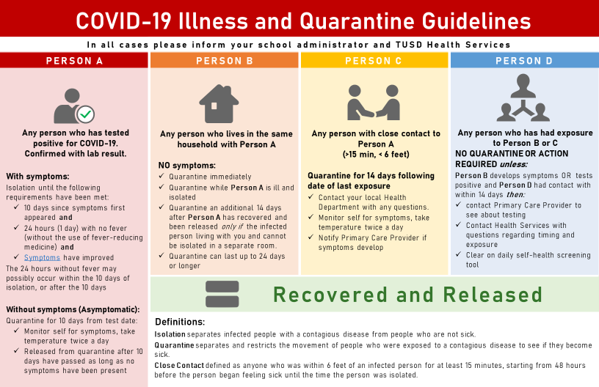

Physical Distancing: How space and routines will be arranged to allow for physical distancing of students and staff.

A Hybrid Learning Model will be implemented in the event of San Joaquin County Health Department providing guidance of required social distancing

- Social Distancing Model with 2 full-day classroom attendance & three-day distance learning program
- All students and staff are required to wear masks, with the exception of those who have a medical/health condition that prohibit it again when attending the 2 full days of instruction at school.
- Integrated social emotional learning
- TUSD’s standards-based, adopted curriculum focused on all Critical & Essential Priority Standards
- Student learning aligned to rigor, relevance, and relationships
- Student engagement through instructional best practices with blended learning embedded

All TUSD school sites will implement Operational COVID-19 Safety Measure Plans
  - Established arrival and departure processes & protocols
  - Classroom Space will recommend to space desks further apart to promote physical distancing where practicable, with one directional seating
  - Remove all excess furniture to allow for maximum distancing within a classroom.
  - Non-Classroom Space will have established processes & protocols for one directional foot trafficking

Staff Training and Family Education: How staff will be trained, and families will be educated on the application and enforcement of the plan.

- All families and staff will be provided TUSD Reopening Guidelines prior to the reopening of schools and will be trained to implement the guidelines that are relevant to them, upon their return to school.

Testing of Students and Staff: How school officials will ensure that students and staff who have symptoms of COVID-19 or have been exposed to someone with COVID-19 will be rapidly tested and what instructions they will be given while waiting for test results. Describe how staff will be tested periodically to detect asymptomatic infections.

TUSD will follow San Joaquin County Health Guidelines regarding testing of students and staff.

Triggers for Switching to Distance Learning: The criteria the superintendent will use to determine when to physically close the school and prohibit in-person instruction.

TUSD will follow all San Joaquin County Health Guidelines regarding triggers to switch to Distance Learning.
What are the criteria for closing a school?
Individual school closure is recommended based on the number of cases, the percentage of the teacher/students/staff that are positive for COVID-19 and following consultation with the Local Health Officer. Individual school closure may be appropriate when there are multiple cases in multiple cohorts at a school or when at least 5 percent of the total number of teachers/student/staff are cases within a 14-day period, depending on the size and physical layout of the school. The Local Health Officer may also determine school closure is warranted for other reasons, including results from public health investigation or other local epidemiological data.

If a school is closed for in-person learning, when may it reopen? Schools may typically reopen after 14 days and the following have occurred:
• Cleaning and disinfection
• Public health investigation
• Consultation with the local public health department

What are the criteria for closing a school district?
A superintendent should close a school district if 25% or more of schools in a district have closed due to COVID-19 within 14 days, and in consultation with the local public health department.

If a school district is closed, when may it reopen?
Districts may typically reopen after 14 days, in consultation with the local public health department.
www.cdph.ca.gov

Communication Plans: How the superintendent will communicate with students, staff, and parents about cases and exposures at the school, consistent with privacy requirements such as FERPA and HIPAA.

TUSD will utilize multiple methods of communication with students, staff and families such as: biweekly informational sessions, automated phone calls, email, social media, and personal outreach.
TUSD also maintains a COVID-19 webpage that provides current information for the public.
TUSD will send home a notification of COVID-19 Exposure Letter that can be found in the Appendix.

APPENDIX
Appendix A Employee/Student Presenting Symptoms on Campus Form
Appendix B Cohort Log
Appendix C COVID-19 Screening Flow chart
Appendix D Exposure Letter to Families
Appendix E COVID-19 Illness and Quarantine Guidelines

Appendix A:
TRACY UNIFIED SCHOOL DISTRICT
EMPLOYEES/STUDENTS PRESENTING SYMPTOMS WHILE ON CAMPUS

Name: Employee _____ Student_____
Date:
Location in District: ______________________________________________________________
Symptoms noticed:
❏ Temperature 100.4 or higher ❏ Fatigue and/or muscle pain
❏ Shortness of breath and/or difficulty breathing ❏ Diarrhea
❏ Cough ❏ Chills
❏ New loss of taste or smell ❏ Congestion or runny nose
❏ Headache ❏ Nausea or vomiting
❏ Sore throat
Additional Notes or other COVID 19 signs or symptoms not listed above: ____________________________________________________________________________________________________________________________________________________________________________________________________________________________________________________________________________________________________________________________________________________
Date and time of fever or onset of symptoms:
Date____________________________ Time__________________________

Location and time of isolation at TUSD:
Location_________________________ Time__________________________

Where is employee/student being referred to (MD., E.R., urgent care, etc.):
____________________________________________________________________________________

Reporter Name/Title:__________________________________________________________________
Appendix B:


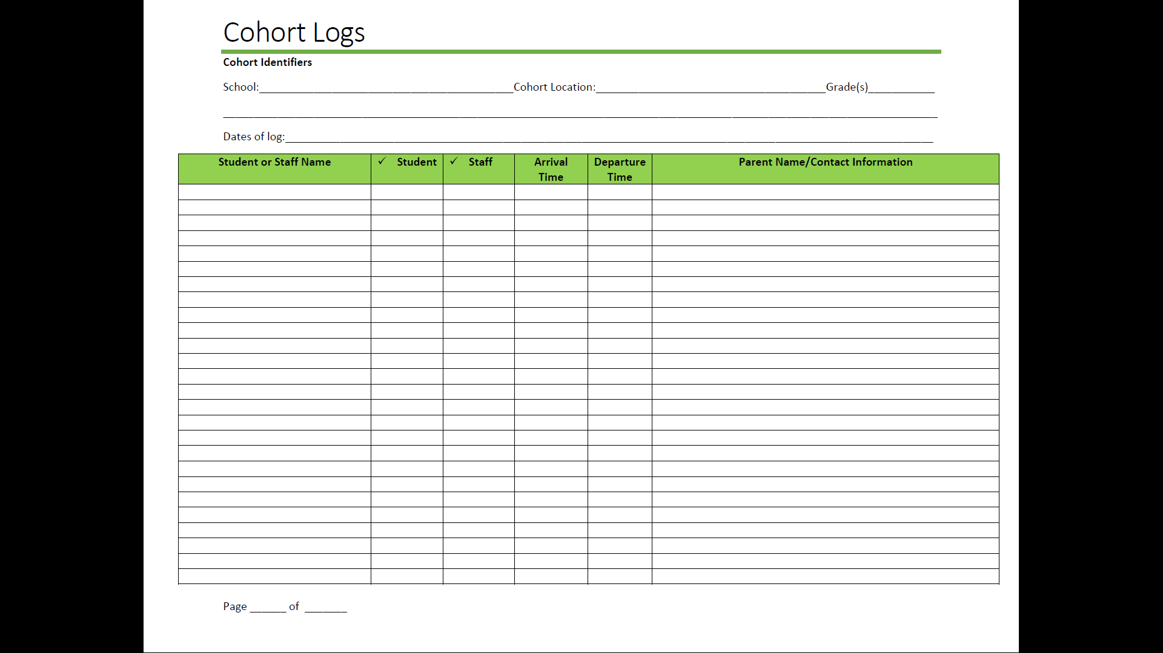

Appendix C:
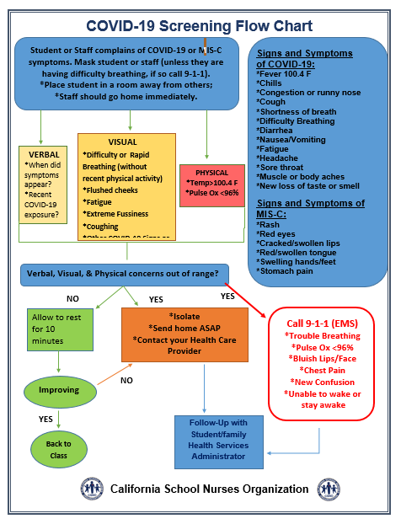
CSNO (2020, August). https://docs.google.com/document/d/1s2EdTE7AHRaBxc4OOYJqr9cFOfTjBRHLIkOH5X5IJp0/edit?ts=5f4c5659
Appendix D (page 1):
Dear TUSD Families:
Our district has been working with our local public health department monitoring the 2019 novel coronavirus (COVID-19). When responding to infectious diseases, it is important to know that our school district follows the directions and recommendations made by the state and county health departments.

Please be aware your child may have been exposed to COVID 19. The information provided below does not replace talking with your health care provider if you or your child is ill. If you or your child have symptoms, please seek diagnosis and treatment from your health care provider as soon as possible.

The student/staff member who was confirmed for COVID-19, attended school premises on the following date/s ______________________________. If you are receiving this notification it is because a 14-day quarantine is required per CDC and CPHD guidelines before the student receiving this notification can return to school. Out of an abundance of caution, we advise you to monitor your health, follow CDC and Public Health guidelines and contact your primary care physician if you have any symptoms or concerns. In accordance with FERPA and HIPPA laws, we are not allowed to disclose any further information regarding the student/staff member who tested positive for COVID 19.

It has been determined that the end of the 14 day self-quarantine period for the student receiving this notification will be _________________________________________.
What is COVID 19?
Coronavirus (COVID-19) is an illness caused by a virus that can spread from person to person. The virus that causes COVID-19 is a new coronavirus that has spread throughout the world. COVID-19 symptoms can range from mild (or no symptoms) to severe illness.

What are some of the symptoms?
- Fever or chills
- Cough
- Shortness of breath or difficulty breathing
- Muscle or body aches
- New loss of taste and/or smell
- Sore throat
- Nausea and/or vomiting
- Diarrhea
- Headache

What is the school district doing?
We are staying in close contact with local and state health officials to ensure we are taking the appropriate steps under the current circumstances, including:
- Thorough and frequent cleaning and disinfecting of high touch surfaces.
- Enhanced infection control precautions, such as wearing personal protective equipment (PPE) when working with students and others.
- Increasing the availability of hand sanitizer.

Appendix D (page 2):

- Screening of students and staff for COVID 19 symptoms, as well as anyone else who must enter our facilities.
- Providing and requiring face masks for students and staff to wear.
- Requiring all others entering our facilities to wear face coverings to help prevent the spread of COVID 19.
- Practicing Social distancing as indicated by CDC and Public Health.

Keeping our students and staff safe is our top priority. In our district, we are following high standards and strict procedures for frequent and thorough cleaning and disinfecting.
What can I do to stay healthy?

- Multiple times a day, wash your hands often with soap and water for at least 20 seconds, especially after going to the bathroom, before eating, and after blowing your nose, coughing, or sneezing.
- Avoid close contact with people who are sick.
- Avoid touching your eyes, nose, and mouth.
- Clean and disinfect frequently touched objects and surfaces.
- Stay home from work or school if you are not feeling well.
- Seek medical attention if you have reason to believe you have been exposed to coronavirus or influenza. Call your healthcare provider before visiting a healthcare facility.
- Monitor your health daily.
- Practice social distancing.

You can also review the CDC website for information about COVID 19, including its symptoms, how it spreads, and actions you can take to protect your health: https://www.cdc.gov/coronavirus/2019-ncov/index.html

Please know that the district is monitoring this situation. Our focus is maintaining the safety of students and staff. We will continue to update staff and families with any new information.
For more detailed information contact TUSD Health Services or your local Public Health Department. More resources are provided below.
Sincerely,
Erica Contreras
Coordinator of Health Services
Tracy Unified School District

Appendix E:
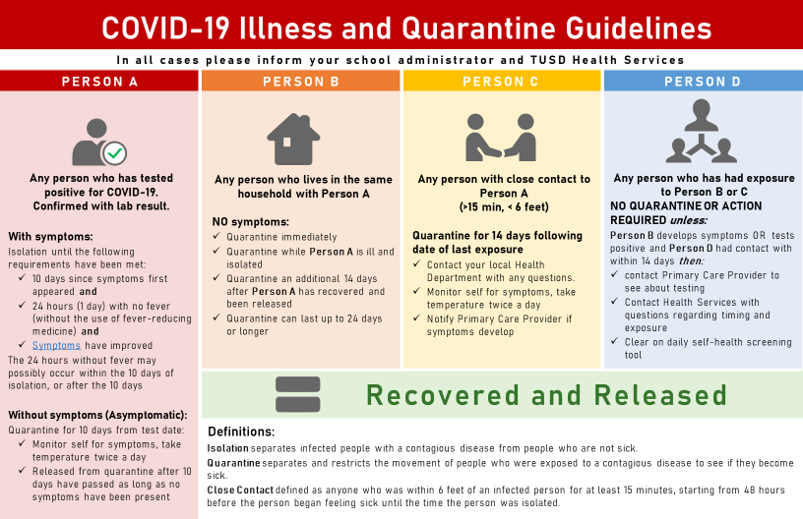

References

California Department of Education. (2020, June). Stronger together, a guidebook for the safe reopening of California public schools. https://www.cde.ca.gov/ls/he/hn/documents/strongertogether.pdf
CDPH. (2020, August). COVID-19 industry guidance for schools and school-based programs. https://www.cdph.ca.gov/Programs/CID/DCDC/Pages/COVID-19/Schools-FAQ.aspx
CSNO. (2020, August). Health services recovery plan resource guide in educational settings. https://docs.google.com/document/d/1s2EdTE7AHRaBxc4OOYJqr9cFOfTjBRHLIkOH5X5IJp0/edit?ts=5f4c5659
San Joaquin County of Education. (2020, July). 2020-2021 School year planning: a guide to address the challenges of COVID 19. https://www.sjcoe.org/newsDetails.aspx?ID=4942

