Sunday | Monday | Tuesday | Wednesday | Thursday | Friday | Saturday
1 | 2 | 3 | 4 | 5 | 6 | 7
8 | 9 | 10 | 11 | 12 | 13 | 14
 |  |  | 
15 | 16 | 17 | 18 | 19 | 20 | 21
22 | 23 | 24 | 25 | 26 | 27 | 28
 |  |  |  |  | 
29 | 30 |  |  |  |  | 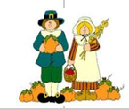
 |  |  | 

