HOME TROUBLESHOOTING TIPS
- Please fully restart laptops before troubleshooting. Many issues can be fixed by this method.

- Dell laptops: If they will not turn on, make sure to plug in the charger and hold the power button down until the side charging light goes out (it will take an several seconds). Once the light goes out, release the power button and press it once to turn it on. Only the Dells have this issue.
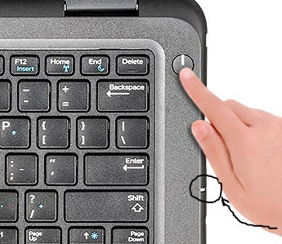Hold power button down until this light goes out
- Test webcam by opening the Camera application on the start menu.
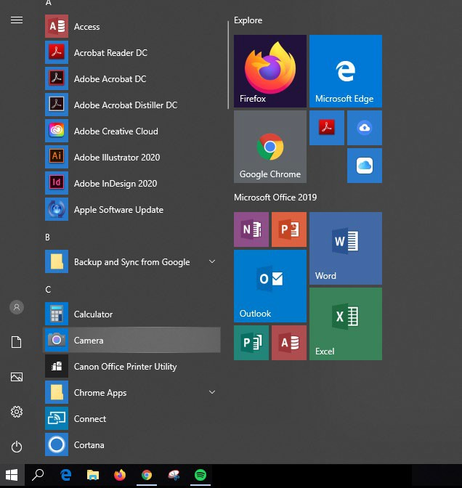

- Test microphone by right-clicking the Volume icon on the bottom right of the screen and click Sounds. Click on the Recording tab and make sure the bars on the right flash green when speaking.
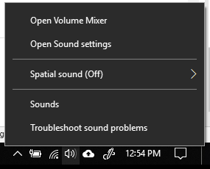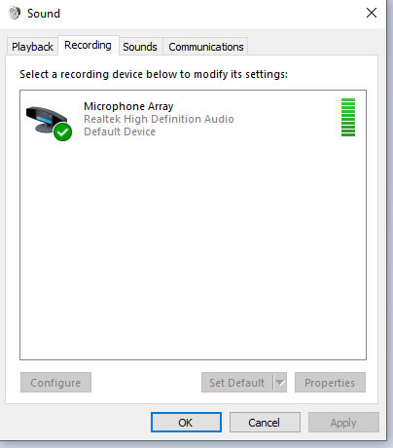

- If slow or feeling very sluggish, make sure multiple programs that are not currently being used are not running in the background, or the desktop is not overloaded with files and folders.

- To test if the keyboard is completely functional and no keys are damaged, open an empty Notepad document or Word document and type out:
The quick brown fox jumps over the lazy dog. 1 2 3 4 5 6 7 8 9 0
This sentence uses all 26 letters of the alphabet as well as all numbers.
- If sound is not working, make sure the laptop is not muted. On some laptops, there is a mute button on the keyboard that may accidently be pressed, causing no sound to come out of the speakers. This button is normally at the top row of the keys on one of the Function buttons (F1-F12). Sometimes, the Fn button has to be pressed along with the Function button.
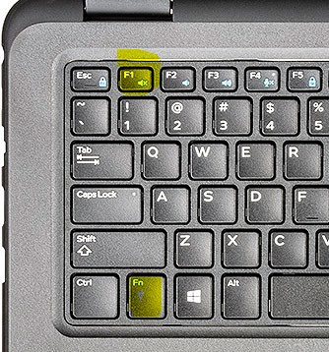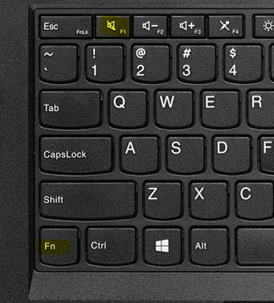
Dell Laptop Lenovo Laptop
Tip: If not muted and no sound comes out, test with headphones. If sound comes out of the headphones, the issue may lie with the laptop’s speaker system.

