Sharing Information HOWTO
PCC Consent to Release Confidential Information

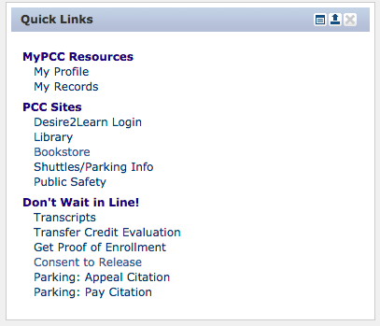
Access to student information is protected by PCC’s privacy guidelines and FERPA law. However, students may elect to provide parent/guardian access to their protected information. ECHS encourages students and families to work cooperatively toward the shared goal of student success. The directions below describe how a student may provide a parent/guardian access to certain information.

1. Student logins into their my.PCC.edu account.

2. Click on “Consent to Release”

3. Enter parent/guardian contact info. Also specify a “Confidential Code”. You will need to supply this when you speak with the Office of Records.
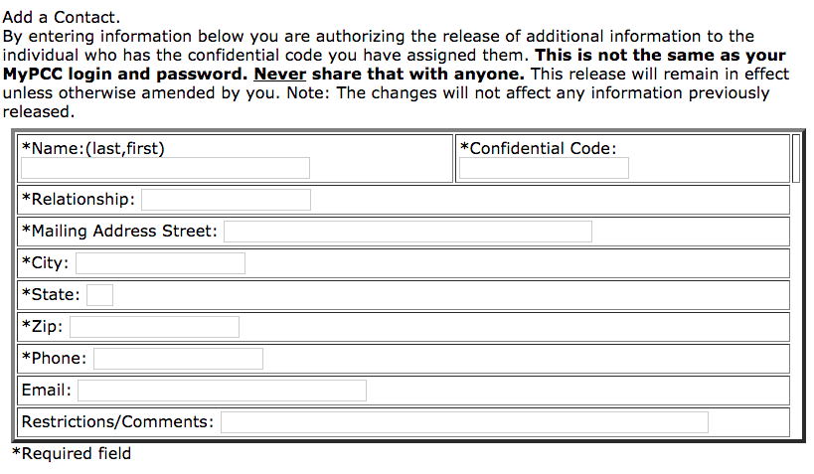
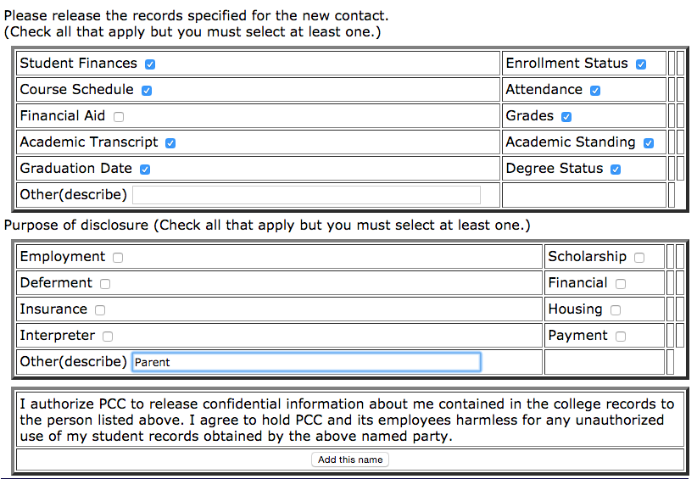

4. Select the types of information to be shared, the purpose, and click “Add this name.”

This process allows a parent or guardian to communicate with the Office of Records (971-722-7100) regarding student information. Note, this does not provide real-time, on-line access nor does this grant the permission to discuss student progress directly with instructors. Also, bear in mind that students in the ECHS program do not qualify for financial aid.

