Notes for Clear Touch Presentation Android Mode (For Beginners)
- The on/off switch in the lower right hand corner of the screen will only turn the screen on/off like your computer monitor…it does not turn off the computer itself. “Restart” is recommended each week for one person who is logged onto the device in the PC mode. This keeps issues from popping up as frequently. You may also turn off the screen using the on/off button when the Clear Touch is not being used.
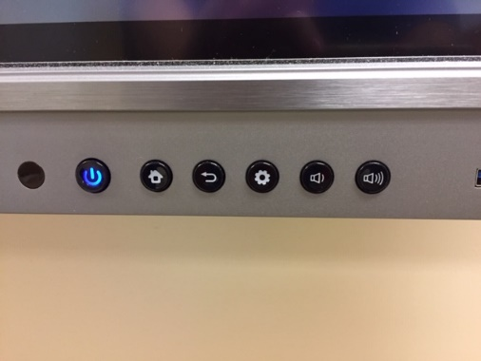

- To quickly use the device as a whiteboard, just walk up to a Clear Touch board (without having to log into the NWCC system) hit the gear icon (lower right hand corner of screen) and choose “ANDROID”.

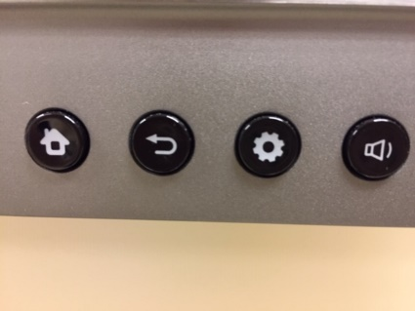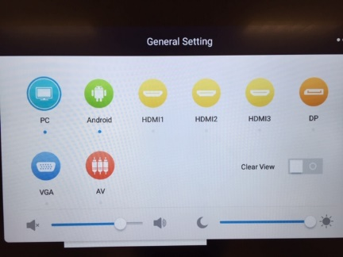

- In this mode, choose “EasiNote” and the screen will now work like a whiteboard.

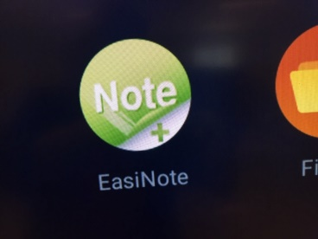

- You may want to choose a different color for the background. The default is green. If so, click the “three bars” in the lower left hand corner, choose “Background”, and select from the color choices. You may also choose an image for a background (from a jump drive???), but I have never tried it.
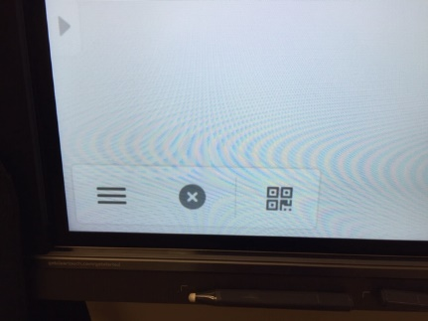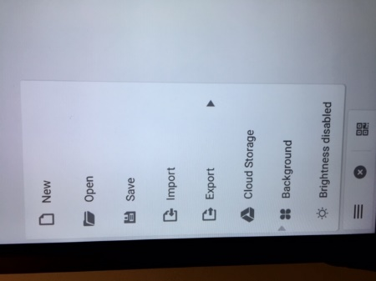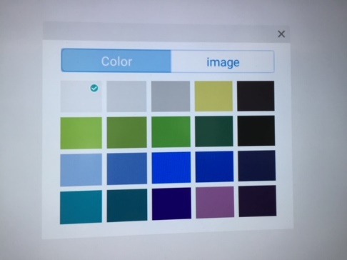

- In the bottom center of the screen, you will see these options. For simply writing, you click on the pencil icon to write. You may change the “ink” color using options that appear when you click the “pencil” icon.
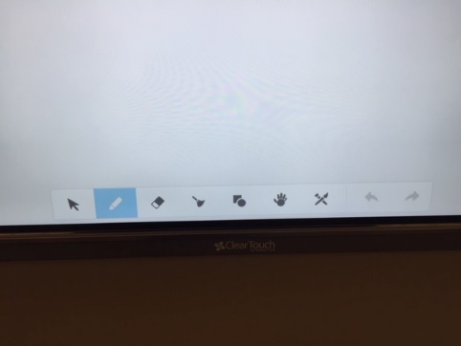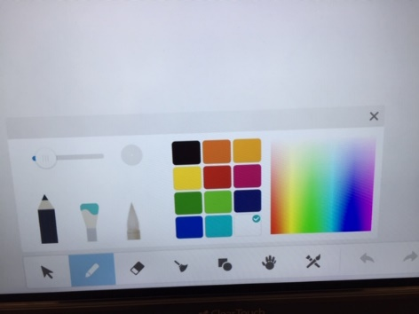

- To erase, you can erase the entire screen at once using the “broom” icon. However, you probably need to use the “eraser” icon and use you open hand to sweep what you wish to erase. You “toggle” between the pencil and eraser buttons.
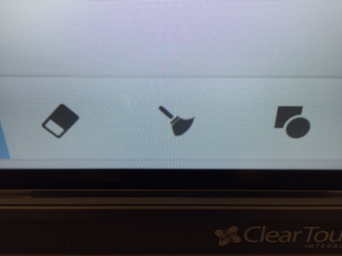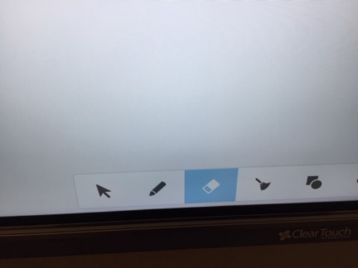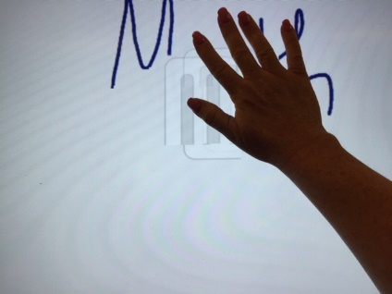

- To add a clear page (without erasing), click on the “plus” in the lower right hand corner. This adds another clear page for you to use. Also notice the arrows and 1/1; this allows the instructor to go back to previous pages of work done this particular session.
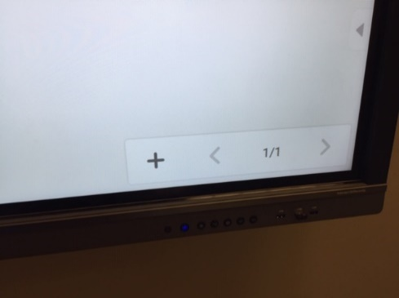

- At the end of class, if you wish to end the session without saving, just click the “X” in the lower left order and choose “Don’t save”. You may then go back to the PC/Android choice (we typically leave it in PC mode for the next instructor). If it is the end of the day, you may wish to turn the screen off using the on/off button.
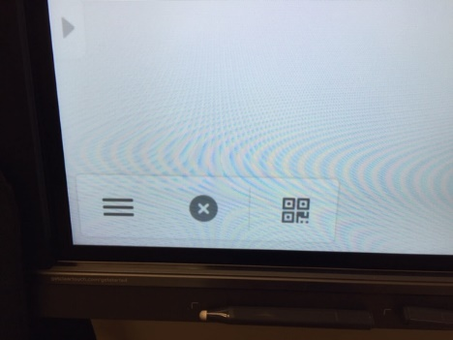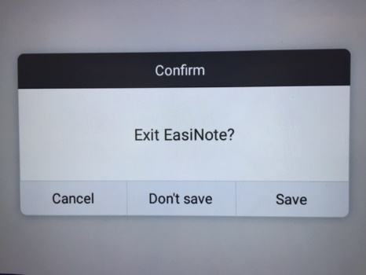
- When the class is over, you may wish to save the session to a jump drive. Make sure your jump drive is inserted into the front of the screen.
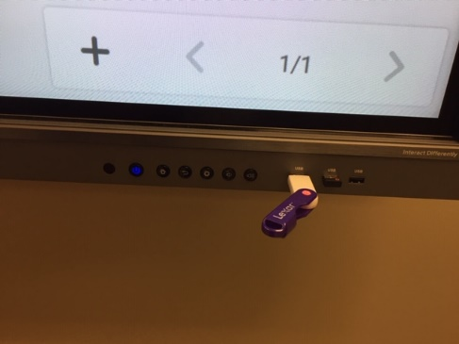
Next, go to the lower left corner and click the three bars. You choose “save”.
Select your jump drive name which will appear under “Storage”.
A file name will be made using number and letters or you can rename it using the keyboard that appears.
Click “OK”.
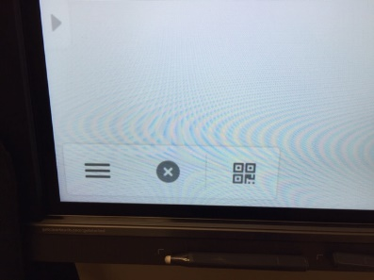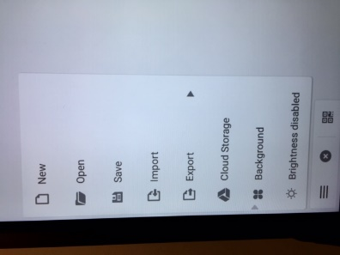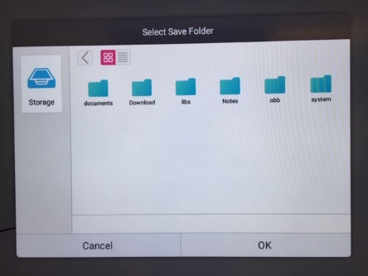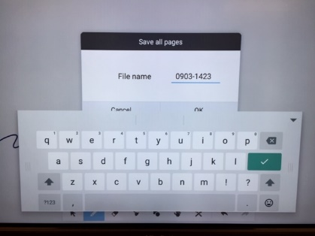
NOTE: I have never “saved” a lecture using ANDROID mode. I would highly suggest using PC mode and saving to your H drive instead of having to keep a jump drive handy.
- You may also allow students to use the “QR code” with their camera on their smart phone to see your Clear Touch document on their device. Hit the “QR code” icon on the lower left hand. Let students scan the QR code with the camera on their phone and then they can choose to view what is on the board using their device.

