Notes for Clear Touch Presentation in PC Mode (For Beginners)
- The on/off switch in the lower right hand corner of the screen will only turn the screen on/off like your computer monitor…it does not turn off the computer itself. “Restart” is recommended each week for one person who is logged onto the device in the PC mode. This keeps issues from popping up as frequently. You may also turn off the screen using the on/off button when the Clear Touch is not being used.
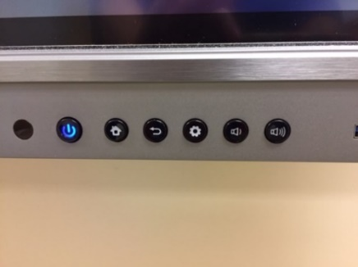

- To use the device as a NWCC computer with access to your H drive, walk up to a Clear Touch board, hit the gear icon (lower right hand corner of screen) and choose “PC”. Most of the time, the Clear Touch is already in PC mode, so this step may not be necessary.

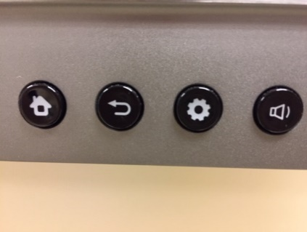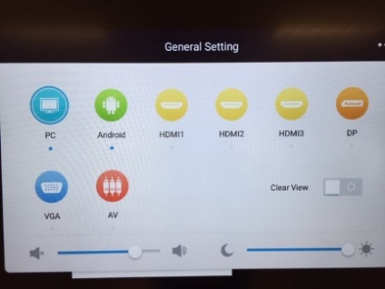

- Click the “NOTE” icon on the desktop or on the bottom tool bar to open a document.
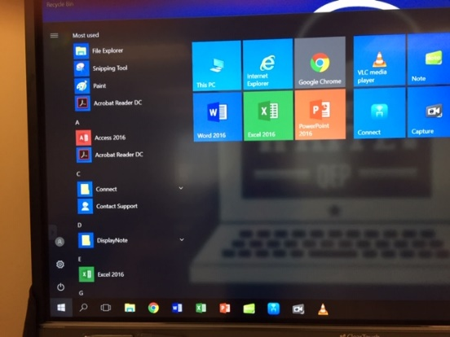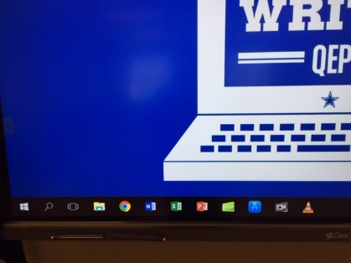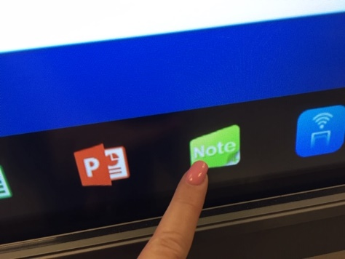

- The Note document will open and you may wish to change the background color (the default is green). Once you change it to your preference, the new color will be the default for you for that particular Clear Touch device. NOTE: If you go to another Clear Touch device at another location, you will still have to change the background color again on that new Clear Touch device…it does not carry over through your NWCC log in.

- Here is how you change the background. Click the three bars in the lower left corner of the screen, choose “settings”, click “default background color” in the box that will be in the center of your screen, choose the color you want from several options, click the check mark. You will see the screen is still green. Exit the Note document without saving it and then click “NOTE” again. Now the background color will be what you chose.
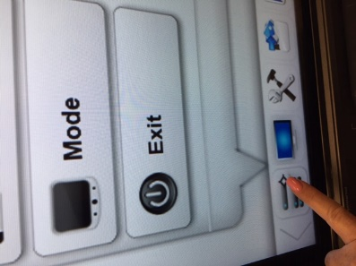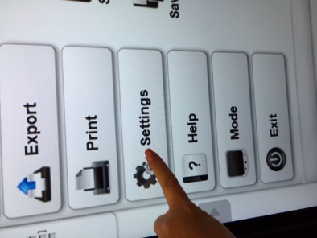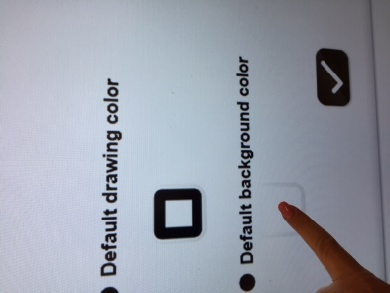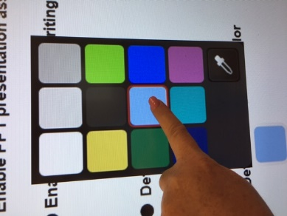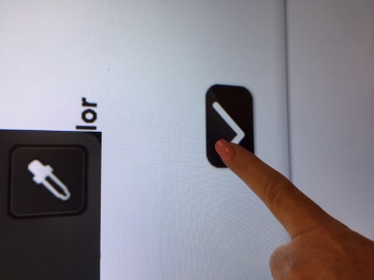

- You will see several menus across the bottom:

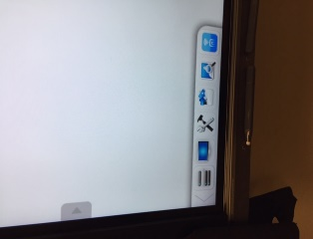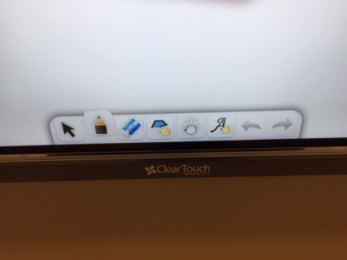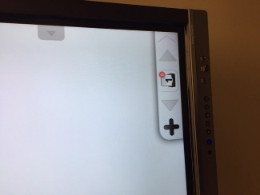

- The menu in the middle is where you find the eraser, pointer, pens,scroll screen up and down options. Click on the pen and you can choose another color, etc. You can use the stylus attached to the bottom of the device, a stylus you may have that is not Clear Touch, or your finger. Warning: You can burn the tips of your finger on the board after prolonged use.

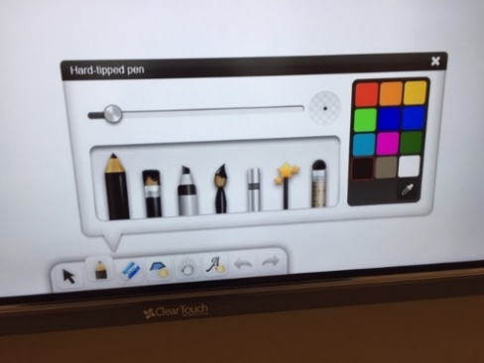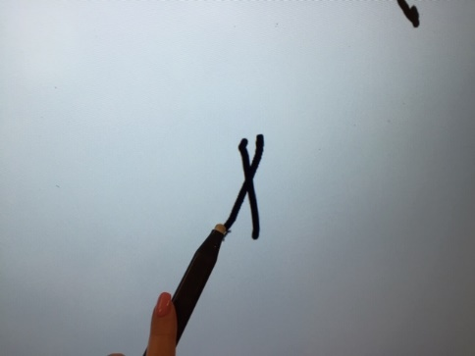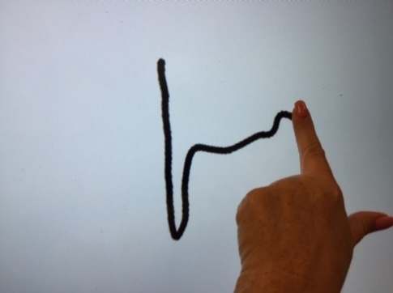

- You can use your flat hand to erase or the eraser icon. I prefer using my hand in place of the icon eraser whose size may need adjusting.
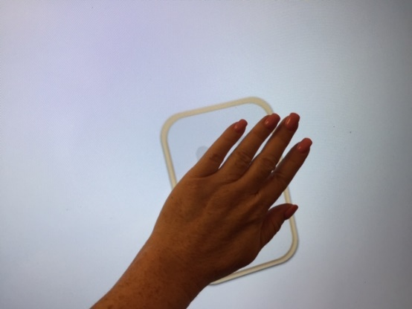

- If you click on the “HAND”, you can use your hand or fingers to scroll the page up or down. Otherwise, your hand is in “eraser” mode. This is handy for continuing a problem down the page instead of creating a new page.

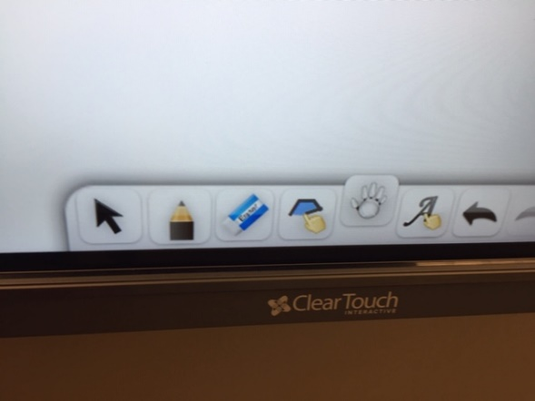
pointer

shapes
handwriting to type
Swipe up and down

There is an option to write with your stylus then use an icon to change the handwriting to type, as long as your handwriting is legible…ha ha! You can also use an icon to draw recognizable shapes. The pointer allows to pick up items and move them on the screen.

- In the corners, these menus can toggle from one side of the screen to the other. This is convenient because you can stay on one side of the board and still access both menus without walking from side to side. Use the arrow key on the far left side of the menu or the far right side of the menu to toggle it to the other corner of the screen. In the left picture below, the “ + ” allows you to add a new page to your document, the number will show which page you are on and the total number of pages, and the left/right arrows take you forward or back to existing pages in your document (like a powerpoint).
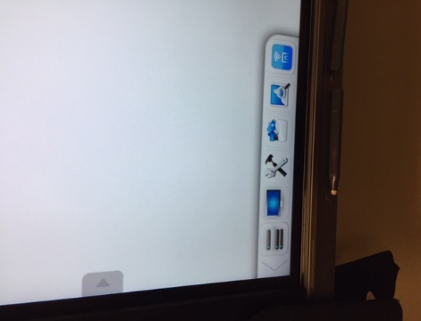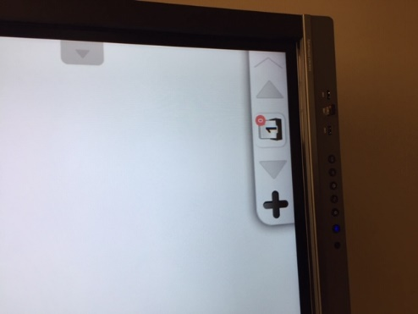

- The last menu to discuss is the left menu (although you can toggle it to the right side of the screen when you need to do so). When you click on the three bars, we have already shown how to change the board’s background color in step 5 using “settings”. There are options other than “settings” that I find useful as an instructor. Click “import” if you wish to bring into your document an image you have saved and want to place in your document. (I import pictures from my H drive frequently). You may also export your finished document as a pdf document, a powerpoint document, word, or image. (I like saving my documents as a pdf so that I can easily attach it as a file in my Canvas shells.) You may print from this option (if there is a printer set up with your Clear Touch). You may want to look at “mode” and “help” options later.
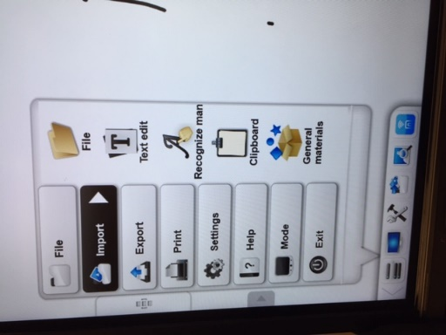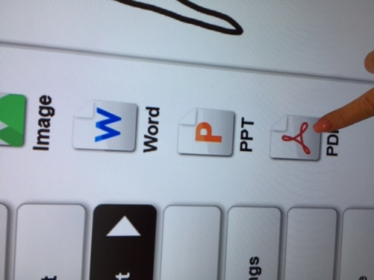
- You also hit “exit” to leave the document and it prompts you to save.

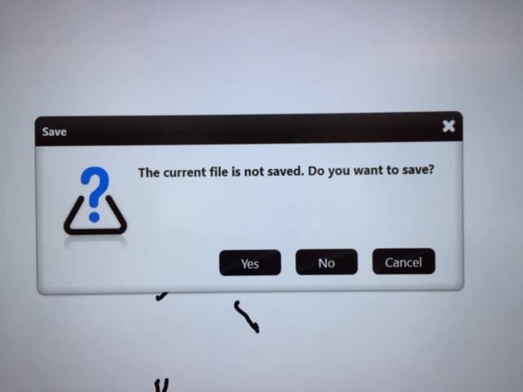

- There are some nice tools you can use from the “toolbox” icon. I use some of the math discipline tools and the clock. However, there are many more…
