Carbon on the Move!

During this “guided lesson” you will apply your understanding of food webs, ecosystems, photosynthesis and cellular respiration to the carbon cycle. The carbon cycle is the movement of carbon throughout the biotic and abiotic factors in an ecosystem. The food web is an integral piece of the carbon cycle as the processes of photosynthesis and cellular respiration play a necessary role in the movement of carbon in an ecosystem.

Please take 20 minutes to carefully read to learn, highlight, and answer the questions on pages 1-4.

Introduction
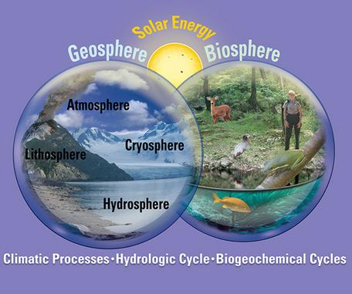
The geosphere and the biosphere are the two components of the Earth System; the geosphere is the collective name for the lithosphere, the hydrosphere, the cryosphere, and the atmosphere. All parts of the Earth System interact and are interrelated through climatic processes and through the water cycle and biogeochemical cycles. The Sun is the dominant source of all external energy to the Earth System. Diagram designed by James A. Tomberlin, USGS.

Carbon is constantly on the move through the different components of Earth's Geosphere and Biosphere, but at very different timescales and spatial scales. For example, the processes that move carbon from the ocean (hydrosphere) to the lithosphere happen over a very large spatial scale and can take timescales of millions of years. In contrast, the process that moves carbon from the leaves of plants in the biosphere to the atmosphere happens in minutes and at a spatial scale as small a leaf's surface.

You will explore the role of food webs in a subset of the natural carbon cycle by analyzing the role of a carbon atom moving through a forest carbon cycle. You will learn that photosynthesis, respiration, ingestion, and decomposition are key food web processes that move carbon from one forest reservoir to another and you will apply thinking strategies to learn about the interconnectedness of the Earth system, feedback loops, and how changes in one part of the carbon cycle system can lead to other changes in the carbon cycle system.

After completing this lesson, you should be able to:
- Describe how the primary carbon cycle processes of photosynthesis, respiration, decomposition, ingestion and combustion transport and transform carbon compounds as they move throughout Earth's Geosphere and Biosphere.
- Identify the four major carbon reservoirs and explain how carbon can move from one reservoir to another.
- Provide examples of the various time scales at which carbon moves through Earth's Geosphere and Biosphere.
- Describe the effects of negative and positive feedbacks on the carbon cycle system.
Organisms in food webs pass the carbon on
In the last unit, you were introduced to food webs and carbon and how carbon cycles through food webs through the processes of photosynthesis and cellular respiration. In this lesson, you will learn how carbon compounds move throughout a terrestrial and aquatic food web.
The global carbon cycle cannot exist without plants and the food webs they support. As autotrophs, plants make their own food in the form of glucose sugar. Heterotrophs, like ourselves, do not photosynthesize and so must find and eat food made of carbon compounds such as proteins, carbohydrates and lipids (fats, oils and waxes). Heterotrophs break these complex organic carbon compounds down into smaller molecules and use the carbon atoms to biosynthesize new organic carbon compounds.
Soil microbes, the smallest organisms in the food web, have one of the most critical roles in transforming and moving carbon compounds through food webs and ecosystems. Their role is threefold:
- When soil microbes (bacteria and fungi) decompose dead material, they break down larger carbon compounds into smaller compounds. This process releases CO₂ to the surrounding soil and to the atmosphere in a process called soil respiration
- Soil microbes move carbon down into the soil where it can be stored for hundreds of years.
- Soil microbes change nitrogen compounds into forms that can be used by plants.

- Examine the terrestrial food web image below, taking time to follow the carbon. Remember that carbon atoms move as part of a carbon compound, not as single atoms.
- Then, check your understanding of how carbon moves through food webs by answering the Checking In and Stop and Think questions below.
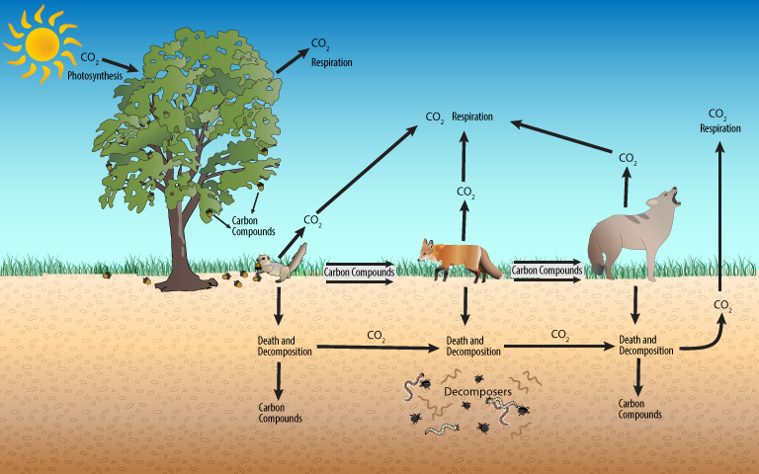
A Terrestrial Carbon Cycle

Checking In
Check your understanding of how carbon moves through food webs by answering the questions below. Select all the answers that are correct and then click the Check Answers button at the bottom of the list.
Top of Form
- What process brings in carbon from the atmosphere into the terrestrial food web?
respiration
photosynthesis
ingestion (eating)
decomposition

- Carbon compounds move from plants to animals via the process(es) of______?
respiration
photosynthesis
ingestion (eating)

- Which process(es) moves carbon from above-ground food webs to the food web in the soil?
respiration
photosynthesis
ingestion (eating)
death and decomposition

- Which process(es) releases carbon from food webs back into the atmosphere in the form of carbon dioxide?
respiration
photosynthesis
ingestion (eating)
decomposition
Bottom of Form

Stop and Think
1: Examine the Terrestrial Carbon Cycle food web diagram again. Describe how the carbon atoms in carbon dioxide molecules originally found in the atmosphere can end up in a coyote. Use a diagram to help you explain your answer if you need to. Take 5 minutes to describe/sketch/diagram in the space below.

Carbon atoms move through a forest ecosystem
The food web carbon cycle you just investigated operates on a much smaller spatial scale than a larger, more complex forest ecosystem carbon cycle. You will view some video clips of the carbon cycle and carbon reservoirs (sinks.) Before beginning, there are two carbon cycle terms you need to know:
Carbon Reservoir: A carbon reservoir is a place in the Earth System where carbon atoms are stored. Carbon reservoirs can be large like an ocean, microscopic like bacteria and somewhere in-between.
Carbon Cycle Process (also called a flux): A carbon cycle process causes carbon to move from one reservoir to another. Processes in the forest carbon cycle include photosynthesis, respiration, decomposition, ingestion, excretion, combustion (burning of materials using oxygen and producing heat and CO₂,) and diffusion (movement of molecules from an area of high concentration to an area of low concentration.)
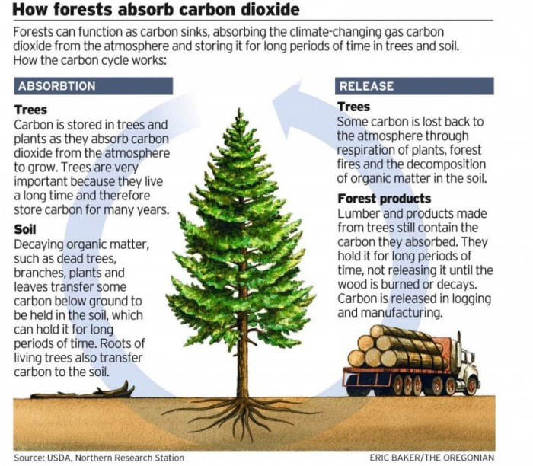

Checking In
Top of Form
- Which forest carbon cycle process(s) moves carbon from the Biosphere to the Geosphere? Choose all that apply.
ingestion
combustion/burning
respiration
photosynthesis
diffusing

2. List the four carbon reservoirs/sinks/stores

