Cities drive animals and plants to evolve
Species are adapting to urban pollution, traffic and shrinking habitats through changes in their genes
SHARON OOSTHOEK
APR 6, 2017 — 7:10 AM EST
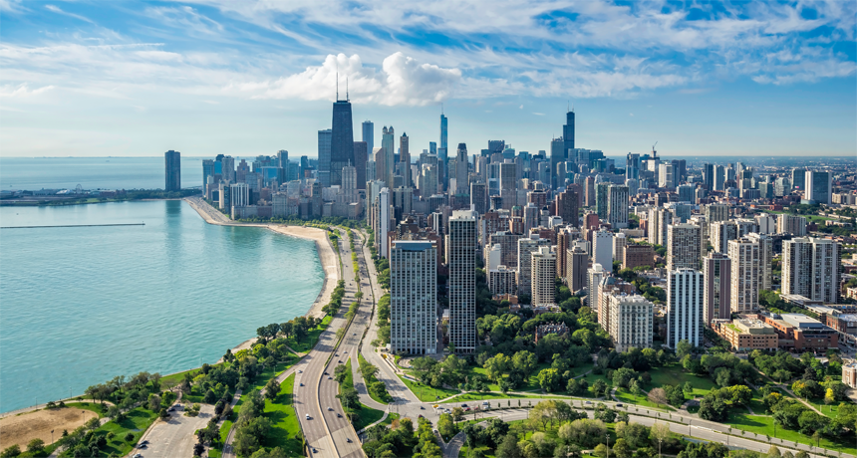
Even in Chicago, here, home to almost 2.7 million people, there are parks and spaces where wildlife live. Some species may have made genetic accommodations, however, to survive in such congested landscapes, studies now show.
MARCHELLO74 /ISTOCKPHOTO
Ever seen a raccoon unlatch a garbage can in search of leftovers? Or shimmy across power lines to get from one rooftop to another? If so, you've witnessed an animal adapting its behavior to city life. That's been going on since people started building cities thousands of years ago.
Now, biologists are seeing signs that animals and plants are also adapting in a more basic way to survive in cities. Their genes are changing.
Genes are segments of DNA that influence how an organism looks and functions. An animal or plant’s DNA is like an instruction book for how it develops and grows. Some instructions guide its reproductive habits. Others influence the way it moves. Still others might let it withstand poison.
Urban pollution, traffic and shrinking wild spaces have been causing changes in these genetic instructions. And scientists have been tracking more and more signs of these genetic changes. They’ve seen it in fish in New York's polluted Hudson River, in weeds growing out of sidewalks in France, in cliff swallows living near highways in Nebraska and in the mice scampering through New York City parks.
When genes change in response to their environment, it’s called evolution. Some of those changes may leave animals and plants better suited to their homes. It may offer new traits that increase the odds of surviving long enough to reproduce. This means the individuals will pass on these new traits to their offspring. Eventually, traits that had once been rare can now become common throughout a population.
Until fairly recently, scientists thought evolution happened very slowly — too slowly for people to notice during their lifetimes. But no more. "We are now showing evolution can occur a lot faster than most people think," says Isaac Wirgin. And, he adds, that’s true "especially in urban environments."
Wirgin is an expert in environmental medicine at New York University Medical Center in New York City. He studies how the environment affects the health of animals, including humans. It may seem like a good thing for animals and plants to adapt to city life. But he warns that there can be costs that biologists are only beginning to understand.
"In my mind, it's not a good thing," he says. "Usually if you evolve to become less sensitive to a pollutant, you're less good at reproduction or life expectancy, or you're more sensitive to other stressors."
Wirgin is talking about evolutionary costs. These are trade-offs. To gain some advantage, a species often will pay a price. For example, if an animal evolves to become bigger, fewer predators can kill it. But being bigger will now mean the animal needs more food. And that can be a problem when food becomes scarce.

The case of the Hudson River PCBs
Urban evolution is hardly new. During the Industrial Revolution in the 1800s, heavily polluted areas of Britain turned black with soot. The light-colored peppered moths that lived there now stood out against dark walls and tree trunks. In no time, they were picked off by predators. But some mutations — accidental genetic changes — caused some peppered moths to have black wings. This camouflaged them in the newly sooty environment. And over time, they survived to breed more black moths. The light-colored ones didn’t. In short order, most peppered moths were now black.
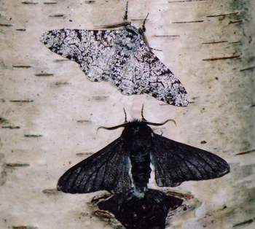
Peppered moths changed from speckled white to mostly black (examples of each here) in Britain during the Industrial Revolution. This darkening let the moths blend in with the soot in heavily polluted areas.
ILIK SACCHERI
In the past hundred years, humans have built and enlarged cities at a much faster pace than ever before. As cities grew, so did their impacts on the environment — and on evolution. A century ago, just two in every 10 people lived in towns. Today, more than half of us do. And our cities are rapidly spreading across more and more of the globe.
A growing number of scientists are asking what this means for city wildlife. Wirgin is among them. He led a research team that studied fish living in a very polluted segment of the Hudson River. Some these fish, called tomcod, carried a genetic variant. That’s a gene with a slightly different DNA sequence — or genetic blueprint — from most others of its species.
This genetic variant helped the tomcod that carried it withstand some toxic chemicals called PCBs, for polychlorinated biphenyls (Paal-ee-KLOR-ih-nay-ted By-FEE-nuls)).
Manufacturers relied on these chemicals for many decades as a fluid to insulate industrial equipment. And from 1947 to 1976, two General Electric plants spewed PCB pollution into the Hudson River. In all, they released nearly 600,000 kilograms (about 1.3 million pounds) of those oily chemicals. PCBs don't easily break down, so they can remain in air, water and soil for a long time.
Eventually, the United States banned the production of PCBs, as did other nations. Prompting that decision: Research showed PCBs could cause cancer in animals, and likely posed a similar risk to people.
What about those Hudson River fish living amidst all of that PCB pollution? Many young fish exposed to PCBs are severely deformed. For instance, they may lack a jaw. With such defects, these fish can starve.

Some protection comes with a cost
But the tomcod with the newfound genetic variant survived. This variant showed up in a gene called AHR2. It appears to shield the fish from PCBs’ normal toxicity. Wirgin and his team published their findings in Science.
Here’s how the gene adaptation works: The normal form of AHR2 gives instructions for building a certain protein in the fish. To do damage, PCBs must attach to this protein. But the variant gene gives slightly different protein-building instructions. This change makes it hard for PCBs to latch on.
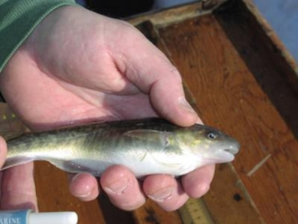
Researchers discovered a mutation in tomcod that is now common among those in a polluted stretch of the Hudson River. It lets these fish survive in these waters, still heavily contaminated with PCBs.
Mark Mattson of Normandeau Assoc.
A small number of tomcod carried this gene variant before this region of the Hudson River became heavily polluted with PCBs. After the oily pollutants started pouring into the river, tomcod with the more common gene mostly died off. Today, nearly all tomcod in this part of the Hudson carry the protective form of the AHR2 gene.
Elsewhere, in less polluted areas — in Canada and New England, for example — tomcod populations still have the susceptible form of the gene.
Wirgin’s group did not look for a cost to the tomcod's resistance to PCBs. But other researchers found such a trade-off in a different fish, the Atlantic killifish.
Joel Meyer and Richard Di Giulio of Duke University in Durham, N.C., studied this species in Virginia's Elizabeth River. A former wood-treatment plant had polluted the water with a family of chemicals known as PAHs, for polycyclic (PAH-lee-SIK-lik) aromatic hydrocarbons. These chemicals have been linked to cancers and heart deformities.
The killifish in this river showed no sign of such effects. They did, however, show less tolerance than most of their species for the low oxygen levels that sometimes occur in many lakes and rivers. Concluded Meyer and DiGiulio: These fish paid a price for evolving the ability to resist these toxic pollutants.
But back to the Hudson River tomcod. When they evolved resistance to PCBs, there may have been wider effects on the ecosystem, says Wirgin. Tomcod are a favorite snack for larger fish. When predators eat those tomcod, they now get a toxic bonus — some PCBs in every bite. Pollutants from the smaller fishes’ bodies build up in larger fish. This process is known as bioaccumulation.
There is no research on how it affects tomcod-munching fish. But Wirgin says this points to how urban evolution could affect entire food webs.

City weeds and cliff swallows
Plants have also evolved to meet the challenges of city living. Pierre-Olivier Cheptou is an evolutionary ecologist at the University of Montpellier in France. He studied a common weed called Crepis sancta. It grows in small patches of soil around sidewalk trees in Montpellier. He compared city-dwelling members of this species to those in the surrounding countryside.
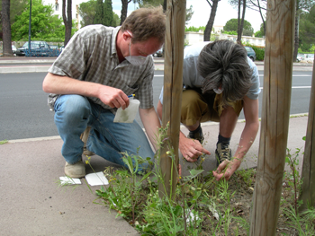
University of Montpellier evolutionary ecologist Pierre-Olivier Cheptou and his student collect seeds from weeds growing around sidewalk trees in Montpellier, France.
S. Popy
Those in the country tend to make lightweight seeds, they found. These easily travel with a breeze. But in the city, such seeds would probably fall onto concrete and die. So there, the city weeds produced compact seeds. Being relatively heavy, they drop close to the plant. That allows them to sprout in the surrounding soil. Cheptou published his team's study in the Proceedings of the National Academy of Sciences.
This change will likely have an evolutionary cost for the plants, he says. If their seeds don’t travel far, the weeds are unlikely to breed with those in other patches of soil. This means the population will develop less variation in its DNA. In other words, they will have little genetic diversity. Wildlife with little genetic diversity tend to be more vulnerable to disease.
Traits that help an organism survive in the short term, such as heavier seeds, “may lead to extinction in the longer term," worries Cheptou.
Still, there may be plants and animals that have evolved to handle city living without paying a price. Cliff swallows nesting under highway overpasses in Nebraska might be among them.
Charles Brown is an ecologist who works at University of Tulsa in Oklahoma. Since 1982, he and Mary Bomberger Brown have been studying cliff swallows. Mary is an ornithologist, or bird biologist. She works at the University of Nebraska in Lincoln.
The cliff swallows they study have been building their gourd-shaped mud nests under highway overpasses in southwestern Nebraska. Over 30 years, the two scientists saw a steady drop in the number of birds killed by cars and trucks. And this surprised them. After all, the bird colonies were growing and the traffic had not declined.
Mist nets are pieces of see-through mesh hung between two poles. Scientists use them to safely capture birds for study. The researchers set up such nets close to the bridge. And as they compared road-killed birds with those caught in nearby mist nets, they got another surprise. Birds in their mist nets had much shorter wings than those killed by the cars.
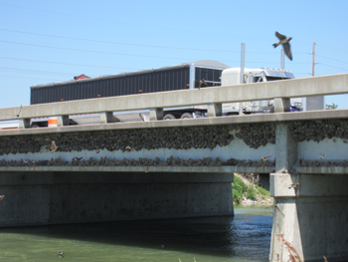
A cliff swallow flies by its nesting site under a highway in Nebraska. These birds have evolved shorter wings that may help them better swerve to avoid oncoming traffic.
Charles Brown
The researchers now think shorter wings help birds dodge traffic better. That’s why short-winged birds were more likely to end up alive in the nets, not dead on the street.
A change to a major physical trait, such as wing length, is almost certainly a result of a genetic change, says Charles Brown. Unlike the road-killed birds, these short-winged fliers have survived long enough to pass down their genes. The researchers published their results a few years ago in the journal Current Biology.
Brown says birds evolving shorter wings over a few decades really surprised him. He agrees with Wirgin and Cheptou that such evolution can sometimes make an animal or plant less able to deal with other types of stress. But he and Bomberger Brown did not find any harmful side effect in the birds they studied.
"It would appear to be a win-win situation for the swallows," he concludes.

Lonely mice
White-footed mice also may be evolutionary winners.
These mice once lived all over North America. But in New York City, they are now stuck mostly in city parks. Those in each park are separated from those elsewhere by roads and buildings. This means that those in one park can't breed with those in another. The mice in each park have therefore evolved genes that help them survive in their specific home turf.
Some populations have evolved a genetic variant that protects them from being poisoned by heavy metals such as lead and chromium. (Heavy metals can be part of a waste produced by some industries. Lead and chromium, for instance, can cause organ damage and probably also cancer.) The mice exposed to such heavy metals likely evolved the genetic variant because the soil in their parks has accumulated so much chromium or lead over the years.
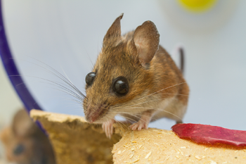
White-footed mice in New York City parks have evolved genes that help them survive exposures to heavy metals and infectious germs.
Wikimedia Commons (CC BY-SA-3.0)
Other populations of park mice evolved genes that boost their ability to fight disease. That is probably because they are crowded into a particularly small area. Such tight quarters tend to make it easier for diseases to spread.
That’s the conclusions that Jason Munshi-South came to, anyway. He’s a biologist at Fordham University in New York City. He has been studying these mice. His team described its findings a few years ago in PLOS ONE.
A small number of mice were likely already carrying the genes that protect against heavy metals or infectious diseases. Mice with these variant genes lived long enough to have babies and pass down their genes. Eventually, more and more of them made up most of the population.
That's good news for the mice. But Munshi-South says that doesn't mean other animals can similarly evolve rapid changes to survive the challenges of city living. Indeed, he observes: "Most species do not do well in cities and no longer occur there."

Power Words
(for more about Power Words, click here)
adaptation (in biology) A process by which living things become better suited to their environment through inheritance. When a community of organisms does this over time, scientists refer to the change as evolution.
bioaccumulate A term for the body’s process of picking up substances (usually from the environment) and then storing them within tissues (such as fat or bone) in ever-growing quantities.
biology The study of living things. The scientists who study them are known as biologists.
breed (verb) To produce offspring through reproduction.
cancer Any of more than 100 different diseases, each characterized by the rapid, uncontrolled growth of abnormal cells. The development and growth of cancers, also known as malignancies, can lead to tumors, pain and death.
chemical A substance formed from two or more atoms that unite (become bonded together) in a fixed proportion and structure. For example, water is a chemical made of two hydrogen atoms bonded to one oxygen atom. Its chemical symbol is H₂O. Chemical can also be an adjective that describes properties of materials that are the result of various reactions between different compounds.
contaminant Pollutant; a chemical, biological or other substance that is unwanted or unnatural in an environment such as water, soil, air or food. Some contaminants may be harmful in the amounts at which they occur or if they are allowed to build up in the body over time.
DNA (short for deoxyribonucleic acid) A long, double-stranded and spiral-shaped molecule inside most living cells that carries genetic instructions. It is built on a backbone of phosphorus, oxygen, and carbon atoms. In all living things, from plants and animals to microbes, these instructions tell cells which molecules to make.
ecosystem A group of interacting living organisms — including microorganisms, plants and animals — and their physical environment within a particular climate. Examples include tropical reefs, rainforests, alpine meadows and polar tundra.
ecology A branch of biology that deals with the relations of organisms to one another and to their physical surroundings. A scientist who works in this field is called an ecologist.
environment The sum of all of the things that exist around some organism or the process and the conditions that those things create for that organism or process. Environment may refer to the weather and ecosystem in which some animal lives, or, perhaps, the temperature, humidity and placement of components in some electronics system or product.
evolution (v. to evolve) A process by which species undergo changes over time, usually through genetic variation and natural selection. These changes usually result in a new type of organism better suited for its environment than the earlier type. The newer type is not necessarily more “advanced,” just better adapted to the particular conditions in which it developed.
evolutionary ecologist Someone who studies the adaptive processes that have led to the diversity of ecosystems on Earth. These scientists can study many different subjects, including the microbiology and genetics of living organisms, how species that share the same community adapt to changing conditions over time, and the fossil record (to assess how various ancient communities of species might be related to each other and to modern-day relatives).
evolve (adj. evolving) To change gradually over a long period of time. In living organisms, evolution usually involves random changes to genes that will then be passed along to an individual’s offspring. But the term may be applied more casually to point to things (such as an individual’s brain development) that change in form or function, over time, in response to cues (such as developmental hormones).
extinction The permanent loss of a species, family or larger group of organisms.
food web (also known as a food chain) The network of relationships among organisms sharing an ecosystem. Member organisms depend on others within this network as a source of food.
gene (adj. genetic) A segment of DNA that codes, or holds instructions, for producing a protein. Offspring inherit genes from their parents. Genes influence how an organism looks and behaves.
genetic diversity The range of genes types — and traits — within a population.
habitat The area or natural environment in which an animal or plant normally lives, such as a desert, coral reef or freshwater lake. A habitat can be home to thousands of different species.
hydrocarbon Any of a range of large molecules containing chemically bound carbon and hydrogen atoms. Crude oil, for example, is a naturally occurring mix of many hydrocarbons.
Industrial Revolution A period of time around 1750 that was marked by new manufacturing processes and a switch from wood to coal and other fossil fuels as a main source of energy.
journal (in science) A publication in which scientists share their research findings with the public. Some journals publish papers from all fields of science, technology, engineering and math, while others are specific to a single subject. The best journals are peer-reviewed: They send out all submitted articles to outside experts to be read and critiqued. The goal, here, is to prevent the publication of mistakes, fraud or sloppy work.
lead A toxic heavy metal (abbreviated as Pb) that in the body moves to where calcium wants to go (such as bones and teeth). The metal is particularly toxic to the brain. In a child’s developing brain, it can permanently impair IQ, even at relatively low levels.
mist net Fine mesh net used by biologists to capture — without harm — birds and bats for research.
mutation (v. mutate) Some change that occurs to a gene in an organism’s DNA. Some mutations occur naturally. Others can be triggered by outside factors, such as pollution, radiation, medicines or something in the diet. A gene with this change is referred to as a mutant.
organ (in biology) Various parts of an organism that perform one or more particular functions. For instance, an ovary is an organ that makes eggs, the brain is an organ that makes sense of nerve signals and a plant’s roots are organs that take in nutrients and moisture.
organism Any living thing, from elephants and plants to bacteria and other types of single-celled life.
ornithologist A scientist who studies birds, their behaviors and ecosystems.
pollutant A substance that taints something — such as the air, water, our bodies or products. Some pollutants are chemicals, such as pesticides. Others may be radiation, including excess heat or light. Even weeds and other invasive species can be considered a type of biological pollution.
polycyclic aromatic hydrocarbons (or PAHs) A family of hydrocarbons. Many form naturally as part of crude oil. Some are formed when materials burn incompletely. Most PAHs occur in groups of two or more. Some of these compounds can be quite toxic.
polychlorinated biphenyls (or PCBs) A family of 209 chlorine-based compounds with a similar chemical structure. They were used for many decades as a nonflammable fluid for insulating electrical transformers. Some companies also used them in making certain hydraulic fluids, lubricants and inks. Their production has been banned in North America and many countries throughout the world since around 1980.
population (in biology) A group of individuals from the same species that lives in the same area.
proteins Compounds made from one or more long chains of amino acids. Proteins are an essential part of all living organisms. They form the basis of living cells, muscle and tissues; they also do the work inside of cells. Among the better-known, stand-alone proteins are the hemoglobin (in blood) and the antibodies (also in blood) that attempt to fight infections. Medicines frequently work by latching onto proteins.
resistance The ability of an organism to fight off disease.
species A group of similar organisms capable of producing offspring that can survive and reproduce.
stress (in biology) A factor, such as unusual temperatures, moisture or pollution, that affects the health of a species or ecosystem.
toxic Poisonous or able to harm or kill cells, tissues or whole organisms. The measure of risk posed by such a poison is its toxicity.
trait A characteristic feature of something. (in genetics) A quality or characteristic that can be inherited.
urban Of or related to cities, especially densely populated ones or regions where lots of traffic and industrial activity occurs. The development or buildup of urban areas is a phenomenon known as urbanization.
variant (in genetics) A gene having a slight mutation that may have left its host species somewhat better adapted for its environment.
waste Any materials that are left over from biological or other systems that have no value, so they can be disposed of as trash or recycled for some new use.

Readability Score:

7.4

Questions for ‘Cities drive animals and plants to evolve’
SCIENCE NEWS FOR STUDENTS
APR 6, 2017 — 7:05 AM EST
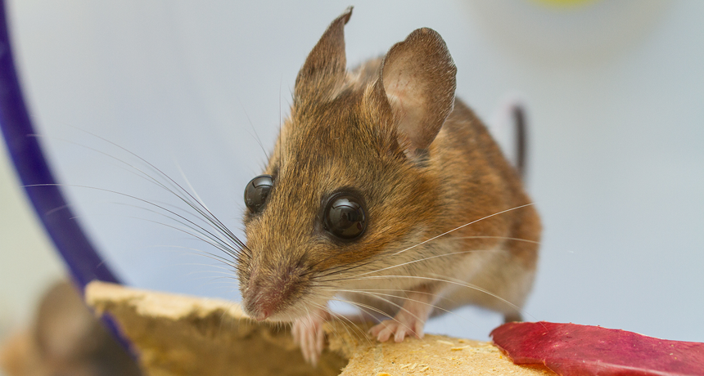
Certain mice have picked up gene changes that leave them adapted to harsh conditions in the New York City parks they call home.
WIKIMEDIA COMMONS (CC BY-SA-3.0)
To accompany feature “Cities drive animals and plants to evolve”

SCIENCE

Before Reading:
1. What is evolution?
2. What kinds of struggles might plants and animals that live in cities experience that their country cousins would not?

During Reading:
1. What are four examples of cases in which scientists have seen the genes of organisms changing in response to the stresses of city living?
2. Describe the basic concept of evolution and how it helps species survive and thrive.
3. Does Isaac Wirgin think urban evolution is a good thing or a bad thing? Why?
4. What is the genetic variant that tomcod fish in PCB-polluted segments of the Hudson River have evolved?
5. What evidence have scientists found that pollution resistance has taken a toll on Atlantic killifish?
6. How has the plant Crepis sancta evolved to survive and thrive in an urban setting?
7. What does the term genetic diversity mean?
8. What is an ornithologist?
9. What type of adaptation have cliff swallows made in certain environments in Nebraska? How has this change apparently allowed these birds to largely avoid becoming roadkill?
10. What two protective genetic variants have white-footed mice in New York City evolved?

After Reading:
1. In the town or city where you live, what kinds of adaptations do you think plants or animals might have evolved that would make it more likely for their species to survive and reproduce? Give two examples.
2. According to the story, some birds living under highway overpasses have evolved a wing adaptation that lets them more easily dodge traffic. Can you think of any disadvantages that such a genetic variant might create?

MATH
1. The story says that from 1947 to 1976, two plants released nearly 600,000 kilograms (about 1.3 million pounds) of PCBs into the Hudson River. If the same amount was released every day, what amount of PCBs was spewed, on average, every day over that period? (Assume that the releases started on Jan. 1, 1947 and were ongoing through Dec. 31, 1976.) Show your work.
2. The story says that a century ago, 2 in every 10 people lived in cities. Today the number is 5 in every 10. Find the number of people that live in your city (or the closest major city to you). If the same trend held for your town (and it may not, owing to its age), how many people would have been living there a century ago? Show your work.

Citation
Journal: S.E. Harris et al. Signatures of rapid evolution in urban and rural transcriptomes of white-footed mice (Peromyscus leucopus) in the New York metropolitan area. PLOS ONE. Vol. 8, August 28, 2013, p. e74938. doi: 10.1371/journal.pone.0074938.
Journal: C.R. Brown and M.B. Brown. Where has all the road kill gone? Current Biology. Vol. 23, March 18, 2013, p. R233. doi: 10.1016j.cub.2013.02.023.
Journal: I. Wirgin et al. Mechanistic basis of resistance to PCBs in Atlantic tomcod from the Hudson River. Science. Vol. 331, March 2011, p. 1322. doi: 10.1126/science.1197296.
Journal: P.O. Cheptou et al. Rapid evolution of seed dispersal in an urban environment in the weed Crepis sancta. Proceedings of the National Academy of Sciences. Vol. 105, March 11, 2008, p. 3796. doi: 10.1073/pnas.0708446105.
Journal: J. N. Meyer et al. Heritable adaptation and fitness costs in killifish (Fundulus heteroclitus) inhabiting a polluted estuary. Ecological Applications. Vol. 13, April 1, 2003, p. 490. doi: 10.1890/1051-0761(2003)013[0490:HAAFCI]2.0.CO;2.

