CREATIVE ANIMAL ADAPTATIONS
Teacher Directions:
After completing lessons on natural selection and evolution, students can make a creative, fictional account about how an organism evolved a particular trait. While the story is fictional, the principles governing the evolution of this animal or adaptation must be sound. Students should be certain to explain how and organisms survival and ability to reproduce and pass on genes led to a change in a population. There are guideline slides below to support students if they opt to also include a change in the bell curve.

Student Directions:
- Choose an animal with one or more “odd” adaptations. Make up a story explaining how the adaptation(s) developed. Please include details about which adaptations were not successful and how they were removed from the gene pool and clearly explain why the current adaptation was successful and how it remained in the gene pool.
- Make a graph (with labeled axes) that shows the original bell curve (dotted line) and where it is now. Identify it as disruptive, stabilizing or directional.
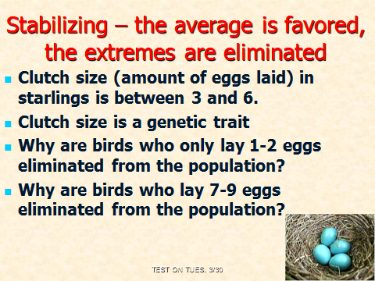
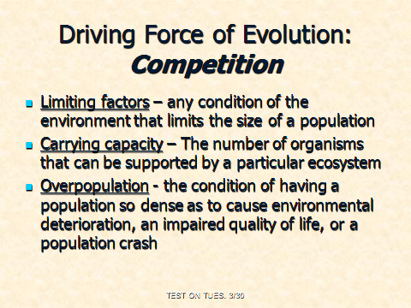

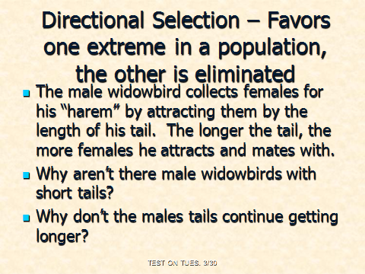
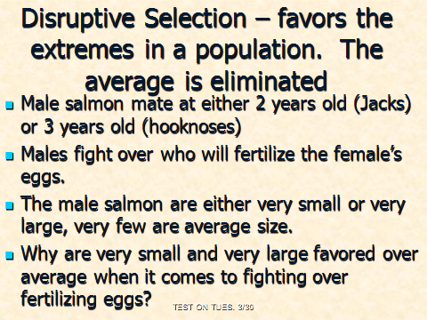

Sarah Sandora – Madison Public Schools

