SCIENCE OUTREACH
DEPARTMENT OF BIOLOGY

The Basics of Evolution
The Fundamental Process
Biological evolution occurs when individual organisms with particular characteristics replace other individuals with other characteristics. It is not that the characteristics of any single individual change, or evolve, during its lifetime. Rather, each individual lives its life in its own way, producing offspring if and when it can.
The key to evolution is the degree of success with which each individual produces offspring. Any genetically-heritable characteristics can be passed on to offspring. Consequently, those individuals that have the most offspring contribute the most to future generations. Those individuals that have the least offspring contribute the least to future generations. Over the course of many generations, some genetically-heritable characteristics are lost from the population overall, while others become common.
Evolution can occur only if there are different genetically-heritable characteristics in a population of organisms. There must be genetic diversity. In nearly all populations of nearly all species, there isgenetic diversity. Partly, this is because the genetic information is re-assorted at each generation. It is also because mutations occasionally occur, causing changes in genetic information. Once a mutation occurs, and is passed on to the offspring of the first individual to carry that mutation, then the mutation becomes a part of the genetic diversity of the population.
Evolution can occur rapidly or very slowly. It occurs slowly, if at all, when the particular characteristics of a population make it well-suited to the environment in which it lives. Under such conditions, most mutational changes make individuals less suited to the environment. As a result, the more common characteristics remain the norm.
Rapid evolution can occur during times of environmental change. A population's environment can change if the individuals in that population migrate to a new location. Or, environmental conditions can change for numerous reasons, including long-term climate change, the introduction of a new species, or the loss of a previously-common species. In a new environment, genetic variations that were previously uncommon may be advantageous. Individuals with these variations may now out-compete their fellows, and their genetic variations may become the new norm for that population.
The fundamental principles of evolution are these:
1. Evolution depends upon genetic variation.
2. Evolution occurs as some genetic variations become common in populations, and others become rare.
3. The source of genetic variation is mutation. Genetic variation can be augmented by genetic reassortment during the production of offspring.
4. Individual organisms do not change or evolve. Evolution is the replacement, over the course of numerous generations, of some genetic variations by other genetic variations.
5. It is not possible to mutate in anticipation of environmental change, or to direct mutations to specific characteristics. Mutation is not a conscious process.
Below, we explore some of the details:
DNA, Genes, Mutations, and the Characteristics of Organisms
Genetic inheritance depends upon genes, which are segments of DNA, the fundamental chemical of chromosomes. DNA carries the "information" that determines how organisms grow and develop, and that determines many of their characteristics. It does not dictate all of an individual's characteristics, because many aspects of most species are shaped by the peculiarities of the environment in which they live.
Every individual of every species begins life as a single cell. In the case of humans, that single cell is the fertilized egg, which contains one set of chromosomes contributed by the mother, and one set of chromosomes contributed by the father. As the fertilized egg divides and the cells differentiate to become all of the different cell types of a human, the DNA molecules of the fertilized egg must be duplicated over and over, so that each of our trillions of cells contains an exact copy of the DNA contained in the fertilized egg. DNA replication must be tremendously accurate to ensure that every cell contains the information that it needs.
Although DNA replication is tremendously accurate, it is not 100% accurate. Occasionally, mistakes are made. If mistakes occur in the DNA of genes, then those genes are altered.
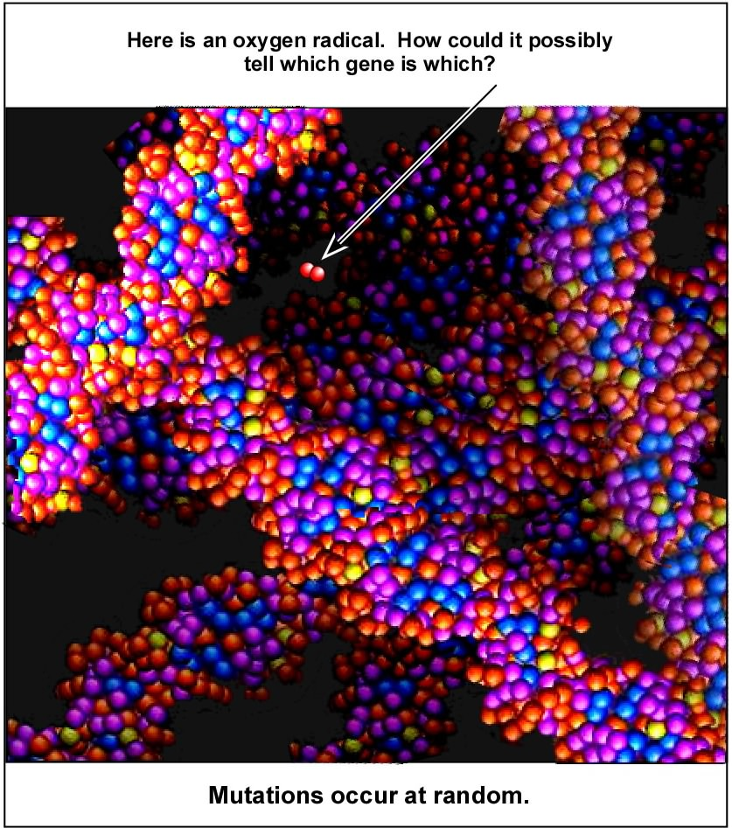
DNA is a chemical. Therefore, it follows the laws of chemistry. Consequently, DNA molecules can be damaged--chemically altered--by radiation, chemicals, cosmic rays, oxygen radicals, etc. Although DNA damage can often be repaired, it is not always repaired, and repair may be imperfect. Damage and/or imperfect repair can also alter genes.
These changes to DNA are mutations. Because they occur by normal, chemical mechanisms, it is impossible to prevent them from occurring. It is also impossible to cause them to occur in specific genes . They occur at random.
"Random mutation" does not mean "un-caused mutation." It means that the mechanisms that cause mutations cannot choose which part of a DNA molecule to affect. This is illustrated in the figure on the right, which shows an oxygen radical (a common mutagen) inside the nucleus of a cell. It is surrounded by DNA, from many different genes, but all of the DNA is chemically the same. The oxygen radical has an equal likelihood of reacting with any nucleotide in any DNA molecule near it. The probability that a base will be modified, and thus cause a mutation, is statistically random.
It is tremendously important to recognize that mutations are changes in DNA. A person cannot mutate. A turtle cannot mutate (and turn into a ninja). Why not? Because a chemical mistake in the DNA of one cell affects only that cell, and is not spread throughout the body to all of the cells. A mutation in the DNA of an adult human will not change that person [unless the mutation occurs in a gene that controls cell division, in which case the mutated cell may begin to divide uncontrollably, and become a cancer].
To change the characteristics of a whole organism, a mutation must occur in a cell in the gonads, destined to become an egg or sperm, and become incorporated into a fertilized egg, and develop into a complete individual. Only then can a new mutation, a new DNA change, become a part of every cell in an individual organism. Only then can a new mutation change the characteristics of the organism. In other words, if an individual is exposed to mutation-causing chemicals or radiation, that individual will not mutate . However, that individual's offspring may carry mutations. Once the offspring reproduce, and pass DNA changes to the next generation, then the mutations become part of the genetic diversity of that species.
If that mutation gives an individual an advantage, so that the individual is more likely to produce healthy offspring, then the numbers of individuals with that particular genetic variation will increase with each generation that passes. If a mutation gives an individual a disadvantage, so that the individual reproduces less successfully (or dies), then that particular genetic variation will be lost from the gene pool of that species.
http://www.indiana.edu/~oso/evolution/basics.htm
The Basics of Evolution
Please answer the questions below:

- How is reproduction key to evolution?

- What does genetically heritable mean?

- How do mutations play a role in evolution?

- How does the environment impact evolution?

- How/why can the environment/ecosystem change?

- Discuss mutations. What are they? What causes them? Are the genetically heritable?

- What happens when a mutation is not advantageous? Is advantageous?

Sarah Sandora – Madison Public Schools

