

Complaints Policy

Date | July 2019
Review Date | July 2022
Chair of Governors | Mr E. Griffiths
Headteacher | Mrs K. Retallick

1. Introduction
1.1 Ysgol Nantgwyn is committed to dealing effectively with complaints. We aim to clarify any issues about which you are not sure. If possible we will put right any mistakes we have made and we will apologise. We aim to learn from mistakes and use that experience to improve what we do.
1.2 Our definition of a complaint is ’an expression of dissatisfaction in relation to the school or a member of its staff that requires a response from the school.’
1.3 This complaints procedure supports our commitment and is a way of ensuring that anyone with an interest in the school can raise a concern, with confidence that it will be heard and, if well-founded, addressed in an appropriate and timely fashion.

2. When to use this procedure
2.1 When you have a concern or make a complaint we will usually respond in the way we explain below. Sometimes you might be concerned about matters that are not decided by the school, in which case we will tell you who to complain to. At other times you may be concerned about matters that are handled by other procedures, in which case we will explain to you how your concern will be dealt with.
2.2 If your concern or complaint is about another body as well as the school (for example, the local authority) we will work with them to decide how to handle your concern.

3. Have you asked us yet?
3.1 If you are approaching us for the first time you should give us a chance to respond. If you are not happy with our response then you may make your complaint using the procedure we describe below. Most concerns can be settled quickly just by speaking to the relevant person in school, without the need to use a formal procedure.

4. What we expect from you
4.1 We believe that all complainants have a right to be heard, understood and respected. But school staff and governors have the same right. We expect you to be polite and courteous. We will not tolerate aggressive, abusive or unreasonable behaviour.
We will also not tolerate unreasonable demands or unreasonable persistence or vexatious complaining. It may be appropriate for the school to develop an ’unacceptable actions’ policy; an example is available from the PSOW, in which case add ’We have a separate policy to manage situations where we find that someone’s actions are unacceptable.’

5. Our approach to answering your concern or complaint
5.1 We will consider all your concerns and complaints in an open and fair way.
5.2 At all times the school will respect the rights and feelings of those involved and make every effort to protect confidential information.
5.3 Timescales for dealing with your concerns or complaints may need to be extended following discussion with you.
5.4 We may ask for advice from the local authority or diocesan authority where appropriate.
5.5 Some types of concern or complaint may raise issues that have to be dealt with in another way (other than this complaints policy), in which case we will explain why this is so, and will tell you what steps will be taken.
5.6 The governing body will keep the records of documents used to investigate your concern or complaint for seven years after it has been dealt with. Records will be kept in school and reviewed by the governing body after seven years to decide if they need to be kept for longer.
5.7 Complaints that are made anonymously will be recorded but investigation will be at the discretion of the school depending on the nature of the complaint.
5.8 Where complaints are considered to have been made only to cause harm or offence to individuals or the school, the governing body will ensure that records are kept of the investigations that are made and what actions are taken, including the reasons for ‘no action’.

6. Answering your concern or complaint
6.1 The chart in Appendix A shows what may happen when you make a complaint or raise a concern. There are up to three Stages: A, B and C. Most complaints can be resolved at Stages A or B. You can bring a relative or companion to support you at any time during the process but you will be expected to speak for yourself. However, we recognise that when the complainant is a pupil it is reasonable for the companion to speak on their behalf and/or to advise the pupil.
6.2 As far as possible, your concern or complaint will be dealt with on a confidential basis. However, there could be occasions when the person dealing with your concern or complaint will need to consider whether anyone else within the school needs to know about your concern or complaint, so as to address it appropriately.
6.3 If you are a pupil under 16 and wish to raise a concern or bring a complaint we will ask for your permission before we involve your parent(s) or carer(s). If you are a pupil under 16 and are involved in a complaint in any other way, we may ask your parent(s) or carer(s) to become involved and attend any discussion or interview with you.

Stage A
6.4 If you have a concern, you can often resolve it quickly by talking to a teacher or [name of school’s designated person]. You should raise your concern as soon as you can; normally we would expect you to raise your issue within 10 school days of any incident.
The longer you leave it the harder it might be for those involved to deal with it effectively.
6.5 If you are a pupil, you can raise your concerns with your school council representative, form tutor or a teacher chosen to deal with pupil concerns (as appropriate for the school). This will not stop you, at a later date, from raising a complaint if you feel that the issue(s) you have raised have not been dealt with properly.
6.6 We will try to let you know what we have done or are doing about your concern normally within 10 school days, but if this is not possible, we will talk to you and agree a revised timescale with you.
6.7 The person overseeing your concern or complaint will keep you informed of the progress being made. This person will also keep a log of the concern for future reference.

Stage B
6.8 In most cases, we would expect that your concern is resolved informally. If you feel that your initial concern has not been dealt with appropriately you should put your complaint in writing to the headteacher.
6.9 We would expect you to aim to do this within five school days of receiving a response to your concern as it is in everyone’s interest to resolve a complaint as soon as possible. There is also a form attached (Appendix B) that you may find useful. If you are a pupil we will explain the form to you, help you complete it and give you a copy.
6.10 If your complaint is about the headteacher, you should put your complaint in writing to the chair of governors, addressed to the school, to ask for your complaint to be investigated.
6.11 In all cases, [name of school’s designated person] can help you to put your complaint in writing if necessary.
6.12 If you are involved in any way with a complaint, [name of the school’s designated person] will explain what will happen and the sort of help that is available to you.
6.13 [Name of the school’s designated person] will invite you to discuss your complaint at a meeting. Timescales for dealing with your complaint will be agreed with you. We will aim to have a meeting with you and to explain what will happen, normally within 10 school days of receiving your letter. The school’s designated person will complete the investigation and will let you know the outcome in writing within 10 school days of completion.

Stage C
6.14 It is rare that a complaint will progress any further. However, if you still feel that your complaint has not been dealt with fairly, you should write, through the school’s address, to the chair of governors setting out your reasons for asking the governing body’s complaints committee to consider your complaint. You do not have to write down details of your whole complaint again.
6.15 If you prefer, instead of sending a letter or e-mail, you can talk to the chair of governors or [person designated by the school] who will write down what is discussed and what, in your own words, would resolve the problem. We would normally expect you to do this within five school days of receiving the school’s response. You will
be asked to read the notes or will have the notes read back to you and then be asked to sign them as a true record of what was said. We will let you know how the complaint will be dealt with and will send a letter to confirm this. The complaints committee will normally have a meeting with you within 15 school days of receiving your letter.
6.16 The letter will also tell you when all the evidence and documentation to be considered by the complaints committee must be received. Everyone involved will see the evidence and documentation before the meeting, while ensuring that people’s rights to privacy of information are protected. The letter will also record what we have agreed with you about when and where the meeting will take place and what will happen. The timescale may need to be changed, to allow for the availability of people,t he gathering of evidence or seeking advice. In this case, the person dealing with the complaint will agree a new meeting date with you.
6.17 Normally, in order to deal with the complaint as quickly as possible, the complaints committee will not reschedule the meeting more than once. If you ask to reschedule the meeting more than once, the committee may think it reasonable to make a decision on the complaint in your absence to avoid unnecessary delays.
6.18 We will write to you within 10 school days of the meeting explaining the outcome of the governing body’s complaints committee’s consideration.
6.19 We will keep records of all conversations and discussions for the purpose of future reference and review by the full governing body. These records will be kept for a minimum of seven years.
6.20 The governing body’s complaints committee is the final arbiter of complaints.

7. Special circumstances
7.1 Where a complaint is made about any of the following the complaints procedure will be applied differently.
- A governor or group of governors
The concern or complaint will be referred to the chair of governors for investigation. The chair may alternatively delegate the matter to another governor for investigation. Stage B onwards of the complaints procedure will apply.
- The chair of governors or headteacher and chair of governors
The vice chair of governors will be informed and will investigate
it or may delegate it to another governor. Stage B onwards of the complaints procedure will apply.
iii. Both the chair of governors and vice chair of governors The complaint will be referred to the clerk to the governing body who will inform the chair of the complaints committee. Stage C of the complaints procedure will then apply.
iv. The whole governing body
The complaint will be referred to the clerk to the governing body who will inform the headteacher, chair of governors,
local authority and, where appropriate, the diocesan authority. The authorities will usually agree arrangements with the governing body for independent investigation of the complaint.
v. The headteacher
The concern or complaint will be referred to the chair of governors who will undertake the investigation or may delegate it to another governor. Stage B onwards of the complaints procedure will apply.
7.2 In all cases the school and governing body will ensure that complaints are dealt with in an unbiased, open and fair way.

8. Our commitment to you
8.1 We will take your concerns and complaints seriously and, where we have made mistakes, will try to learn from them.
8.2 If you need help to make your concerns known we will try and assist you. If you are a young person and need extra assistance the Welsh Government has established MEIC which is a national advocacy and advice helpline for children and young people. Advice and support can also be accessed from the Children’s Commissioner for Wales.
8.3 The governing body has consulted with staff and pupils on this policy and will consult further if any amendments are made in the future.
MEIC may be contacted by freephone: 0808 802 3456, or text: 84001. This service is operated 24 hours a day.
The Children’s Commissioner for Wales can be contacted by freephone: 0808 801 1000 (Monday to Friday 9a.m. to 5p.m.), text: 80 800 (start your message with COM) or e-mail: advice@childcomwales.org.uk
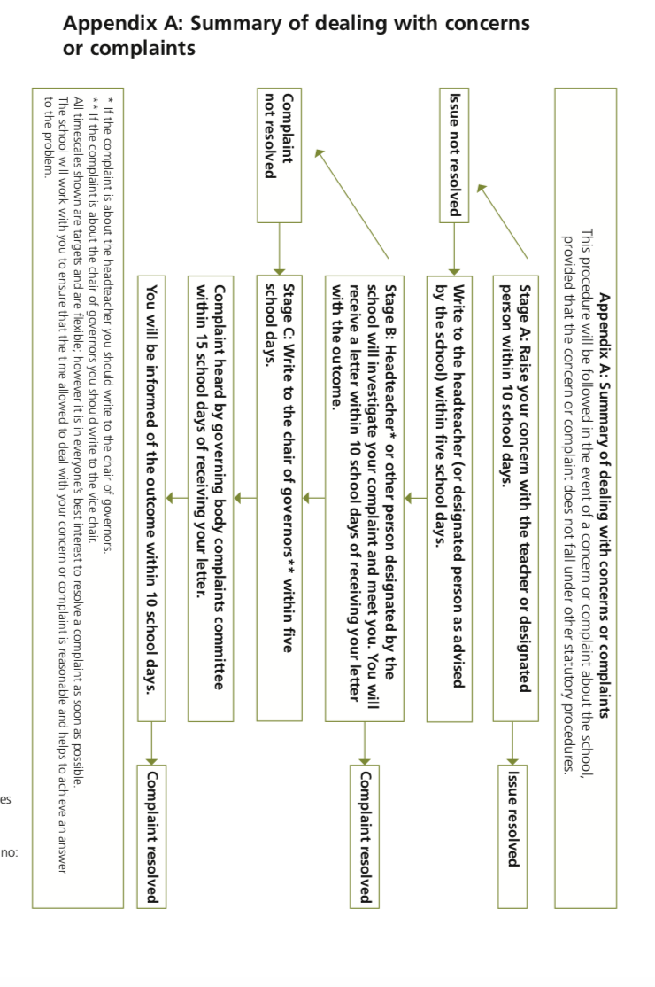

Complaint form
The person who experienced the problem should normally fill in this form. If you are making a complaint on behalf of someone else, please fill in Section B also. Please note that before taking forward the complaint we will need to be satisfied that you have the authority to act on behalf of the person concerned. If you are a pupil the school will help you complete this form, will explain it to you and will give you a copy of it when it is completed.
- Your details
Surname
Forename(s)
Title: Mr/Mrs/Ms/other
Address and postcode
Daytime phone number
Mobile phone number
e-mail address
How would you prefer us to contact you?

If you are making a complaint on behalf of someone else, what are their details?
Their name in full
Address and postcode
What is your relationship to them?
Why are you making a complaint on their behalf?

C. About your complaint (continue your answers on separate sheets of paper if necessary)

C.6 What do you think should be done to put matters right?

C.7 Have you already put your complaint to a member of staff?
If so, please give brief details about how and when you did so.

Signature of complainant: Date:

Signature if you are making a complaint on behalf of someone else

Signature: Date:

Please send this form and any documents to support your complaint to:
The Headteacher, Ysgol Nantgwyn head@ysgolnantgwyn.co.uk

Official Use
Date acknowledgement sent: By whom:
Complaint referred to:
Date:
Implementation

The headteacher will be responsible for ensuring that this policy is implemented consistently.

Monitoring and evaluation

This policy will be monitored on an ongoing basis in order to inform an annual review by Governors.

Appendix I: Information for Pupil leaflets for handling complaints from or involving pupils
Have your say
Do you have a suggestion, concern or complaint? By working together we can make a difference.
We want you to feel safe and happy at school, but sometimes you may feel worried, have a concern or want to make a suggestion. We also want to hear about areas of school life that you enjoy and value.
If you are worried about something please tell a member of staff straight away so that we can look into it. We will take your concerns and any issues that you raise very seriously.
If you don’t want to raise the concern yourself, you can ask a member of the school council, a member of staff or someone else you trust to take the matter up on your behalf (the school may have a designated person for pupils to speak to). [insert contact details] or Normally in this school [insert name] will do this.

When you raise a suggestion, concern or complaint:
- we will listen to everything you say
- we will ask you questions to help make things clear
- we will treat you fairly
- someone can help you, such as a parent/carer, friend, relative or someone else
- the person dealing with your concern will tell you what is happening.

Privacy
Usually, we will not tell anyone about what you say unless they are involved in dealing with your concern. Sometimes we will tell other people, for instance, if you or someone else is in danger of being hurt or upset. If this is the case we will explain it to you.

When you have a concern or complaint against another person, then that person will normally have a right to be made aware of the concern or complaint and be allowed to give their side of the story.

School council
If your concern or suggestion affects the whole school or a group of pupils, we might suggest that the school council considers it or you might want to ask the school council yourself. We all want our school to be safe, caring and successful – the best it can be. With your help we can make it so.

Appendix II: Working with the law
The legal framework
Education Act 2002
1. Section 29(1) of the Education Act 2002 (‘the Act‘) requires governing bodies of all maintained schools to establish procedures for dealing with complaints relating to the school or to the provision of facilities or services. Under section 27 of the Act7, governing bodies must also publicise their complaints procedures.
2. There are separate statutory processes for complaints and appeals relating to the curriculum, special educational needs (SEN), religious worship, admissions, exclusions, staff grievance, teacher capability and staff discipline. You can find guidance on these topics at www.learning.wales.gov.uk.
3. Section 29(2) requires a governing body to have regard to guidance issued by the Welsh Ministers in establishing and publishing complaints procedures relating to the school or to the provision of facilities or services under section 27 of the Act.
4. This circular is published under section 29(2) in relation to the establishing and publicising of procedures for dealing with all complaints relating to the school or to the provision of facilities or services under section 27 of the Act. Governing bodies must have regard to the statutory guidance with respect to these matters and follow it unless there are compelling reasons for concluding that, in the particular circumstances of the school or the complaint, the guidance is not relevant or is outweighed by other considerations.
Education Act 1996
5. The model procedure and the remainder of this circular are published under section 10 of the Education Act 1996, under which the Welsh Ministers shall promote the education of the people
of Wales.

Appendix III: Leaflets used for pupils


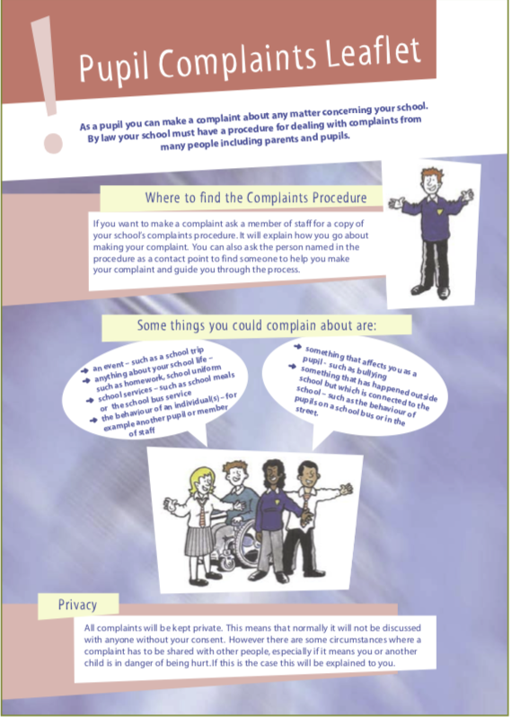

Workload Impact Assessment

Policy name: | Accessibility Plan
Date of assessment:
Assessed by:

The policy complies with and is consistent with the teachers’ contractual entitlements.
The policy and any related procedures were introduced following full consultation with the each union.
The policy and any related procedures include a specific statement regarding workload impact.
The policy has been piloted/trailed/evaluated to enable an assessment of workload impact to be made.
The impact of the policy and related procedures is that they have not added additional hours of working
The policy does not duplicate any other existing policy.
All policy has been reviewed in order to access whether any outdated and unnecessary.
The College has identified the resources necessary to support the policy, including staff time, any additional staffing and appropriate equipment.
Implementation of this policy will not result in any additional meetings/activities that have not been identified within the College calendar, published and revised in consultation with the Unions.
All staff (including the headteacher) have had training to ensure that the policy and any related procedures are carried out without increasing workload burdens.
The policy and related procedures are reviewed regularly to ensure that additional workload burdens have not been added over time.

