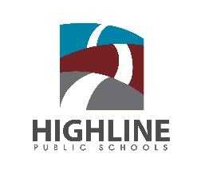
Highline Public Schools Community Partnerships

Highline Public Schools values strong community partnerships. We cannot do this work alone. We are better when students, families, community and educators work hand-in-hand. We are lucky to have partners bringing their expertise and care to our community.
Many of these partners come on to schools grounds to administer their programming directly to students. These partners require a partnership agreement. Currently we have partnership agreements with 75 different partners. Our partnerships have grown by 60 percent since 2015-16.
Community partners and partnership agreements are managed under the department of Student Support and Family Engagement by Nikki Fogerty, Community Partnership Specialist with support by Kisa Hendrickson, our Chief Engagement and Partnership Officer.
In this report, organizations with partnership agreements are documented. We show the amount, the growth, the program type, the breakdown by service area, and the highlights of their work.

2019-20 and Beyond
- Increase depth of partnership through intentional collaboration, especially with mental health partners
- Becoming a Man (BAM) program and expansion into schools
- Strategic work around restorative practices and partners
- Increase accountability with partners
- Connect partnerships with data resign
- Grow partnership work through expanding staff in partnership team

Total Partners

Partnership Agreements Created

Partnerships by Type

Arts: | Arts Corps
 | 5th Ave Theater
 | Pacific Northwest Ballet
 | Trackademics
Reading and Writing: | Brown Girls Write
 | Team Read
 | Reading Partners
STEM: | eMode Math Foundation
 | Playwell Teknologies
 | Environmental Science Center (ESC)
 | Washington Informal Science Education Consortium (WISE)
 | SeaTac United
 | Techbridge Girls
Health and Physical Education: | Cascade Bike Club
 | FEEST
 | Girls on the Run
 | Team Works
 | Washington Youth Soccer
 | WSU Food Sense
 | HealthPoint
 | Planned Parenthood
 | Upower
 | Smile Partners
College and Career: | South Seattle College TRIO Program
 | College Access Now
 | College Success Foundation
 | Summer Search
 | UW Dream Project
Mental Health: | Accelerator YMCA
 | Asian Counseling and Referral Services
 | Atlantic Street Centers
 | Catholic Community Services
 | Childhaven
 | Consejo Counseling & Referral Services
 | Cowlitz Indian Tribe
 | NAVOS
 | Seneca Family of Agencies
 | Sound Mental Health
 | Southwest Youth and Family Services
 | Therapeutic Health Services
 | Valley Cities
 | WAPI- Washington Asian Pacific Islanders
 | You Grow Girl!
Mentorship: | Ace Academy
 | Boys and Girls Club
 | Burien Parks and Rec
 | Communities in Schools
 | Gay City: Seattle's LGBTQ Center
 | GEM
 | Girls Inc.
 | Harvard-Crimson Achievement Program
 | Highline College
 | Shine Bright
 | Somali Youth & Family Club
 | Urban Impact
 | Friends of the Children
 | Treehouse
 | Rainier Scholars
 | YMCA-Tyee Scholars
 | YMCA-Alive and Free
 | Yes! Foundation
 | Yes! For Schools
Prevention/intervention: | Domestic Abuse Women's Network
 | Nexus Youth and Families
 | PSESD
 | Avanza-King County
 | KCHA
 | King County Superior Court
 | Reconnect to Opportunity
 | UW School of Social Work
 | White Center Community Development Association
 | YMCA Case Management
 | Guided Pathways
Restorative Justice: | Choose 180
 | PointOneNorth Consulting

Partnerships by Service Area
Mental Health partners and DAWN are open to all schools.
WISE is open to all elementary schools.
Mount Rainier Service Area
Mount Rainier: | Choose 180
 | College Access Now
 | College Success Foundation
 | Dream Project
 | Highline College
 | Nexus Youth and Families
 | Rainier Scholars
Summer Search
Team Read
 | Treehouse
 | Brown Girls Write, SPC
Pacific: | Dream Project
 | Environmental Science Center (ESC)
 | Highline College
 | Nexus Youth and Families
 | Treehouse
 | Yes! For Schools
Des Moines: | Environmental Science Center (ESC)
Marvista: | Environmental Science Center (ESC)
 | Girls on the Run
 | Shine Bright
Midway: | ACE Academy
Environmental Science Center (ESC)
Team Read
 | WSU Food $ense Program
North Hill: | Environmental Science Center (ESC)
 | Girls on the Run
 | Techbridge
Parkside: | Environmental Science Center (ESC)
 | Girls on the Run
 | Shine Bright
 | Washington Youth Soccer

Tyee Service Area
Tyee: | 5th Ave Theater
 | Cascade Bike Club-Major Taylor Project
 | Choose 180
 | College Success Foundation
 | Communities in Schools
 | Dream Project
 | FEEST
 | Highline College
 | Nexus Youth and Families
 | South Seattle College TRIO Program
 | Summer Search
 | Techbridge
 | Treehouse
Chinook: | Dream Project
 | Environmental Science Center (ESC)
 | Highline College
 | Nexus Youth and Families
 | TEAM-WORKS
 | Techbridge
 | Treehouse
Bow Lake: | Environmental Science Center (ESC)
 | Girls on the Run
 | SeaTac United
 | Somali Youth and Family Club
 | Techbridge
 | Washington Youth Soccer
Hilltop: | Arts Corps
 | Burien Parks and Rec
 | Environmental Science Center (ESC)
 | SeaTac United
Madrona: | Communities in Schools
 | Environmental Science Center (ESC)
 | GEM
 | Girls on the Run
 | SeaTac United
 | Techbridge
McMicken Heights: | eMode Learning Foundation
 | Environmental Science Center (ESC)
 | Play-Well Technologies
 | SeaTac United
 | Techbridge

Highline Service Area
Highline HS: | Burien Parks and Rec
 | Cascade Bike Club-Major Taylor Project
 | College Access Now
 | College Success Foundation
 | Communities in Schools
 | Dream Project
 | Harvard Club of Seattle- Crimson Achievement Program
 | Highline College
 | Nexus Youth and Families
 | Rainier Scholars
 | Summer Search
 | Treehouse
Sylvester: | Burien Parks and Rec
 | Choose 180
 | College Success Foundation
 | Environmental Science Center (ESC)
 | Highline College
 | Nexus Youth and Families
 | Rainier Scholars
 | Southwest Youth and Family Services
 | Treehouse
Gregory Heights: | Arts Corps
 | Environmental Science Center (ESC)
 | Girls on the Run
 | Shine Bright
Cedarhurst: | Arts Corps
 | Burien Parks and Rec
 | Environmental Science Center (ESC)
 | Girls on the Run
 | Shine Bright
Hazel Valley: | Arts Corps
 | Burien Parks and Rec
 | Environmental Science Center (ESC)
 | Girls Inc.
 | Girls on the Run
Shine Bright
Team Read
 | Techbridge
 | Washington Youth Soccer
Seahurst: | ACE Academy
 | Arts Corps
 | Environmental Science Center (ESC)
 | Girls Inc.
 | Girls on the Run
 | WSU Food $ense Program

Evergreen Service Area
Evergreen: | Boys and Girls Club
 | Cascade Bike Club-Major Taylor Project
 | Choose 180
 | College Success Foundation
 | Dream Project
 | FEEST
 | Highline College
 | Nexus Youth and Families
 | South Seattle College TRIO Program
Summer Search
Team Read
 | Treehouse
 | Urban Impact
Cascade: | Boys and Girls Club
 | Cascade Bike Club-Major Taylor Project
 | College Success Foundation
 | Dream Project
 | Environmental Science Center (ESC)
 | Gay City: Seattle's LGBTQ Center
 | Highline College
 | Nexus Youth and Families
 | South Seattle College TRIO Program
Techbridge
Team Read
 | Treehouse
 | Yes Foundation
Beverly Park: | Environmental Science Center (ESC)
 | Girls on the Run
 | Pacific Northwest Ballet
 | Reading Partners
 | Techbridge
 | Washington Youth Soccer
Mount View: | Arts Corps
 | eMode Learning Foundation
 | Environmental Science Center (ESC)
 | Play-Well Technologies
 | Shine Bright
 | White Center CDA
Shorewood: | Environmental Science Center (ESC)
 | Girls on the Run
Southern Heights: | Arts Corps
 | Burien Parks and Rec
 | Environmental Science Center (ESC)
 | Shine Bright
 | WSU Food $ense Program
White Center Heights: | Environmental Science Center (ESC)
 | White Center CDA

Alternative Programs
New Start: | Avanza-King County Superior Court
 | Environmental Science Center (ESC)
 | Nexus Youth and Families
 | PointOneNorth Consulting
 | Reconnect to Opportunity
 | Trackademics
 | Upower
 | YMCA at New Start
Big Picture: | Arts Corps
 | Environmental Science Center (ESC)
 | Gay City: Seattle's LGBTQ Center
 | Highline College
 | Nexus Youth and Families
Raisbeck Aviation: | Nexus Youth and Families
PSSC: | Nexus Youth and Families

Program Highlights
Choose 180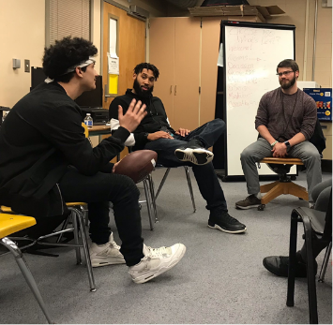
  Students Served: | 65
  Schools Served: | 4
  Highlight of your work this year: | One of the highlights this year has been working with Highline High School to support two young people who were at risk of suspension as a result of their involvement in perpetrating hate speech on campus. Through their engagement, the students participated in transformative conversations around race, privilege and social justice.
  Strength of your partnership with Highline: | Through our work we have been able to build strong relationships with both the students and the staff which has been a terrific asset in helping bridge connections between them. The students have benefited from the space we create is structured to amplify their voice which helps them set goals while building a self-lead strategy to reach them.
Feest  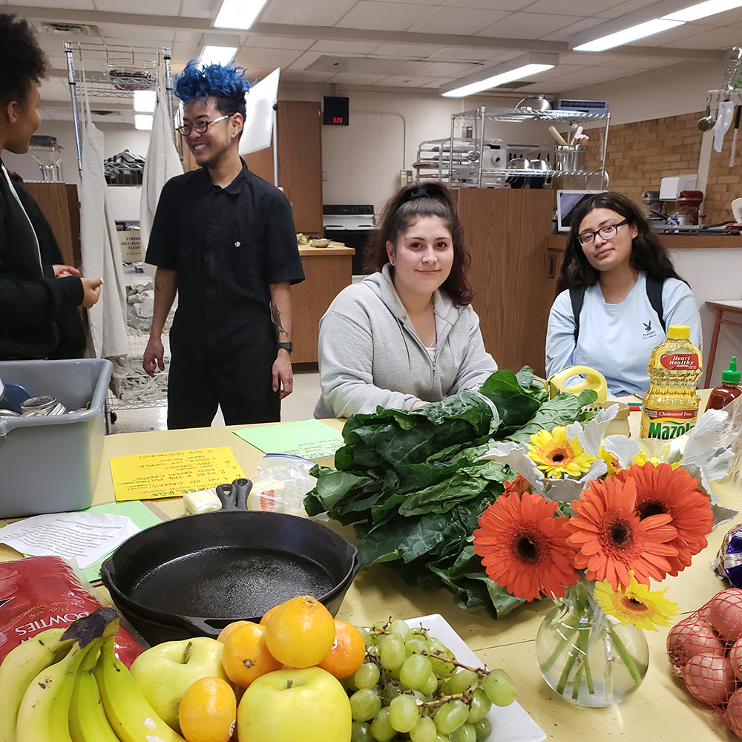
  Students Served: | 194
  Schools Served: | 2
  Highlight of your work this year: | We heard from hundreds of students about their experiences with school food and improvements they'd like to see implemented. We collaborated with Nutrition Services to add six youth-created recipes to the district lunch menu and implement new culturally relevant items on the menu every week.
  Strength of your partnership with Highline: | This year, we’ve deepened our partnerships with teachers, students and administrators in the Tyee and Evergreen communities, and have expanded the breadth of our connection to include a broad range of partners and collaborators.
Navos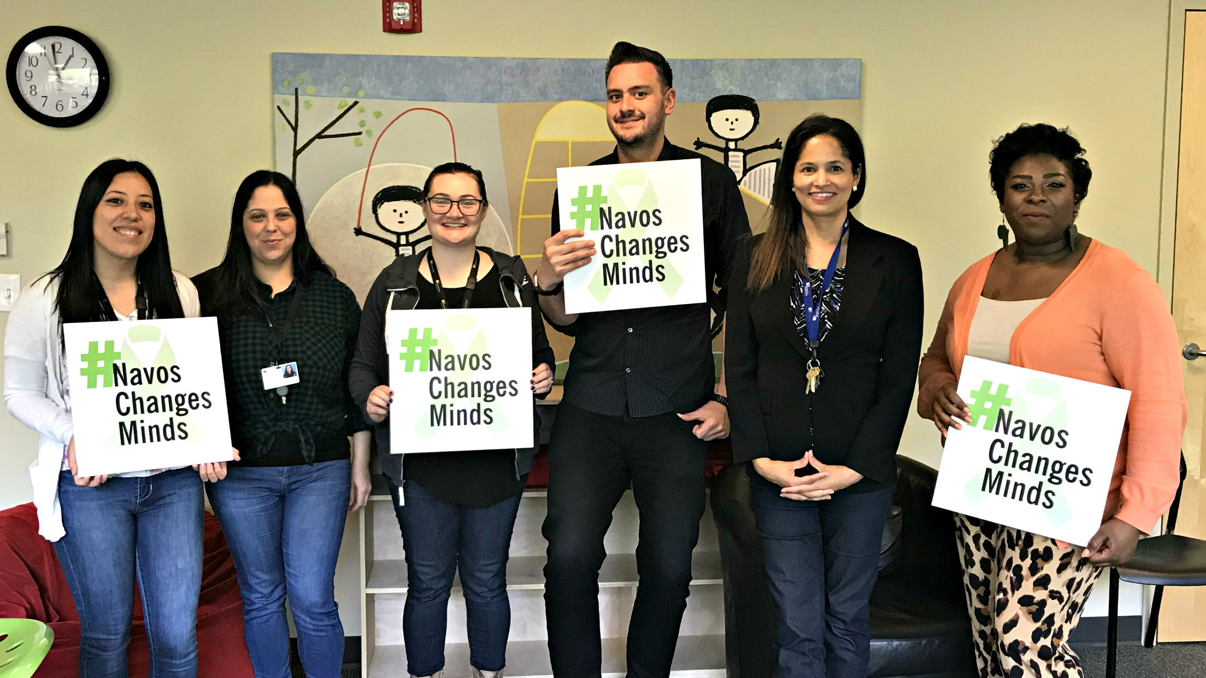
  Students Served: | 500
  Schools Served: | 16
  Highlight of your work this year: | The facilitation of the Latina Girls group at Mount View Elementary has been a highlight. We all appreciate the open lines of communication with school staff to ensure students connect with mental health support. Schools value our services to students and work hard to make sure our staff had adequate confidential space to meet with students.
  Strength of your partnership with Highline: | The quarterly meetings we have with the Highline district team are a strength. We appreciate and value the collaborative spirit of these meetings.
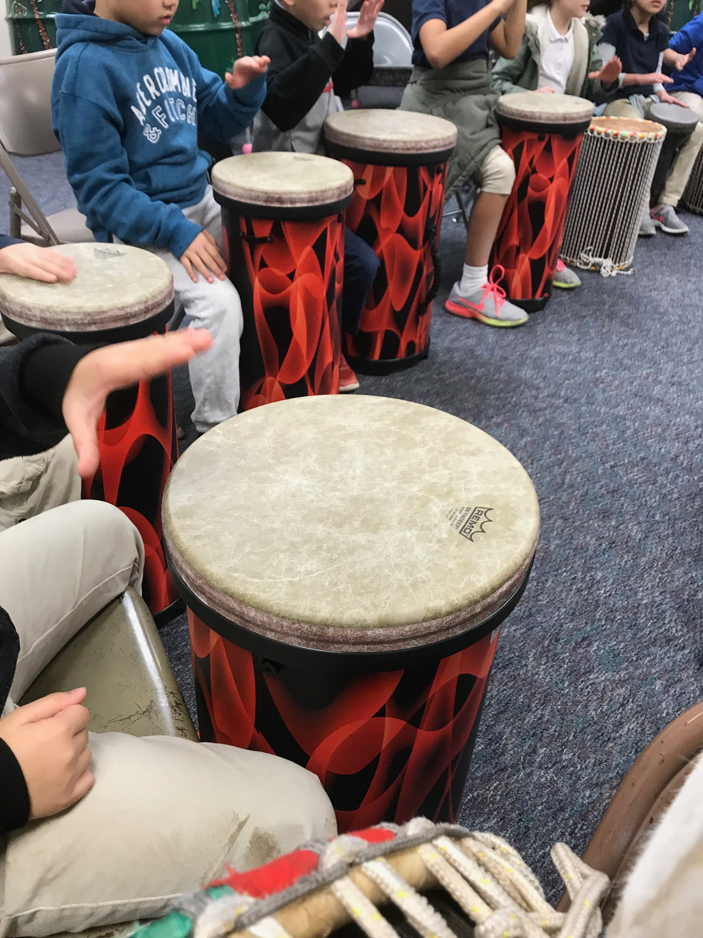  Arts Corps
  Students Served: | 1676
  Schools Served: | 9
  Highlight of your work this year: | Our Creative Schools Learning and Belonging program has had the wonderful opportunity of serving Hazel Valley and Mount View Elementary for the entirety of the school year. These particular partnerships involved having an in-school teaching artist and having after school teaching artists. Our teaching artists have supported events and workshops at these schools which allowed for families to be exposed to the creative experiences of their children.
  Strength of your partnership with Highline: | Nikki Fogerty and Stefan Nelson from Highline Public Schools have been great advocates to our programming by providing us support with logistical information such as classroom enrollments and information to professional developments.
Techbridge  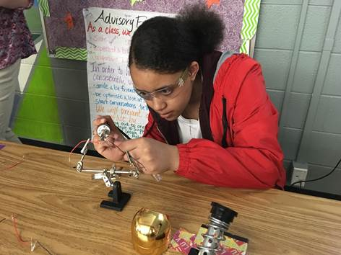
  Students Served: | 296
  Schools Served: | 11
  Highlight of your work this year: | The girls at Cascade Middle School visited Amazon and Valve for their field trips. During the Amazon trip, they learned about Amazon’s many robots used at their warehouses and designed their own. They also worked with UX designers to analyze the Amazon website.
  Strength of your partnership with Highline: | Integration with district-level planning. Because the Techbridge Girls partnership is coordinated at the district level, Highline Public Schools staff guide and accelerate our expansion, enabling us to serve more girls each year.
College Success Foundation 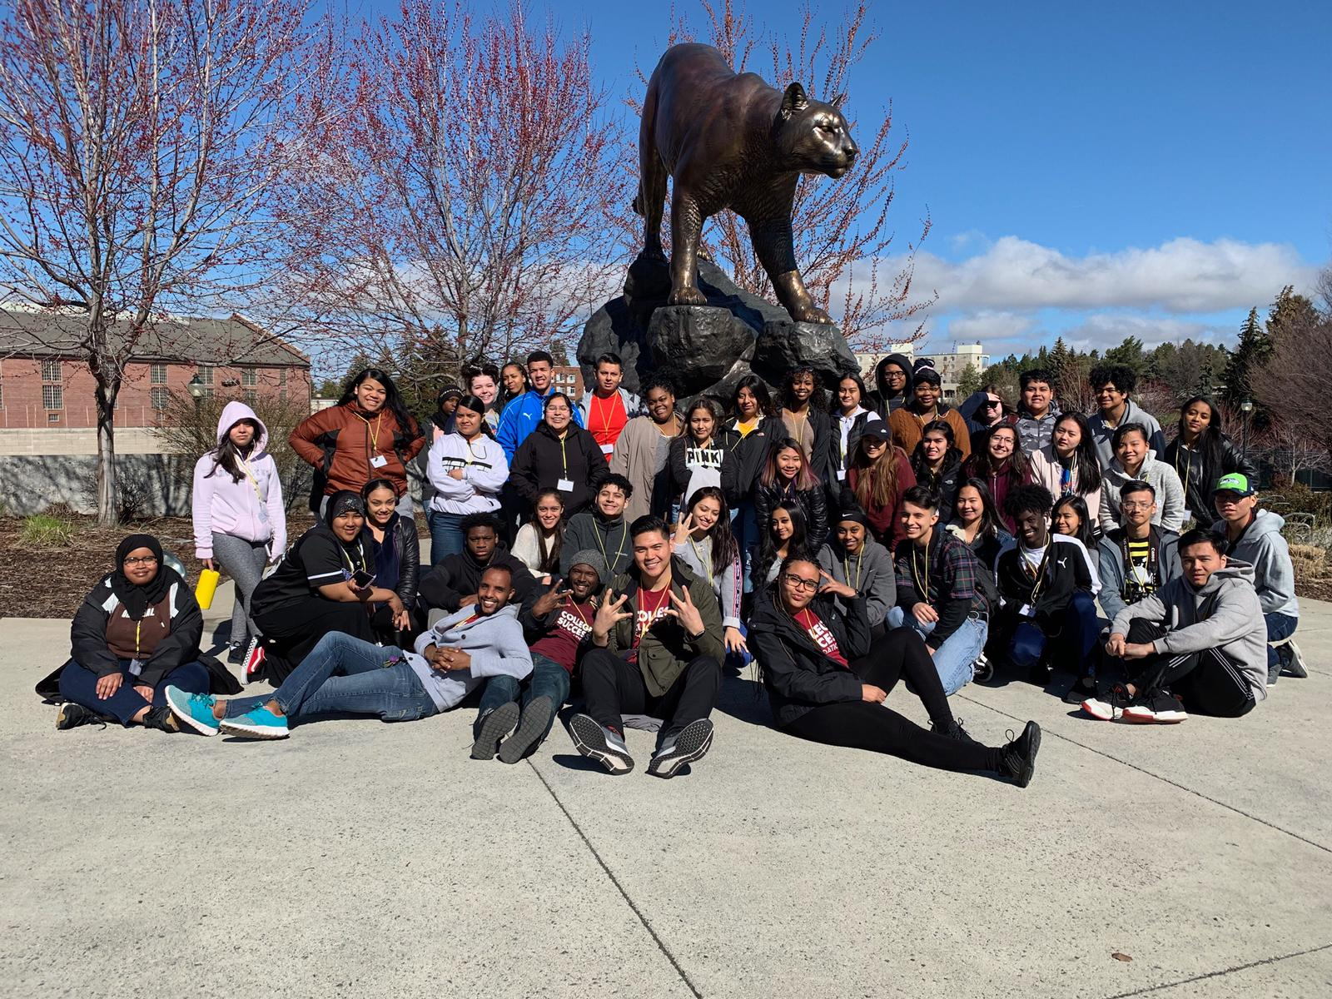
  Students Served: | 949
  Schools Served: | 7
  Highlight of your work this year: | FAFSA/WASFA completion rate for all Achievers (88% and climbing) & a push for other non-CSF students to complete as well (in support of College/Career Specialists), Overnight Spring Break College Tours- 45 Junior Achievers explored EWU, CWU & WSU, Signature scholarships awarded to senior Achievers:  - HHS- 9 seniors received WSOS scholarship, 1 Act Six, 7 received the Highline Alumni Foundation Scholarship  - MRHS- 8 seniors received WSOS scholarship, 2 won Des Moines Dollars for Scholars, 1- Highline Council PTSA scholarship  - THS- 8 awarded WSOS, 3 L1000, 5 Highline Foundation  - EHS- 5 seniors awarded WSOS scholarships
  Strength of your partnership with Highline: | Alignment and support for school/district events and activities related to college/career such as: CollegeCon, Future U, and Career Exploration Trips. CSF advisor and program manager participating in the Highline/YDEKC Community Partnership Cohort.
Communities In Schools  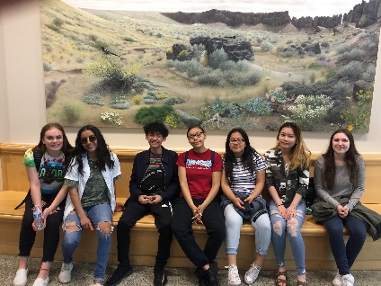
  Students Served: | 1290
  Schools Served: | 3
  Highlight of your work this year: | A highlight of our work this year has been relationships with students. One student in particular is Yasmine. Yasmine and I met outside one day as I was speaking French to a couple of students. She was in awe as she stated “oh my god I didn’t know you speak French! I always see you around. Are you a teacher?’ From that day on, Yasmine comes to my desk to check in everyday and eventually turned in her case management permission slip. As the weeks went on Yasmine was getting into fights, skipping class and failing all of her classes. Besides building a relationship with Yasmine, I also built a relationship with her mom who is from West Africa. Her mom was very worried that Yasmine was going on the wrong path. For weeks, Yasmine and I worked on a plan where she worked on missing assignments, stayed after school and tried to stay out of trouble. Right now Yasmine is passing all of her classes except one, which she is working on getting that grade up.
  Strength of your partnership with Highline: | Strengths of our partnership are relationship development with students, families, school staff, teachers, counselors, and administration, development of partnership with outside resources (i.e Mary's Place) and collaboration with social worker team and partnership team at Highline.

