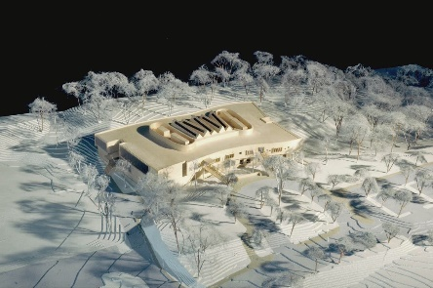
NEW LEBANON ELEMENTARY SCHOOL BUILDING COMMITTEE
Community Update – June 2019

About the School Building Project
This intra-district elementary International Baccalaureate magnet school will serve students in grades PreK-5. The centrally located learning commons, equipped with flexible furnishings & adaptable technological infrastructure, allows for multiple zones of simultaneous learning. The building is designed to meet the sustainability goals established by the Educational Specifications and to achieve a gold-level LEED rating from US Green Building Council.
The following work was accomplished:
  - Punch List and remaining items to be completed is ongoing
- Building Demolition will be complete in early June
Work anticipated for the coming weeks:
  - Last Day of School 6.18
  - Baseball field reconstruction will begin late June
  - Bus loop sitework will begin in late June
  - Playground equipment PO to be issued.
The project has received its 4th reimbursement from the state, $3,495,815, totaling $15,738,167 to date.
A 5th reimbursement has been revised to the amount of $1,196,911, due in early June
If you have a concern, please contact the Gilbane Project Manager, Daniel Phillips at (914) 246-4862.

Front Entrance Demo – 5/29/19
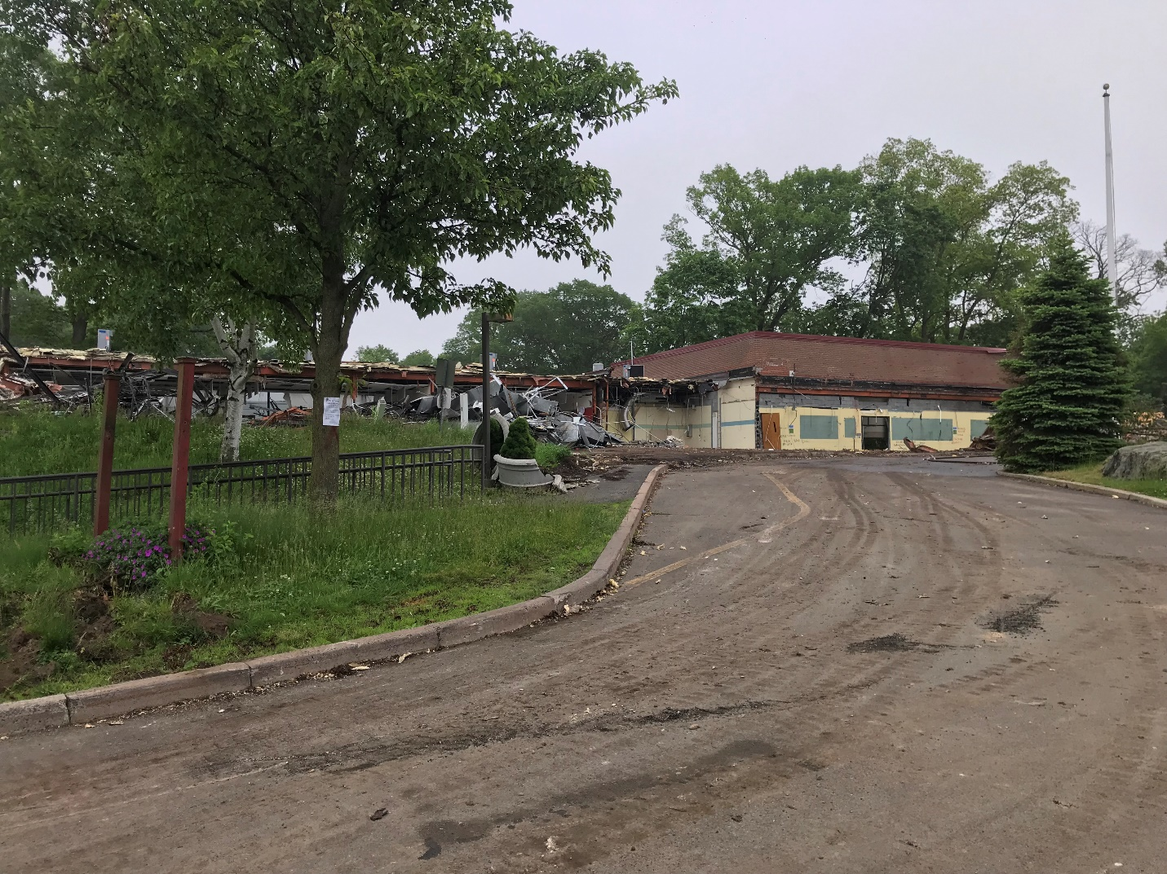

Demolition looking East – 5/29/19
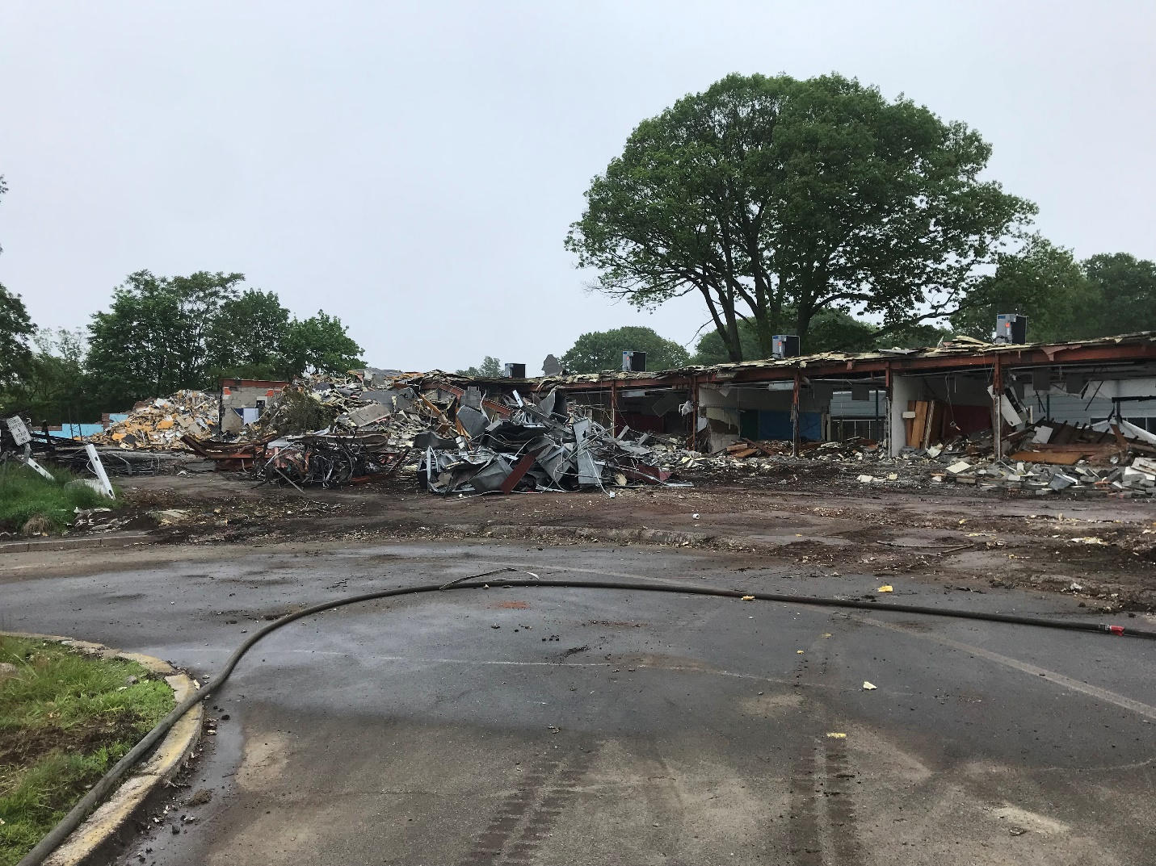

Demolition looking West – 5/29/19
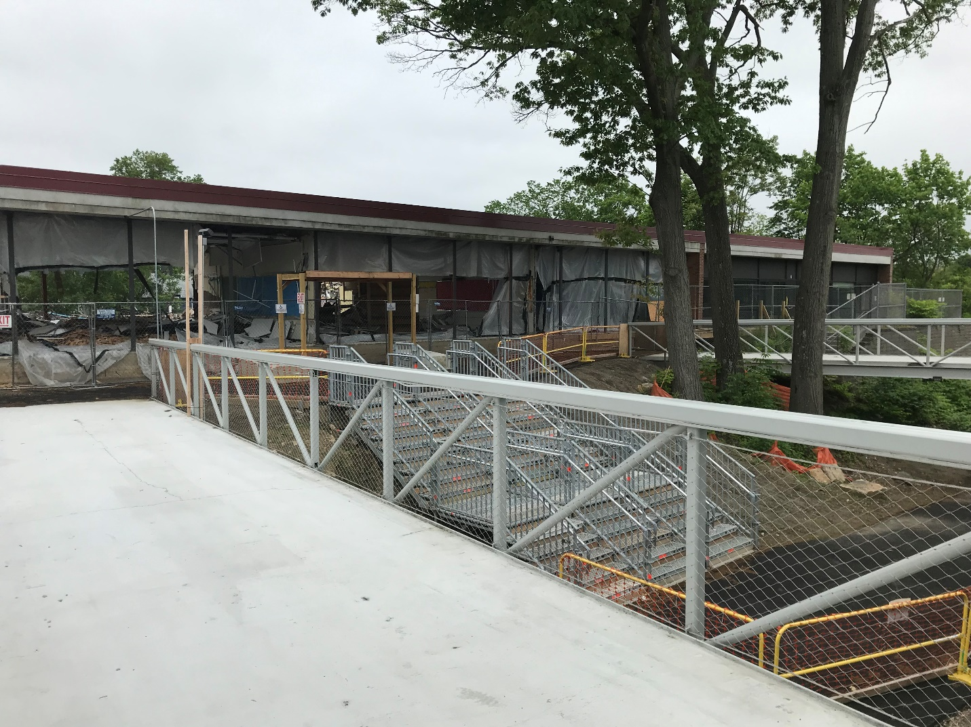

Gym Demolition – 5/29/19
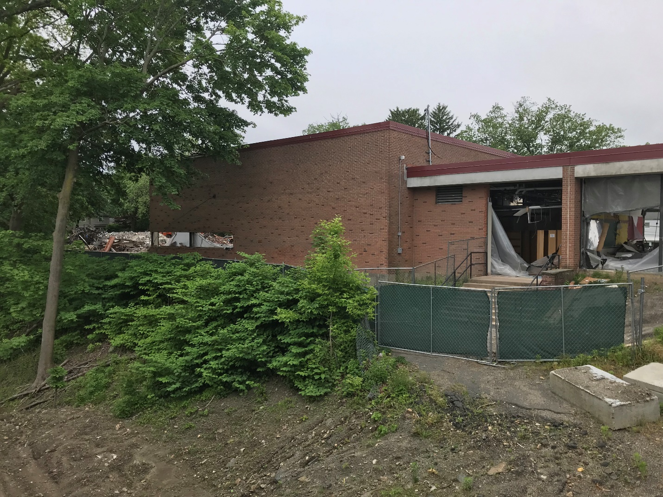

Visit our website: www.greenwichschools.org/NLSBC

