Fun Facts Instructions
The following energy and sustainability facts have been pulled from a variety of sources in order to provide students and staff with opportunities to learn about these topics. These can be distributed in any manner that makes sense for your school or district. Some ideas include:
- Create a People.Power.Planet wall and post a new energy fact every week.
- Send the full list of fun facts to the school’s newsletter editor for inclusion as space is available.
- Forward fun facts every week for the school’s news broadcast.
- Send themed monthly fun facts to school staff via email.
- Post an energy fun fact on your school’s peoplepowerplanet.com What’s Happening page each month.



Learn: Quick Facts About Energy & Waste
- Almost 50% of the electricity used in the United States is for lighting.
- Lighting consumes almost 20% of the world’s electricity generation.
- The carbon dioxide emissions caused by lighting is equal to 70% of global emissions from passenger vehicles and is three times more than emissions from aviation.
- The electricity used to power a single incandescent light bulb over its lifespan costs five to ten times the cost of the bulb itself.
- If a 13-watt CFL and its equivalent — a 60-watt incandescent bulb — are both lit for 8,000 hours each, the CFL uses about 75% less energy than the incandescent bulb.
- CFLs last, on average, ten times longer than regular bulbs.
- An ENERGY STAR® CFL bulb can save more than $40 in electricity over its life.
- If each home in the U.S. replaced just one incandescent light bulb with a CFL, the energy saved would be enough to light 3 million homes and the greenhouse gas emissions would be reduced by the equivalent of 800,000 cars.
- Less than 1% of the world’s water is usable freshwater.
- Though we may like to think of water as an infinite resource, 36 U.S. states anticipate a freshwater shortage by 2013.
- The average daily water use for a family of four is 400 gallons.
- The best way to ensure that fresh water will continue to be available in the future is for each of us to reduce our individual water use.
- Turn off the faucet while brushing your teeth and save 25 gallons a month.
- Each American generates 4.6 pounds of waste per day.
- Americans collectively generate around 250 million tons of waste each year. Of that waste, just over 30% is recycled or composted and 12.5% is burned, which leaves 170 million tons of trash going to landfills.
- Three easy strategies achieve the goal of eliminating waste: reduce, reuse, and recycle.
- Just one gallon of gas in your car can create 19 pounds of carbon dioxide, the biggest greenhouse gas, in the air.
- A research group found that global carbon dioxide emissions are increasing at a rate three times faster than in the 1990s.
- When trees are cut down, we lose a valuable natural air cleaner.
- The average car on the road produces six tons of carbon dioxide each year.
- Even when these electronics are turned “off,” they often consume energy to light their displays or remain in standby mode.
- The average household pays $200 a year to power electronics that are plugged in but not being used (standby mode) — consuming as much electricity as seven power plants generate.
- Turning off your computer at night alone will save you $90 each year.
- The average American’s carbon footprint is 27 tons of CO2 per year.
- The average American’s carbon footprint is nearly five times the average elsewhere in the world.
- The biggest contributors to greenhouse gases in America are heating, lighting, and transportation.
- The average American household spends more than $1,000 a year to heat and cool their home, accounting for around half of their total household energy consumption (Source: ENERGY STAR®).
- According to ENERGY STAR®, homeowners can save about $180 a year by properly setting their programmable thermostats and maintaining those settings.
- America spends more than $13 million each hour on foreign oil.
- Currently, one-third of our oil comes from the Middle East.
- A person driving to a grocer three miles from her home once a week in a vehicle that gets 20 miles per gallon uses 0.3 gallons of gasoline and emits 5.7 pounds of carbon dioxide per trip. This adds up to 15.6 gallons of gas and 296.4 pounds of CO₂ annually for that weekly grocery run alone.

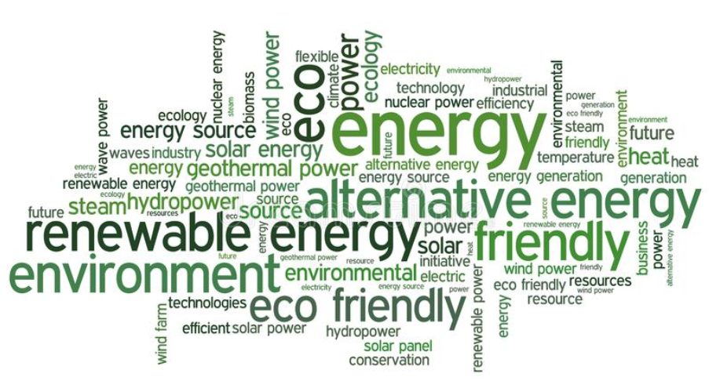

Do/Share: Energy & Conservation Tips
- Turn off lights whenever you are leaving a room for more than a couple of minutes.
- As lights inside and outside your home burn out, replace them with ENERGY STAR CFL lights.
- Rely on natural daylight whenever possible.
- Rather than turn on all of the light switches in a room, use task lighting in the area where you need it.
- Place stickers near light switches reminding people to turn out the lights when leaving a room.
- Remind habitual lighting energy wasters of the importance of conservation.
- Reduce your car wash frequency.
- Wash dishes or toys in a bin instead of running water over items. Water shrubs or plants with the extra water instead of tossing it down the drain.
- Use a rain gauge to help determine if lawn watering is necessary.
- Use a water-efficient showerhead and shorten your shower by a minute or two.
- Lead by example: If you make significant efforts to reduce your water use, others will take notice.
- Encourage your family and friends to install WaterSense® showerheads, faucets, and toilets.
- You can recycle more materials than you think — many areas are starting to offer “e-cycling” programs for electronic devices that would otherwise be thrown in landfills.
- Pause and consider the necessity and lifecycle of an item before purchasing it. Ask yourself, “Do I need this? Will I use it? How long will I use it?”
- Purchase used or recycled items whenever possible.
- Consider giving away unwanted items rather than throwing them in the trash.
- Recycle steel, rubber tires, electronics, glass, paper, aluminum, plastic, and cardboard.
- Send your friends a link to sites like freecycle.com to find and list unwanted items that would otherwise be thrown in a landfill
- Help organize an electronics recycling drive for your school district or neighborhood.
- Carpool with friends, family, coworkers, or carpool groups.
- Bike or walk to your destination whenever reasonable.
- Research your options for local public transportation. Take a bus or train to your destination.
- Buy a hybrid or alternative fuel vehicle to reduce your emissions when you drive.
- Check with coworkers, family, and friends to organize a carpool for work, school, and social events. Sharing driving responsibilities has numerous social, financial, and environmental benefits.
- Participate in Bike to Work Day and encourage coworkers to join you.
- Plug all components of your computer or television into a power strip so you can cut the power to each item in one motion.
- Leave appliances and electronics that you use infrequently unplugged.
- Kitchens and bathrooms are often the biggest energy wasters with numerous items plugged in that are used once a day or less (e.g., coffee makers, toasters, curling irons, hair dryers).
- Unplug phone, camera, and other chargers when not in use. They use power even when they aren’t charging a device.
- Purchase ENERGY STAR® appliances. They do not necessarily eliminate phantom energy use, but they do reduce energy consumption over the life of the appliance.
- If you consistently rely on power strips to switch off unused appliances and make sure to unplug individual electronics, you could save enough money to purchase new ENERGY STAR appliances when your existing devices need replacing.
- Many people have heard about phantom energy use, but may have dismissed it as a myth. Talk to your friends and family about it.
- Encourage friends & family to think about how many outlets at home or work are supplying latent power to unused electronics.
- Buy a power strip to go along with the next electronic device you purchase for a friend so they can reduce their phantom power use.
- Adjusting your thermostat even a few degrees can conserve a great deal of energy.
- Check out an online carbon footprint calculator to find out your individual contribution to greenhouse gases. The EPA offers a good option: http://www.epa.gov/climatechange/emissions/ind_calculator.html
- Install a programmable thermostat at your home to regulate your energy use.
- Replace traditional light bulbs with energy-efficient models.
- Rely on shared transportation, walking and biking, or alternative fuel vehicles to get around town.
- Compare your carbon footprint to others. Find out your carbon footprint number online and ask your friends to do the same. You can motivate one another to make a difference.
- Purchase carbon offset credits for yourself, a friend, a coworker, etc.
- In cooler months, if you program your thermostat to maintain 68° during hours you are awake and home, and 53–58° while you are asleep or away (eight or more hours per day), you can save 5–15% on your energy bill.
- Install a programmable thermostat in your home.
- Vary your heating and cooling settings for different seasons and times of day in order to optimize your energy reduction.
- Be sure to adjust your thermostat up or down to save energy when you are on vacation.
- Consider purchasing a programmable thermostat as a housewarming gift for friends or family members moving into new homes or as a holiday gift for those who don’t already own one. They are inexpensive and useful on a daily basis.
- Drive less. Optimize your trips by combining errands to a concentrated area and reduce your automobile travel altogether.
- Buy a hybrid or alternative fuel vehicle. This website has a great calculator to help you compare your car to a hybrid vehicle, from costs to environmental factors: http://www.hybridcars.com/calculator/.
- Carpool with friends or take public transit.
- Walk or bike whenever reasonable.
- Organize a carpool with friends or family the next time you have a party or get-together.
- Offer a coworker a ride to work.
- If you have an alternative fuel vehicle, talk about the benefits of your car with others.
- Once you start making changes in your driving habits, tell friends and family about it and the reasons behind those changes. Opening a dialogue is their first step to changing their own habits.
- Buy produce from your local farmers’ market to reduce the carbon footprint from your food.
- Regularly visit local family-owned boutiques and restaurants.
- Encourage larger chain stores to carry local merchants’ products.
- Invite friends and family to join you at your local farmer’s market, carpool there to even further reduce your carbon footprint.
- Participate in a Buy Local event in your community, or better yet, volunteer to help.

